Supplementary Materials

Task | Form | Mean | Std. Deviation | Std. Error Mean
TT | A | 0.71 | 0.14 | 0.02
 | B | 0.71 | 0.12 | 0.02
TC | A | 0.78 | 0.09 | 0.01
 | B | 0.79 | 0.08 | 0.01
STM | A | 0.78 | 0.05 | 0.01
 | B | 0.77 | 0.07 | 0.01
Supplementary Table 1. Descriptive analysis of the parallel versions of the three memory tasks (N=50).

Task | t | Sig. (2-tailed) | Mean Difference
TT | 0.263 | 0.79 | 0.01
TC | -0.733 | 0.46 | -0.01
STM | 0.597 | 0.55 | 0.01
Supplementary Table 2. Independent samples t-tests confronting both versions of each memory task (N=50).

TRIAL | 1st segment | 1st turn angle | 2nd segment | Return turn angle | Homing distance
A | 175 | -90 | 350 | -155 | 395
B | 175 | -75 | 185 | -135 | 285
C | 175 | -125 | 395 | -140 | 350
D | 175 | -100 | 185 | -120 | 210
E | 350 | -135 | 495 | -125 | 350
F | 350 | -120 | 215 | -90 | 290
G | 350 | -110 | 395 | -110 | 395
H | 350 | -145 | 290 | -90 | 215
I | 175 | 125 | 395 | 140 | 350
J | 175 | 100 | 185 | 120 | 210
K | 175 | 90 | 350 | 155 | 395
L | 175 | 75 | 185 | 135 | 285
M | 350 | 135 | 495 | 125 | 350
N | 350 | 145 | 290 | 90 | 215
O | 350 | 120 | 215 | 90 | 290
P | 350 | 110 | 395 | 110 | 395
Supplementary Table 3. Measures of the paths included in the egocentric navigational training. Distance is reported in centimeters and angles in degrees.

Supplementary Figure 1. Mean accuracy for each parallel version of the three memory tasks (N=50).

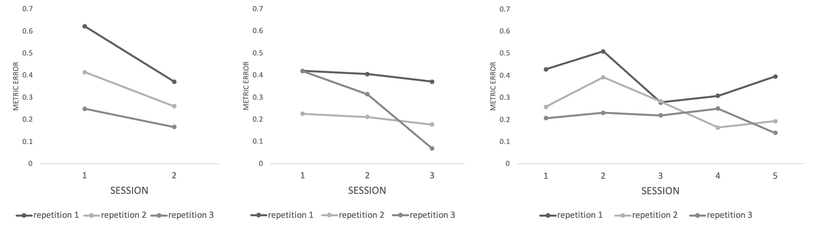
Supplementary Figure 2. Examples of behavioral progression during the navigational training in three exemplar participants. Plotted values represent mean distance errors for each repetition (N=3) within a session.

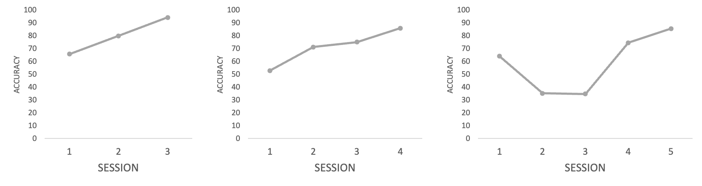
Supplementary Figure 3. Examples of behavioral progression during the visual perceptual learning in three exemplar participants. Plotted values represent mean accuracy during the different training sessions.

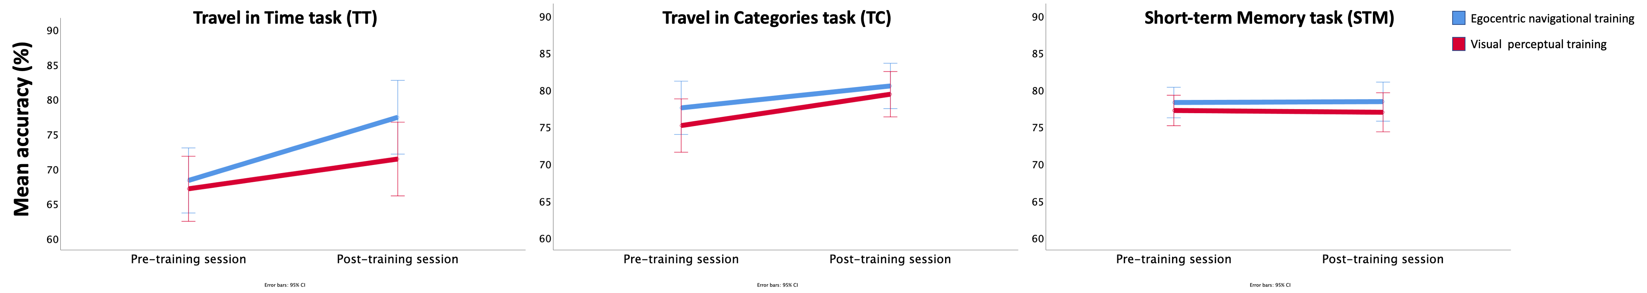
Supplementary Figure 4. Mixed model comparing Experiments 1 and 2, including the group (experimental vs. control) as a between factor, session and task as within factors, and accuracy (%) as dependent variable.

