Supplementary Materials
Effect Plots for Accuracy Analysis
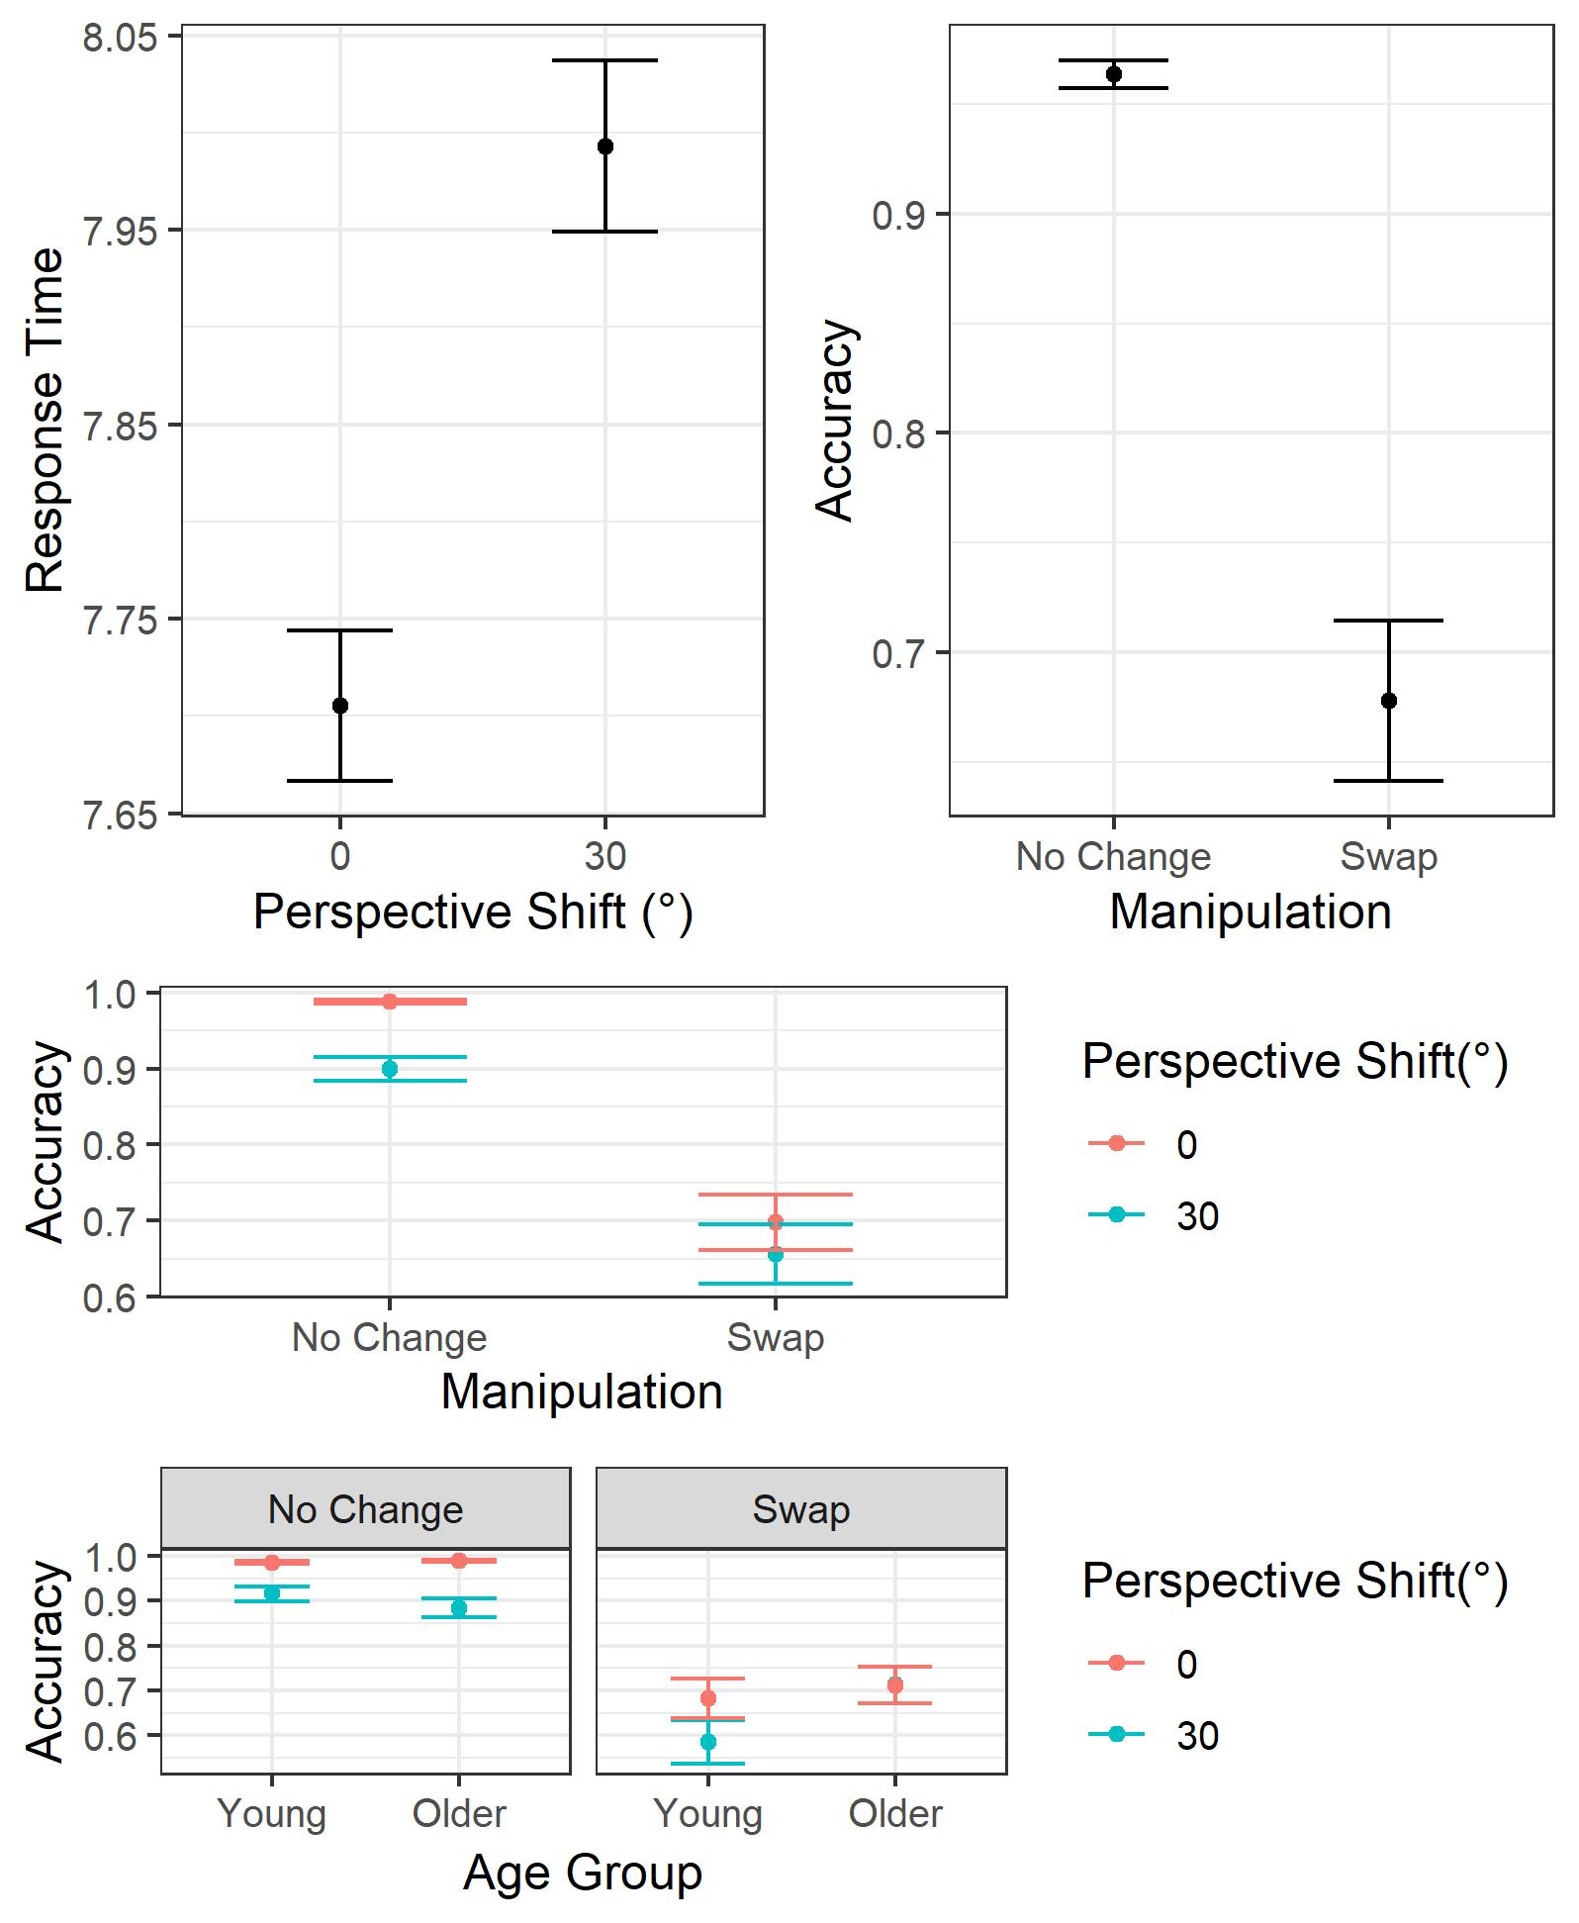
Figure 1. LMM Effect plots for significant main effects and interactions for performance accuracy
Effect Plots for Response Time Analysis
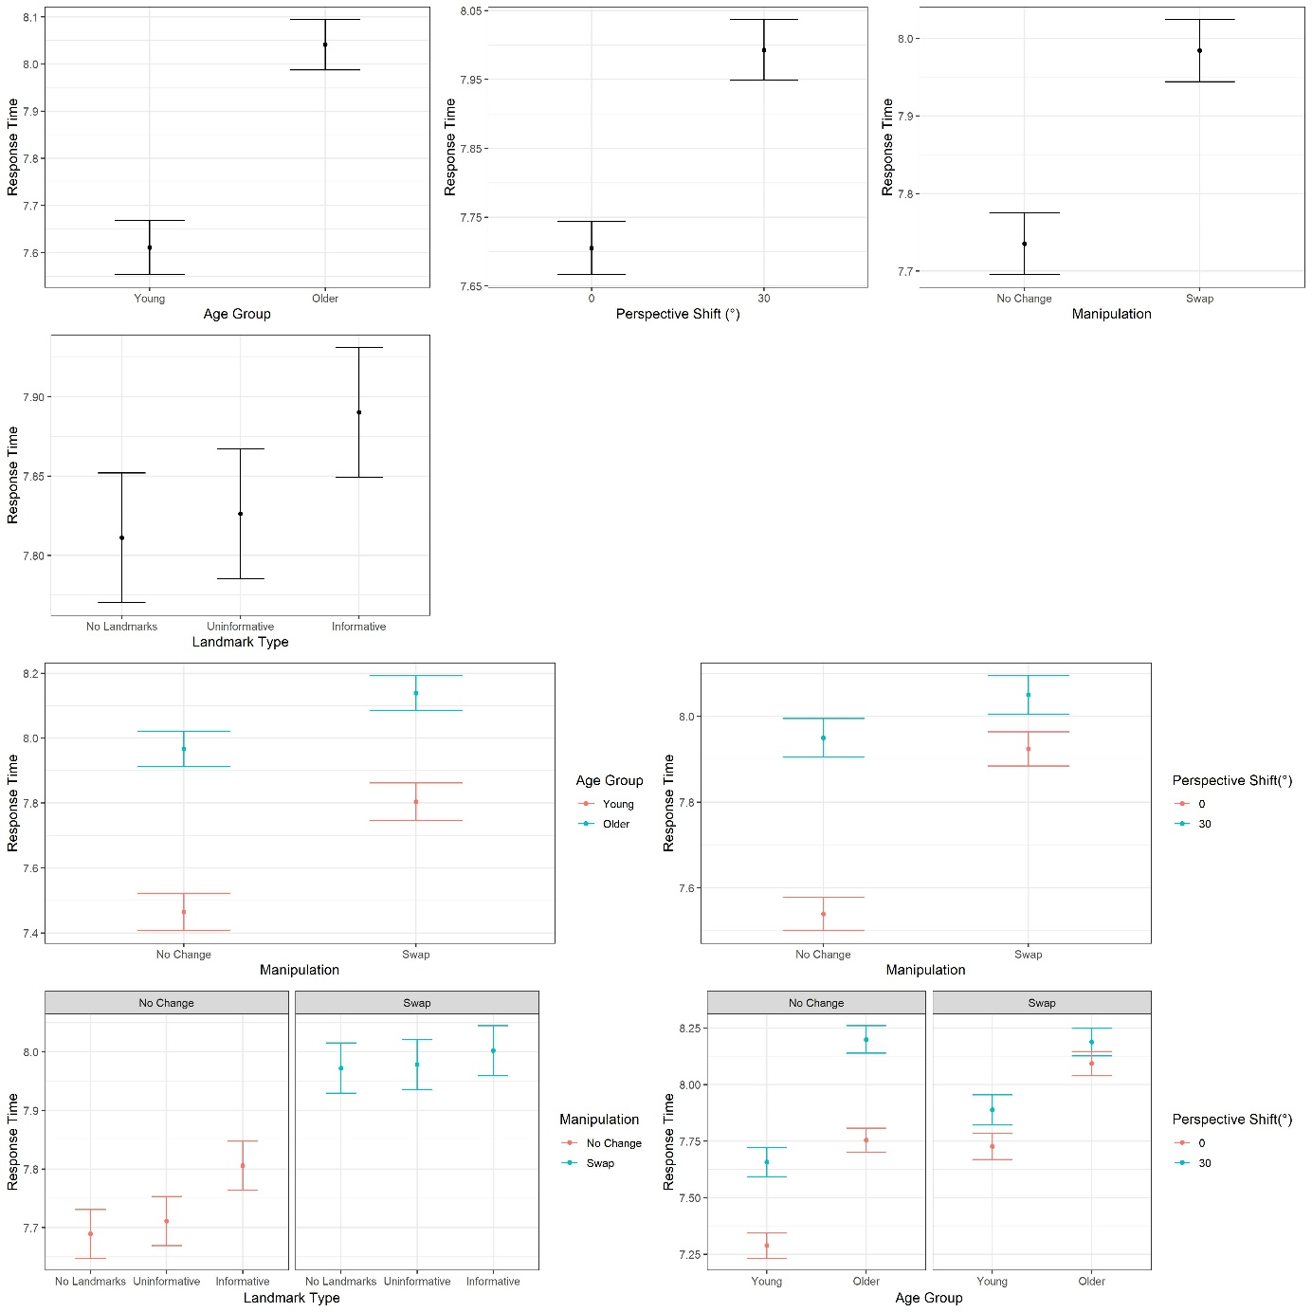
Figure 2. LMM Effect plots for significant main effects and interactions for response times

Basic Fixation and Saccade Parameters.
Differences in basic fixation and saccade parameters were examined using the Bootstrap-t method (5000 resampling) with 20% trimmed means (Wilcox & Keselman, 2003). This method provides a robust estimation of central tendency as it reduces the probability of Type 1 error and bias and does not compromise power as median-based methods do (Wilcox & Keselman, 2003). During the 12 second encoding period, older adults made shorter and more frequent fixations as well as more frequent saccades (see Table 1). Note however that these variables are not independent of each other especially in a fixed time interval.
Table 1 Means and t-test results for saccade and fixation parameters between younger and older adults from the Learning Phase
Gaze measure | Mean Young | Mean Old | Confidence Interval | t-value | p-value
Saccade Frequency | 2.51 | 2.84 | [-0.55, -0.11] | -2.94 | .004
Average velocity | 138.98 | 134.85 | [-9.51, 17.77] | -0.62 | .524
Peak velocity | 252.01 | 246.81 | [-21.23, 31.63] | 0.40 | .697
Amplitude | 6.81 | 6.41 | [0.46, 1.25] | 0.94 | .337
Saccade duration (ms) | 39.36 | 39.58 | [-2.59, 2.13] | -0.20 | .844
Fixation Frequency | 2.67 | 3.11 | [-0.67, -0.21] | -3.74 | .001
Fixation Duration (ms) | 286.23 | 255.88 | [10.98, 50.77] | 3.10 | .005
Note: significant p values are in bold type

Gaze Behaviour at Test
As in the encoding phase of trials, an LME analysis with Age Group and landmark Type as fixed factors and by-subject and by-item random intercepts in the test phase showed that landmark Type was predictive of Dwell Time on landmarks (Table 2). Specifically, we also found an Age Group and landmark Type interaction with older adults showing a larger increase in Dwell time on Informative compared to Uninformative landmarks compared to younger adults. Interestingly, at test older adults no longer displayed a larger increase in Dwell Time compared to younger adults between the No landmarks and Uninformative landmarks conditions, suggesting that they may have realised that Uninformative landmarks were not useful for solving the task.
Table 2 Coefficients from Dwell Time on the top IA at Test LME analysis
 | Dwell Time
Predictors | Estimates | std. Error | t-value
(Intercept) | 7.939 | 1.311 | 6.058
Age Group (Older Adults) | 1.899 | 1.262 | 1.505
landmark Type (No landmarks) | -4.002 | 0.682 | -5.868
landmark Type (Informative) | 10.798 | 0.682 | 15.839
Age Group (Older Adults): landmark Type (No landmarks) | -0.872 | 0.462 | -1.889
Age Group (Older Adults): landmark Type (Informative) | 3.132 | 0.461 | 6.791
Significant t values (|t|≥1.96) in bold

