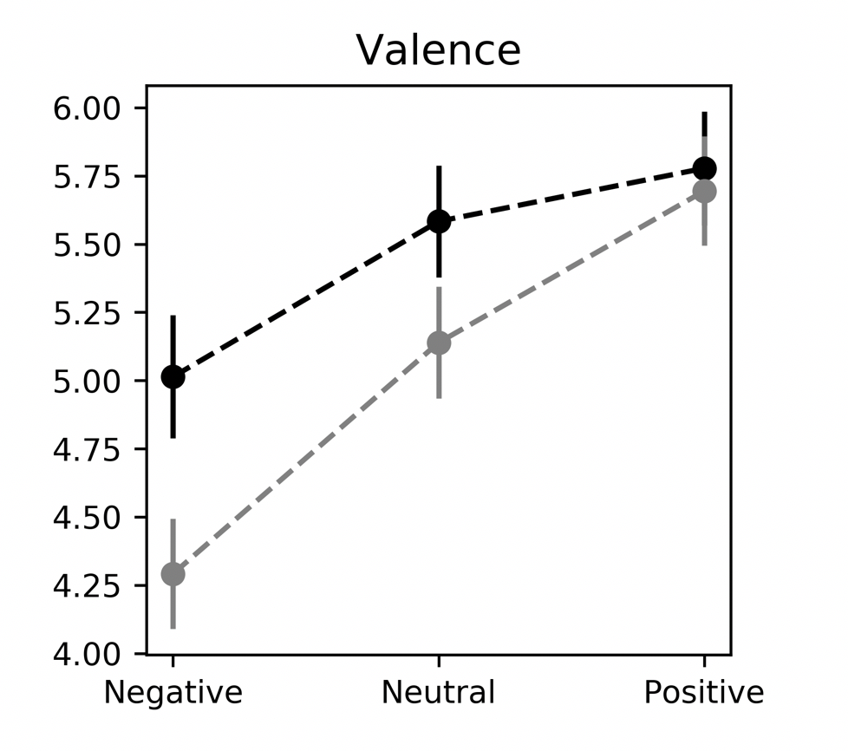
Supplementary Figure 1. Valence scores in Experiment 1 (black) and Experiment 2 (gray). Error bars denote between-participants s.e.m.
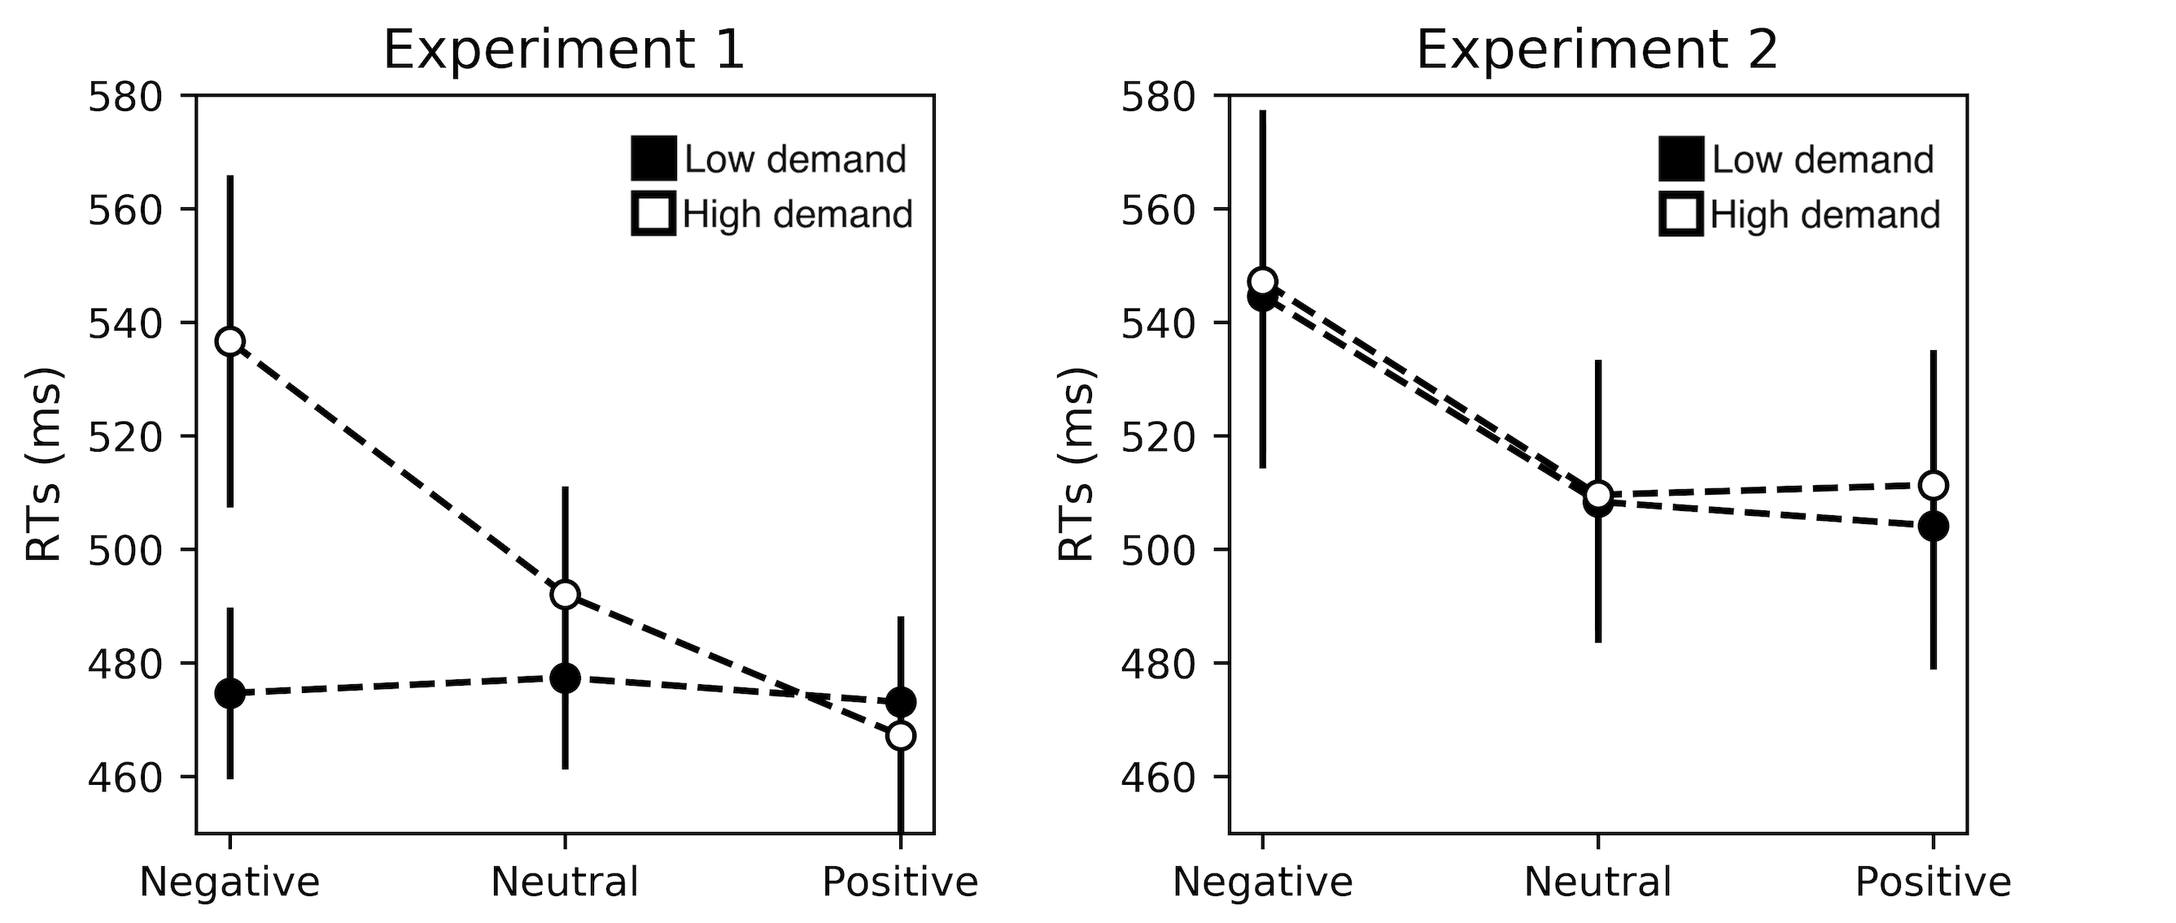
Supplementary Figure 2. Decision reaction times in Experiment 1 (left) and Experiment 2 (right). Error bars denote between-participants s.e.m.
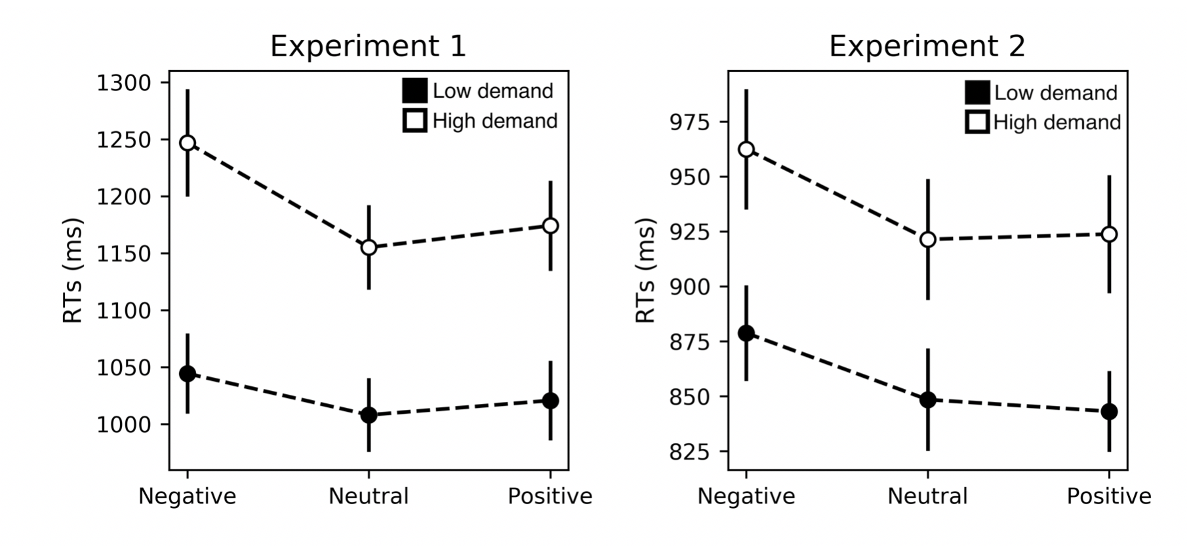
Supplementary Figure 3. Task reaction times in Experiment 1 (left) and Experiment 2 (right). Error bars denote between-participants s.e.m.

Supplementary Table 1. Mean (M) and Standard Deviation (SD) for task repetition and switch trials of Experiment 1
 |  | Task repetition |  |  | Task switch
Measure | M |  | SD | M |  | SD
Low-demand selection (%) | 83 |  | 37 | 20 |  | 43
Decision RTs (ms) | 448 |  | 499 | 466 |  | 1051
Task RTs (ms) | 967 |  | 1076 | 1183 |  | 1112
Task accuracy (%) | 96 |  | 18 | 94 |  | 23

Supplementary Table 2. Mean (M) and Standard Deviation (SD) for task repetition and switch trials of Experiment 2
 |  | Task repetition |  |  | Task switch
Measure | M |  | SD | M |  | SD
Low-demand selection (%) | 75 |  | 43 | 31 |  | 46
Decision RTs (ms) | 515 |  | 425 | 519 |  | 386
Task RTs (ms) | 821 |  | 258 | 953 |  | 555
Task accuracy (%) | 94 |  | 23 | 91 |  | 28

