Supplemental Materials

Figure 1

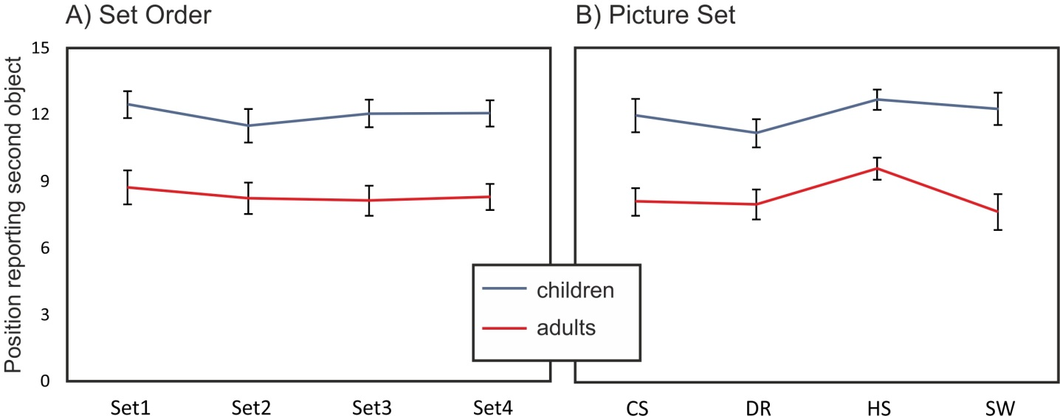
Figure 1. Average position at which children (blue line) and adults (red line) reported the second object, separately displayed for A. set-order and B. picture-set. CS = cat/swan, DR = duck/rabbit, HS = horse/seal, SW = snail/whale. Error bars reflect 95% confidence interval.

