Appendix I
Table S1.
Rotated structure matrix of the 3-factor and 2-factor solution using Principal Axis Factoring with oblique rotation
 |  | Three-factor solution |  |  | Two-factor solution
Paradigm | Measure | Factor 1 | Factor 2 | Factor 3 | Factor 1 | Factor 2
1 | HG Cost (VM) | .662 | .026 | .290 | .665  .703  .679  .657  .564  .533  -.050  .264 | .198
2 | The PRP effect | .633 | .338 | .135 | .609 | .368
1 | HG Cost (AV) | .603 | .070 | .137 | .611 | .159
 | Dual-task cost (VM) | .578 | .137 | .089 | .574 | .189
 | Dual-task cost (AV) | .505 | .205 | .215 | .507 | .290
6 | PD (subtraction) | .406 | .105 | .052 | .404 | .129
5 | Cue-switch cost | .100 | .746 | .163 | .078 | .553
4 | Mixing cost | .371 | .524 | .329 | .352 | .623
5 | Task-switch cost | .100 | .142 | .735 | .125 | .338
4 | Switch cost | .293 | .351 | .467 | .289 | .508
Note. The variables were sorted by their values of factor loadings and the factor loadings larger than 0.3 are presented in boldface. Paradigm 1 = Equal Priority Dual-task paradigm, Paradigm 2 = The PRP paradigm, Paradigm 4 = Task-switching paradigm with 1:1 cue-task mapping, Paradigm 5 = Task-switching paradigm with 2:1 cue-task mapping, Paradigm 6 = Task-switching paradigm with a problem state requirement.

Table S2.
Results of initial eigenvalues and explained variance of each component/factor of both PCA and PAF.
Component/Factor | Initial Eigenvalues | Explained variance (PCA) | Explained variance (PAF)
1 | 2.981 | 29.81% | 23.55%
2 | 1.460 | 14.60% | 9.095%
3 | 1.058 | 10.58% | 5.69%

Appendix II

“[insert Figure S1.]"
Figure S1. The 3-factor and 2-factor models examined in the CFA.
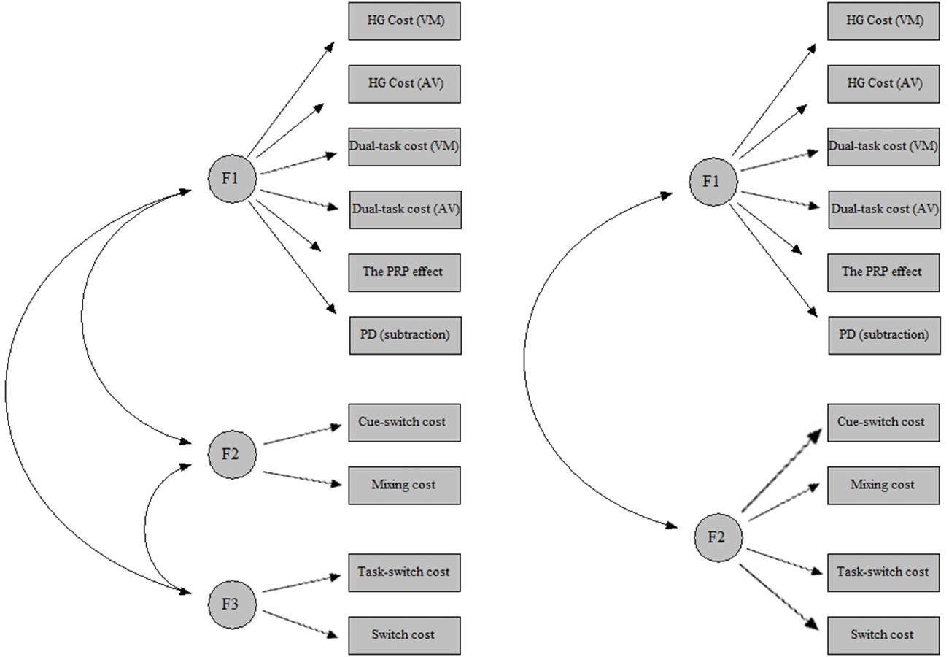

Appendix III
Table S3.
Rotated structure matrix of the factor solution using only a subset of variables

 |  | Cue-switch cost included |  | Task-switch cost included
Paradigm | Measure | Factor 1 | Factor2 | Factor 1 | Factor 2
2 | The PRP effect | .759 | .274 | .773 | .160
1 | Dual-task cost (VM) | .752 | .098 | .740 | .088
6 | PD (subtraction) | .629 | .019 | .616 | -.009
1 | Dual-task cost (AV) | .580 | .385 | .593 | .343
5 | Cue/Task-switch cost | .052 | .827 | -.014 | .839
4 | Switch cost | .304 | .706 | .313 | .761
Note. The variables were sorted by their values of factor loadings and the factor loadings larger than 0.3 are presented in boldface. Paradigm 1 = Equal Priority Dual-task paradigm, Paradigm 2 = The PRP paradigm, Paradigm 4 = Task-switching paradigm with 1:1 cue-task mapping, Paradigm 5 = Task-switching paradigm with 2:1 cue-task mapping, Paradigm 6 = Task-switching paradigm with a problem state requirement.

