Human amniotic membrane products for patients with diabetic foot ulcers. Do they help? A Systematic Review and Meta-analysis.
Authors’ Names
Authors’ Names
Yasmine Adel Mohammed ^{*1,6}, Hossam Khaled Farouk ^{2,6}, Mohamed Ibrahim Gbreel ^{3,6}, Abdelrahman Mahmoud Ali ^{4,6}, Ali Ashraf Salah ^{4,6}, Anas Zakarya Nourelden ^{5,6}, Mohamed Mahmoud Abd-El Gawad ^{2,6}
Authors’ affiliations
¹ Faculty of Medicine, Assiut University, Assiut, Egypt.
² Faculty of Medicine, Al-Fayoum University, Fayoum, Egypt.
³ Faculty of Medicine, October 6 University, Giza, Egypt.
⁴ Faculty of Medicine, Minia University, Minia. Egypt.
⁵Faculty of Medicine, Al-Azhar University, Cairo, Egypt.
⁶ International Medical Research Association (IMedRA), Egypt.
*Correspondence to: Yasmine Adel Mohammed, Faculty of Medicine, Assiut University, Assiut, Egypt. Postal code: 71631, Address: Assiut governorate, Egypt, Tel: +0201126057816, Email: yasminea126@gmail.com
(Supplementary 1)

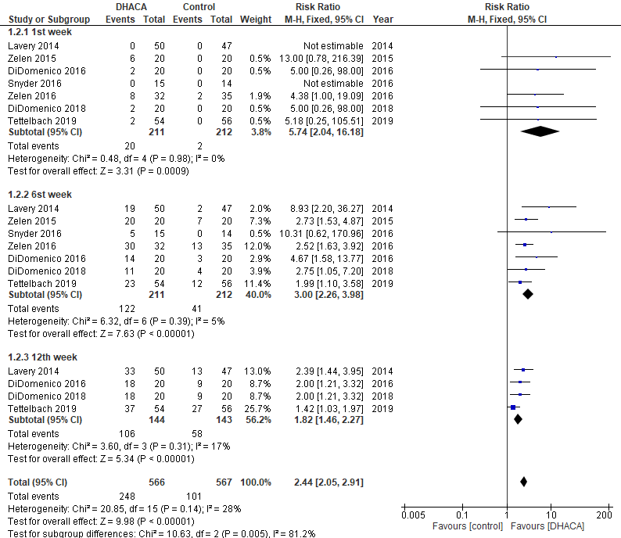
Figure S.1. Forest plot of risk ratio (RR) in time to heal after 4th, 6th, 12th follow-up durations

Figure S.2. Forest plot of mean difference (MD) in Kaplan–Meier plot of time to heal within 1st, 6th and 12th weeks
