Home Exercise Programme

Dear
Can a form of physiotherapy reduce stiffness in the foot joints of people with diabetes?

This leaflet provides written explanation and should act as a reminder of the exercises prescribed to you by your physiotherapist. These exercises should NOT cause you any pain but you should feel a sensation of “pulling”, “stretching” or “tightness” in the area that you are stretching. If any of these exercises cause you pain or discomfort you should stop them immediately and inform your physiotherapist at your next appointment.

Calf stretches
Standing with the leg to be stretched at the back and both hands against a wall at shoulder height.
EXERCISE 1: Bending the front leg at knee level and leaning forwards, keeping the back leg and knee straight and pushing the heel down into the floor; 20-30 sec hold, 2 times each leg twice daily.
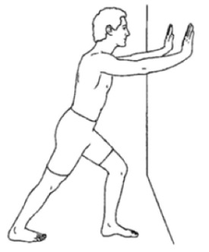
EXERCISE 2: Bending both legs at knee level, and pushing the heel of the back leg down into the floor; 20-30 sec hold, 2 times each leg twice daily.
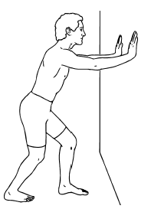
Plantar fascia stretch
EXERCISE 3: Place your toes, concentrating on your big toe, against a wall and lean forward or push your knee forward over your toes; 20-30 hold, 2 times each leg twice daily.
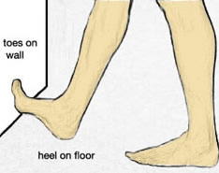

If you feel confused on how to carry out any of the exercises or you would like further explanation, please let your physiotherapist know who will be happy to demonstrate to you how to perform these exercises efficiently and safely.

Please record the exercises by ticking them as appropriately in your exercise diary sheet supplied to you.

What if I have any further questions or require further information?

Contact:
Jon Marsden
01752 587 590
jonathan.marsden@plymouth.ac.uk (mon-friday)

Thank you for taking part in the study

