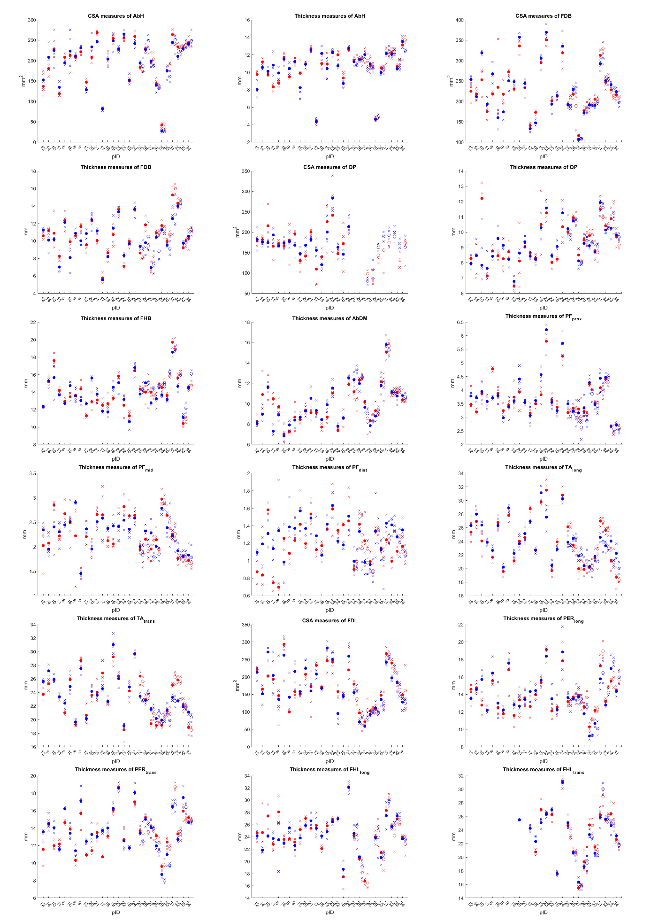
Raw data. CSA: cross-sectional area; AbH: m. abductor hallucis, FDB: m. flexor digitorum brevis, QP: m. quadratus plantae, FHB: m. flexor hallucis brevis, AbDM: m. abductor digiti minimi, PF: plantar fascia, prox: proximal, mid: middle, dist: distal, TA: m. tibialis anterior, long: longitudinal, trans: transversal, FDL: m. flexor digitorum longus, PER: m. musculus peroneus, FHL: m. flexor hallucis longus, red: occasion 1, blue: occasion 2; cross markers: trials, circle markers: average morphology measure per participant, filled markers: tablet-based machine, non-filled markers: mainframe machine.

