Online Supplementary Materials for
The Compassion Balance: Understanding the Interrelation of Self- and Other-Compassion for Optimal Well-being
Sahdra, B. K., Ciarrochi, J., Fraser, M. I., Yap, K., Haller, E., Hayes, S. C., Hofman, S. & Gloster, A. (2023).
Table S1
Counts and percentages of responses for the most important activity since the last prompt
Most important activity since last prompt | Count | Percent
0 = Work/school | 519 | 14.52%
1 = Being on the way from A to B | 161 | 4.50%
2 = Media/TV/Internet | 176 | 4.92%
3 = Contact with family/conversation | 231 | 6.46%
4 = Contact with other people/conversation | 540 | 15.11%
5 = Being on my own/bored | 73 | 2.04%
6 = Shopping/household | 259 | 7.25%
7 = Leisure (excl. physical activities) | 126 | 3.53%
8 = Physical activity | 211 | 5.90%
9 = Eat/drink | 251 | 7.02%
10 = Enjoy/relax | 606 | 16.96%
11 = Other | 421 | 11.78%

Table S2
Descriptive statistics of the within-person correlation of state self-compassion and state other-compassion in the three a-prior groups of individuals with self and other compassion as discordant, independent, or harmonious

n | M | SD | median | trimmed | mad | min | max | range | skew | kurtosis | SE
Self- and Other-Compassion as Discordant (within-person correlation =<0.10)
19 | -0.34 | 0.25 | -0.23 | -0.32 | 0.07 | -1.00 | -0.12 | 0.88 | -1.37 | 0.73 | 0.06
Self- and Other-Compassion as Independent (within-person correlation between -0.10 and 0.10)
15 | 0.01 | 0.07 | 0.03 | 0.01 | 0.07 | -0.09 | 0.09 | 0.18 | -0.33 | -1.67 | 0.02
Self- and Other-Compassion as Harmonious (within-person correlation >= 0.10)
115 | 0.54 | 0.25 | 0.54 | 0.52 | 0.30 | 0.10 | 1.00 | 0.9 | 0.05 | -1.09 | 0.02

Table S3
Standardized estimates of fixed effects and random effects from multilevel models of self-compassion predicting other-compassion with or without type of patients as a moderator
 | State Other-Compassion |  |  | Moderation by Patient Type
Predictors | Estimates | CI | p | Estimates | CI | p
(Intercept) | -0.09 | -0.20 – 0.02 | 0.108 | -0.13 | -0.29 – 0.03 | 0.113
State Self-Compassion | 0.41 | 0.34 – 0.49 | <0.001 | 0.39 | 0.29 – 0.49 | <0.001
clinical type  [Outpatient] |  |  |  | 0.07 | -0.15 – 0.29 | 0.535
State Self-Compassion *  clinical type  [Outpatient] |  |  |  | 0.05 | -0.09 – 0.19 | 0.492
Random Effects
σ² | 0.35 |  |  | 0.35
τ₀₀ | 0.41 |  |  | 0.42
τ₁₁ | 0.12 |  |  | 0.12
ρ₀₁ | -0.46 |  |  | -0.47
ICC | 0.60 |  |  | 0.60
N | 153 |  |  | 153
Observations | 3524 |  |  | 3524
Marginal R² / Conditional R² | 0.162 / 0.667 |  |  | 0.166 / 0.669

Note. σ² = variance of the residual; τ₀₀ = variance of the intercept; τ₁₁ ₌ variance of state self-compassion; ρ₀₁ = correlation of τ₀₀ and τ₁₁; ICC = intra-class correlation; N = sample size; CI = 95% confidence interval.

Table S4
Standardized estimates of fixed effects and random effects from multilevel models predicting state life satisfaction
 | Model 1b |  |  | Model 2b |  |  | Model 3b
Predictors | Estimates | CI | p | Estimates | CI | p | Estimates | CI | p
(Intercept) | -0.06 | -0.16 – 0.05 | 0.306 | -0.00 | -0.11 – 0.11 | 0.958 | -0.01 | -0.10 – 0.09 | 0.905
MSC | 0.22 | 0.10 – 0.34 | <0.001 |  |  |  | 0.10 | -0.00 – 0.20 | 0.058
Cor | -0.05 | -0.17 – 0.07 | 0.440 | 0.20 | 0.08 – 0.31 | 0.001
SC | 0.45 | 0.43 – 0.48 | <0.001 |  |  |  | 0.39 | 0.36 – 0.42 | <0.001
Cor * SC | 0.11 | 0.08 – 0.14 | <0.001
MOC |  |  |  | 0.29 | 0.18 – 0.40 | <0.001 | 0.20 | 0.10 – 0.30 | <0.001
OC |  |  |  | 0.30 | 0.28 – 0.33 | <0.001 | 0.16 | 0.14 – 0.19 | <0.001
Cor * OC |  |  |  | 0.15 | 0.12 – 0.18 | <0.001
SC * OC |  |  |  |  |  |  | -0.03 | -0.04 – -0.01 | 0.005
Random Effects
σ² | 0.22 |  |  | 0.25 |  |  | 0.21
τ₀₀ | 0.42 |  |  | 0.44 |  |  | 0.31
ICC | 0.66 |  |  | 0.64 |  |  | 0.59
N | 148 |  |  | 148 |  |  | 153
Observations | 3519 |  |  | 3519 |  |  | 3524
Marginal R² / Conditional R² | 0.369 / 0.782 |  |  | 0.321 / 0.755 |  |  | 0.465 / 0.782

Note. MSC = mean of state self-compassion; Cor = within-person correlation of state self-compassion and state other-directed compassion; SC = state self-compassion; OC = state other-directed compassion; MOC = mean of state other-directed compassion; σ² = variance of the residual; τ₀₀ = variance of the intercept; ICC = intra-class correlation; N = sample size; CI = 95% confidence interval. Mean state measures were averages of state measures by person.

Table S5
Standardized estimates of fixed effects and random effects from multilevel models predicting state life satisfaction, testing moderation by type of clinical patients
 | Model 1c |  |  | Model 2c |  |  | Model 3c
Predictors | Estimates | CI | p | Estimates | CI | p |  | Estimates | CI | p
(Intercept) | -0.17 | -0.34 – 0.01 | 0.066 | -0.12 | -0.30 – 0.07 | 0.203 |  | -0.10 | -0.26 – 0.05 | 0.190
TSC | 0.04 | -0.08 – 0.16 | 0.498 |  |  |  |  | 0.06 | -0.04 – 0.17 | 0.240
Cor | 0.13 | -0.05 – 0.32 | 0.161 | 0.30 | 0.11 – 0.49 | 0.002
SC | 0.44 | 0.39 – 0.48 | <0.001 |  |  |  |  | 0.36 | 0.32 – 0.40 | <0.001
clinical type  [Outpatient] | 0.18 | -0.07 – 0.42 | 0.151 | 0.17 | -0.08 – 0.43 | 0.172 |  | 0.12 | -0.10 – 0.33 | 0.284
Cor * SC | 0.11 | 0.07 – 0.16 | <0.001
Cor * clinical type  [Outpatient] | -0.15 | -0.40 – 0.10 | 0.237 | -0.17 | -0.43 – 0.09 | 0.199
SC * clinical type  [Outpatient] | 0.03 | -0.02 – 0.09 | 0.268 |  |  |  |  | 0.05 | -0.01 – 0.10 | 0.125
(Cor * SC) * clinical  type [Outpatient] | -0.03 | -0.10 – 0.04 | 0.363
TOC |  |  |  | 0.10 | -0.03 – 0.22 | 0.127 |  | 0.09 | -0.01 – 0.19 | 0.085
OC |  |  |  | 0.35 | 0.31 – 0.39 | <0.001 |  | 0.20 | 0.16 – 0.24 | <0.001
Cor * OC |  |  |  | 0.16 | 0.12 – 0.20 | <0.001
OC * clinical type  [Outpatient] |  |  |  | -0.06 | -0.11 – -0.01 | 0.027 |  | -0.05 | -0.10 – 0.01 | 0.101
(Cor * OC) * clinical  type [Outpatient] |  |  |  | 0.01 | -0.05 – 0.07 | 0.701
SC * OC |  |  |  |  |  |  |  | -0.02 | -0.05 – 0.00 | 0.100
(SC * OC) * clinical type  [Outpatient] |  |  |  |  |  |  |  | 0.00 | -0.04 – 0.04 | 0.942
Random Effects
σ² | 0.21 |  |  | 0.23 |  |  |  | 0.20
τ₀₀ | 0.45 |  |  | 0.49 |  |  |  | 0.35
ICC | 0.68 |  |  | 0.68 |  |  |  | 0.64
N | 132 |  |  | 132 |  |  |  | 137
Observations | 3135 |  |  | 3135 |  |  |  | 3140
Marginal R² / Conditional R² | 0.279 / 0.768 |  |  | 0.208 / 0.744 |  |  |  | 0.346 / 0.761

Note. TSC = trait self-compassion; Cor = within-person correlation of state self-compassion and state other-directed compassion; SC = state self-compassion; OC = state other-directed compassion; TOC = trait other-directed compassion; σ² = variance of the residual; τ₀₀ = variance of the intercept; ICC = intra-class correlation; N = sample size; CI = 95% confidence interval.
Table S6
Standardized estimates of fixed effects and random effects from multilevel models predicting mood state
 | Model 4b |  |  | Model 5b |  |  | Model 6b
Predictors | Estimates | CI | p | Estimates | CI | p | Estimates | CI | p
(Intercept) | -0.03 | -0.11 – 0.06 | 0.568 | 0.03 | -0.07 – 0.13 | 0.524 | 0.03 | -0.05 – 0.11 | 0.421
MSC | 0.07 | -0.03 – 0.17 | 0.161 |  |  |  | 0.03 | -0.06 – 0.13 | 0.496
Cor | -0.01 | -0.11 – 0.09 | 0.881 | 0.17 | 0.07 – 0.28 | 0.001
SC | 0.51 | 0.47 – 0.55 | <0.001 |  |  |  | 0.42 | 0.38 – 0.46 | <0.001
Cor * SC | 0.14 | 0.10 – 0.19 | <0.001
MOC |  |  |  | 0.04 | -0.06 – 0.15 | 0.418 | -0.02 | -0.11 – 0.07 | 0.677
OC |  |  |  | 0.38 | 0.34 – 0.42 | <0.001 | 0.24 | 0.20 – 0.28 | <0.001
Cor * OC |  |  |  | 0.16 | 0.12 – 0.20 | <0.001
SC * OC |  |  |  |  |  |  | -0.01 | -0.04 – 0.01 | 0.386
Random Effects
σ² | 0.49 |  |  | 0.51 |  |  | 0.47
τ₀₀ | 0.26 |  |  | 0.33 |  |  | 0.22
ICC | 0.35 |  |  | 0.40 |  |  | 0.32
N | 148 |  |  | 148 |  |  | 153
Observations | 3519 |  |  | 3519 |  |  | 3524
Marginal R² / Conditional R² | 0.290 / 0.535 |  |  | 0.192 / 0.512 |  |  | 0.319 / 0.538

Note. MSC = mean of state self-compassion; Cor = within-person correlation of state self-compassion and state other-directed compassion; SC = state self-compassion; OC = state other-directed compassion; MOC = mean of state other-directed compassion; σ² = variance of the residual; τ₀₀ = variance of the intercept; ICC = intra-class correlation; N = sample size; CI = 95% confidence interval. Mean state measures were averages of state measures by person.

Table S7
Standardized estimates of fixed effects and random effects from multilevel models predicting mood state, moderation by patient type
 | Model 4c |  |  | Model 5c |  |  |  | Model 6c
Predictors | Estimates | CI | p |  | Estimates | CI | p |  | Estimates | CI | p
(Intercept) | -0.19 | -0.33 – -0.05 | 0.007 |  | -0.14 | -0.29 – 0.02 | 0.082 |  | -0.13 | -0.26 – 0.00 | 0.053
TSC | -0.02 | -0.12 – 0.07 | 0.627 |  |  |  |  |  | -0.01 | -0.10 – 0.08 | 0.847
Cor | 0.12 | -0.02 – 0.27 | 0.098 |  | 0.28 | 0.12 – 0.44 | 0.001
SC | 0.49 | 0.43 – 0.55 | <0.001 |  |  |  |  |  | 0.41 | 0.34 – 0.47 | <0.001
clinical type  [Outpatient] | 0.30 | 0.11 – 0.49 | 0.003 |  | 0.29 | 0.08 – 0.50 | 0.008 |  | 0.26 | 0.08 – 0.44 | 0.005
Cor * SC | 0.16 | 0.09 – 0.22 | <0.001
Cor * clinical type  [Outpatient] | -0.14 | -0.35 – 0.06 | 0.169 |  | -0.15 | -0.37 – 0.08 | 0.200
SC * clinical type  [Outpatient] | 0.04 | -0.04 – 0.12 | 0.353 |  |  |  |  |  | 0.03 | -0.05 – 0.12 | 0.461
(Cor * SC) * clinical  type [Outpatient] | -0.04 | -0.14 – 0.06 | 0.483
TOC |  |  |  |  | 0.01 | -0.10 – 0.12 | 0.856 |  | 0.02 | -0.07 – 0.10 | 0.675
OC |  |  |  |  | 0.39 | 0.33 – 0.44 | <0.001 |  | 0.26 | 0.19 – 0.32 | <0.001
Cor * OC |  |  |  |  | 0.18 | 0.12 – 0.23 | <0.001
OC * clinical type  [Outpatient] |  |  |  |  | -0.01 | -0.09 – 0.06 | 0.748 |  | -0.03 | -0.11 – 0.05 | 0.424
(Cor * OC) * clinical  type [Outpatient] |  |  |  |  | -0.02 | -0.11 – 0.06 | 0.584
SC * OC |  |  |  |  |  |  |  |  | 0.02 | -0.02 – 0.07 | 0.268
(SC * OC) * clinical type  [Outpatient] |  |  |  |  |  |  |  |  | -0.08 | -0.13 – -0.02 | 0.009
Random Effects
σ² | 0.48 |  |  |  | 0.51 |  |  |  | 0.47
τ₀₀ | 0.26 |  |  |  | 0.33 |  |  |  | 0.22
ICC | 0.35 |  |  |  | 0.40 |  |  |  | 0.32
N | 132 |  |  |  | 132 |  |  |  | 137
Observations | 3135 |  |  |  | 3135 |  |  |  | 3140
Marginal R² / Conditional R² | 0.284 / 0.533 |  |  |  | 0.212 / 0.525 |  |  |  | 0.323 / 0.542

Note. TSC = trait self-compassion; Cor = within-person correlation of state self-compassion and state other-directed compassion; SC = state self-compassion; OC = state other-directed compassion; TOC = trait other-directed compassion; σ² = variance of the residual; τ₀₀ = variance of the intercept; ICC = intra-class correlation; N = sample size; CI = 95% confidence interval.

Table S8
Standardized estimates of fixed effects and random effects from multilevel models predicting state life satisfaction, moderation by gender
 | Model 1e |  |  | Model 2e |  |  | Model 3e
Predictors | Estimates | CI | p | Estimates | CI | p | Estimates | CI | p
(Intercept) | -0.05 | -0.22 – 0.11 | 0.532 | -0.05 | -0.22 – 0.13 | 0.602 | -0.01 | -0.16 – 0.13 | 0.870
TSC | 0.07 | -0.05 – 0.19 | 0.280 |  |  |  | 0.08 | -0.03 – 0.18 | 0.142
Cor | 0.06 | -0.13 – 0.25 | 0.554 | 0.27 | 0.07 – 0.47 | 0.008
SC | 0.46 | 0.42 – 0.50 | <0.001 |  |  |  | 0.39 | 0.35 – 0.42 | <0.001
Gender [Male] | -0.04 | -0.28 – 0.19 | 0.712 | 0.02 | -0.23 – 0.27 | 0.882 | -0.05 | -0.26 – 0.16 | 0.611
Cor * SC | 0.11 | 0.07 – 0.16 | <0.001
Cor * Gender [Male] | -0.01 | -0.26 – 0.25 | 0.958 | -0.08 | -0.34 – 0.19 | 0.570
SC * Gender [Male] | -0.01 | -0.07 – 0.05 | 0.683 |  |  |  | 0.00 | -0.06 – 0.06 | 0.979
(Cor * SC) * Gender  [Male] | -0.03 | -0.11 – 0.04 | 0.341
TOC |  |  |  | 0.13 | 0.00 – 0.25 | 0.043 | 0.10 | -0.00 – 0.20 | 0.057
OC |  |  |  | 0.33 | 0.29 – 0.36 | <0.001 | 0.19 | 0.16 – 0.23 | <0.001
Cor * OC |  |  |  | 0.18 | 0.14 – 0.22 | <0.001
OC * Gender [Male] |  |  |  | -0.03 | -0.08 – 0.02 | 0.245 | -0.04 | -0.09 – 0.01 | 0.140
(Cor * OC) * Gender  [Male] |  |  |  | -0.04 | -0.10 – 0.02 | 0.159
SC * OC |  |  |  |  |  |  | -0.02 | -0.05 – 0.00 | 0.069
(SC * OC) * Gender [Male] |  |  |  |  |  |  | -0.01 | -0.04 – 0.03 | 0.733
Random Effects
σ² | 0.21 |  |  | 0.24 |  |  | 0.20
τ₀₀ | 0.46 |  |  | 0.50 |  |  | 0.36
ICC | 0.68 |  |  | 0.68 |  |  | 0.64
N | 132 |  |  | 132 |  |  | 137
Observations | 3130 |  |  | 3130 |  |  | 3135
Marginal R² / Conditional R² | 0.270 / 0.768 |  |  | 0.193 / 0.743 |  |  | 0.340 / 0.761

Note. TSC = trait self-compassion; Cor = within-person correlation of state self-compassion and state other-directed compassion; SC = state self-compassion; OC = state other-directed compassion; TOC = trait other-directed compassion; σ² = variance of the residual; τ₀₀ = variance of the intercept; ICC = intra-class correlation; N = sample size; CI = 95% confidence interval.

Table S9
Standardized estimates of fixed effects and random effects from multilevel models predicting state life satisfaction, moderation by age
 | Model 1f |  |  | Model 2f |  |  | Model 3f
Predictors | Estimates | CI | p | Estimates | CI | p | Estimates | CI | p
(Intercept) | -0.00 | -0.41 – 0.40 | 0.981 | -0.09 | -0.51 – 0.33 | 0.669 | 0.02 | -0.33 – 0.36 | 0.926
TSC | 0.07 | -0.05 – 0.19 | 0.242 |  |  |  | 0.07 | -0.03 – 0.17 | 0.162
Cor | 0.27 | -0.16 – 0.70 | 0.211 | 0.42 | -0.03 – 0.86 | 0.069
SC | 0.42 | 0.31 – 0.52 | <0.001 |  |  |  | 0.30 | 0.19 – 0.40 | <0.001
age | -0.00 | -0.01 – 0.01 | 0.699 | 0.00 | -0.01 – 0.01 | 0.789 | -0.00 | -0.01 – 0.01 | 0.730
Cor * SC | 0.21 | 0.08 – 0.34 | 0.002
Cor * age | -0.01 | -0.02 – 0.01 | 0.303 | -0.01 | -0.02 – 0.01 | 0.385
SC * age | 0.00 | -0.00 – 0.00 | 0.580 |  |  |  | 0.00 | -0.00 – 0.01 | 0.089
(Cor * SC) * age | -0.00 | -0.01 – 0.00 | 0.083
TOC |  |  |  | 0.13 | 0.00 – 0.25 | 0.044 | 0.09 | -0.01 – 0.19 | 0.069
OC |  |  |  | 0.50 | 0.41 – 0.60 | <0.001 | 0.38 | 0.29 – 0.48 | <0.001
Cor * OC |  |  |  | 0.20 | 0.09 – 0.31 | <0.001
OC * age |  |  |  | -0.01 | -0.01 – -0.00 | <0.001 | -0.01 | -0.01 – -0.00 | <0.001
(Cor * OC) * age |  |  |  | -0.00 | -0.00 – 0.00 | 0.373
SC * OC |  |  |  |  |  |  | 0.04 | -0.02 – 0.11 | 0.208
(SC * OC) * age |  |  |  |  |  |  | -0.00 | -0.00 – 0.00 | 0.070
Random Effects
σ² | 0.21 |  |  | 0.23 |  |  | 0.20
τ₀₀ | 0.45 |  |  | 0.50 |  |  | 0.35
ICC | 0.68 |  |  | 0.68 |  |  | 0.63
N | 132 |  |  | 132 |  |  | 137
Observations | 3135 |  |  | 3135 |  |  | 3140
Marginal R² / Conditional R² | 0.270 / 0.767 |  |  | 0.202 / 0.745 |  |  | 0.346 / 0.760

Note. TSC = trait self-compassion; Cor = within-person correlation of state self-compassion and state other-directed compassion; SC = state self-compassion; OC = state other-directed compassion; TOC = trait other-directed compassion; σ² = variance of the residual; τ₀₀ = variance of the intercept; ICC = intra-class correlation; N = sample size; CI = 95% confidence interval.

Table S10
Standardized estimates of fixed effects and random effects from multilevel models predicting state mood, moderation by gender
 | Model 4e |  |  | Model 5e |  |  |  | Model 6e
Predictors | Estimates | CI | p | Estimates | CI | p | Estimates |  | CI | p
(Intercept) | -0.05 | -0.18 – 0.09 | 0.473 | -0.02 | -0.17 – 0.13 | 0.823 | 0.00 |  | -0.12 – 0.13 | 0.956
TSC | 0.01 | -0.09 – 0.10 | 0.914 |  |  |  | 0.01 |  | -0.08 – 0.10 | 0.853
Cor | 0.06 | -0.10 – 0.21 | 0.478 | 0.25 | 0.08 – 0.42 | 0.005
SC | 0.49 | 0.44 – 0.55 | <0.001 |  |  |  | 0.39 |  | 0.33 – 0.45 | <0.001
Gender [Male] | 0.02 | -0.17 – 0.22 | 0.801 | 0.06 | -0.16 – 0.28 | 0.581 | 0.02 |  | -0.16 – 0.20 | 0.841
Cor * SC | 0.16 | 0.09 – 0.22 | <0.001
Cor * Gender [Male] | 0.00 | -0.21 – 0.21 | 0.981 | -0.05 | -0.28 – 0.18 | 0.675
SC * Gender [Male] | 0.04 | -0.04 – 0.12 | 0.334 |  |  |  | 0.08 |  | -0.00 – 0.17 | 0.063
(Cor * SC) * Gender  [Male] | -0.03 | -0.13 – 0.07 | 0.536
TOC |  |  |  | 0.05 | -0.06 – 0.16 | 0.355 | 0.04 |  | -0.05 – 0.13 | 0.378
OC |  |  |  | 0.42 | 0.37 – 0.47 | <0.001 | 0.27 |  | 0.22 – 0.32 | <0.001
Cor * OC |  |  |  | 0.15 | 0.09 – 0.21 | <0.001
OC * Gender [Male] |  |  |  | -0.08 | -0.15 – -0.00 | 0.042 | -0.10 |  | -0.17 – -0.02 | 0.016
(Cor * OC) * Gender  [Male] |  |  |  | 0.02 | -0.06 – 0.11 | 0.573
SC * OC |  |  |  |  |  |  | -0.03 |  | -0.07 – 0.01 | 0.100
(SC * OC) * Gender [Male] |  |  |  |  |  |  | 0.03 |  | -0.02 – 0.09 | 0.248
Random Effects
σ² | 0.48 |  |  | 0.51 |  |  | 0.47
τ₀₀ | 0.28 |  |  | 0.35 |  |  | 0.23
ICC | 0.36 |  |  | 0.41 |  |  | 0.33
N | 132 |  |  | 132 |  |  | 137
Observations | 3130 |  |  | 3130 |  |  | 3135
Marginal R² / Conditional R² | 0.265 / 0.532 |  |  | 0.186 / 0.521 |  |  | 0.311 / 0.539

Note. TSC = trait self-compassion; Cor = within-person correlation of state self-compassion and state other-directed compassion; SC = state self-compassion; OC = state other-directed compassion; TOC = trait other-directed compassion; σ² = variance of the residual; τ₀₀ = variance of the intercept; ICC = intra-class correlation; N = sample size; CI = 95% confidence interval.

Table S11
Standardized estimates of fixed effects and random effects from multilevel models predicting state mood, moderation by age
 | Model 4f |  |  | Model 5f |  |  | Model 6f
Predictors | Estimates | CI | p | Estimates | CI | p | Estimates | CI | p
(Intercept) | 0.09 | -0.24 – 0.42 | 0.577 | -0.01 | -0.37 – 0.35 | 0.956 | 0.10 | -0.19 – 0.40 | 0.498
TSC | 0.01 | -0.09 – 0.10 | 0.904 |  |  |  | 0.01 | -0.08 – 0.10 | 0.788
Cor | 0.19 | -0.17 – 0.55 | 0.288 | 0.39 | -0.01 – 0.78 | 0.055
SC | 0.56 | 0.41 – 0.71 | <0.001 |  |  |  | 0.44 | 0.29 – 0.59 | <0.001
age | -0.00 | -0.01 – 0.01 | 0.432 | 0.00 | -0.01 – 0.01 | 0.892 | -0.00 | -0.01 – 0.01 | 0.535
Cor * SC | -0.03 | -0.21 – 0.15 | 0.766
Cor * age | -0.00 | -0.01 – 0.01 | 0.409 | -0.00 | -0.02 – 0.01 | 0.377
SC * age | -0.00 | -0.01 – 0.00 | 0.533 |  |  |  | -0.00 | -0.00 – 0.00 | 0.847
(Cor * SC) * age | 0.00 | -0.00 – 0.01 | 0.063
TOC |  |  |  | 0.04 | -0.06 – 0.15 | 0.427 | 0.03 | -0.05 – 0.12 | 0.439
OC |  |  |  | 0.53 | 0.39 – 0.66 | <0.001 | 0.37 | 0.23 – 0.51 | <0.001
Cor * OC |  |  |  | 0.30 | 0.15 – 0.45 | <0.001
OC * age |  |  |  | -0.00 | -0.01 – -0.00 | 0.023 | -0.00 | -0.01 – -0.00 | 0.045
(Cor * OC) * age |  |  |  | -0.00 | -0.01 – 0.00 | 0.064
SC * OC |  |  |  |  |  |  | 0.02 | -0.08 – 0.13 | 0.660
(SC * OC) * age |  |  |  |  |  |  | -0.00 | -0.00 – 0.00 | 0.546
Random Effects
σ² | 0.48 |  |  | 0.50 |  |  | 0.47
τ₀₀ | 0.28 |  |  | 0.35 |  |  | 0.23
ICC | 0.37 |  |  | 0.41 |  |  | 0.33
N | 132 |  |  | 132 |  |  | 137
Observations | 3135 |  |  | 3135 |  |  | 3140
Marginal R² / Conditional R² | 0.264 / 0.536 |  |  | 0.191 / 0.524 |  |  | 0.309 / 0.537

Note. TSC = trait self-compassion; Cor = within-person correlation of state self-compassion and state other-directed compassion; SC = state self-compassion; OC = state other-directed compassion; TOC = trait other-directed compassion; σ² = variance of the residual; τ₀₀ = variance of the intercept; ICC = intra-class correlation; N = sample size; CI = 95% confidence interval.

Figure S1
Within-person raw correlations between self-compassion and other compassion in the three groups of individuals in the sample
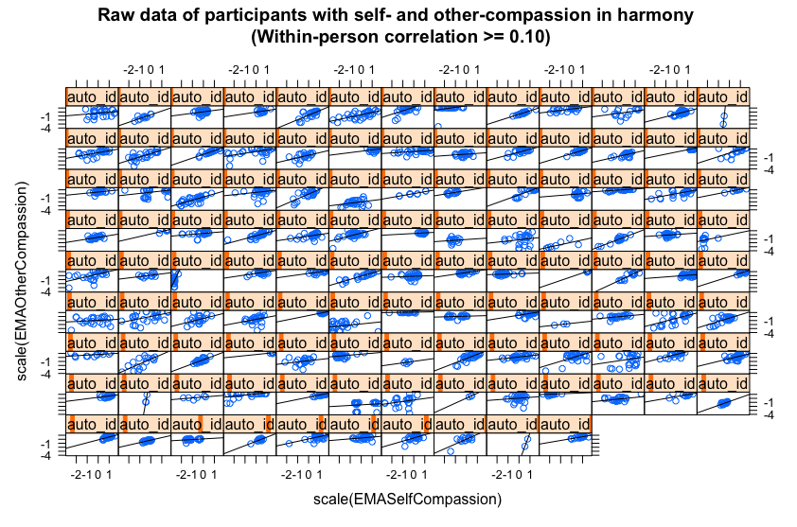 | 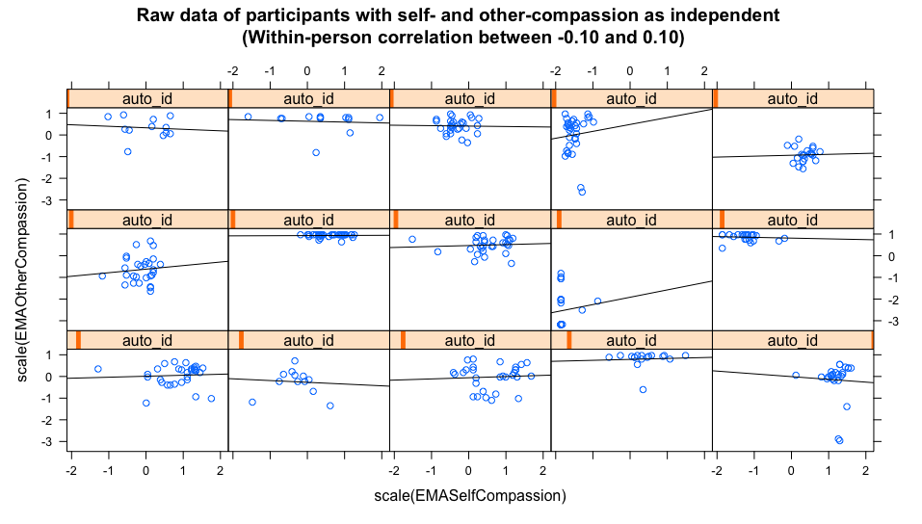
Figure S2
Multilevel model implied individual associations of state self-compassion and state other-compassion
