Supplementary Online Material 6: Results and sensitivity analyses of broad categories
TE = Treatment effect (standardized mean difference – SMD), seTE = standard error of treatment effect

Post-intervention

1.1 Mindfulness

Figure S6.1.1.1: Forest plot – Mindfulness with all studies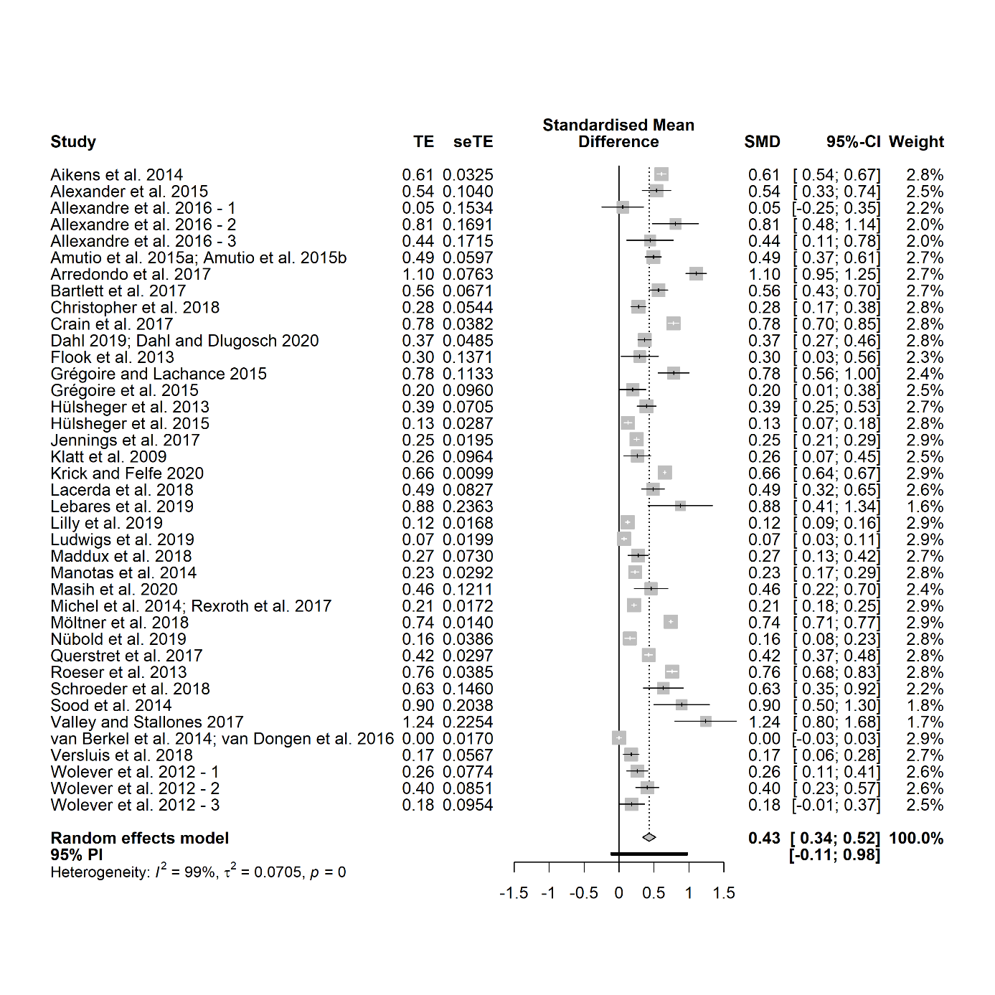

Figure S6.1.1.2: Funnel plot – Mindfulness with all studies
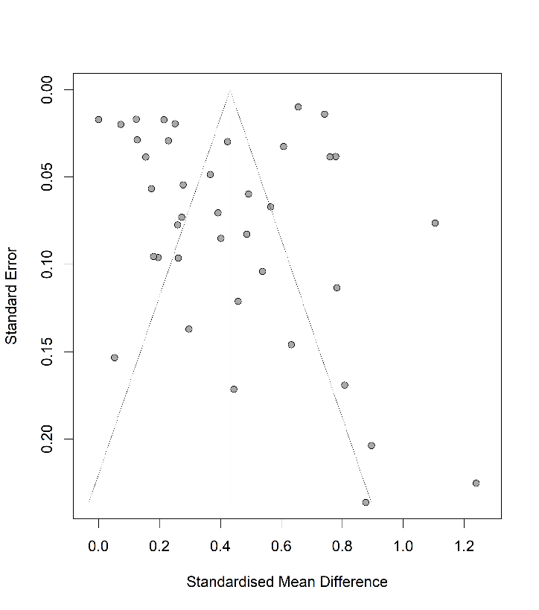

Table S6.1.1.1: Egger’s test – Mindfulness with all studies
Eggers' test of the intercept
intercept | 95% CI | t | p
-0.703 | [-4.97 - 3.56] | -0.323 | 0.748
Eggers' test does not indicate the presence of funnel plot asymmetry.
P-curve analysis
- Total number of provided studies: k = 39
- Total number of p<0.05 studies included into the analysis: k = 36 (92.31%)
- Total number of studies with p<0.025: k = 34 (87.18%)

Figure S6.1.1.3: Forest plot – Mindfulness without outliers
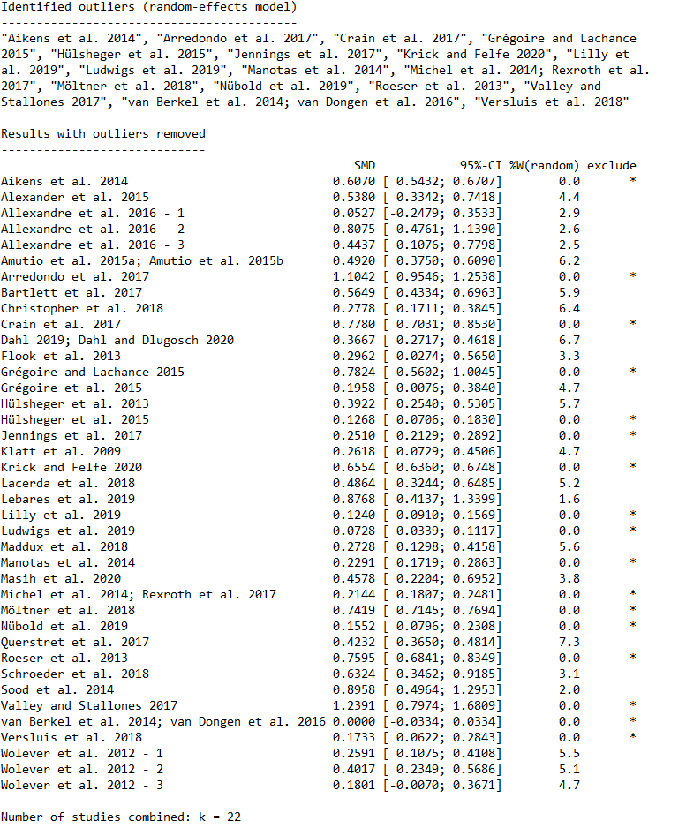

1.2 Well-being

Figure S6.1.2.1: Forest plot – Well-being with all studies
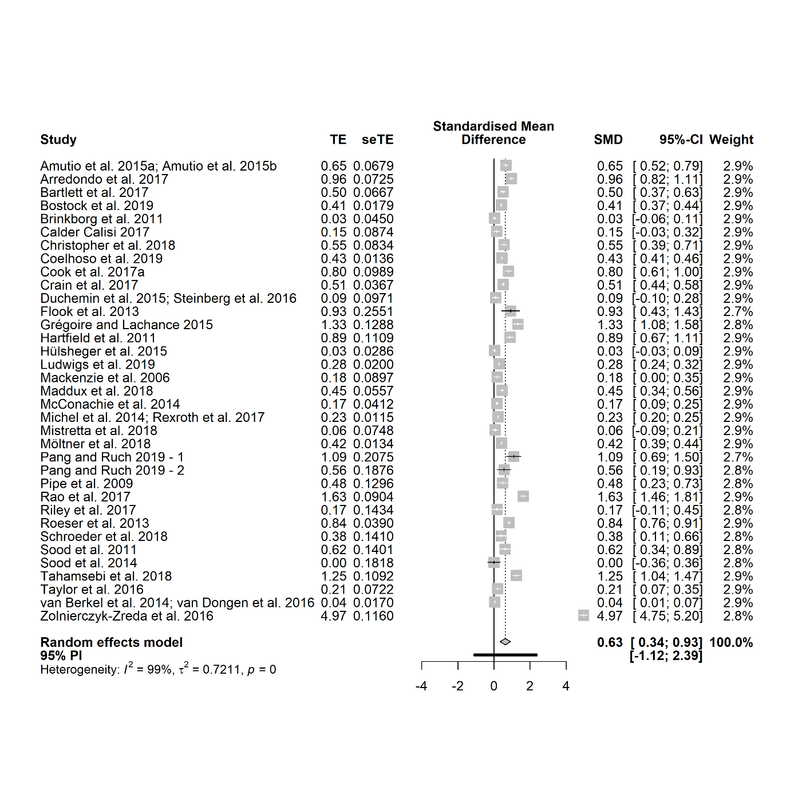

Figure S6.1.2.2: Funnel plot – Well-being with all studies
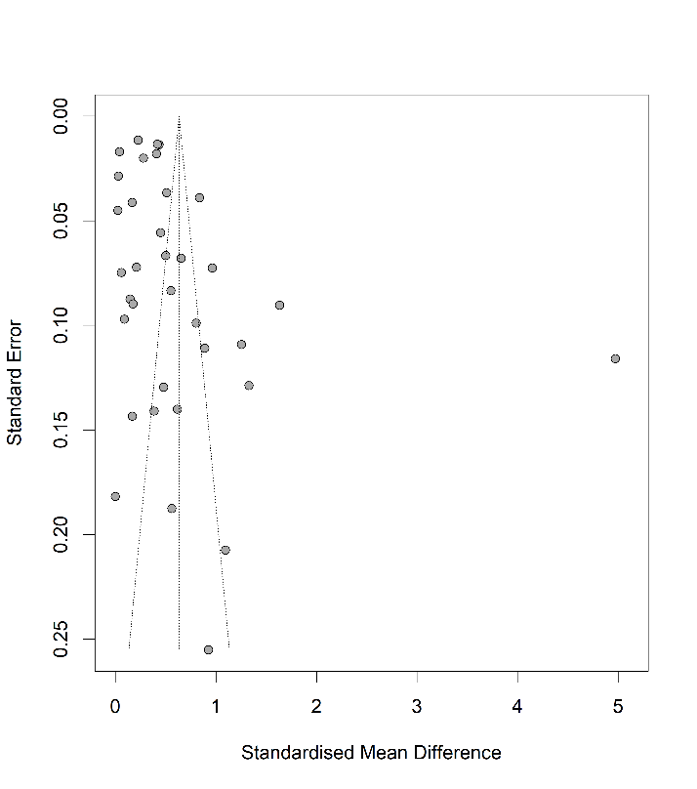

Table S6.1.2.1: Egger's test – Well-being with all studies

Eggers' test of the intercept
intercept | 95% CI | t | p
4.602 | 0.39;8.81] | 2.144 | 0.0395
Eggers' test indicates the presence of funnel plot asymmetry.
P-curve analysis
- Total number of provided studies: k = 35
- Total number of p<0.05 studies included into the analysis: k = 28 (80%)
- Total number of studies with p<0.025: k = 27 (77.14%)

Figure S6.1.2.3: Forest plot – Well-being without outliers
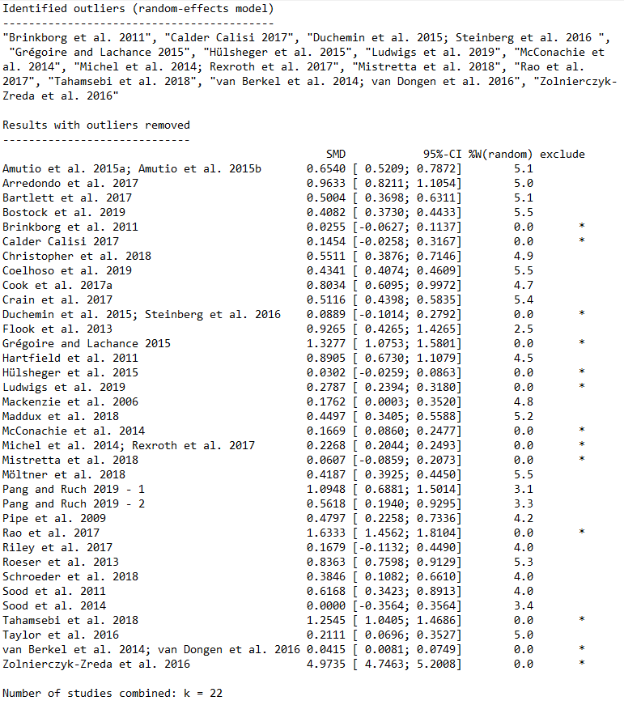

Physical Health

Figure S6.1.3.1: Forest plot – Physical Health with all studies
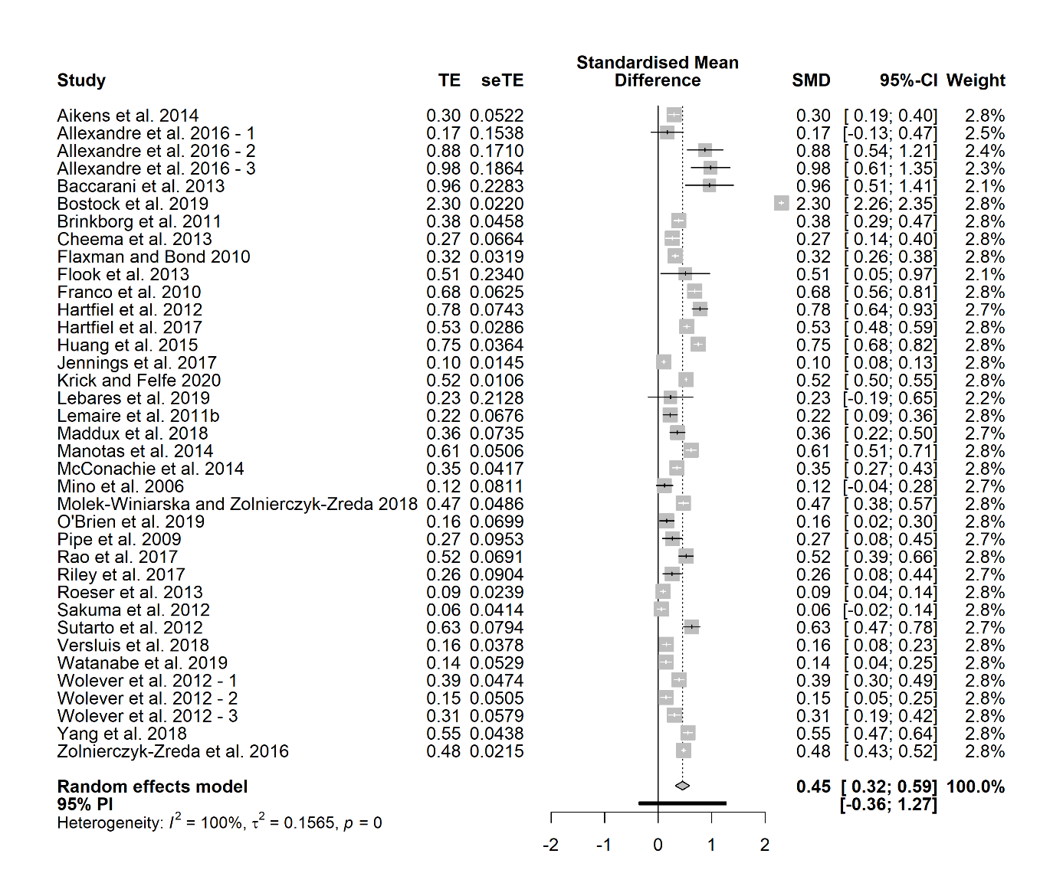

Figure S6.1.3.2: Funnel plot – Physical Health with all studies
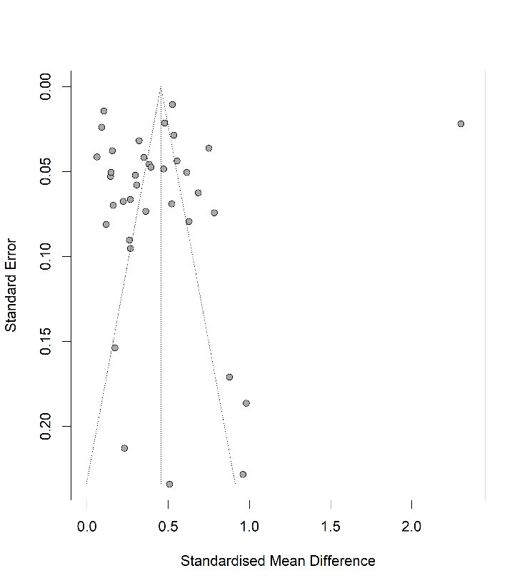

Table S6.1.3.1: Egger's test – Physical Health with all studies

Eggers' test of the intercept
intercept | 95% CI | t | p
-1.448 | [-9.36; 6.47] | -0.359 | 0.722
Eggers' test does not indicate the presence of funnel plot asymmetry.
P-curve analysis
- Total number of provided studies: k = 37
- Total number of p<0.05 studies included into the analysis: k = 33 (89.19%)
- Total number of studies with p<0.025: k = 32 (86.49%) Mental Health

Figure S6.1.3.3: Forest plot – Physical Health without outliers
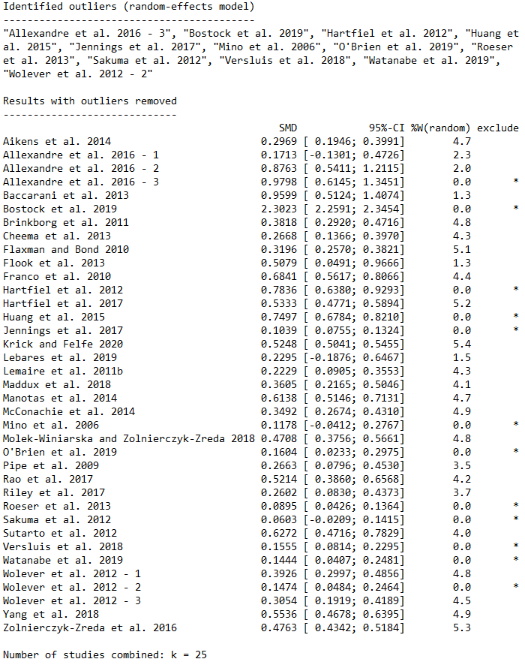

Mental Health

Figure S6.1.4.1: Forest plot – Mental Health with all studies
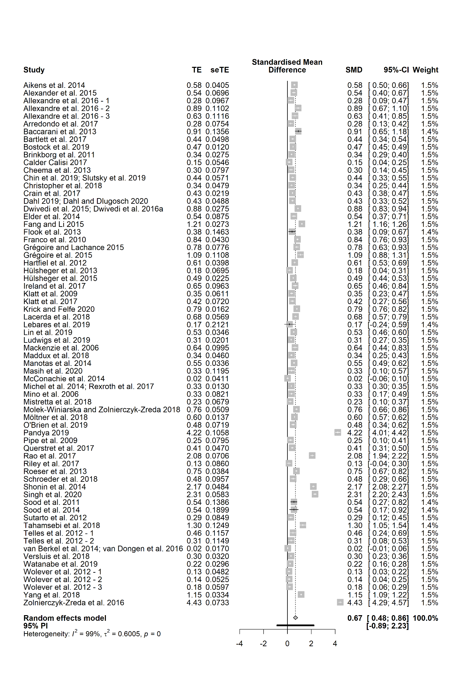

Figure S6.1.4.2: Funnel plot – Mental Health with all studies
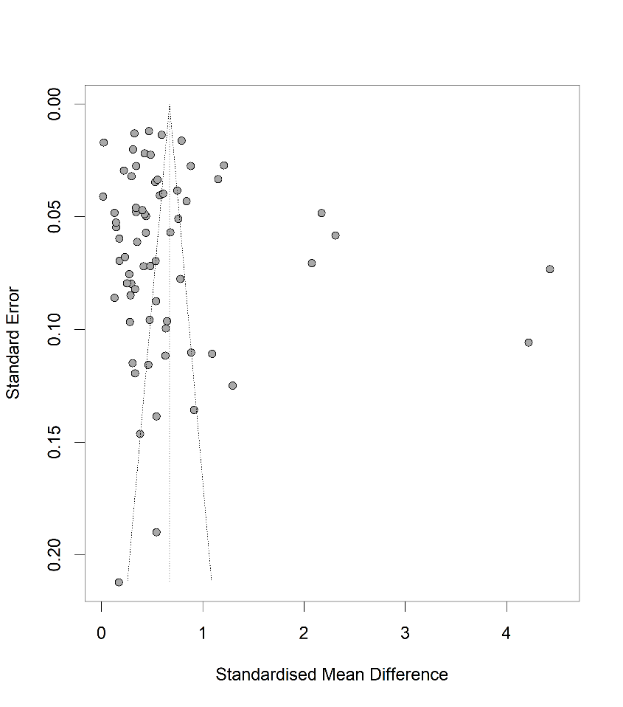

Table S6.1.4.1: Egger's test – Mental Health with all studies
Eggers' test of the intercept
intercept | 95% CI | t | p
4.32 | [-0.44; 9.09] | 1.777 | 0.080
Eggers' test does not indicate the presence of funnel plot asymmetry.
P-curve analysis
- Total number of provided studies: k = 68
- Total number of p<0.05 studies included into the analysis: k = 64 (94.12%)
- Total number of studies with p<0.025: k = 64 (94.12%)

Figure S6.1.4.3: Forest plot – Mental Health without outliers
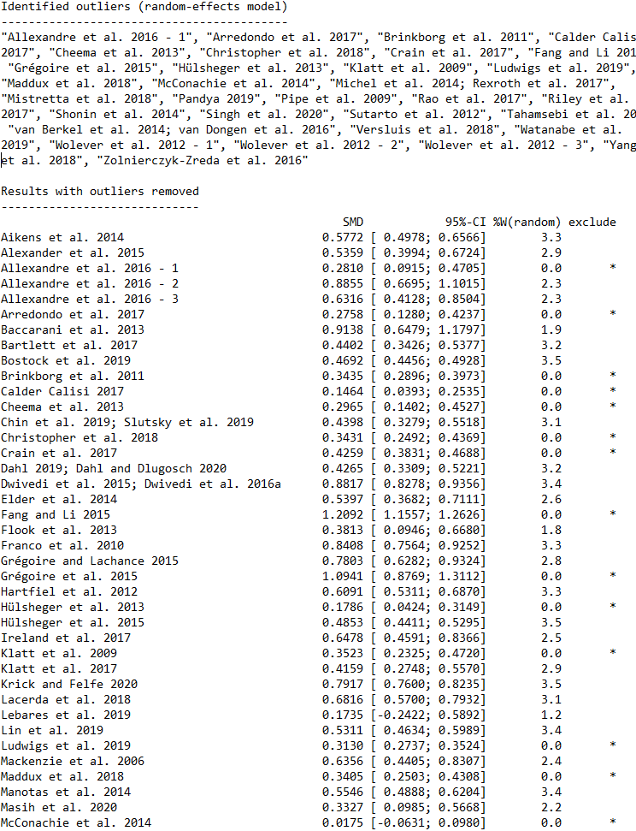
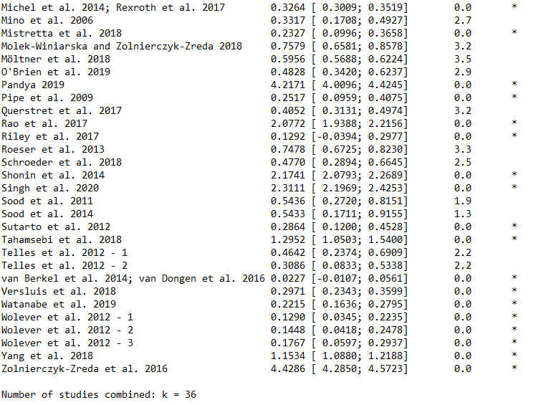

Stress

Figure S6.1.5.1: Forest plot – Stress with all studies
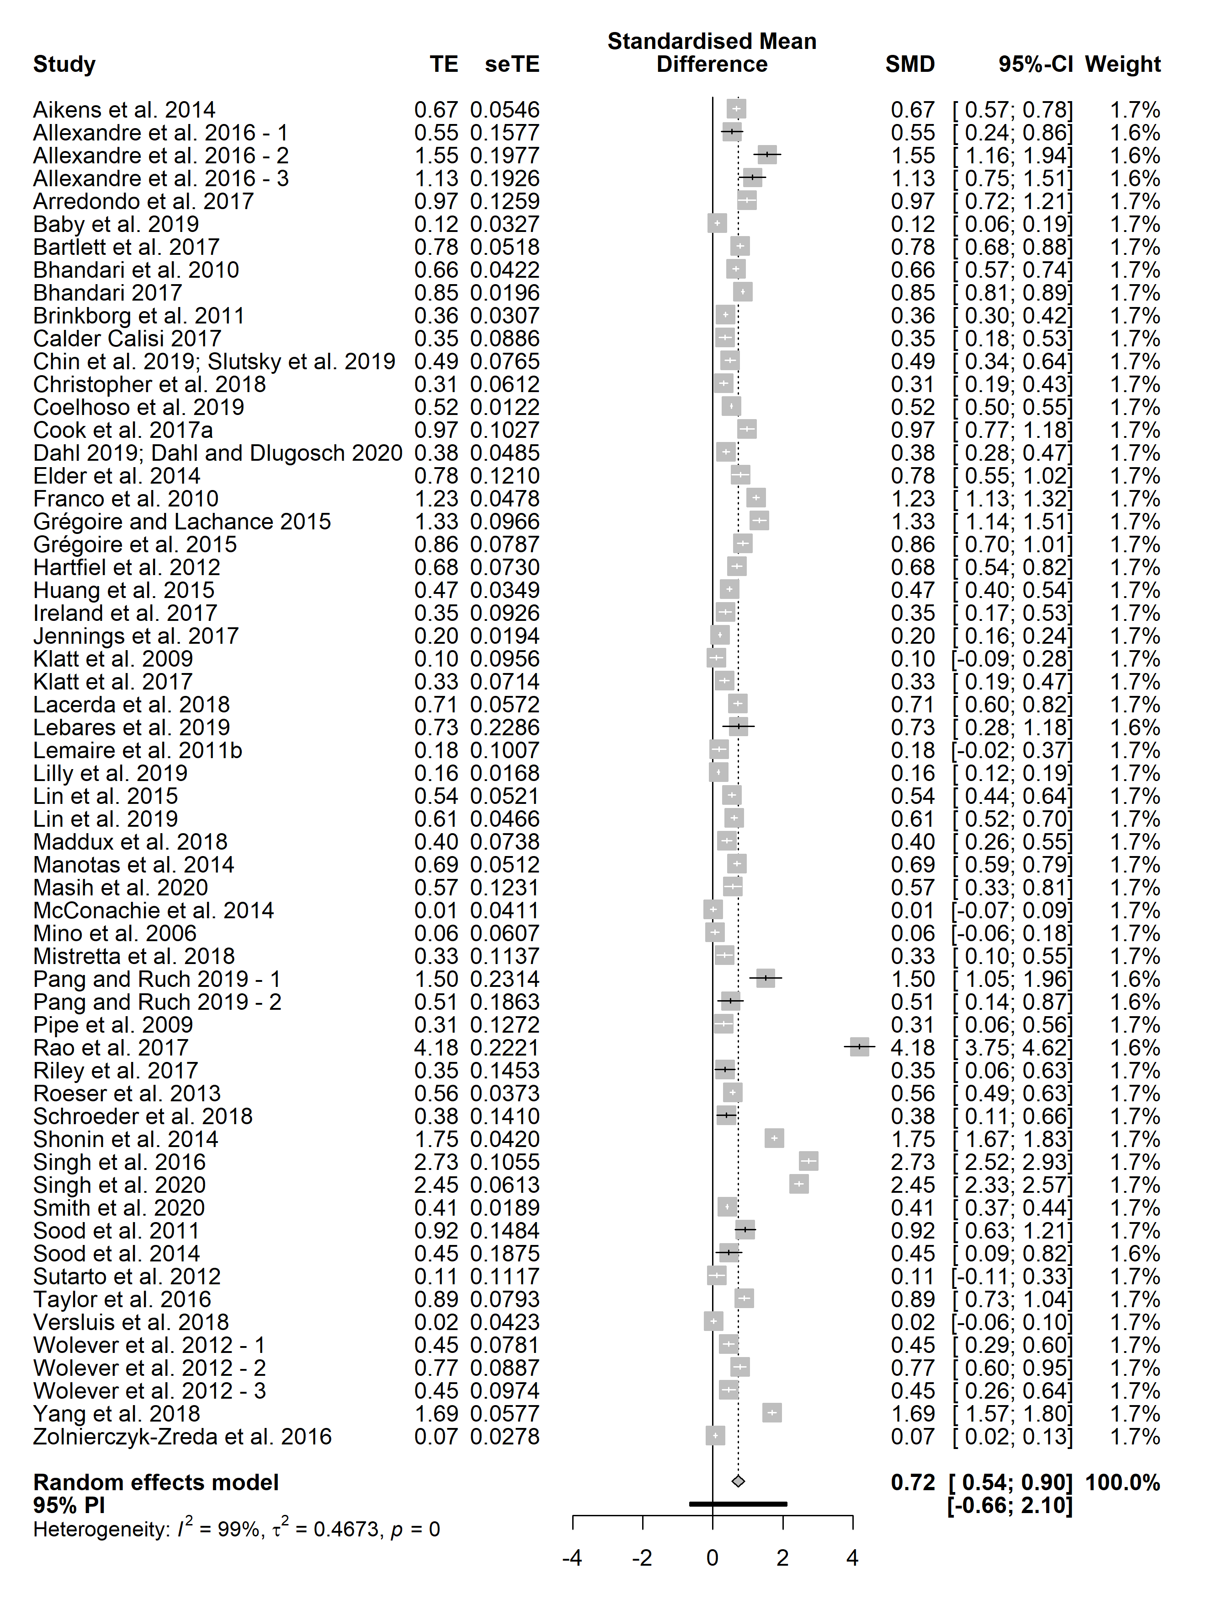

Figure S6.1.5.2: Funnel plot – Stress with all studies
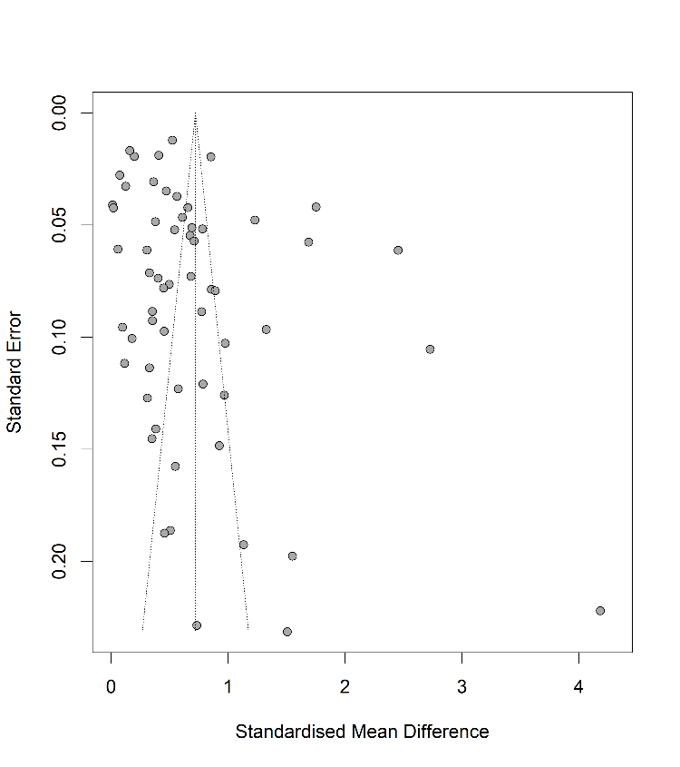

Table S6.1.5.1: Egger's test – Stress with all studies

Eggers' test of the intercept
intercept | 95% CI | t | p
4.298 | [0.56;8.03] | 2.256 | 0.0279
Eggers' test does not indicate the presence of funnel plot asymmetry.
P-curve analysis
- Total number of provided studies: k = 59
- Total number of p<0.05 studies included into the analysis: k = 53 (89.83%)
- Total number of studies with p<0.025: k = 53 (89.83%)

Figure S6.1.5.3: Forest plot – Stress without outliers
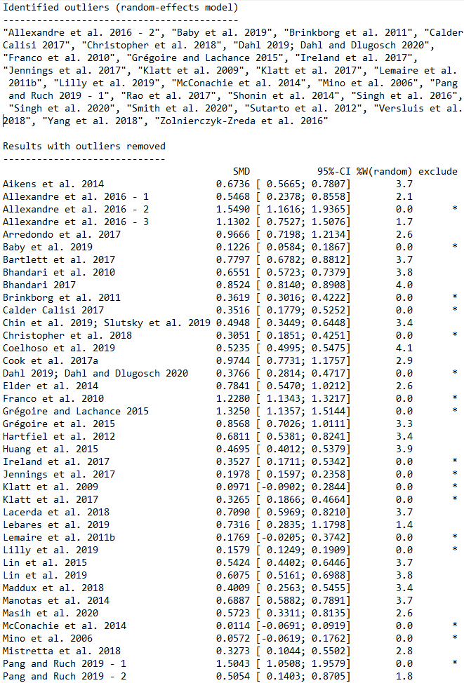

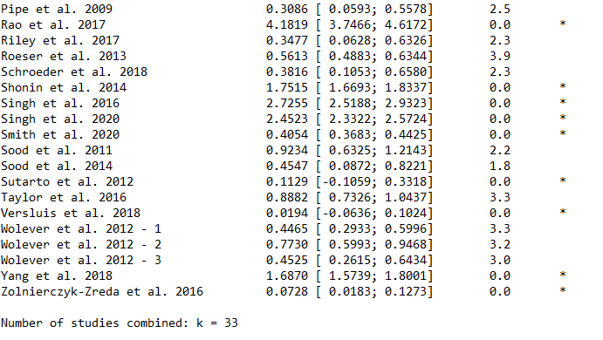

Resilience

Figure S6.1.6.1: Forest plot – Resilience with all studies
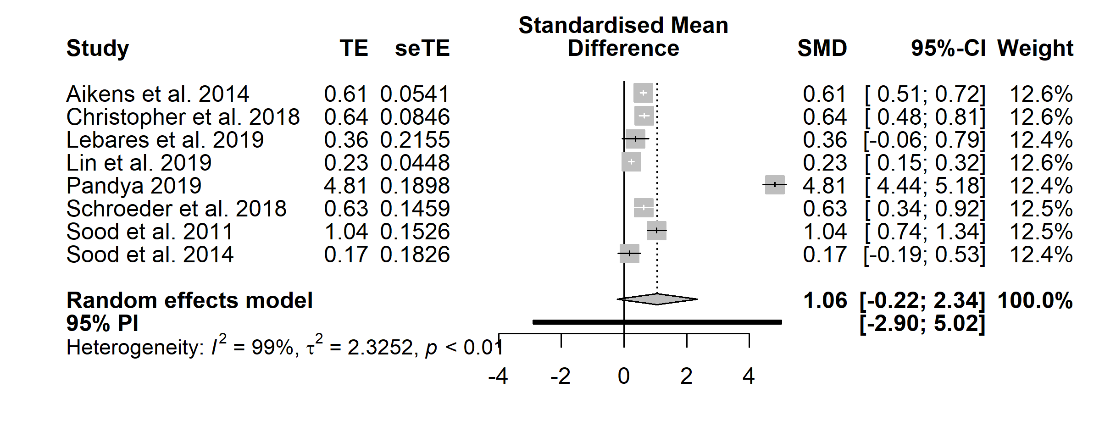

Figure S6.1.6.2: Funnel plot – Resilience with all studies
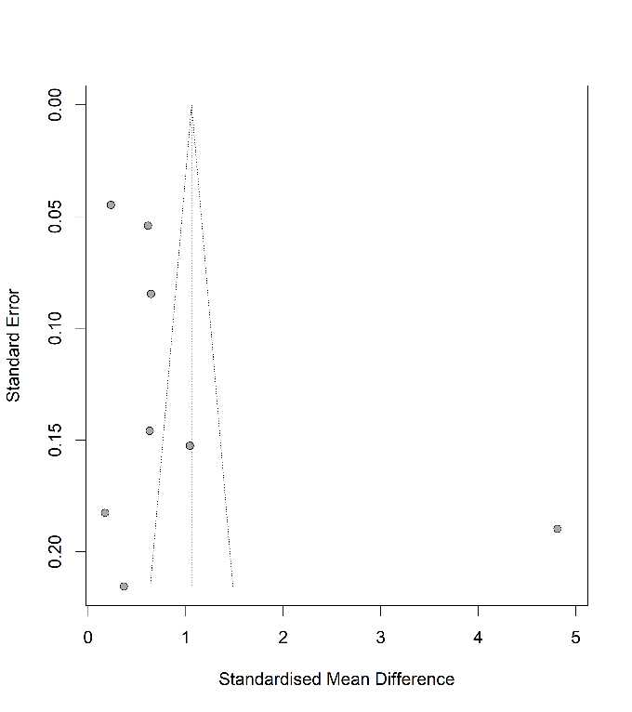

Table S6.1.6.1: Egger's test – Resilience with all studies

Eggers' test of the intercept
intercept | 95% CI | t | p
8.153 | -2.89;19.2] | 1.447 | 0.198
Eggers' test does not indicate the presence of funnel plot asymmetry.
P-curve analysis
- Total number of provided studies: k = 8
- Total number of p<0.05 studies included into the analysis: k = 6 (75%)
- Total number of studies with p<0.025: k = 6 (75%)

Figure S6.1.6.3: Forest plot – Resilience without outliers
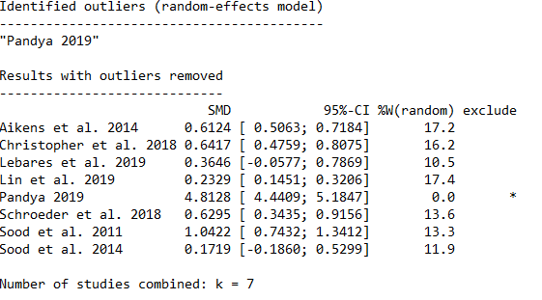

1.7 Work-related factors

Figure S6.1.7.1: Forest plot – Work-related factors with all studies
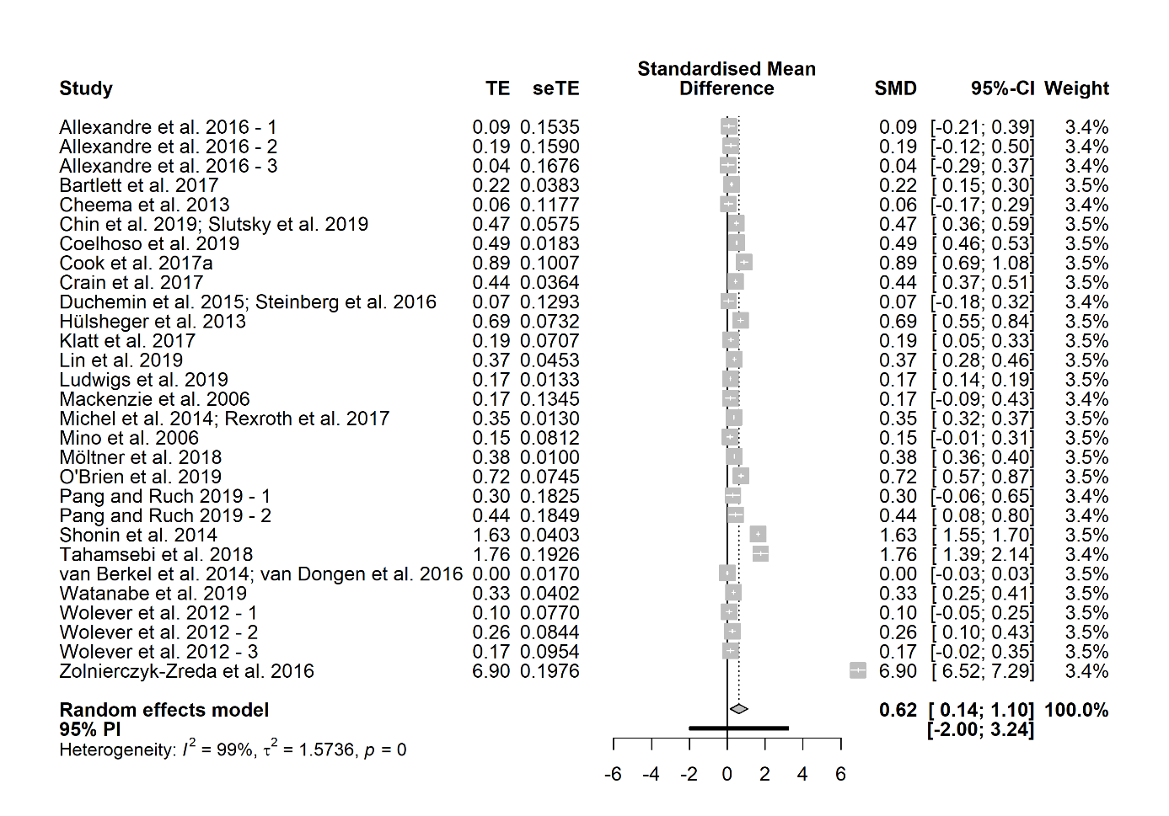

Figure S6.1.7.2: Funnel plot – Work-related factors with all studies
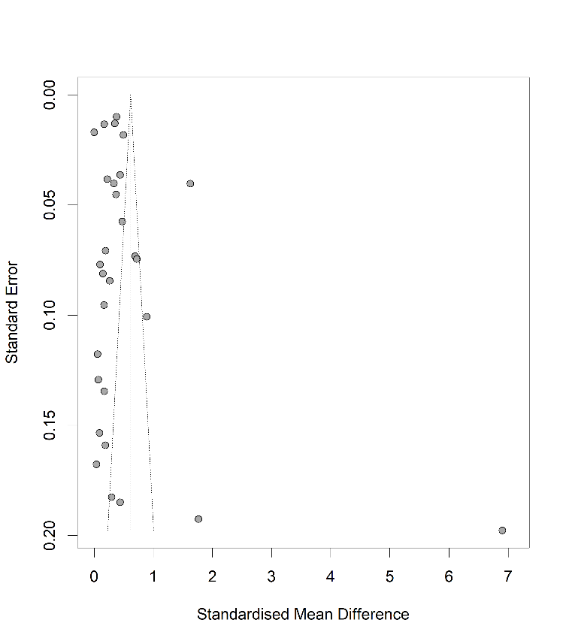

Table S6.1.7.1: Egger's test – Work-related factors with all studies
Eggers' test of the intercept
intercept | 95% CI | t | p
3.535 | [1.53; 8.6] | 1.369 | 0.182
Eggers' test does not indicate the presence of funnel plot asymmetry.
P-curve analysis
- Total number of provided studies: k = 29
- Total number of p<0.05 studies included into the analysis: k = 18 (62.07%)
- Total number of studies with p<0.025: k = 18 (62.07%)

Figure S6.1.7.3: Forest plot – Work-related factors without outliers
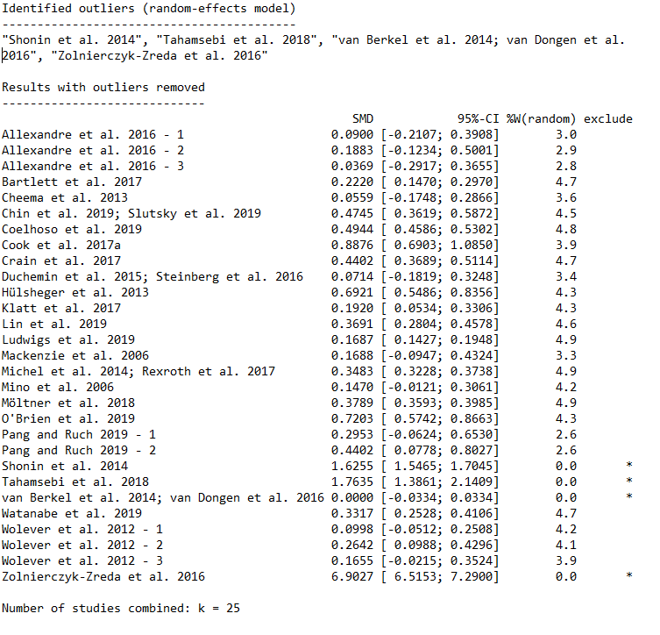

Short-term follow-up

Mindfulness

Figure S6.2.1.1: Forest plot – Mindfulness with all studies
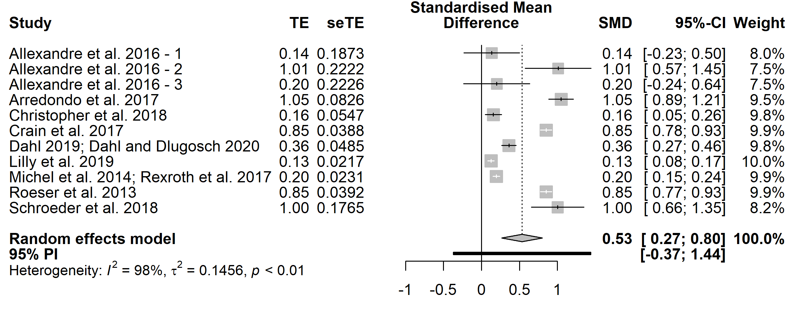

Figure S6.2.1.2: Funnel plot – Mindfulness with all studies
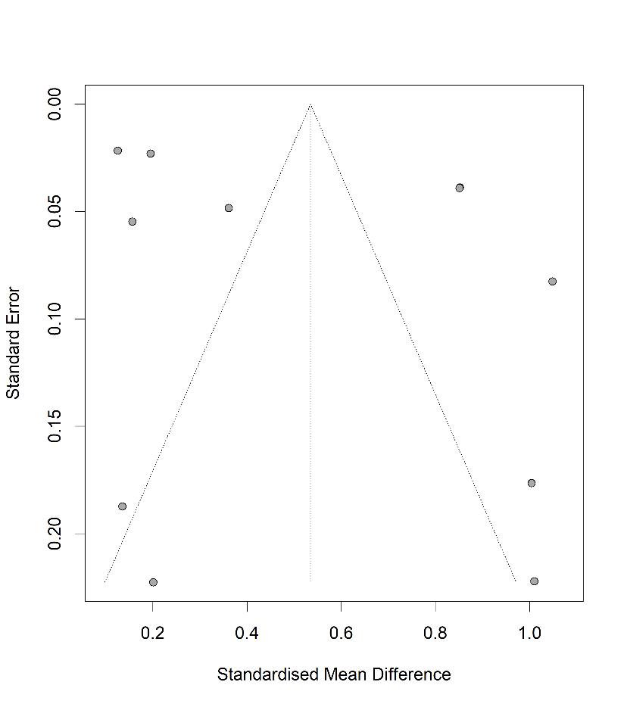

Table S6.2.1.1: Egger’s test – Mindfulness with all studies
Eggers' test of the intercept
intercept | 95% CI | t | p
5.116 | [-2.18; 12.42] | 1.374 | 0.203
Eggers' test does not indicate the presence of funnel plot asymmetry.
P-curve analysis
- Total number of provided studies: k = 11
- Total number of p<0.05 studies included into the analysis: k = 9 (81.82%)
- Total number of studies with p<0.025: k = 9 (81.82%)

Figure S6.2.1.3: Forest plot – Mindfulness without outliers

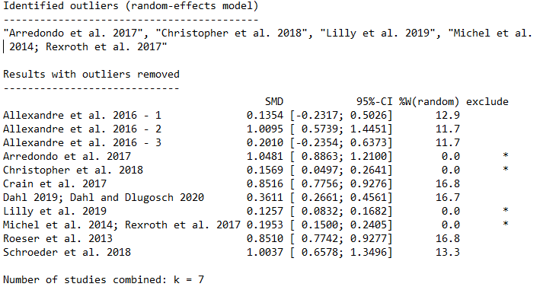

Well-being

Figure S6.2.2.1: Forest plot – Well-being with all studies
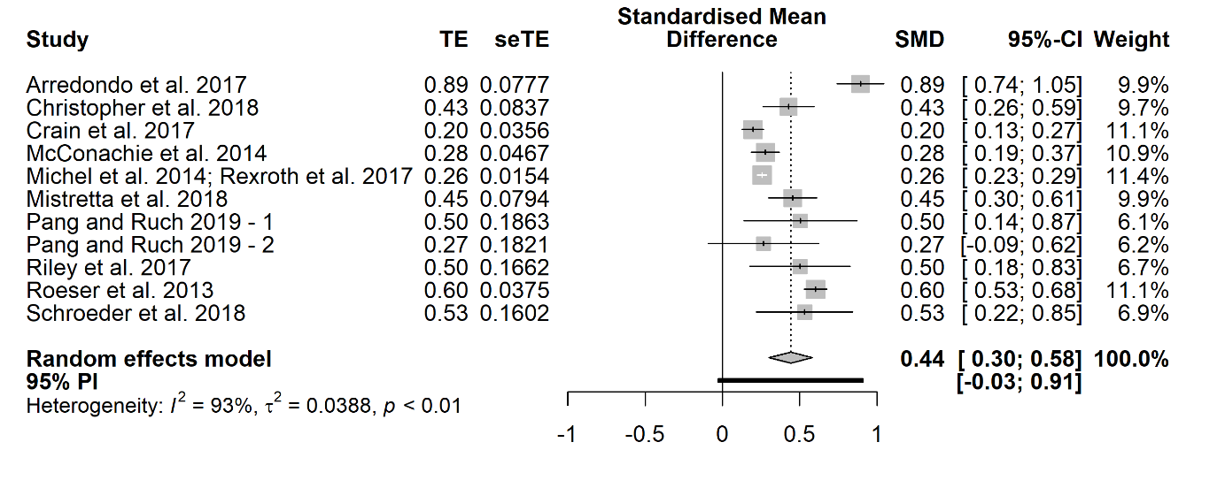

Figure S6.2.2.2: Funnel plot – Well-being with all studies
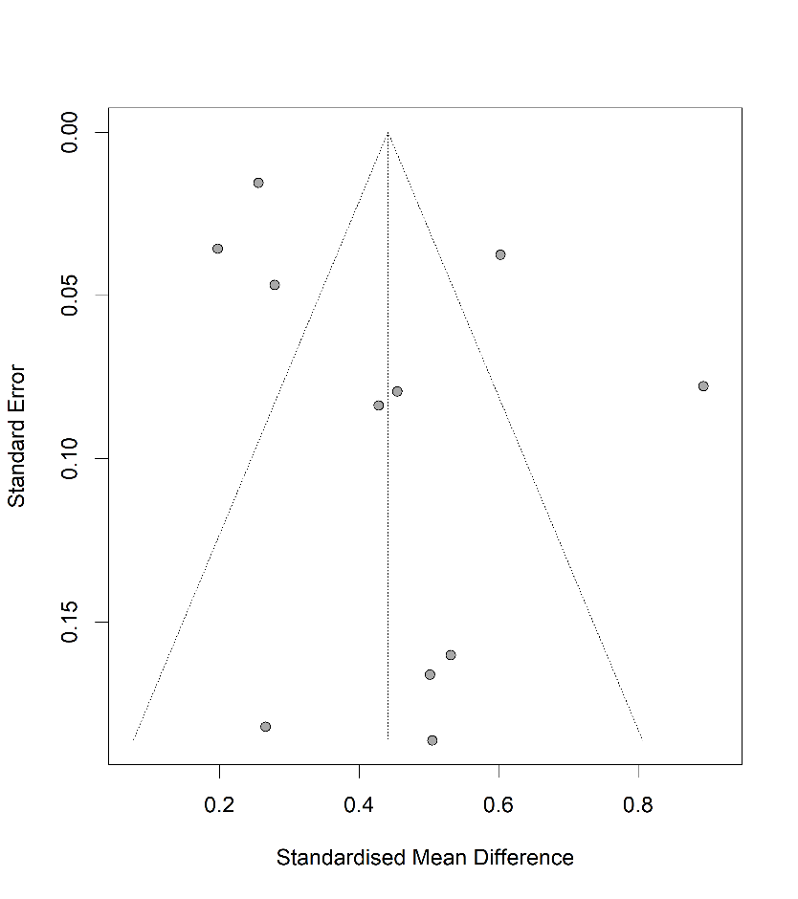

Table S6.2.2.1: Egger’s test – Well-being with all studies
Eggers' test of the intercept
intercept | 95% CI | t | p
2.714 | [-0.4; 5.82] | 1.711 | 0.121
Eggers' test does not indicate the presence of funnel plot asymmetry.
P-curve analysis
- Total number of provided studies: k = 11
- Total number of p<0.05 studies included into the analysis: k = 10 (90.91%)
- Total number of studies with p<0.025: k = 10 (90.91%)

Figure S6.2.2.3: Forest plot – Well-being without outliers
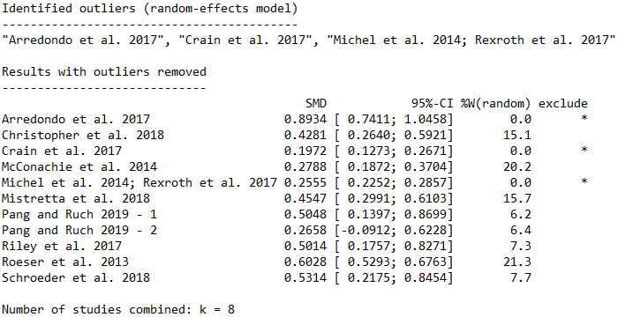

Physical Health

Figure S6.2.3.1: Forest plot – Physical Health with all studies
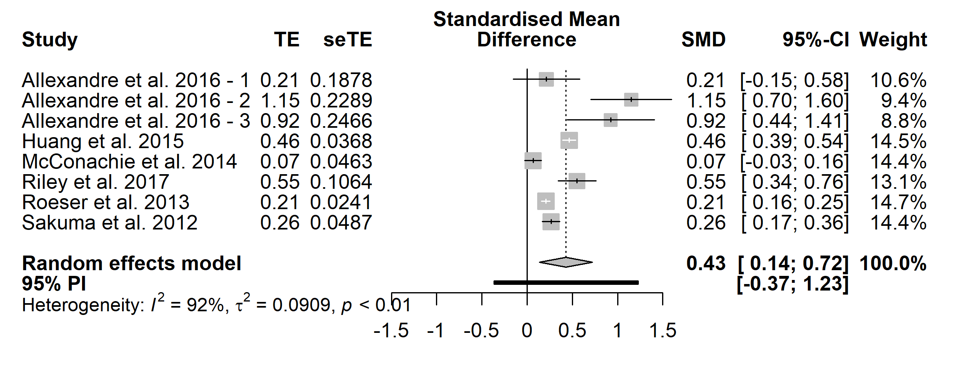

Figure S6.2.3.2: Funnel plot – Physical Health with all studies
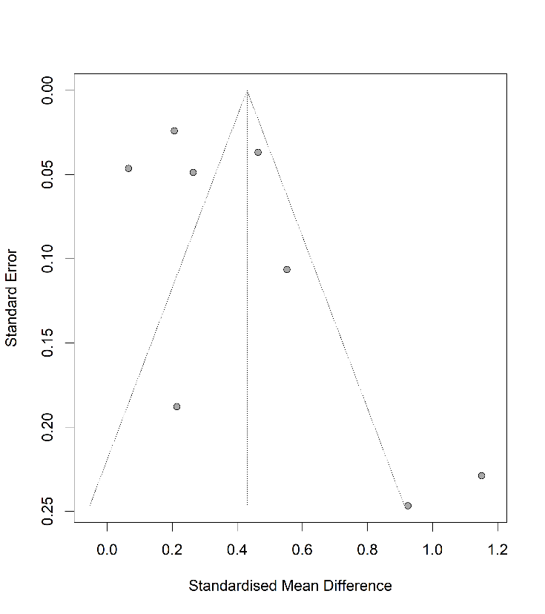

Table S6.2.3.1: Egger’s test – Physical Health with all studies

Eggers' test of the intercept
intercept | 95% CI | t | p
2.594 | [-1.18; 6.36] | 1.349 | 0.226
Eggers' test does not indicate the presence of funnel plot asymmetry.
P-curve analysis
- Total number of provided studies: k = 8
- Total number of p<0.05 studies included into the analysis: k = 6 (75%)
- Total number of studies with p<0.025: k = 6 (75%)

Mental Health

Figure S6.2.4.1: Forest plot – Mental Health with all studies
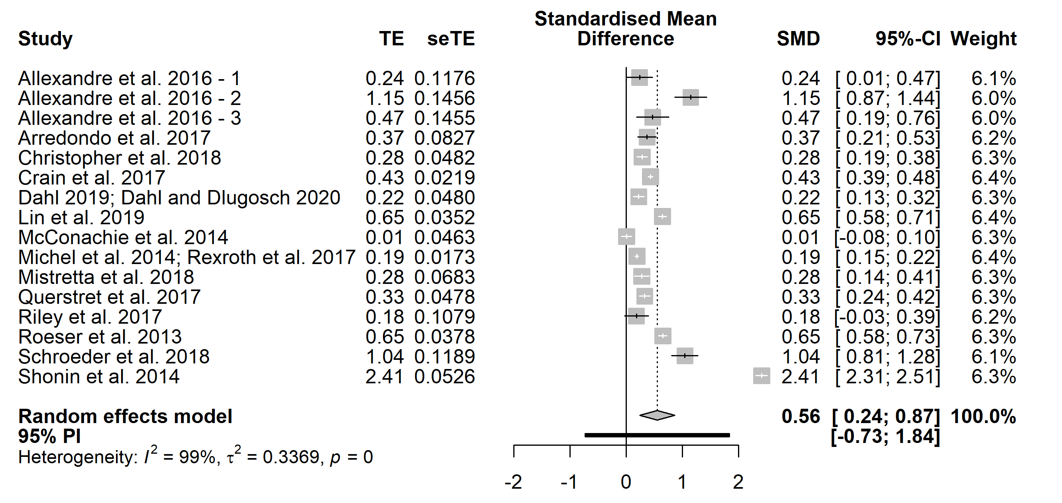

Figure S6.2.4.2: Funnel plot – Mental Health with all studies
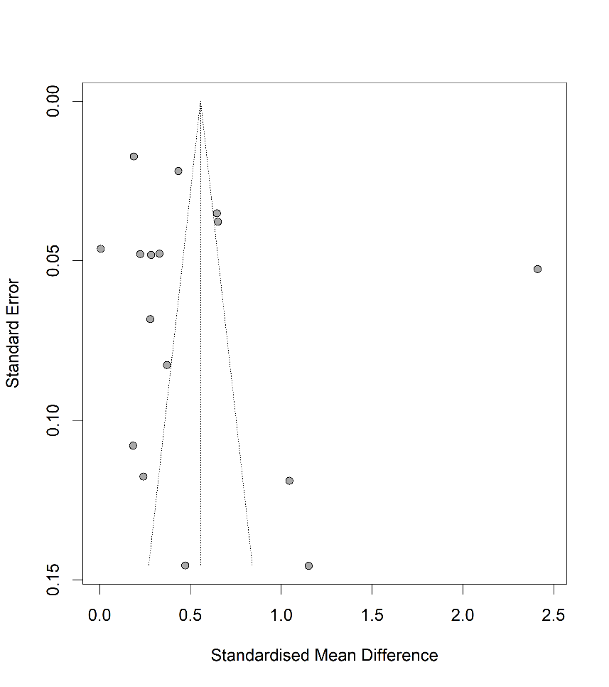

Table S6.2.4.1: Egger’s test – Mental Health with all studies

Eggers' test of the intercept
intercept | 95% CI | t | p
5.186 | [-4.61; 14.98] | 1.037 | 0.317
Eggers' test does not indicate the presence of funnel plot asymmetry.
P-curve analysis
- Total number of provided studies: k = 16
- Total number of p<0.05 studies included into the analysis: k = 14 (87.5%)
- Total number of studies with p<0.025: k = 13 (81.25%)

Figure S6.2.4.3: Forest plot – Mental Health without outliers
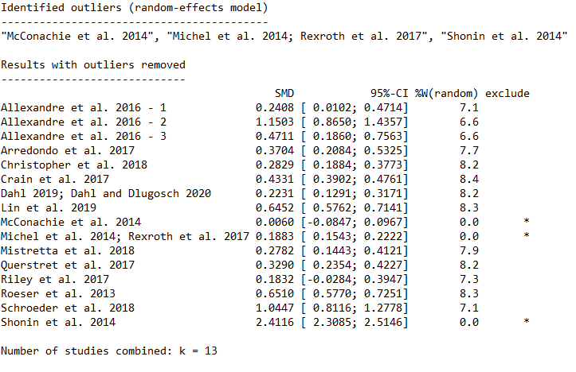

2.5 Stress

Figure S6.2.5.1: Forest plot – Stress with all studies
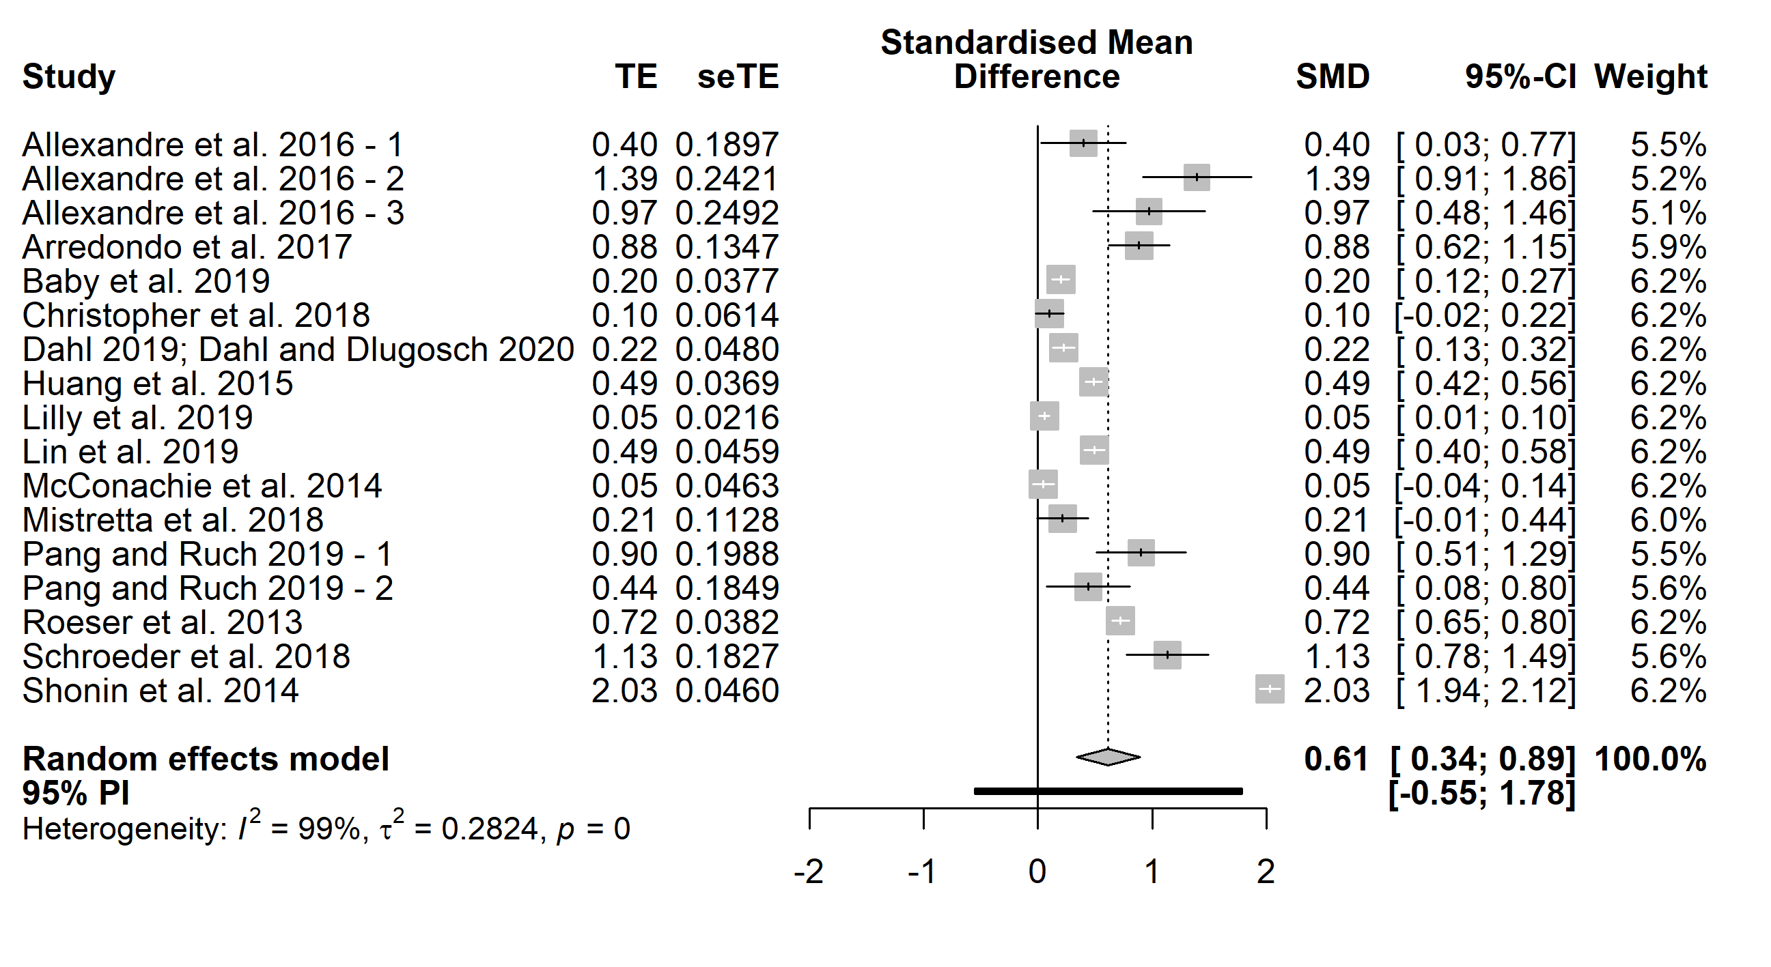

Figure S6.2.5.2: Funnel plot – Stress with all studies
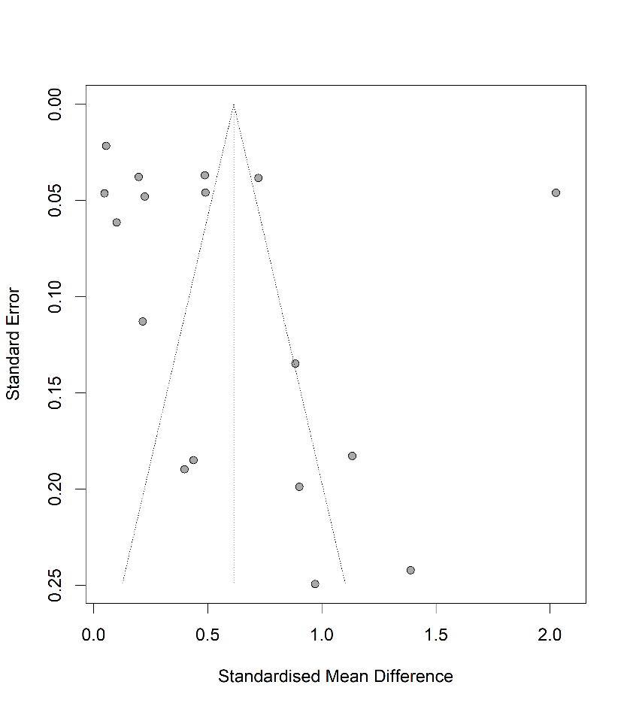

Table S6.2.5.1: Egger’s test – Stress with all studies

Eggers' test of the intercept
intercept | 95% CI | t | p
4.706 | [-3.87;13.28] | 1.075 | 0.299
Eggers' test does not indicate the presence of funnel plot asymmetry.
P-curve analysis
- Total number of provided studies: k = 17
- Total number of p<0.05 studies included into the analysis: k = 14 (82.35%)
- Total number of studies with p<0.025: k = 13 (76.47%)

Figure S6.2.5.3: Forest plot – Stress without outliers
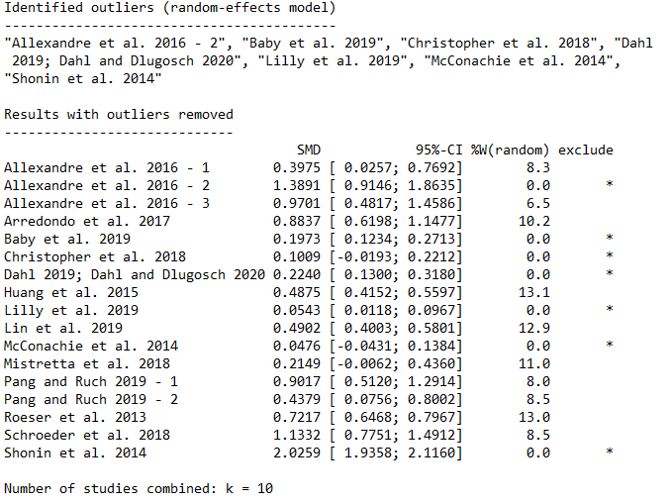

2.6 Resilience
/

2.7 Work-related factors

Figure S6.2.7.1: Forest plot – Work-related factors with all studies
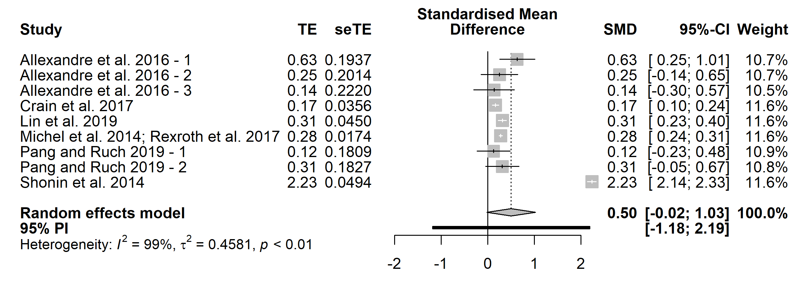

Figure S6.2.7.2: Funnel plot – Work-related factors with all studies
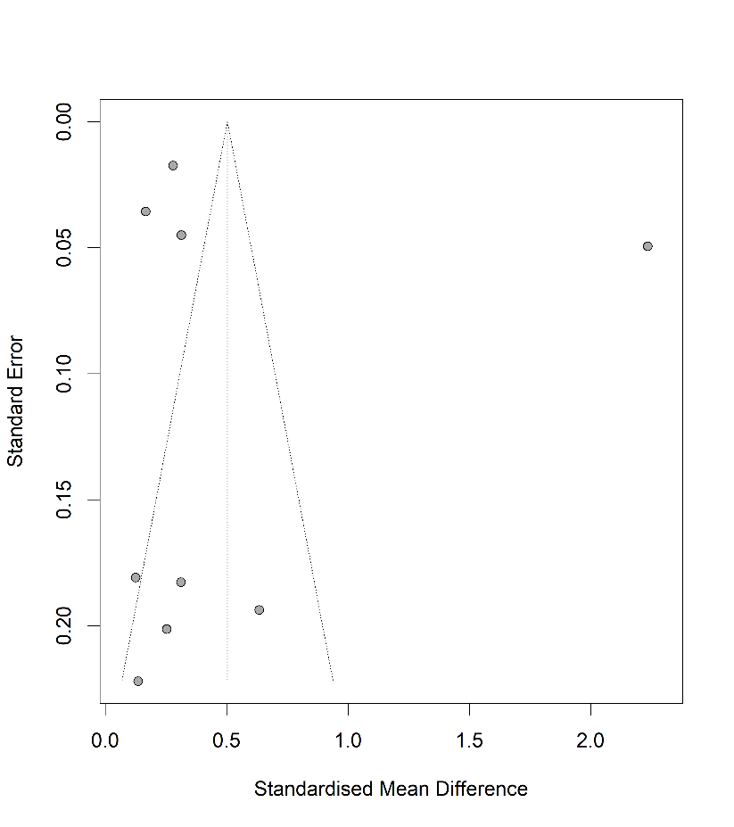

Table S6.2.7.1: Egger’s test – Work-related factors with all studies

Eggers' test of the intercept
intercept | 95% CI | t | p
3.559 | [-9.77;16.89] | 0.523 | 0.617
Eggers' test does not indicate the presence of funnel plot asymmetry.
P-curve analysis
- Total number of provided studies: k = 9
- Total number of p<0.05 studies included into the analysis: k = 5 (55.56%)
- Total number of studies with p<0.025: k = 5 (55.56%)

Figure S6.2.7.3: Forest plot – Work-related factors without outliers
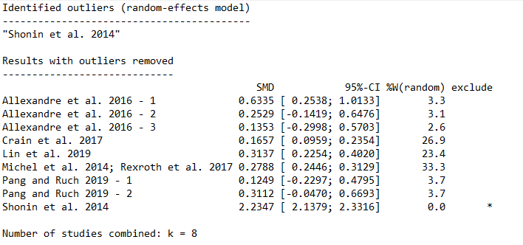

Long-term follow-up

3.1 Mindfulness
/

3.2 Well-being

Figure S6.3.2.1: Forest plot – Well-being with all studies
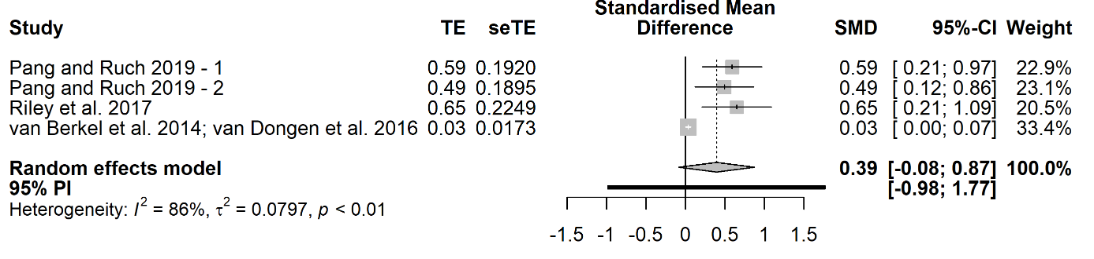

Figure S6.3.2.2: Funnel plot – Well-being with all studies
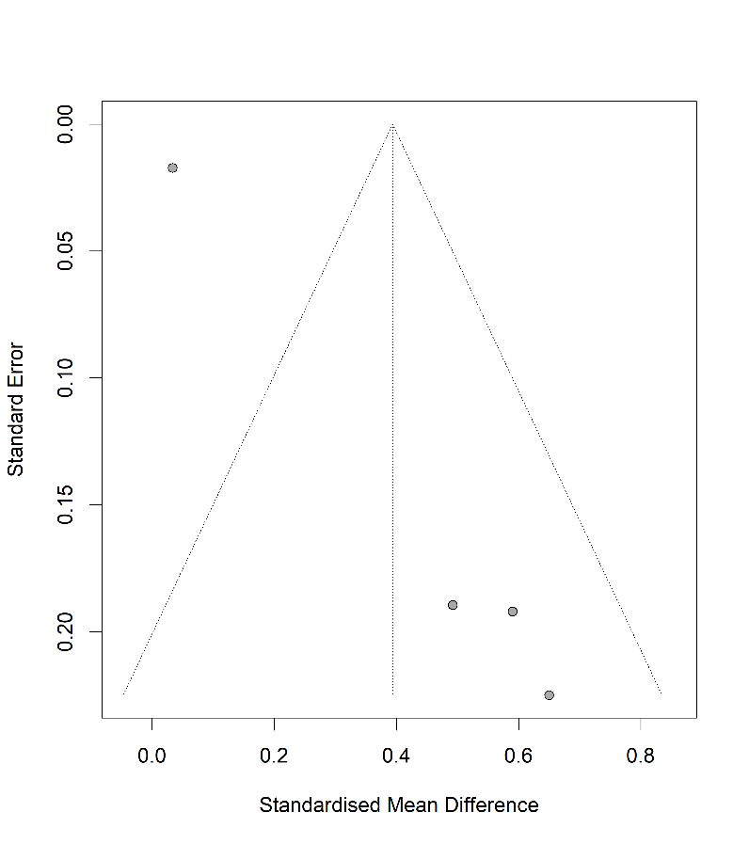

Table S6.3.2.1: Egger’s test – Well-being with all studies
Eggers' test of the intercept
intercept | 95% CI | t | p
2.938 | [2.64; 3.24] | 19.22 | 0.003
Eggers' test does indicate the presence of funnel plot asymmetry.
P-curve analysis
- Total number of provided studies: k = 4
- Total number of p<0.05 studies included into the analysis: k = 3 (75%)
- Total number of studies with p<0.025: k = 3 (75%)

3.3 Physical Health

Figure S6.3.3.1: Forest plot – Physical Health with all studies
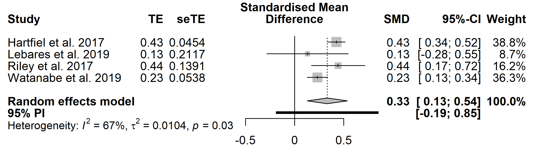

Figure S6.3.3.2: Funnel plot – Physical Health with all studies
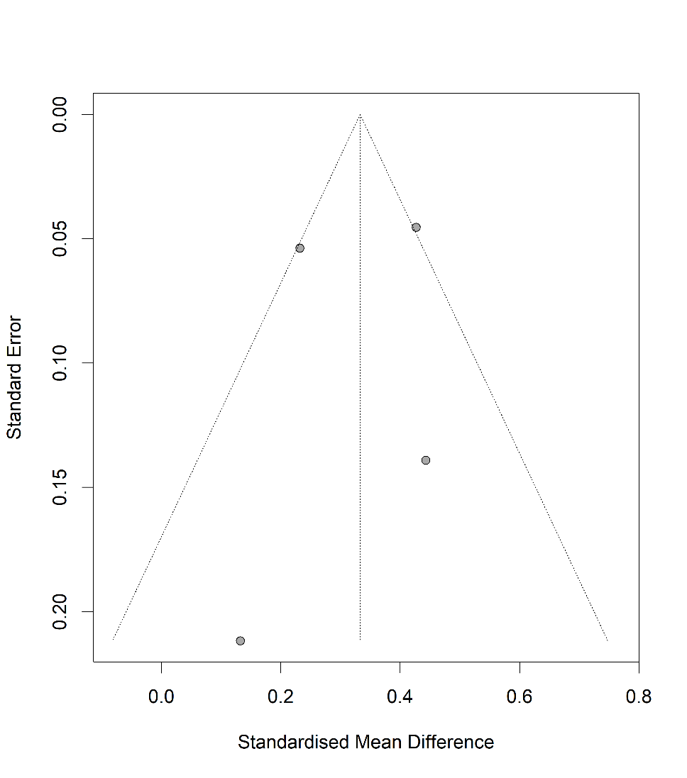

Table S6.3.3.1: Egger’s test – Physical Health with all studies
Eggers' test of the intercept
intercept | 95% CI | t | p
-0.691 | [-4.89;3.51] | -0.322 | 0.778
Eggers' test does not indicate the presence of funnel plot asymmetry.
P-curve analysis
- Total number of provided studies: k = 4
- Total number of p<0.05 studies included into the analysis: k = 3 (75%)
- Total number of studies with p<0.025: k = 3 (75%)

3.4 Mental Health

Figure S6.3.4.1: Forest plot – Mental Health with all studies
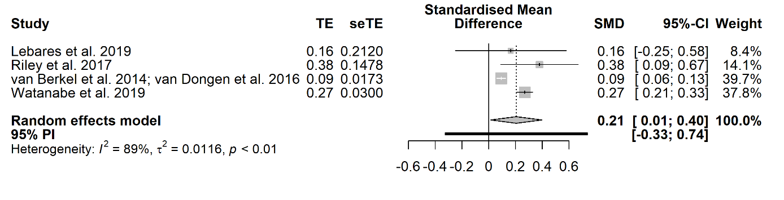

Figure S6.3.4.2: Funnel plot – Mental Health with all studies
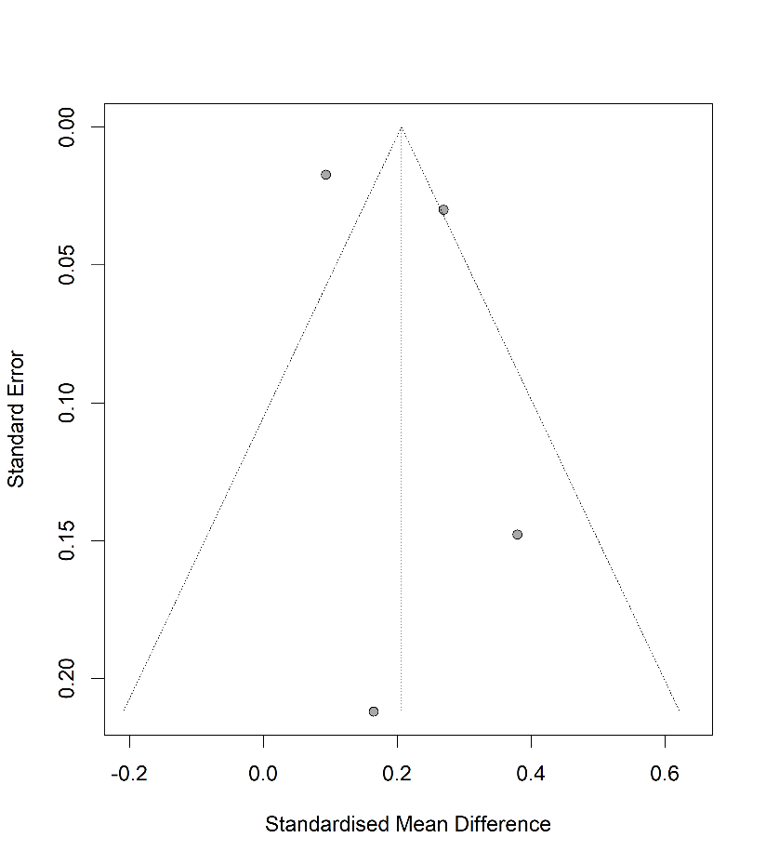

Table S6.3.4.1: Egger’s test – Mental Health with all studies

Eggers' test of the intercept
intercept | 95% CI | t | p
2.013 | [-2.97; 7] | 0.792 | 0.511
Eggers' test does not indicate the presence of funnel plot asymmetry.
P-curve analysis
- Total number of provided studies: k = 4
- Total number of p<0.05 studies included into the analysis: k = 3 (75%)
- Total number of studies with p<0.025: k = 3 (75%)

Stress

Figure S6.3.5.1: Forest plot – Stress with all studies
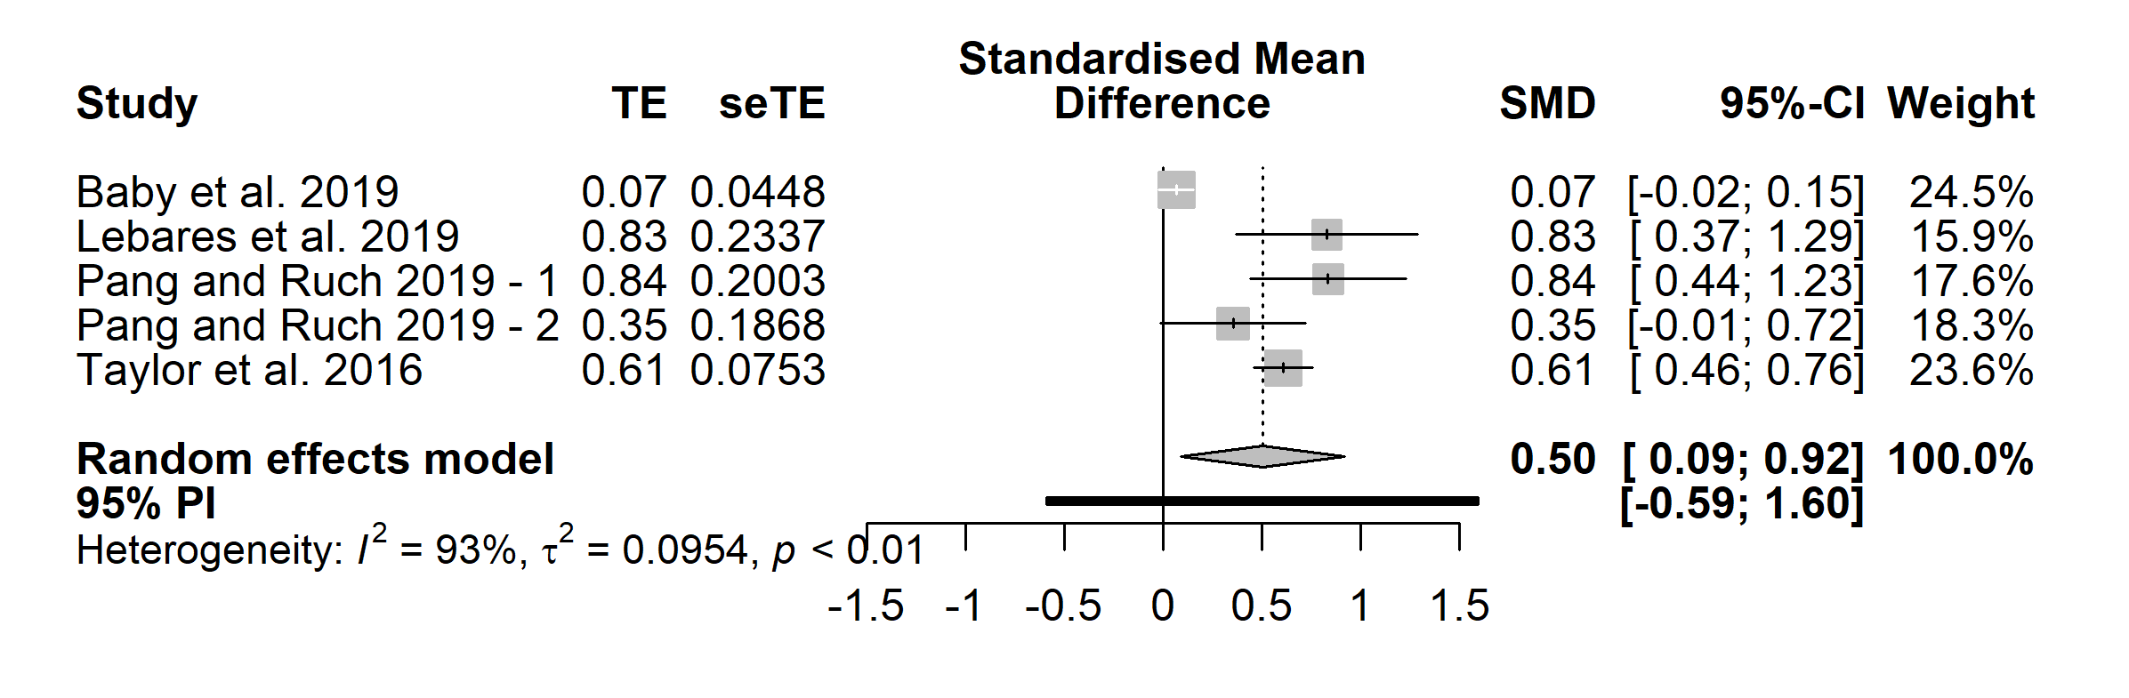

Figure S6.3.5.2: Funnel plot – Stress with all studies
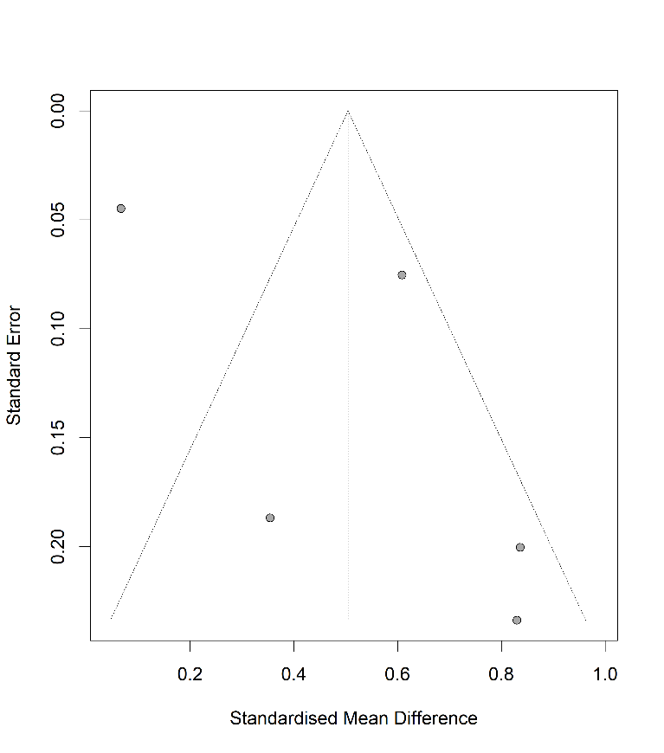

Table S6.3.5.1: Egger’s test – Stress with all studies

Eggers' test of the intercept
intercept | 95% CI | t | p
4.089 | [-0.56; 8.73] | 1.725 | 0.183
Eggers' test does not indicate the presence of funnel plot asymmetry.
P-curve analysis
- Total number of provided studies: k = 5
- Total number of p<0.05 studies included into the analysis: k = 3 (60%)
- Total number of studies with p<0.025: k = 3 (60%)

Resilience
/

Work-related factors

Figure S6.3.7.1: Forest plot – Work-related factors with all studies
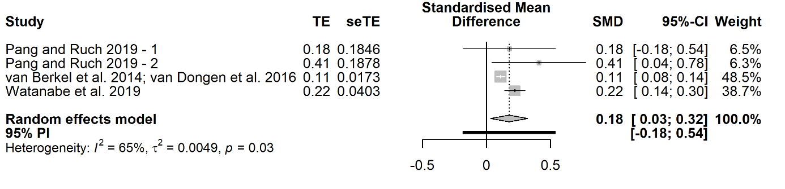

Figure S6.3.7.2: Funnel plot – Work-related factors with all studies
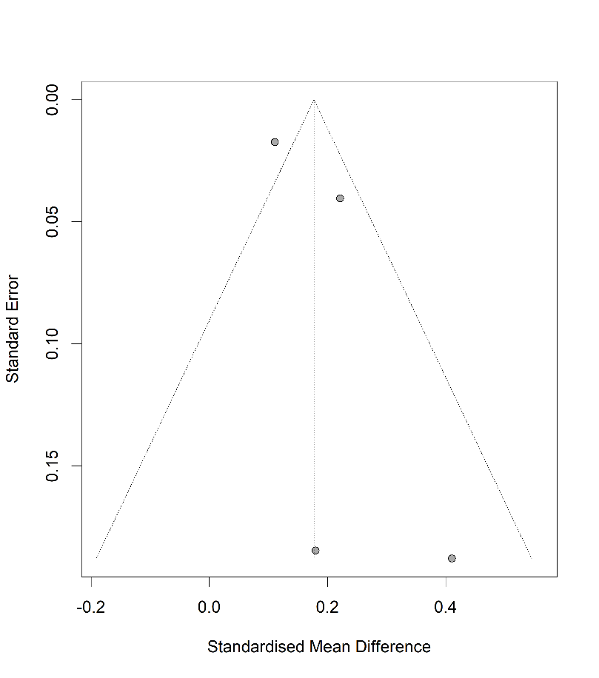

Table S6.3.7.1: Egger’s test – Work-related factors with all studies

Eggers' test of the intercept
intercept | 95% CI | t | p
1.577 | [-0.5; 3.66] | 1.486 | 0.275
Eggers' test does not indicate the presence of funnel plot asymmetry.
P-curve analysis
- Total number of provided studies: k = 4
- Total number of p<0.05 studies included into the analysis: k = 3 (75%)
- Total number of studies with p<0.025: k = 2 (50%)

