Supplementary materials

List of the abbreviations and acronyms used in Figures S1 and S2
Sex: participants’ sex (dummy coding: males = 0, females = 1); AQ: Autism Spectrum Quotient; AQ-soc: AQ social skill subscale; AQ-switch: AQ attention switching subscale; AQ-detail: AQ attention-to-detail subscale; AQ-comm: AQ communication subscale; AQ-ima: AQ imagination subscale; MASS: Mindful Attention Awareness Scale; RRS: Ruminative Response Scale; RRS-reflect: RRS reflective subscale; RRS-brood: RRS brooding subscale; PSWQ: Penn State Worry Questionnaire; ASI: Anxiety Sensitivity Index-3; BDI: Beck Depression Inventory-II.

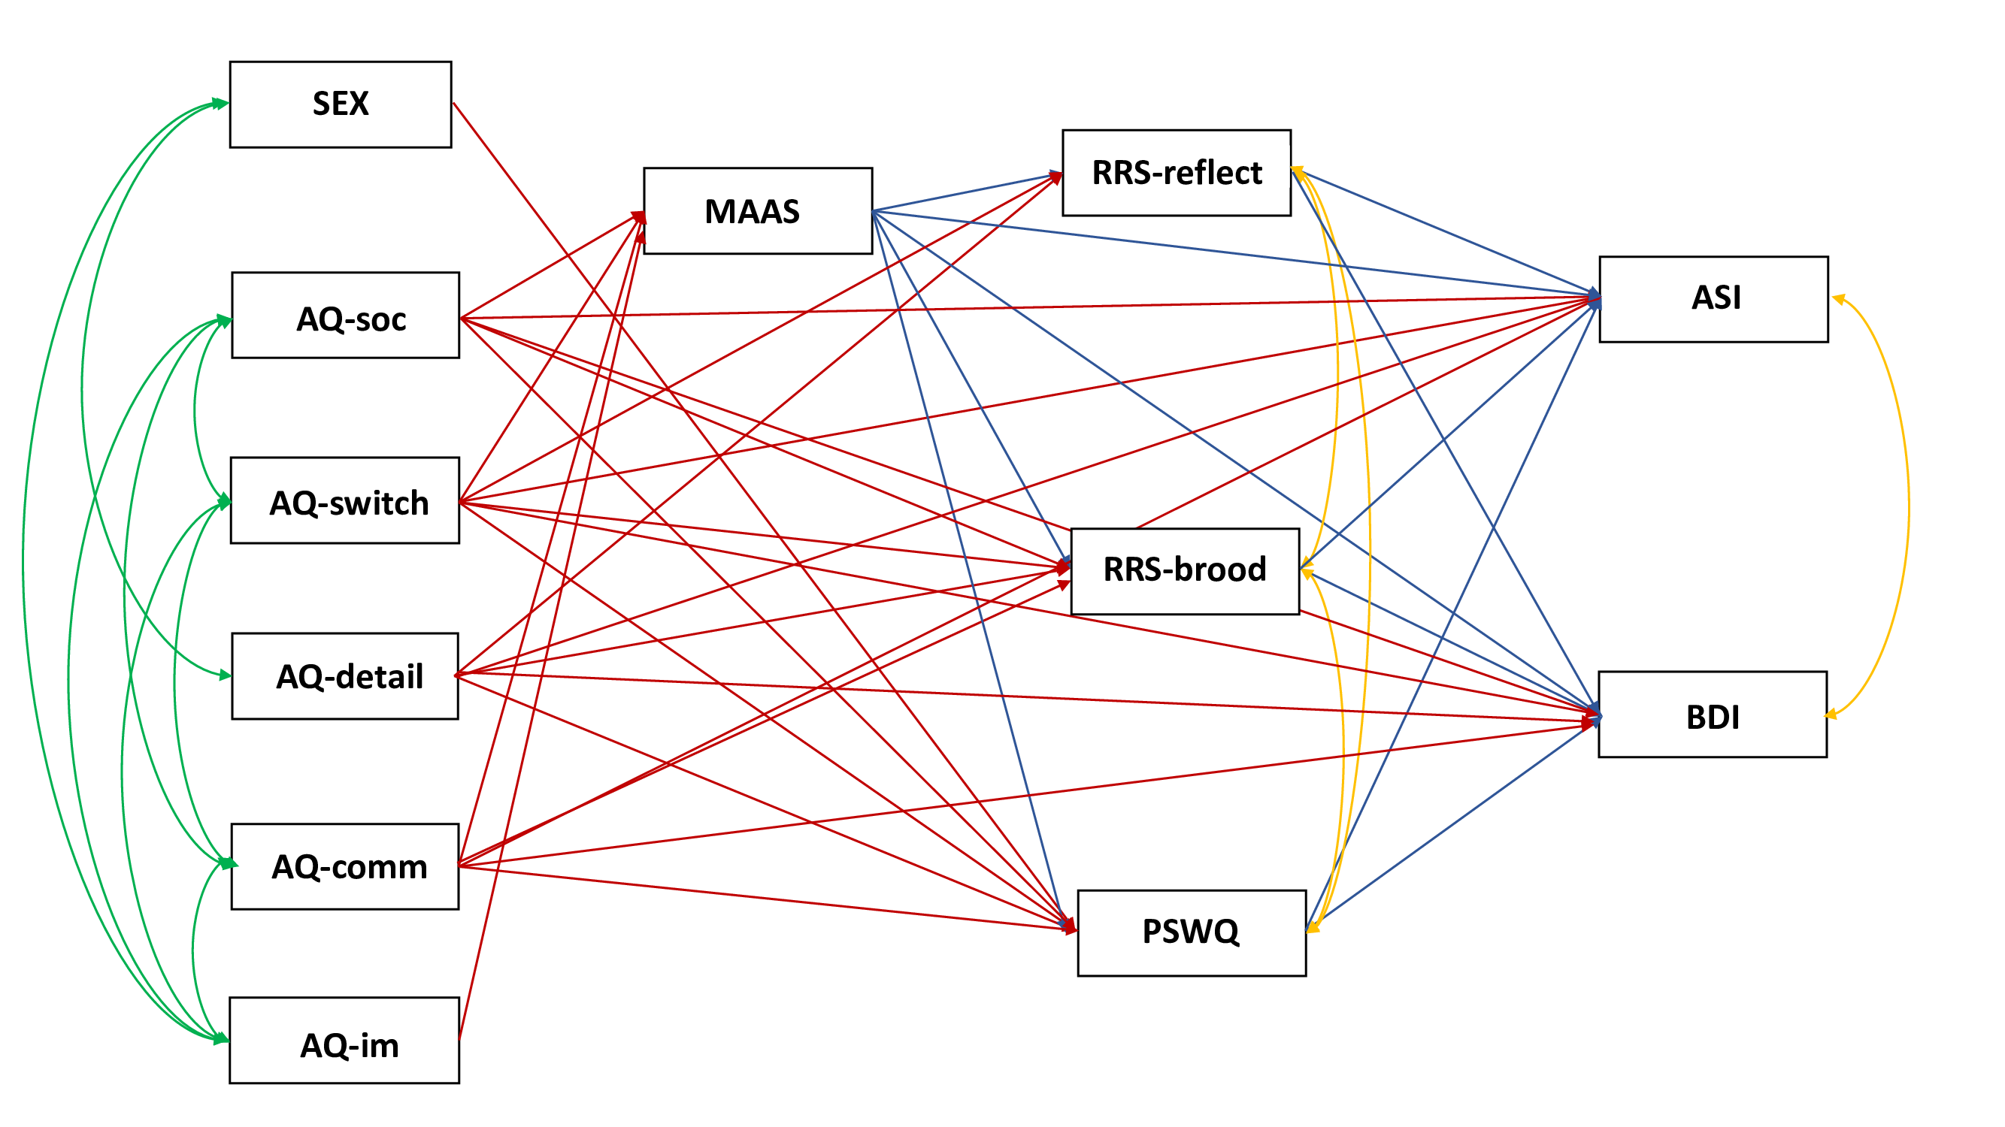Figure S1. Path diagram for the basic model predicting anxiety sensitivity and depression. Causal paths were represented with arrows and non-directional correlations with arcs: green lines indicate paths for phi matrix; red lines indicate paths for gamma matrix; blue lines indicate paths for beta matric; yellow lines indicate paths for psi matrix.
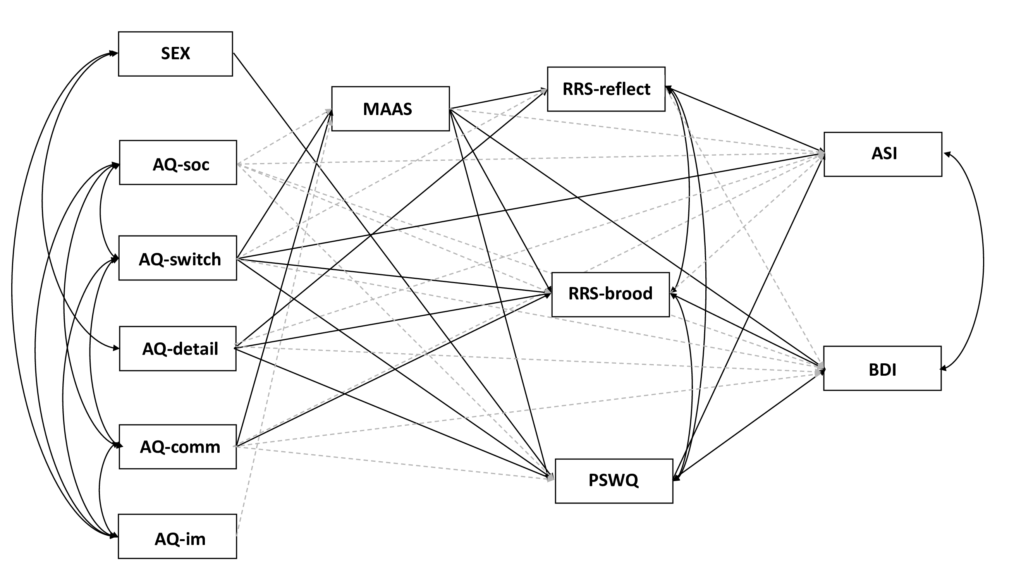

Figure S2. Path diagram changes from the basic/reference model to the pruned model.
Causal paths were represented with arrows (gamma and beta matrices) and non-directional correlations with arcs (phi and psi matrices); lines indicate significant paths (standardized partial regression coefficients with p value < 0.05) and dashed lines indicate the non-significant removed paths (p > 0.05).

