Temporal Changes in the State Effect of Meditation on Response Inhibition Processes
Table of contents
Supplementary Explanations 2
1. Reason participants could not perform the entire procedure as scheduled 2
2. The color-word matching Stroop task 3
3. The 10-item quizzes related to the documentary videos 4
Supplementary Analyses 5
1. Temporal changes in the Stroop interference obtained from the practice of the Stroop task 5
2. Influences of session orders on temporal changes in ΔRT 6
3. Differences in subjective assessments between the sessions 7
4. TDMS 8
5. The 10-item quizzes related to the documentary videos 9
Supplementary Figures 10
Figure S1 10
Figure S2 11
Figure S3 12
Figure S4 13
Figure S5 14
Figure S6 15
Figure S7 16

Supplementary Explanations

1. Reason participants could not perform the entire procedure as scheduled
Five participants could not perform the entire procedure as scheduled. Two participants had scheduling issues, and three were ill. Due to scheduling issues, the first participant underwent the main experiment five days after the briefing, and the third participant underwent the second session 10 days after the first. Due to illness, the second participant underwent the main experiment nine days after the briefing, the fourth participant underwent the second session 14 days after the first, and the fifth participant underwent the second session 16 days after the first.

2. The color-word matching Stroop task
The Stroop task consisted of neutral, congruent, and incongruent conditions. For the neutral condition, the top row included a meaningless letter string (i.e., “XXXX”) printed in one of the four colors (i.e., red, green, blue, or yellow), and the bottom row included one of four words (i.e., “RED,” “GREEN,” “BLUE,” or “YELLOW”) printed in black. For the congruent condition, the top row included one of the four words colored with itself (e.g., “GREEN” printed in green), and the bottom row included one of the words printed in black. For the incongruent condition, the top row included one of the four words printed in an incongruent color (e.g., “RED” printed in blue), and the bottom row included one of the words printed in black. The Stroop task was started with 10 s of rest. The top row was shown 0.1 s before the bottom row’s appearance, so that the participants’ viewpoint was not fixed on the bottom row. The bottom row was presented for 2 s, along with the top row. An inter-stimulus interval showing a fixation cross for 9–13 s was inserted between the trials. Both the “Yes” and “No” stimuli were presented with equal probabilities (i.e., 50%). The “Yes” and “No” order of the two buttons was counterbalanced across the participants.

3. The 10-item quizzes related to the documentary videos
Ten questions were related to these townscapes and people’s behavior contained in the documentary videos, and there was one correct answer to each question (for example, “How many people were cleaning the courtyard?” “What was the name of the ice-cream shop?”). To avoid boredom among the participants, we manipulated the difficulty of the questions by varying the questions’ perspectives or the duration to find the answer. The first author rated the participants’ responses based on the sample answers made in advance. The score range of the 10 items was from 0 to 10.

Supplementary Analyses

1. Temporal changes in the Stroop interference obtained from the practice of the Stroop task
We checked temporal changes in the Stroop interference (i.e., RT) obtained from the practice of the Stroop task. This study included 39 participants, however, one was excluded from the analysis because the data could not be collected due to a mechanical failure. Each participant practiced the Stroop task 14 times throughout the briefing and the main experiment. RT obtained from each practice was averaged across all the participants, and temporal changes in RT were examined.
We found that RT continued to decrease throughout the practice (Figure S2). The results indicated that the participants could obtain a learning effect even after finishing the practice.

2. Influences of session orders on temporal changes in ΔRT
Fifteen of the 28 participants underwent the FAM session first and then the SHAM session. The remaining participants underwent the SHAM session first and then the FAM session. Although the session order was counterbalanced, temporal changes in ΔRT may differ between when the FAM session (or the SHAM session) was performed first and when it was performed last.
We investigated whether the different session orders showed different temporal changes in ΔRT using two-way repeated measures ANOVA with the order as a between-subject factor and with the time as a within-subject factor. For the FAM session, no statistically significant order × time interaction (F(3, 78) = 0.45, p = 0.72, η_{p}² = 0.02) was identified. Also, no main effects were found, that is, for order (F(1, 26) = 0.05, p = 0.82, η_{p}² = 0.00) and time (F(3, 78) = 0.97, p = 0.41, η_{p}² = 0.04) (Figure S3). For the SHAM session, no statistically significant order × time interaction (F(3, 78) = 1.97, p = 0.13, η_{p}² = 0.07) was identified. Similarly, no main effects were found, that is, for order (F(1, 26) = 0.00, p = 0.99, η_{p}² = 0) and time (F(3, 78) = 2.16, p = 0.10, η_{p}² = 0.08) (Figure S4). These results indicated no influence of the session order on temporal changes in ΔRT.

3. Differences in subjective assessments between the sessions
We confirmed differences in each of the four subjective assessments (i.e., subjective effort, spontaneous thought, meditation quality, and sleepiness) between the FAM and the SHAM sessions using Wilcoxon signed rank tests (V). The reason for using Wilcoxon signed-rank tests is that it is applicable to ordinal data.
Results obtained by the analysis were shown in Figure S5. A significant difference was found in the spontaneous thought (V = 38.5, p = 0.00, Cliff’s d = 0.50; FAM: 3.6 ± 0.4 (mean ± standard error), SHAM: 5.6 ± 0.5), while no significant differences were observed in the other subjective assessments: effort (V = 170, p = 0.86, Cliff’s d = −0.11; FAM: 6.1 ± 0.4, SHAM: 6.0 ± 0.5), meditation quality (V = 64.0, p = 0.12, Cliff’s d = 0.36; FAM: 7.1 ± 0.3, SHAM: 7.5 ± 0.3), and sleepiness (V = 129, p = 0.17, Cliff’s d = −0.18; FAM: 3.3 ± 0.2, SHAM: 2.9 ± 0.1). These results suggested that the participants were engaged in both the FAM and SHAM sessions with equal effort, meditation quality, and sleepiness, except for spontaneous thought.

4. TDMS
We investigated whether the FAM and the SHAM sessions showed different temporal changes in mood states (i.e., vitality, stability, pleasure, and arousal). First, temporal changes in individual mood states were calculated by subtracting Q1 from Q2, Q3, Q4, Q5, and Q6. Next, the temporal differences were analyzed using three-way repeated measures ANOVA with the session, the mood state, and the time as within-subject factors.
The three-way repeated measures ANOVA showed a significant interaction of mood state × time (F(3.47, 93.77) = 3.29, p = 0.02, η_{p}² = 0.11), while no other significant interactions were found for session × time (F(2.6, 70.14) = 0.04, p = 0.98, η_{p}² = 0.00), session × mood state (F(1.59, 42.88) = 1.26, p = 0.29, η_{p}² = 0.04), and session × time × mood state (F(3.97, 107.2) = 0.129, p = 0.97, η_{p}² = 0.00). There was a significant main effect of time (F(2.18, 58.87) = 9.30, p = 0.00, η_{p}² = 0.26), while there were no main effects for session (F(1, 27) = 0.31, p = 0.58, η_{p}² = 0.01) or mood state (F(1.42, 38.41) = 1.58, p = 0.22, η_{p}² = 0.06). These results indicated that the temporal changes in the mood states were similar between the FAM and SHAM sessions (Figure S6).

5. The 10-item quizzes related to the documentary videos
We confirmed whether there were differences in the concentration of the participants during each video between the FAM and the SHAM sessions. Specifically, we counted the number of correct responses to the 10 items in each interval. The greater the number of correct answers indicated that the participants were focused more on the video. The data were analyzed using two-way repeated measures ANOVA with the session and the interval (first, second, and third) as within-subject factors.
The two-way repeated measures ANOVA revealed no significant interaction of session × interval (F(2, 54) = 3.08, p = 0.05, η_{p}² = 0.10), and no significant main effects for session (F(1, 27) = 0.247, p = 0.62, η_{p}² = 0.01) or interval (F(2, 54) = 2.65, p = 0.08, η_{p}² = 0.09). These results indicated that the participants paid equal attention to all the videos between the two sessions (Figure S7).

Supplementary Figures

Figure S1
Experimental Environment
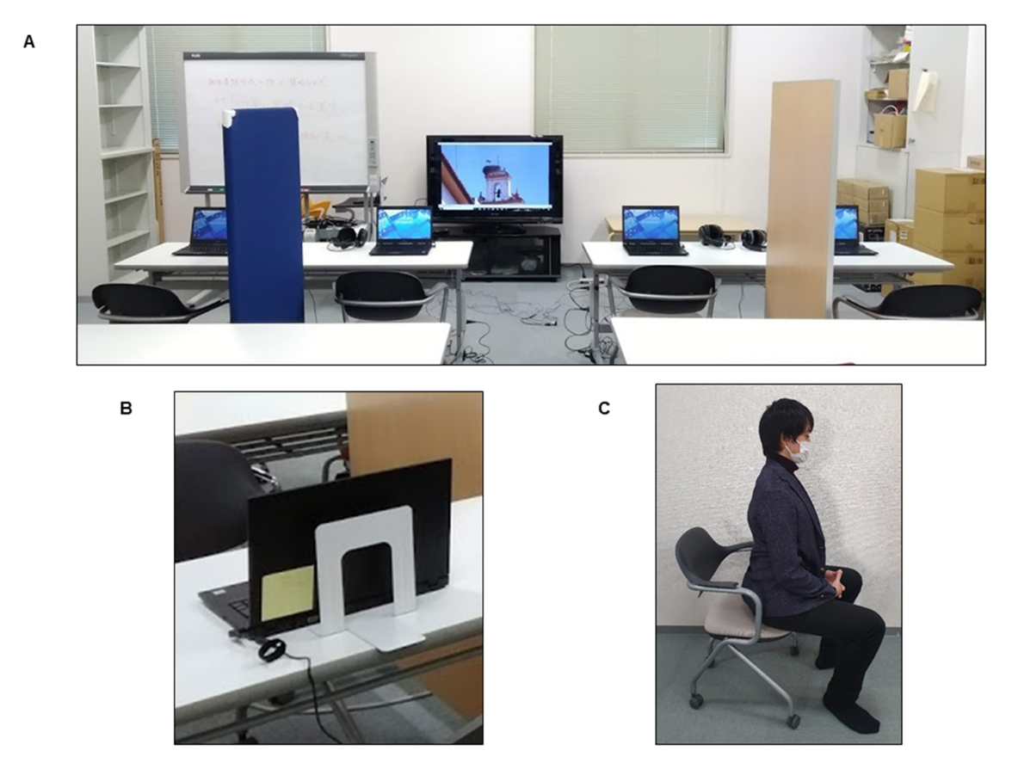

Note. A: A room in which the main experiment was performed. Each participant was seated in a chair in front of a laptop. Partitions were used so that the participants could not see each other. Each participant performed the Stroop task on their laptop and wore headphones while watching videos on a centered monitor. B: A bookstand showing a fixation point. C: Posture for each meditation. The participants performed meditations retaining their posture and fixing their eyes at the fixation point shown by the bookstand.

Figure S2
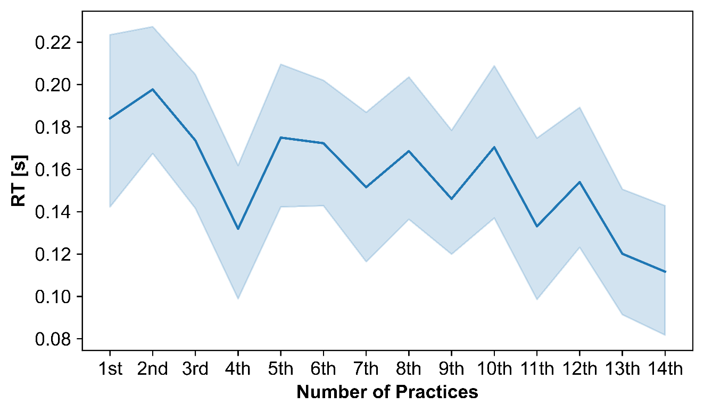
Temporal Changes in the Stroop Interference (RT) Obtained from the Practice of the Stroop Task

Note. The x-axis indicates the number of practices. The practices from the 1st to the 8th were performed in the briefing. The practices from the 9th to the 11th were performed in the first session. The practices from the 12th to the 14th were performed in the second session. The solid line indicates the mean RT at each practice. Shading: 95% confidence interval.

Figure S3
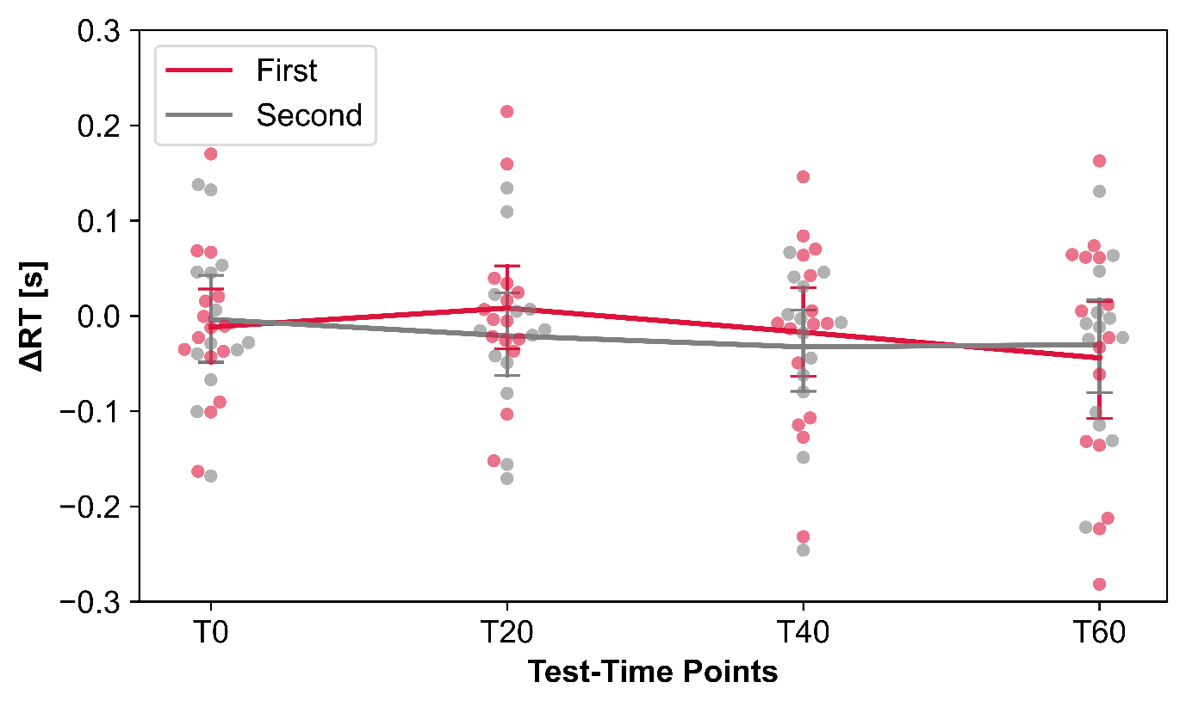
Temporal Changes in Stroop Task Performance (ΔRT) of Each Session Order within the FAM

Note. Fifteen of the 28 participants underwent the FAM session first, and the remaining participants underwent the FAM session second. Four time points (T0, T20, T40, and T60) correspond to those shown in Figure 1. Each dot indicates the Stroop task performance of each participant. The solid lines indicate the group means of the task performance, and the error bars represent 95% confidence interval. Two-way repeated measures ANOVA did not show significant interactions or main effects (order and time).

Figure S4
Temporal Changes in Stroop Task Performance (ΔRT) of Each Session Order within the SHAM
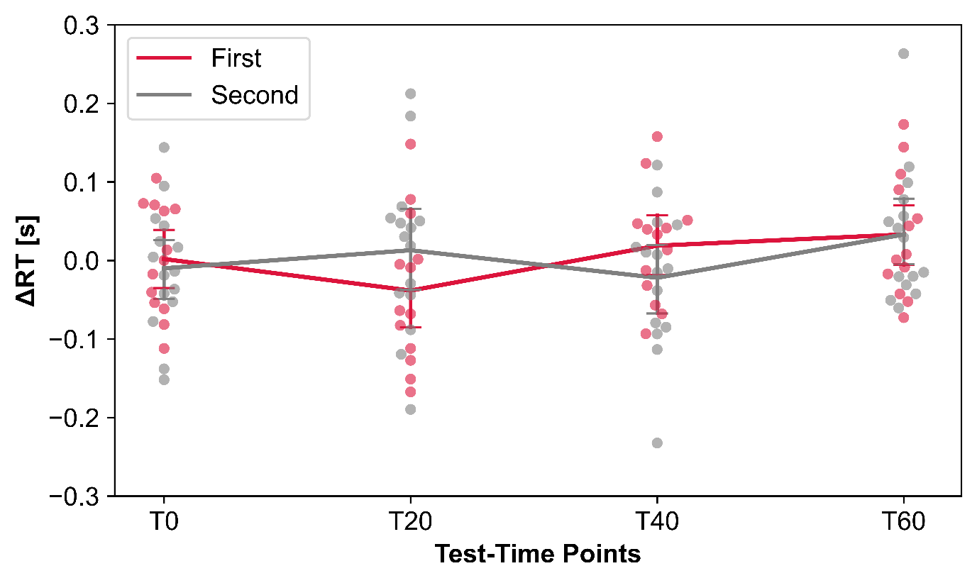

Note. Thirteen of the 28 participants underwent the SHAM session first, and the remaining participants underwent the SHAM session second. Four time points (T0, T20, T40, and T60) correspond to those shown in Figure 1. Each dot indicates the Stroop task performance of each participant. The solid lines indicate the group means of the task performance, and the error bars represent 95% confidence interval. Two-way repeated measures ANOVA did not show significant interactions or main effects (order and time).

Figure S5
Comparison of Individual Subjective Assessments between the Sessions
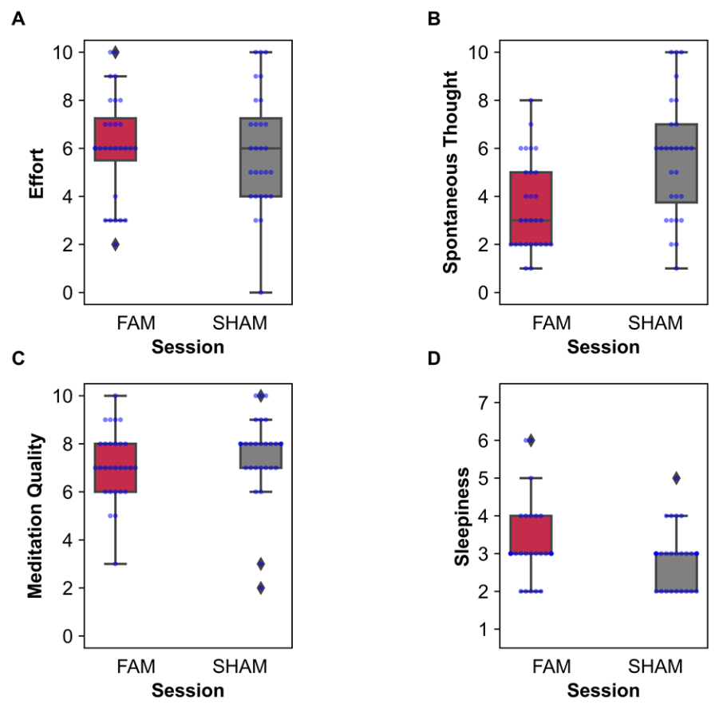

Note. Comparison of individual subjective assessments between the FAM and SHAM sessions. A: Comparison of the subjective effort between the sessions. B: Comparison of the spontaneous thought between the sessions. C: Comparison of the meditation quality between the sessions. D: Comparison of the sleepiness between the sessions. The centerline in each box plot indicates the median, and the box extent indicates the interquartile range (IQR; 25th–75th percentile). Individual whiskers extend to 1.5 × IQR. Each semi-transparent dot indicates individual-participant data. Wilcoxon’s signed-rank test revealed that the FAM showed lower spontaneous thought than the SHAM (p < 0.05). No other significant differences were found.

Figure S6
Comparison of the Temporal Changes in the Four Mood States between the FAM and SHAM Sessions

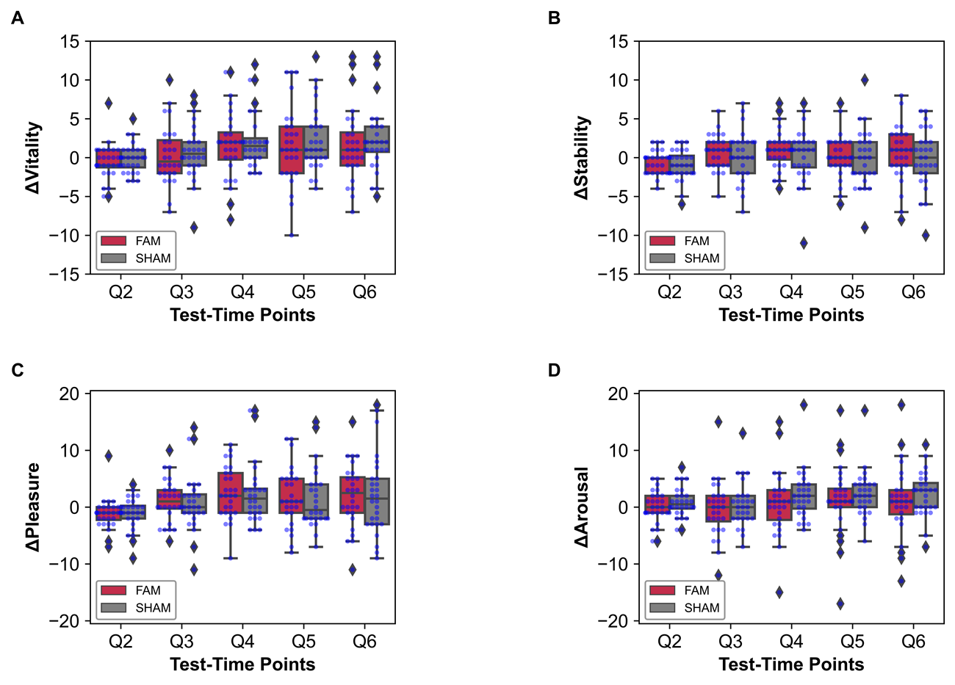

Note. Five time points (Q2–Q6) correspond to those shown in Figure 1. A change at each time point (Δ) was evaluated by subtracting Q1 from each of Q2–Q6. A: Comparison of the vitality between the sessions. B: Comparison of the stability between the sessions. C: Comparison of the pleasure between the sessions. D: Comparison of the arousal between the sessions. The centerline in each box plot indicates the median, and the box extent indicates the interquartile range (IQR; 25th–75th percentile). Individual whiskers extend to 1.5 × IQR. Each semi-transparent dot indicates individual-participant data. Three-way repeated measures ANOVA revealed a significant interaction of mood state × time and a significant main effect of the time (p < 0.05). No other significant effects were found.

Figure S7
Comparison of the Score of the 10-Item Quizzes between the FAM and SHAM Sessions
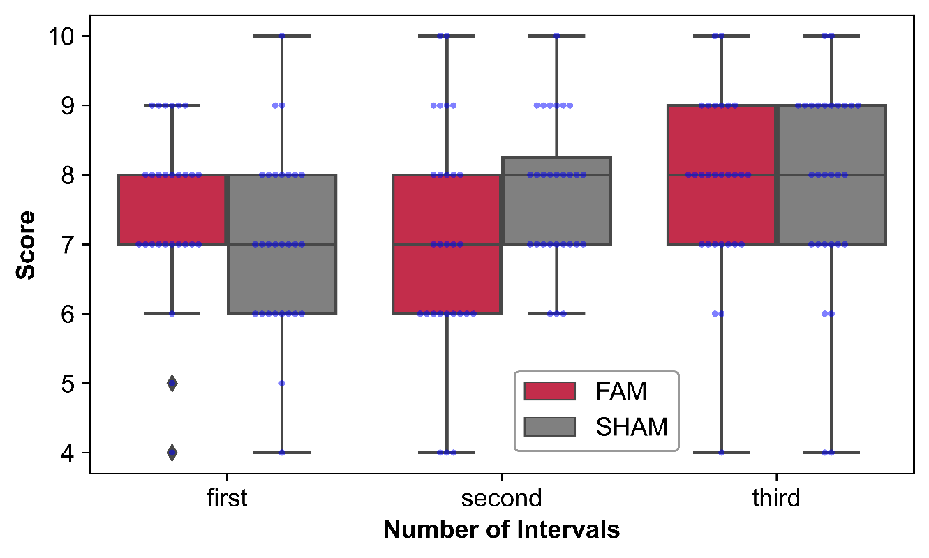

Note. The x-axis indicates the interval (first, second, and third). The centerline in each box plot indicates the median, and the box extent indicates the interquartile range (IQR; 25th–75th percentile). Individual whiskers extend to 1.5 × IQR. Each semi-transparent dot indicates individual-participant data. Two-way repeated measures ANOVA showed no significant interaction for session × interval and no significant main effects for the session and the interval.

