SUPPLEMENT
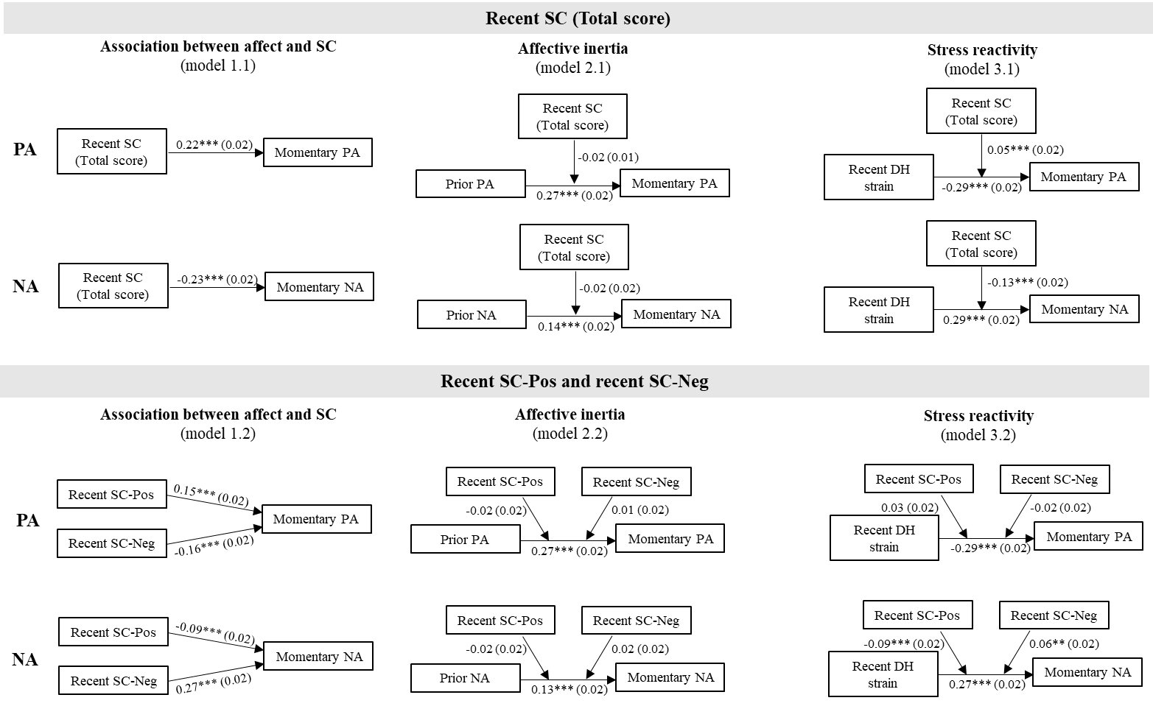
Figure S1. Path diagrams of the multilevel models.

Note. Displayed statistics are the estimates (standard errors in brackets) of the respective multilevel models (based on within-person standardized variables).
*p < .05, **p < .01, ***p < .001.

