Supplemental Table 1
Risk of Bias Across the Included Studies
Study name | Selection bias | Study design | Confounders | Blinding | Collection methods | Withdrawals and drop-outs
Ahola Kohut et al. (2020) | Weak | Moderate | Weak | Moderate | Strong |  | Strong
Anand & Sharma (2014) | Moderate | Moderate | Weak | Weak | Strong |  | Strong
Berger et al. (2018) | Moderate | Strong | Strong | Weak | Strong |  | Strong
Bokoch & Hass-Cohen (2020) | Moderate | Strong | Weak | Weak | Strong |  | Strong
Carey (2017) | Moderate | Moderate | Weak | Weak | Strong |  | Weak
Carro et al. (2020) | Moderate | Strong | Weak | Weak | Strong |  | Weak
Carro et al. (2022) | Moderate | Strong | Moderate | Moderate | Strong |  | Strong
Faraji et al. (2019) | Moderate | Strong | Weak | Weak | Strong |  | Weak
Haydicky et al. (2015) | Weak | Moderate | Moderate | Weak | Strong |  | Strong
Liu et al. (2021) | Moderate | Strong | Strong | Weak | Strong |  | Strong
Matsuba et al. (2021) | Moderate | Strong | Strong | Weak | Strong |  | Moderate
Meadows (2018) | Weak | Strong | Weak | Weak | Strong |  | Weak
Mendelson et al. (2010) | Moderate | Strong | Strong | Weak | Strong |  | Strong
Menghetti (2015) | Moderate | Moderate | Weak | Weak | Strong |  | Strong
Meyer & Eklund (2020) | Moderate | Strong | Moderate | Weak | Strong |  | Weak
Muelller (2014) | Moderate | Moderate | Weak | Weak | Moderate |  | Strong
Ricard et al. (2013) | Moderate | Strong | Moderate | Weak | Strong |  | Weak
Schonert-Reichl et al. (2015) | Moderate | Strong | Moderate | Strong | Strong |  | Strong
Terjestam et al. (2016) | Moderate | Strong | Moderate | Weak | Strong |  | Strong
Valero et al. (2021) | Moderate | Strong | Strong | Weak | Strong |  | Strong
Waldemar et al. (2016) | Moderate | Strong | Strong | Weak | Strong |  | Strong

Supplemental Figure 1
Follow-Up Within-Group Effect Size for Intervention Effect on Overall Peer Relationship Outcomes

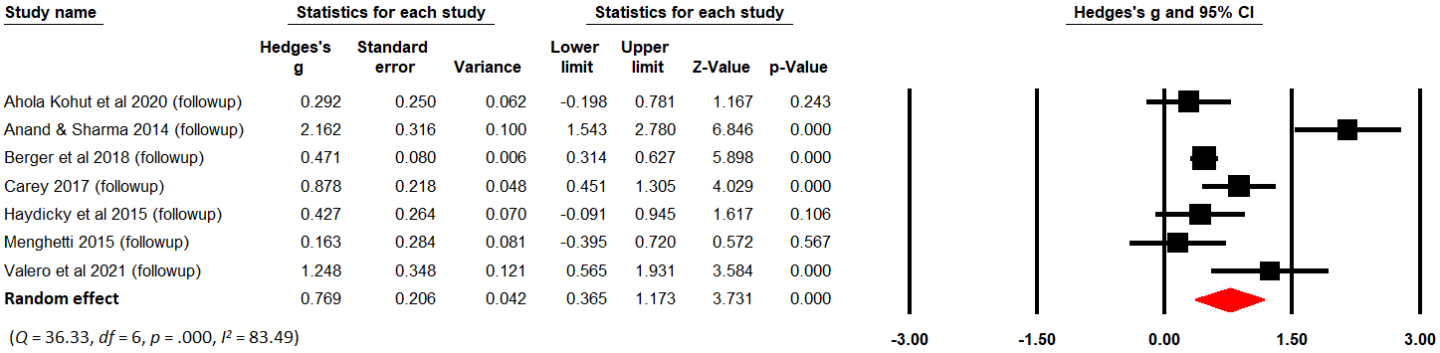
Supplemental Figure 2
Sensitivity Analysis: Intervention Effect on Peer Relationship with Outliersª Removed
(a) Within-group effect sizes (k = 19, excluding Anand & Sharma, 2014)
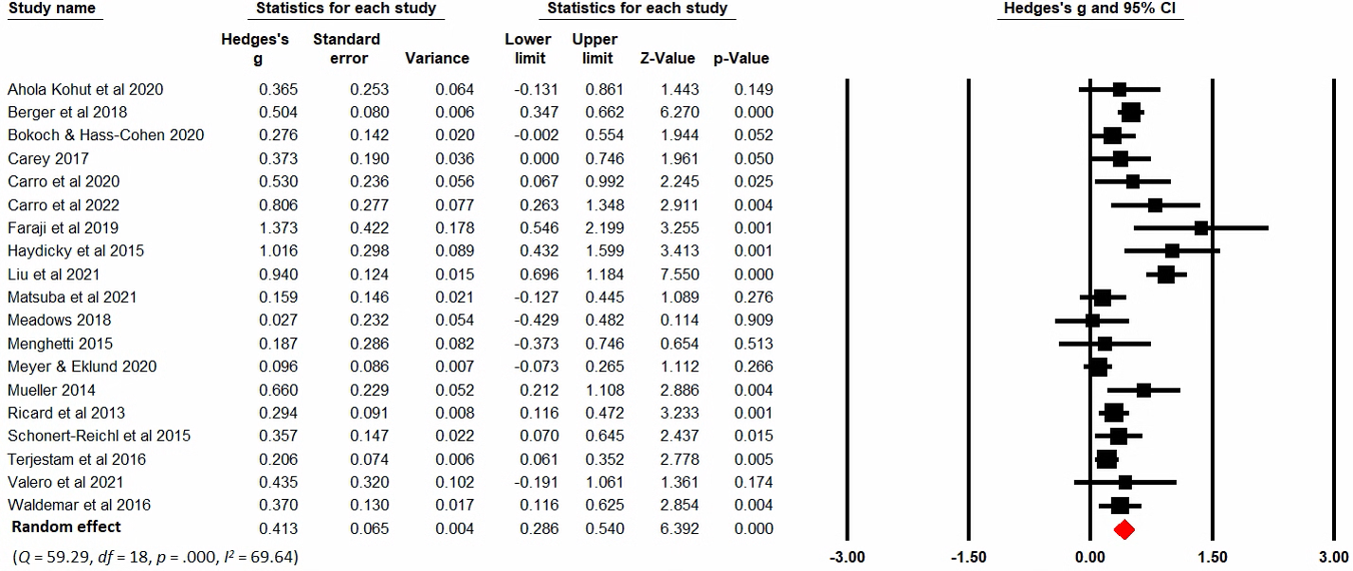

(b) Between-group effect sizes (k = 14, excluding Faraji et al., 2019)
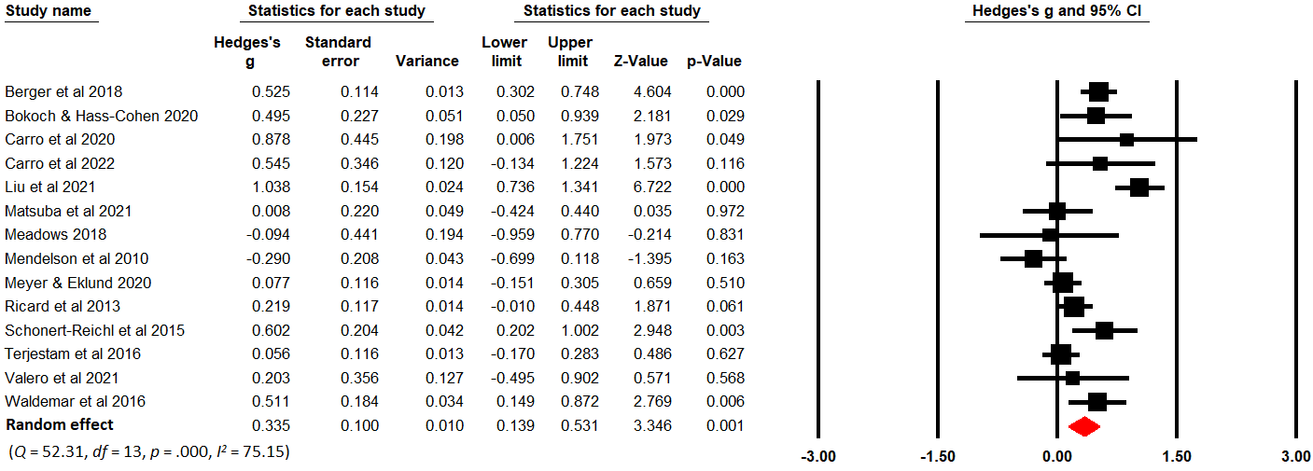
Note. ªStudies with effect sizes 3 standard deviations above or below the mean were identified as outliers.

Sensitivity Analysis: Moderator Analyses of Within-Group Intervention Effect with Outliers Removed (k = 18, excluding Anand & Sharma, 2014 and Faraji et al., 2019)
 | Peer Relationship
Study Characteristics | k | Hedge’s g (95% CI) | Q_{b} | df | p
Participant age
School-age children (6-12 years) | 9 | 0.39 (0.25, 0.53)*** | 4.82 | 2 | 0.09+
Adolescents (13-18 years) | 6 | 0.48 (0.17, 0.80)**
Mixed | 3 | 0.20 (0.07, 0.34)**
Participant gender
Predominantly female (female >= 50%) | 8 | 0.46 (0.22, 0.70)*** | 1.43 | 1 | 0.23
Predominantly male (female < 50%) | 9 | 0.30 (0.20, 0.40)***
Participant pre-existing condition
Predominantly clinical/at-risk | 6 | 0.35 (0.19, 0.51)*** | 0.20 | 1 | 0.65
None/Not mentioned | 12 | 0.40 (0.24, 0.56)***
Type of mindfulness intervention
Manualized mindfulness-based program | 12 | 0.39 (0.21, 0.57)*** | 0.03 | 1 | 0.86
General mindfulness practice | 6 | 0.37 (0.22, 0.51)***
Any adaptation of intervention program^{b}
Yes | 13 | 0.42 (0.26, 0.57)*** | 0.50 | 1 | 0.48
No | 5 | 0.32 (0.13, 0.52)**
Other activities involved in intervention
Yes | 12 | 0.35 (0.26, 0.44)*** | 0.35 | 1 | 0.55
No | 6 | 0.47 (0.08, 0.85)*
Dosage
Low | 5 | 0.25 (0.12, 0.38)*** | 3.84 | 2 | 0.15
Medium | 7 | 0.47 (0.18, 0.75)**
High | 6 | 0.42 (0.27, 0.57)***
Facilitator
Non-teaching personnel only^{c} | 9 | 0.43 (0.22, 0.65)*** | 18.20 | 2 | 0.0001***
Schoolteacher only | 4 | 0.18 (0.09, 0.28)***
Mixed | 5 | 0.52 (0.39, 0.65)***
Intervention target
Children only | 14 | 0.38 (0.24, 0.52)*** | 0.24 | 1 | 0.62
Children & others (parents/teachers) | 4 | 0.46 (0.16, 0.77)**
Group setting
Classroom-based intervention | 12 | 0.40 (0.24, 0.56)*** | 0.20 | 1 | 0.65
Group-based intervention | 6 | 0.35 (0.19, 0.51)***
Study design
Controlled studies | 13 | 0.37 (0.23, 0.51)*** | 0.84 | 1 | 0.36
Non-controlled studies | 5 | 0.50 (0.25, 0.75)***
+ p < .1, * p < .05, ** p < .01, *** p < .001.
Supplemental Figure 3
Sensitivity Analysis: Within-Group Effect Sizes Assuming Pre-Post Correlations = 0.7
(a) All peer relationship outcomes (k = 20)
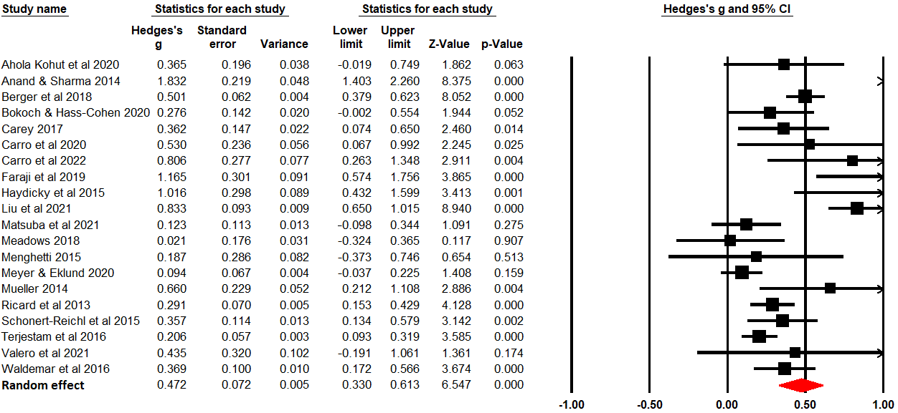
(b) Negative peer interactions (k = 14)
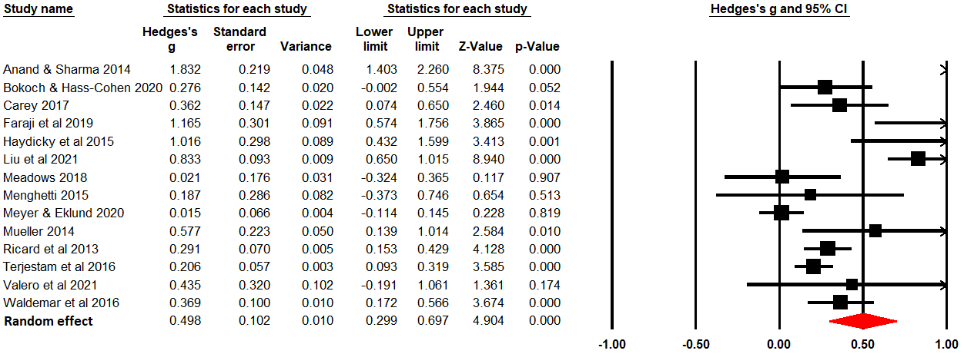
(c) Positive peer interactions (k = 8)
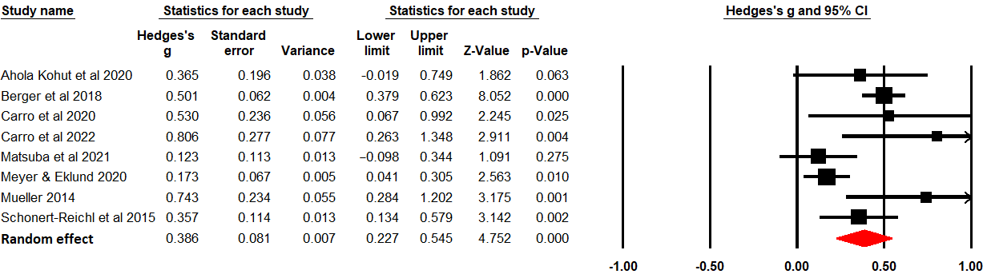

Sensitivity Analysis: Within-Group Effect Sizes Assuming Pre-Post Correlations = 0.9
(a) All peer relationship outcomes (k = 20)
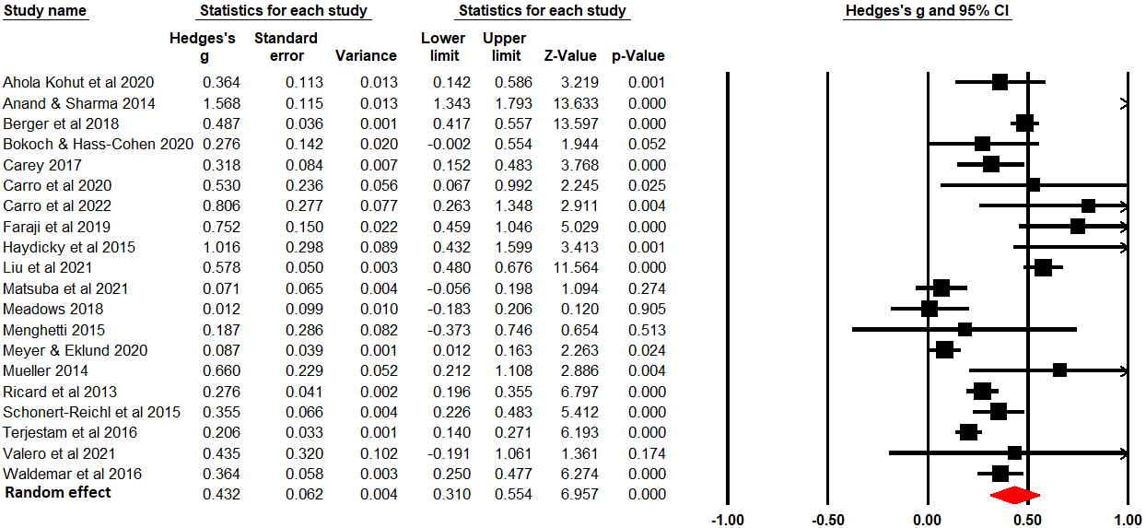
(b) Negative peer interactions (k = 14)
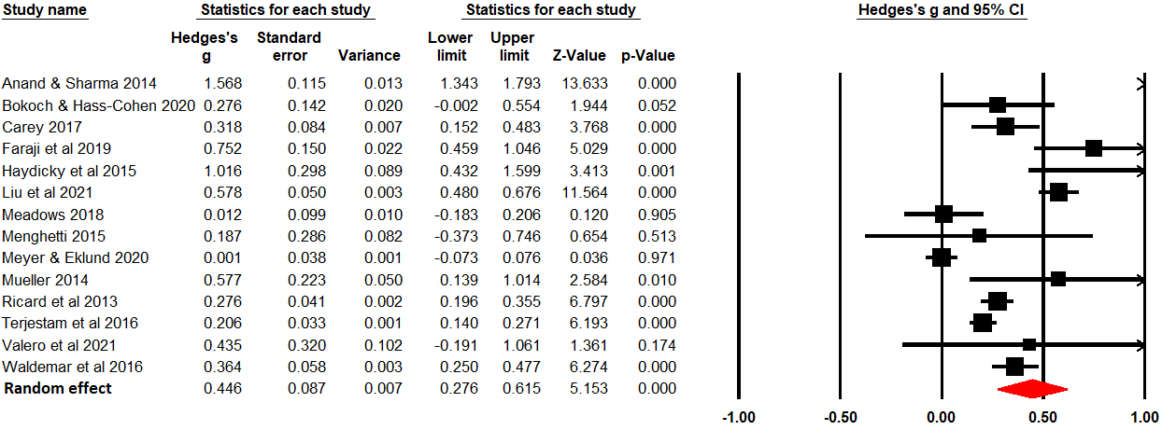
(c) Positive peer interactions (k = 8)
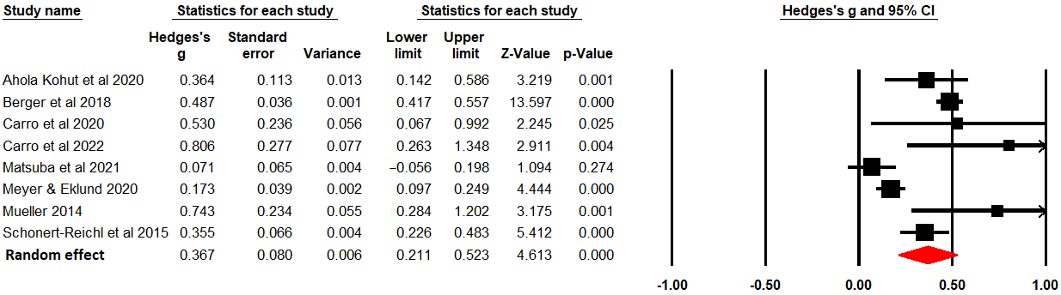

Supplemental Figure 4
Funnel Plots of Standard Error by Effect Sizes on All Peer Relationship Outcomes
(a) Within-group effect sizes (k = 20)
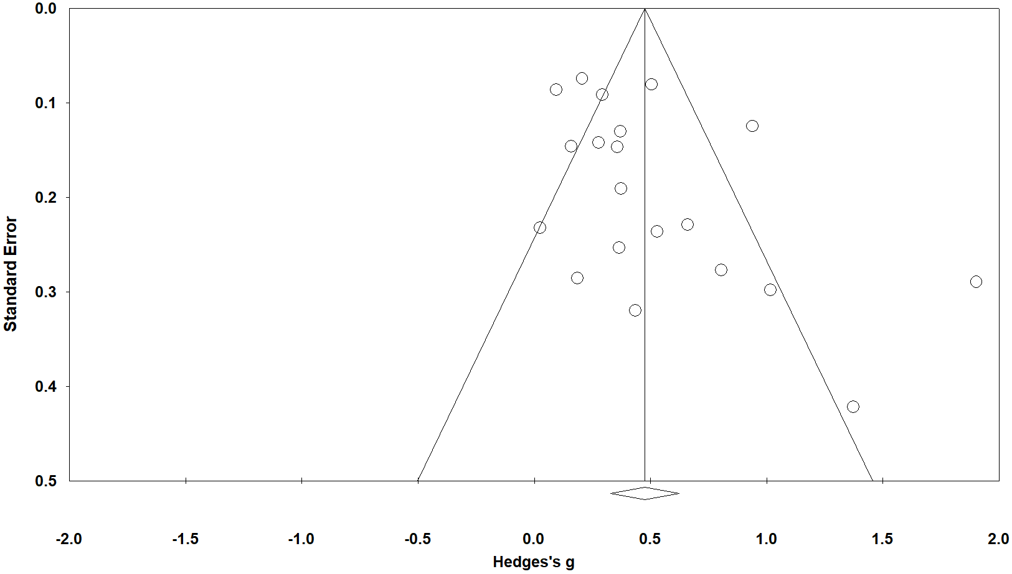
(b) Between-group effect sizes (k = 15)
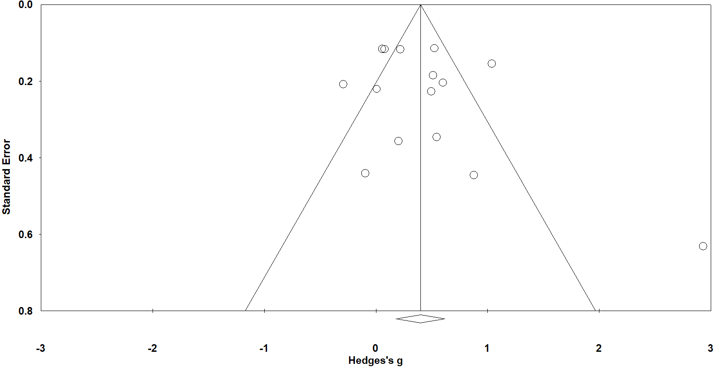

Note. Each circle represents an included study; the diamond represents the overall random effect size of all included studies on peer relationship outcomes. The x-axis represents the mean result (Hedge’s g), and the y-axis represents study precision (standard errors of the effect estimates). Studies with smaller standard errors or larger sample sizes appear toward the top.

Supplemental Figure 5
Publication Bias Assessed by Trim and Fill Analysis
(a) Between-group effect sizes (assuming missing studies were to the left of the mean)
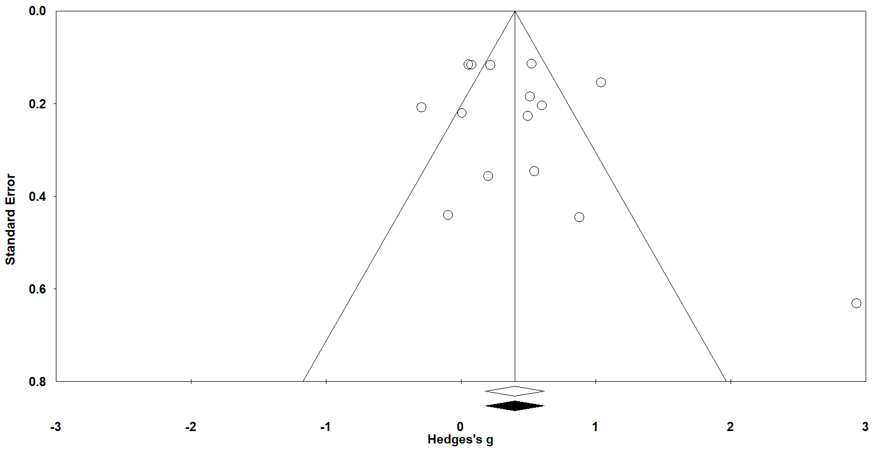
(b) Between-group effect sizes (assuming missing studies were to the right of the mean)
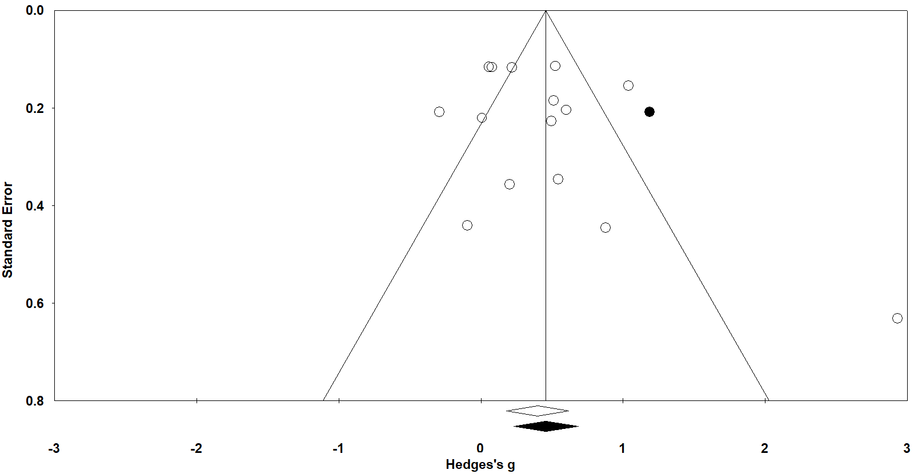
Note. The funnel plots present random-effects model results. The white dots represent actual effect sizes observed in the studies; the black dots represent imputed studies assuming there was potential estimation bias. The white diamond represents actual effect size based on our meta-analysis; the black diamond represents adjusted effect size based on Trim and Fill analysis. In Figure (a), when assuming there were missing studies to the left of the mean, no missing study was identified; the average effect size remained the same with our main analysis. In Figure (b), when assuming there were missing studies to the right of the mean, one missing study was identified; the imputed average effect size was g = 0.46, 95% CI [0.23, 0.69]. Given that no potential missing studies were identified for the within-group effect size, only between-group effect size is presented here.

Supplemental Figure 6
Meta-Regression Result of Within-Group Effect Sizes on Intervention Dosage (Total Minutes)
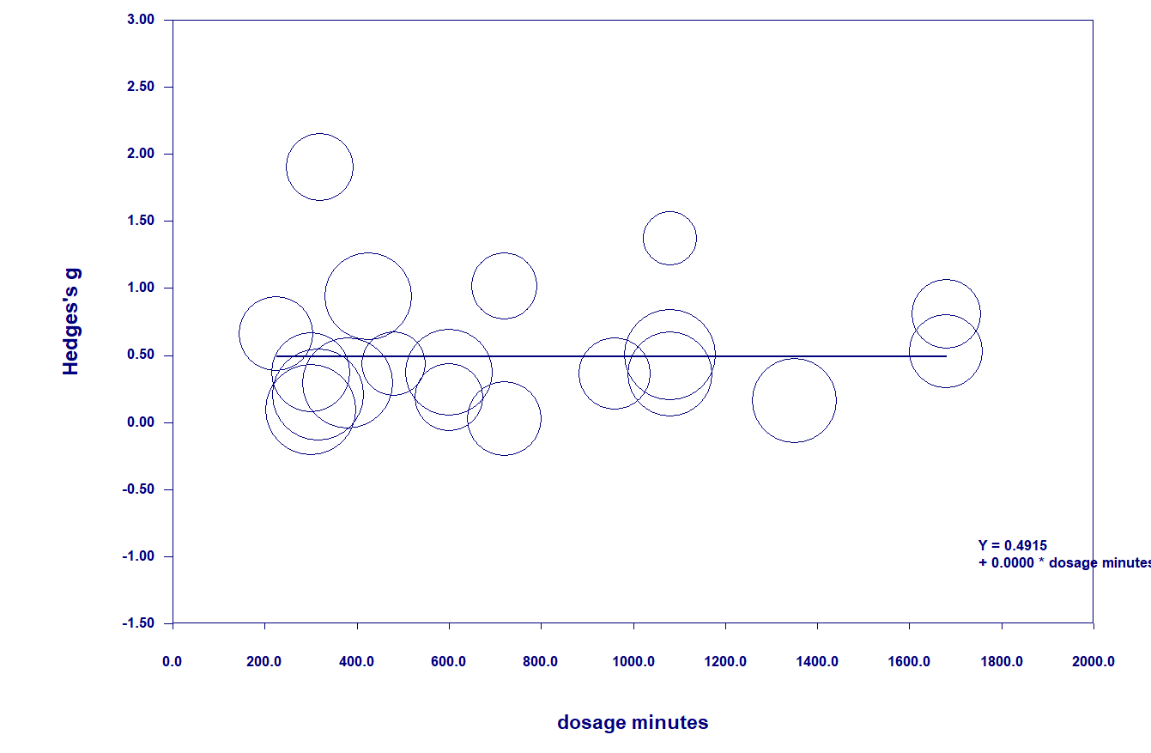
Note. This figure presents a meta-regression result with dosage (total intervention minutes) as a continuous variable. The scatter plot showed that dosage was not associated with the overall effect size (regression β = 0.00, p = .98).

