Supplementary Information
Table 5 Regression analyses for primary and secondary outcomes (ITT sample)
 | Beta | SE | t | 95% CI | p
Mindfulness (FMI)
Intercept | -0.59 | 0.08 | -7.64 | -0.74; -0.44 | <0.001
Group | 1.18 | 0.11 | 10.84 | 0.96; 1.40 | <0.001
Baseline FMI | 0.49 | 0.06 | 9.05 | 0.39; 0.60 | <0.001
Mental quality of life (SF12-MCS)
Intercept | -0.35 | 0.10 | -3.52 | -0.54; -0.15 | 0.001
Group | 0.70 | 0.14 | 4.96 | 0.42; 0.98 | <0.001
Baseline SF12-MCS | 0.46 | 0.07 | 6.54 | 0.322; 0.60 | <0.001
Physical quality of life (SF12-PCS)
Intercept | -0.01 | 0.10 | -0.10 | -0.21; 0.19 | 0.921
Group | 0.02 | 0.14 | 0.14 | -0.26; 0.30 | 0.888
Baseline SF12-PCS | 0.50 | 0.72 | 6.92 | 0.36; 0.64 | <0.001
*Depressive symptoms (PHQ-9)
Intercept | 0.37 | 0.08 | 4.34 | -0.73; -0.37 | <0.001
Group | -0.75 | 0.12 | -6.24 | 0.85; 1.37 | <0.001
Baseline PHQ-9 | 0.67 | 0.08 | 7.91 | -0.48; -0.08 | <0.001
Group x Baseline PHQ-9 | -0.25 | 0.12 | -2.06 | -0.23; 0.37 | 0.041
*Anxiety symptoms (GAD-7)
Intercept | 0.25 | 0.10 | 2.51 | 0.05; 0.44 | 0.013
Group | -0.49 | 0.14 | -3.54 | -0.77; -0.22 | 0.001
Baseline GAD-7 | 0.62 | 0.10 | 6.50 | 0.43; 0.81 | <0.001
Group x Baseline GAD-7 | -0.38 | 0.14 | -2.72 | -0.66; -0.10 | 0.007
*Stress (PSQ-20)
Intercept | 0.48 | 0.08 | 6.04 | 0.33; 0.64 | <0.001
Group | -0.94 | 0.11 | -8.28 | -1.17; -0.72 | <0.001
Baseline PSQ-20 | 0.75 | 0.08 | 9.37 | 0.59; 0.91 | <0.001
Group x Baseline PSQ-20 | -0.35 | 0.11 | -3.11 | -0.58; -0.13 | 0.002
Note. SE: standard error; CI: Confidence interval; FMI: Freiburg Mindfulness Inventory; PHQ-9: Patient Health Questionnaire-9; Generalized Anxiety Disorder-7; PSQ-20: Perceived Stress Questionnaire-20; SF12-PCS: Short Form Health Survey-12 Physical Component Scale; SF12-MCS: SF12 Mental Component Scale.
*Interactions were added to the regression models due to heterogeneity of regression slopes.

Table 6 Moderation analyses for intervention effectiveness on mindfulness at t1 (ITT sample)
Moderator | Beta | SE ª | t | 95% CI | p
Baseline Mindfulness (FMI)
Intercept | -0.59 | 0.07 | -8.70 | -0.72; -0.46 | <0.001
Group | 1.18 | 0.11 | 10.87 | 0.97; 1.39 | <0.001
Moderator | 0.56 | 0.09 | 6.59 | 0.41; 0.73 | <0.001
Group x Moderator | -0.14 | 0.13 | -1.11 | -0.40; 0.11 | 0.267
Baseline Depression (PHQ-9)
Intercept | -0.58 | 0.07 | -8.36 | -0.72; -0.44 | <0.001
Group | 1.17 | 0.11 | 10.44 | 0.95; 1.39 | <0.001
Moderator | -0.14 | 0.09 | -1.57 | -0.31; -0.03 | 0.118
Group x Moderator | 0.09 | 0.16 | 0.57 | -0.23; 0.41 | 0.573
Baseline Anxiety (GAD-7)
Intercept | -0.57 | 0.07 | -8.58 | -0.72; -0.45 | <0.001
Group | 1.18 | 0.11 | 10.84 | 0.96; 1.39 | <0.001
Moderator | -0.12 | 0.08 | -1.58 | -0.27; -0.03 | 0.116
Group x Moderator | 0.14 | 0.12 | 1.19 | -0.09; 0.37 | 0.232
Baseline Stress (PSQ-20)
Intercept | -0.60 | 0.07 | -8.81 | -0.73; -0.46 | <0.001
Group | 1.19 | 0.11 | 10.86 | 0.97; 1.41 | <0.001
Moderator | -0.13 | 0.09 | -1.56 | -0.30; -0.04 | 0.120
Group x Moderator | 0.15 | 0.15 | 1.04 | -0.14; 0.37 | 0.402
Baseline Extraversion (BFI-E)
Intercept | -0.58 | 0.07 | -8.35 | -0.72; -0.45 | <0.001
Group | 1.18 | 0.11 | 10.69 | 0.96; 1.39 | <0.001
Moderator | 0.03 | 0.07 | 0.41 | -0.11; 0.17 | 0.681
Group x Moderator | 0.08 | 0.12 | 0.63 | -0.16; 0.32 | 0.528
Baseline Neuroticism (BFI-N)
Intercept | -0.59 | 0.07 | -8.46 | -0.74; -0.46 | <0.001
Group | 1.22 | 0.11 | 10.82 | 0.99; 1.44 | <0.001
Moderator | -0.08 | 0.08 | -0.95 | -0.23; -0.08 | 0.343
Group x Moderator | -0.08 | 0.13 | -0.67 | -0.33; 0.16 | 0.502
Baseline Openness (BFI-O)
Intercept | -0.59 | 0.07 | -9.03 | -0.72; -0.46 | <0.001
Group | 1.18 | 0.11 | 10.96 | 0.97; 1.39 | <0.001
Moderator | 0.17 | 0.06 | 2.87 | 0.05; 0.29 | 0.005
Group x Moderator | -0.24 | 0.10 | -2.39 | -0.44; -0.04 | 0.018*
Baseline Conscientiousness (BFI-C)
Intercept | -0.58 | 0.07 | -8.53 | -0.71; -0.44 | <0.001
Group | 1.16 | 0.11 | 10.66 | 0.95; 1.38 | <0.001
Moderator | 0.15 | 0.08 | 1.92 | -0.00; 0.30 | 0.057
Group x Moderator | -0.03 | 0.13 | -0.27 | -0.28; 0.21 | 0.786
Baseline Agreeableness (BFI-A)
Intercept | -0.59 | 0.07 | -8.58 | -0.72; -0.45 | <0.001
Group | 1.18 | 0.11 | 10.82 | 0.97; 1.40 | <0.001
Moderator | 0.07 | 0.07 | 1.11 | -0.57; 0.20 | 0.271
Group x Moderator | -0.05 | 0.11 | -0.46 | -0.26; 0.16 | 0.644
Attitudes towards IMI (APOI-total)
Intercept | -0.58 | 0.07 | -8.49 | -0.72; -0.45 | <0.001
Group | 1.17 | 0.11 | 10.76 | 0.96; 1.39 | <0.001
Moderator | 0.02 | 0.06 | 0.33 | -0.11; 0.15 | 0.738
Group x Moderator | 0.02 | 0.11 | 0.21 | -0.20; 0.25 | 0.836
Age
Intercept | -0.59 | 0.07 | -8.45 | -0.72; -0.45 | <0.001
Group | 1.18 | 0.11 | 10.63 | 0.96; 1.39 | <0.001
Moderator | -0.02 | 0.06 | -0.35 | -0.14; 0.09 | 0.728
Group x Moderator | -0.01 | 0.13 | -0.08 | -0.27; 0.25 | 0.936
Gender
Intercept | -0.54 | 0.08 | -7.19 | -0.69; -0.39 | <0.001
Group | 1.11 | 0.12 | 8.94 | 0.86; 1.35 | <0.001
Moderator | -0.21 | 0.19 | -1.09 | -0.58; 0.17 | 0.276
Group x Moderator | 0.38 | 0.26 | 1.45 | -0.14; 0.89 | 0.149
Marital Status
Intercept | -0.57 | 0.09 | -6.25 | -0.75; -0.39 | <0.001
Group | 1.14 | 0.15 | 7.79 | 0.85; 1.43 | <0.001
Moderator | -0.05 | 0.15 | -0.34 | -0.35; 0.25 | 0.738
Group x Moderator | 0.11 | 0.23 | 0.47 | -0.34; 0.56 | 0.636
Psychotherapy Experience
Intercept | -0.58 | 0.08 | -7.34 | -0.74; -0.43 | <0.001
Group | 1.27 | 0.12 | 10.92 | 1.04; 1.49 | <0.001
Moderator | -0.01 | 0.15 | -0.09 | -0.32; 0.29 | 0.927
Group x Moderator | -0.41 | 0.29 | -1.39 | -1.00; 0.17 | 0.167
Note. CI: Confidence interval; FMI: Freiburg Mindfulness Inventory; PHQ-9: Patient Health Questionnaire-9; Generalized Anxiety Disorder-7; PSQ-20: Perceived Stress Questionnaire-20; BFI: Big Five Inventory; BFI-E: BFI Extraversion; BFI-N: BFI Neuroticism; BFI-C: BFI Conscientiousness; BFI-A: BFI Agreeableness; BFI-O: BFI Openness for experiences; APOI total: Attitudes towards Psychological Online Interventions Questionnaire, total score.
All moderator analyses were controlled for baseline mindfulness values.
ª SE: Heteroscedasticity consistent standard error
* significant moderation effect

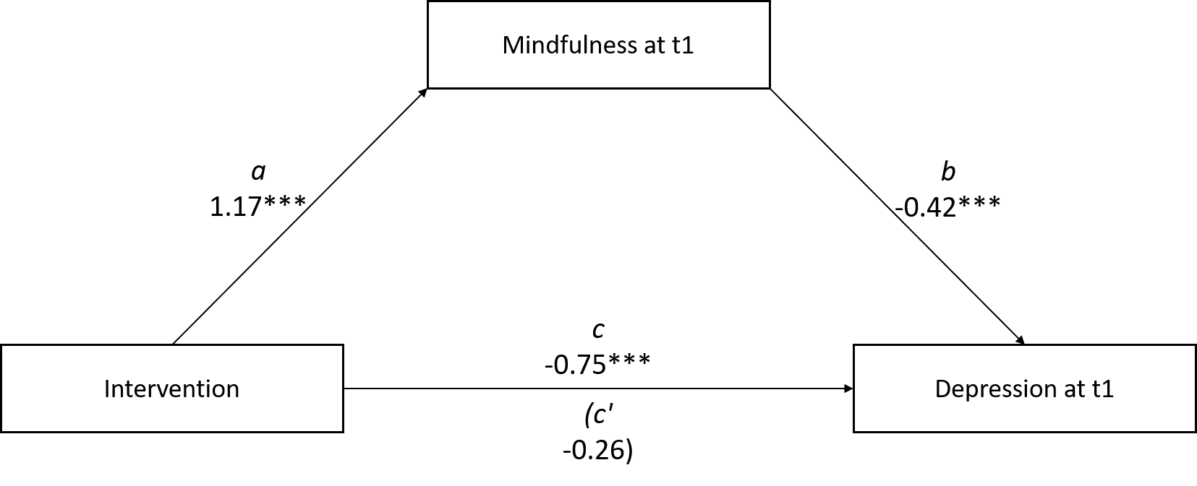

a) Outcome Variable: Depression (PHQ-9) at t1

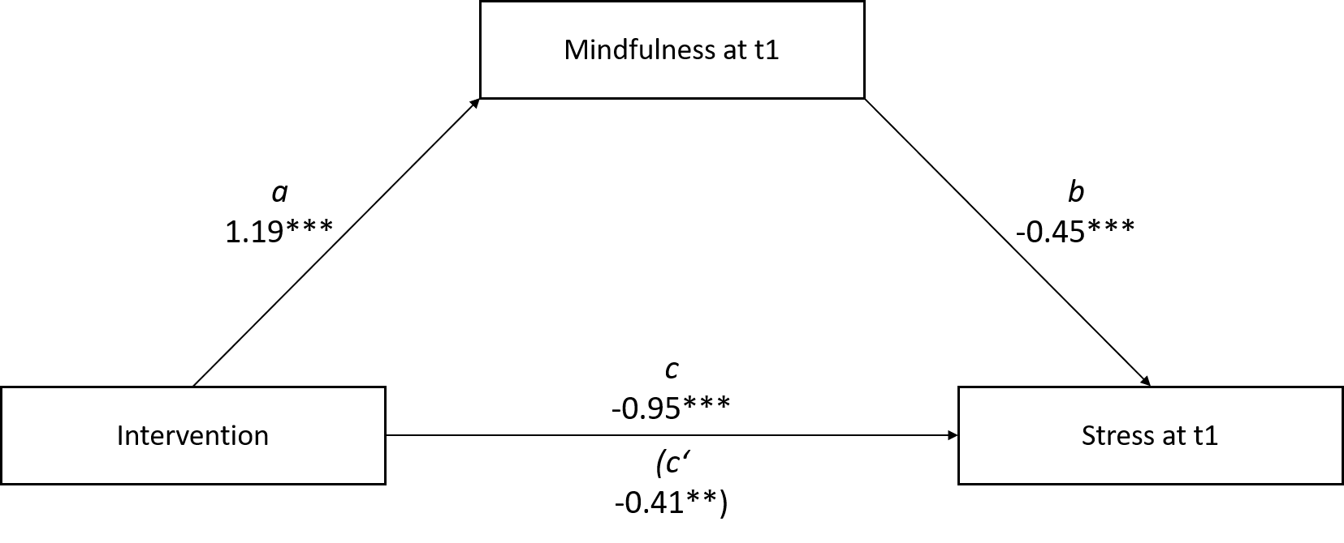
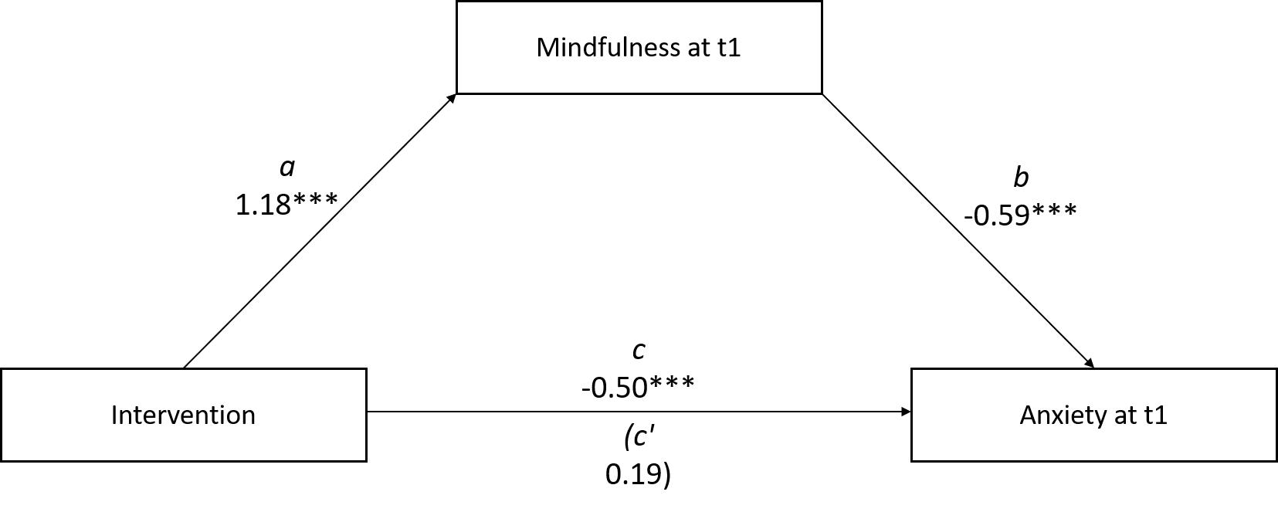
Figure 2. Note. *p < .05. **p < .01. ***p < 0.001
The paths of each model are controlled for the covariates baseline value of mindfulness and the respective outcome variable.

c) Outcome Variable: Stress (PSQ-20) at t1

b) Outcome Variable: Anxiety (GAD-7) at t1

