Supplementary information
Supplementary Figure 1. Boxplots of behavioural results across treatment groups (baseline vs follow up sessions). NOTE: Boxplots marked with red squares represent statistically significant paired t-test following multiple comparisons correction (alpha = 0.05).

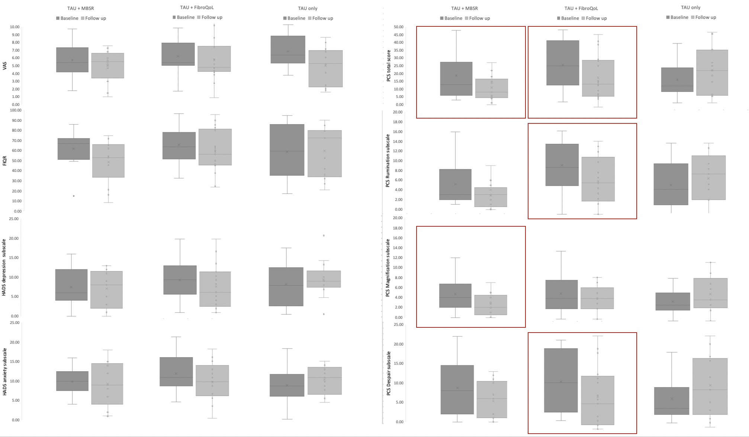
Supplementary Figure 2. Information on treatment as usual across patients in each treatment arm
 |  | MBSR+TAU | FIbroQoL+TAU | TAU only
Anti-inflammatory (%) | 30.8 |  | 11.1 | 15.4
Opioids (%) | 23.1 |  | 38.9 | 30.8
Antiepileptic (%) | 15.4 |  | 16.7 | 15.4
Muscle relaxant (%) | 0 |  | 5.6 | 0
Antidepressants (%) | 46.2 |  | 50.0 | 46.2
Anxiolytics (%) | 15.4 |  | 44.4 | 46.2

