Supplementary materials:

Figure III: Paternal above or below threshold ADHD symptoms predicting fathers’ own ADHD symptoms outcome.

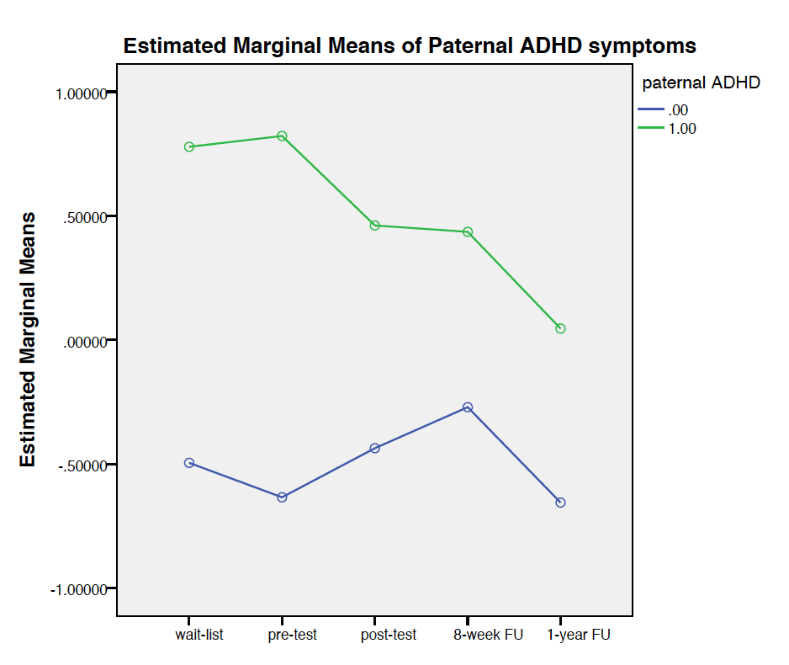
Figure IV: Maternal above or below threshold ADHD symptoms predicting mothers’ own ADHD symptoms outcome