Supplemental Materials
MBAT Curriculum
The MBAT program is similar to prior short-form MT formats created and successfully implemented in high-demand civilian cohorts (Morrison et al., 2014; Rooks, Morrison, Goolsarran, Rogers, & Jha, 2017). MBAT’s session structure is modeled on and informed by prior contextualized short-form MT offered to time-pressured groups (Rogers, 2009a; Rogers, 2009b). Its conceptual framework is informed by prior discussion of MT as cognitive training (Jha, Krompinger & Baime, 2007; Jha, 2013). And, its core practice exercises (i.e., concentration, body awareness, open monitoring, and connection) align with practices offered in a myriad of mindfulness-based interventions, such as Mindfulness-Based Stress Reduction (MBSR; Kabat-Zinn, 1990). MBAT was reviewed with an advisory team of mindfulness experts and military leaders who offered guidance and suggestions on the training materials.
MBAT comprises four central themes delivered over 4, 2-hour sessions over 4 weeks. The concentration theme introduces participants to mindfulness “basics,” including discussion of mind wandering and the science of mindfulness. The body awareness theme involves cultivation of greater self-awareness, the development of equanimity, and learning to distinguish “(over)-reactions” from “responses.” The open monitoring theme leads to the further development of self-regulation skills through awareness of unpleasant experiences and moments of uncertainty. The theme of connection addresses adaptive and effective leadership and explores group cohesion and the cultivation of kindness/connection practices (see Rooks et al, 2017). These themes are communicated in a manner that is contextualized for active-duty Soldiers. To this end, training incorporates military terminology and cultural references, and examples relatable to those familiar with military life.
In addition to each week’s theme, corresponding mindfulness exercises were introduced during weekly training sessions. The guided concentration sitting exercise instructs participants to focus on the breath, notice mind wandering and return attention to the breath following distraction. The guided body scan involves noticing sensations in certain parts of the body with a nonjudgmental stance while attending to the pleasantness, unpleasantness, or neutrality of the sensation without making any adjustments in response. The open monitoring exercise involves expanding the field of awareness beyond the breath and noticing the rising, changing, and passing away of other sensory and mental phenomena (e.g., sounds, body sensations, thoughts). The connection exercise guides participants to engage in expressions of kindness and interpersonal connection directed to the self and others.
MBAT Practicum
The PEs (n = 8) completed a training practicum developed and delivered by a master MT trainer with extensive experience developing and offering MT programs for a wide variety of populations. The formal MBAT training practicum comprised a foundational training and a basic teacher training. In addition, an auxiliary training period was necessary between the end of the formal training practicum and the launch of MBAT course delivery to Soldiers.
Foundational Training
PEs experienced the 4-week foundational training as trainees. This foundational training was designed to be in line with well-established guidelines recommending participation in an introductory mindfulness course emphasizing the personal engagement in mindfulness exercises and cultivation of mindfulness skills before learning how to deliver a mindfulness-based program (Crane, Kuyken, Hashtings, Rothwell & Williams, 2010). The core practices and themes of the MBAT foundational course for PEs were nearly identical to those in the MBAT course for Soldiers. However, since the trainers were not Soldiers themselves, the course was not contextualized for active-duty military and instead incorporated discussion and examples relating to typical civilian life. The training materials, however, were specifically designed so that the PEs subsequent introduction to the contextualized format would resemble, in large measure, the 4-week MBAT course materials and hence facilitate a time-efficient and heavily scaffolded transition to the basic teacher training course to prepare for the delivery of MBAT. Furthermore, the foundational training for PEs included additional time spent engaging in discussion and practicing as a group. As such, it included more hours compared to the 4-week, 8-hour MBAT course for soldiers.
During the foundational training, PEs participated in in-person sessions and 4 hr of remote sessions. The in-person sessions occurred at the University of Miami over two consecutive days for two of the course weeks (week 1 = 11 hr; week 3 = 15 hr). The remote sessions occurred via remote video chat applications (e.g., Skype; https://www.skype.com/en/) twice weekly for the two other weeks of the foundation course (week 2 = 2 hr and week 4 = 2 hr); one remote session per week was in a group setting (1 hr), and the other session was in a one-on-one meeting with the master MT trainer (1 hr). Thus, the foundation course involved live training with a master trainer for 30 hr over 4 weeks.
During these live sessions with the master MT trainer, the PEs learned and practiced a series of mindfulness exercises (see Supplemental Figure S1). After being guided through and discussing these exercises during each session, PEs were assigned to complete the corresponding exercises as individual out-of-class practice at least for 15 mininutes four times per week. They were also assigned to complete at least 30 minutes of group practice each week. The assigned mindfulness practices were guided by recordings, which were prepared by the master MT trainer and were consistent with the exercises assigned to the Soldiers during the MBAT course.
Because the ME was already familiar with mindfulness practices, concepts, and skills and had an established daily MT practice, the ME trainer did not participate in the foundational training.
Basic Teacher Training
Basic teacher training was intended to specifically prepare trainers for the successful delivery of the MBAT Soldier program. Again, this is in line with established MBP guidelines (see Crane et al., 2010). For the PE trainers, this training consisted of a 2-day (16 hr), in-person teaching course, and assigned personal and group mindfulness practice for 8 weeks. The purpose of the 2-day session was to provide trainers with the basic skills for delivering MBAT to groups of active-duty soldiers. Seventy-five percent of the in-person portion of the basic teacher training was spent focused on refining their knowledge of core mindfulness concepts and building the skills needed to lead a mindfulness course. This involved leading mindfulness exercises, guiding discussion, and brief periods of lecturing on the didactic material to each other and mock participants in a group setting. For the remaining 25% of the time, the master trainer facilitated group discussions with all the PEs to reflect on how the MBAT material could specifically be related to the experiences and challenges that PEs had encountered during their prior interactions of Soldiers delivering mental skills training. For the entirety of the basic teacher training phase of the practicum, PEs were instructed to complete individual out-of-class homework practice for at least 15-20 minutes five times per week as well as group practice of at least 30 minutes per week. The recordings with the mindfulness exercises were the same as those used in the foundational training.
The ME trainer also received training in the MBAT Soldier materials and worked directly with the master trainer to familiarize himself with the program. In addition, he led MBAT mindfulness exercises, guided discussion, and engaged in brief periods of lecturing to mock participants in a group setting.
Auxiliary Training
After the formal 12-week MBAT training practicum, due to unforeseen delays in the availability of Soldiers at the collaborating military installation, a 6-week auxiliary training period was employed to maintain trainer readiness for MBAT delivery to Soldiers. The auxiliary training consisting of a 2-day booster training and continued personal mindfulness practice over 6 weeks.
The booster training included reinforcement of MBAT course content and practice delivering didactic material, guiding mindfulness exercises, leading discussions, and group discussion on preparing to deliver the material to soldiers.
Given that the ME already had an established daily mindfulness practice, no formal requirements to practice were provided to the ME, but he was encouraged to continue with his daily practice. In addition, the ME joined the PEs for a portion of the in-person discussions over the 2-day booster training. These discussions were regarding contextualization to facilitate his understanding of the Soldier context.
Supplemental Results
We performed a series of additional analyses to (1) check that excluding observations as performance outliers did not unduly influence our results, and (2) examine whether reported changes were consistent across the two PE subgroups (PE₁ & PE₂) for both the SART and WMDA tasks. In addition, response times were examined during the SART.
Sustained Attention to Response Task (SART)
Analyses with no Exclusions. In our main analyses, observations representing performance outliers as well as data from participants who did not comply with proper task instructions were excluded so as not to unduly influence our results. Accordingly, our main analyses included participant data in which it can be reasonably assumed that individuals understood the task instructions and provided motivated effort towards appropriately completing the cognitive tasks, as instructed. Nevertheless, to provide a more complete picture of our results, analyses of all data, inclusive of previously excluded observations is provided here. When all available data (Participants n = 180; Obs. n = 494) were retained, the interaction between time and group for SART A′ remained significant, F(4, 308) = 3.90, p = .004. This interaction indicated that the PE group declined significantly less from T1 to T2 (b = 0.116, p < .001, 95% CI [0.052, 0.179]) compared to the NTC group, and directionally but not significantly compared to the ME group (b = 0.050, p = .118, 95% CI [-0.013, 0.113]). These results are in line with benefits reported for the PE group relative the NTC in our main analyses in which we excluded participants as outliers.
Analyses separating PE groups (PE₁ & PE₂). Comparisons among all four groups (NTC, ME, PE₁, and PE₂ groups) revealed a significant effect of time, F(2, 227) = 35.20, p < .001, no significant effect of group, F(3, 171) = 2.33, p = .076, and a significant interaction of time and group, F(6, 227) = 2.84, p = .011. At the onset of the study (T1), the ME (b = -0.019, p = .510, 95% CI [-0.076, 0.038]), PE₁ (b = -0.040, p = .162, 95% CI [-0.096, 0.016]), and PE₂ groups (b = -0.008, p = .787, 95% CI [-0.064, 0.049]), did not significantly differ from the NTC group. The PE₁ group did not significantly decline in A′ from T1 to T2 (b = -0.030, p = .111, 95% CI [-0.067, 0.007]), but declined from T1 to T3 (b = -0.109, p < .001, 95% CI [-0.147, -0.070]). Similarly, the PE₂ group did not significantly decline in A′ from T1 to T2 (b = -0.023, p = .245, 95% CI [-0.063, 0.016]), and did not significantly decline from T1 to T3 (b = -0.038, p = .080, 95% CI [-0.081, 0.005]). Both PE groups thus showed similar patterns of change from T1 to T2. However, the PE₂ group appeared to decline less from T1 to the end of the study duration (T3).
Compared to the NTC group, the PE₁ group declined significantly less from T1 to T2 (b = 0.073, p = .016, 95% CI [0.014, 0.132]), but did not significantly differ from T1 to (b = -0.010, p = .733, 95% CI [-0.069, 0.049]). Compared to the ME group, the PE₁ group did not change significantly different from T1 to T2 (b = 0.052, p = .063, 95% CI [-0.003, 0.107]), and did not change differently from T1 to T3 (b = -0.015, p = .612, 95% CI [-0.072, 0.042]). Compared to the NTC group, the PE₂ group they declined significantly less from T1 to T2 (b = 0.080, p = .011, 95% CI [0.019, 0.141]), but did not change differently from T1 to T3 (b = 0.061, p = .052, 95% CI [-0.001, 0.123]). Compared to the ME group, the PE₂ group declined significantly less from T1 to T2 (b = 0.059, p = .043, 95% CI [-0.003, 0.107]), but did not change differently from T1 to T3 (b = 0.057, p = .062, 95% CI [-0.003, 0.116]). Finally, the PE₂ group declined significantly less from T1 to T3 compared to the PE₁ group (b = 0.071, p = .016, 95% CI [0.013, 0.129]). Model estimated change in A′ is depicted in Supplemental Figure S2 for separate groups.
Analyses of Response times (msec). In addition, we examined whether reported change in SART A′ was likely to have resulted from systematic differences in mean response times. Mean non-target response times, however, did not change over time, F(2, 229) = 0.58, p = .558 or differ among groups, F(2, 172) = 1.75, p = .177, and there was no significant interaction of time and group, F(4, 229) = 1.90, p = .111. Thus, it is unlikely that group differences in mean response time systematically contributed to changes in SART performance over time.

Working Memory Delayed-Recognition Task with Affective Distracters
Analyses with no Exclusions. When all available data (Participants n = 180; Obs. n = 1970) were retained, the interaction between time and group remained significant, F(4, 307) = 10.77, p < .001. This interaction indicated that the PE group declined significantly less from T1 to T3 (b = 4.020, p = .013, 95% CI [0.863, 7.178]) compared to the NTC group, and compared to the ME group (b = 9.137, p < .001, 95% CI [5.795, 12.479]), in line with benefits reported for the PE group in our main analyses.
Analyses separating PE groups (PE₁ & PE₂). Comparisons among all four groups (NTC, ME, PE₁, and PE₂ groups) revealed a significant effect of time, F(2, 278) = 58.31, p < .001, a significant effect of group, F(3, 175) = 3.46, p = .018, and a significant interaction of time and group, F(6, 278) = 5.21, p < .001. Effects of load, affect, and the interaction between load and affect remained significant (all ps < .001).
At the onset of the study (T1), the ME (b = 0.378%, p = .853, 95% CI [-3.649, 4.404]), PE₁ (b = -1.439%, p = .472, 95% CI [-5.375, 2.497]), and PE₂ groups (b = 1.873%, p = .348, 95% CI [-2.052, 5.798]), did not significantly differ from the NTC group. The PE₁ group did not significantly decline in accuracy from T1 to T2 (b = -0.362%, p = .728, 95% CI [-2.408, 1.685]), but declined from T1 to T3 (b = -4.036%, p < .001, 95% CI [-6.187, -1.885]). The PE₂ group, however, significantly declined from T1 to T2 (b = -2.450%, p = .022, 95% CI [-4.548, -0.353]), and also declined from T1 to T3 (b = -4.128%, p < .001, 95% CI [-6.467, -1.788]).
Compared to the NTC group, the PE₁ group declined significantly less from T1 to T2 (b = 3.577%, p = .031, 95% CI [0.338, 6.816]), but did not change differently from T1 to T3 (b = 3.183%, p = .061, 95% CI [-0.147, 6.512]). Compared to the ME group, the PE₁ group declined significantly less from T1 to T2 (b = 8.082%, p < .001, 95% CI [4.776, 11.388]), and also declined significantly less from T1 to T3 (b = 6.806%, p < .001, 95% CI [3.392, 10.221]). Compared to the NTC group, the PE₂ group did not change differently from T1 to T2 (b = 1.488%, p = .371, 95% CI [-1.784, 4.759]), and did not change differently from T1 to T3 (b = 3.091%, p = .079, 95% CI [-0.364, 6.546]). Compared to the ME group, the PE₂ group declined significantly less from T1 to T2 (b = 5.993%, p < .001, 95% CI [2.655, 9.330]), and also declined significantly less from T1 to T3 (b = 6.715%, p < .001, 95% CI [3.178, 10.251]). Model estimated change in accuracy is depicted in Supplemental Figure S3 for separate groups.

Supplemental Figures
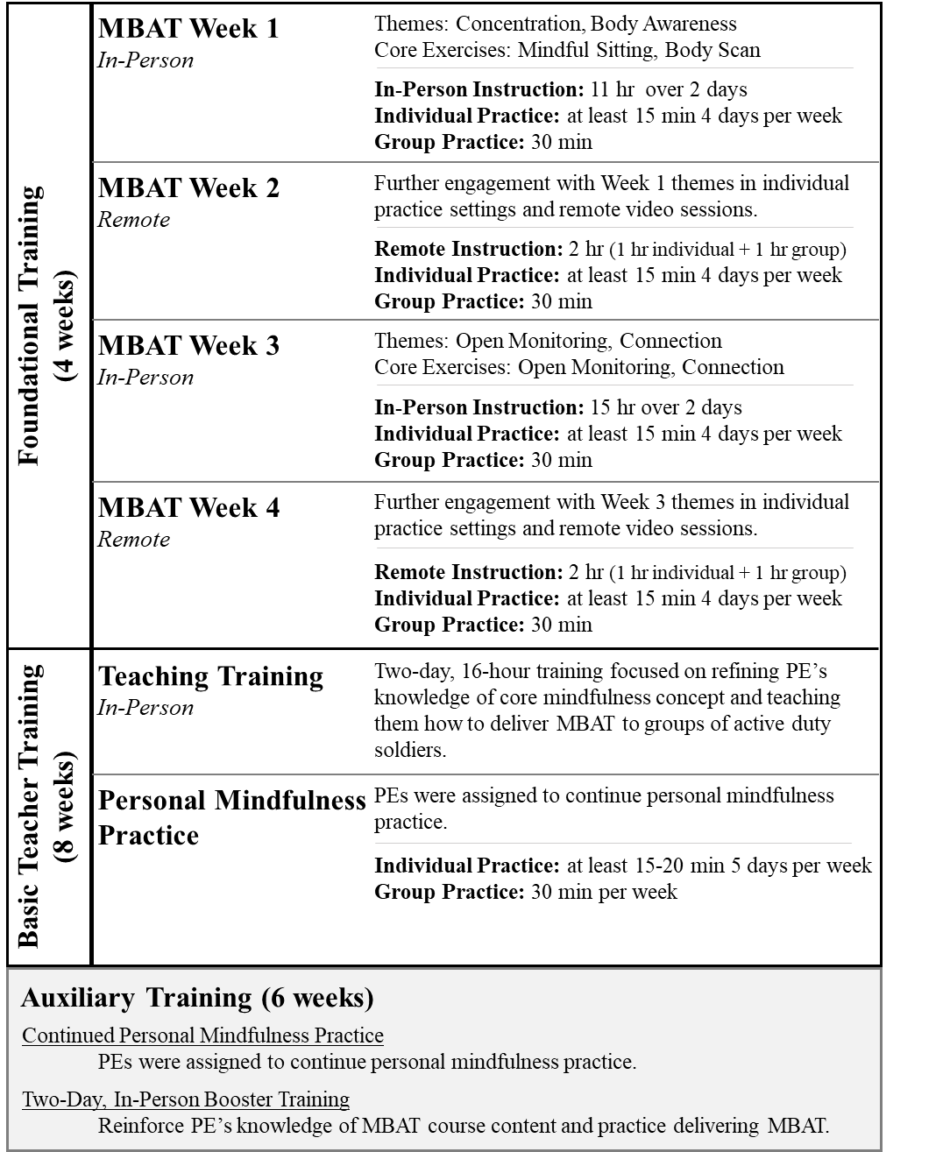
Figure S1: Overview of the 12-week formal training practicum offered to the PEs and the auxiliary training prior to delivering MBAT to active-duty cohorts.

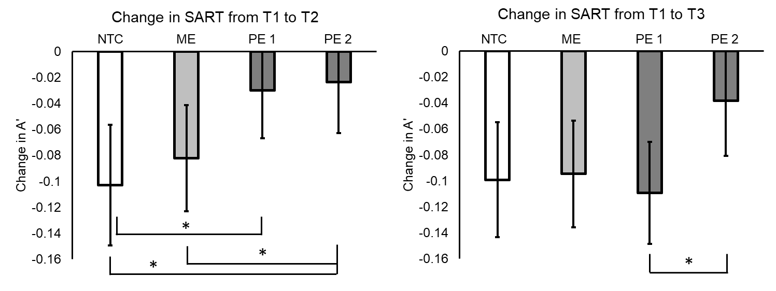
Figure S2: Parameter estimates derived from mixed-effects models depicting the change from T1 to T2 and change from T1 to T3 for the NTC, ME PE₁ and PE₂ groups for SART (A'). Error bars represent 95% confidence intervals surrounding the model estimated change. *p < .05, **p < .01, ***p < .001.

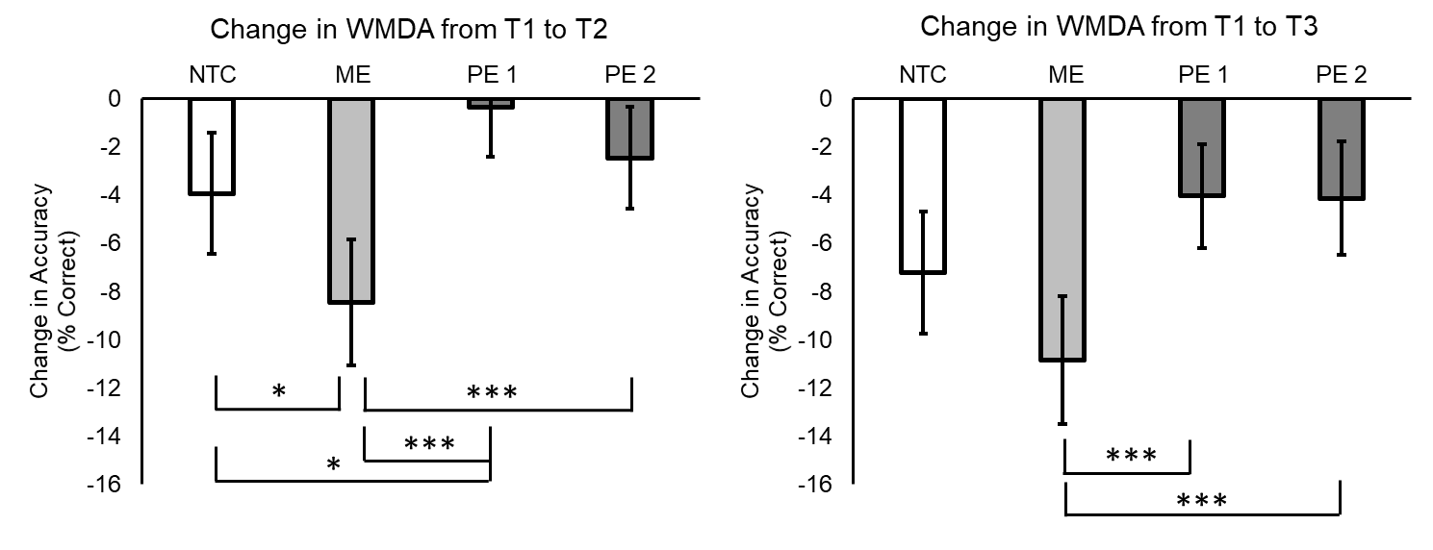
Figure S3: Parameter estimates derived from mixed-effects models depicting the change from T1 to T2 and change from T1 to T3 for the NTC, ME, PE₁, and PE₂ groups for WMDA accuracy (% correct). Error bars represent 95% confidence intervals surrounding the model estimated change. *p < .05, **p < .01, ***p < .001.

Supplemental Materials References
Crane, R., Kuyken, W., Hastings, R., Rothwell, N., & Williams, J. M. G. (2010). Training teachers to deliver mindfulness-based interventions: learning from the UK experience. Mindfulness, 3(1), 74-86. https://doi.org/10.1007/s12671-010-0010-9
Jha, A. P. (2013). Being in the now. Scientific American Mind, 24, 26-33. https://doi.org/10.1038/scientificamericanmind0313-26
Jha, A. P., Krompinger, J., & Baime, M. J. (2007). Mindfulness training modifies subsystems of attention. Cognitive Affective and Behavioral Neuroscience, 7(2), 109-119. https://doi.org/10.3758/CABN.7.2.109
Kabat-Zinn, J. (1990). Using the wisdom of your body and mind to face stress, pain, and illness. New York, NY: Dell Publishing.
Morrison, A. B., Goolsarran, M., Rogers, S. L., & Jha, A. P. (2014). Taming a wandering attention: Short-form mindfulness training in student cohorts. Frontiers in Human Neuroscience, 7(897), 1-12. https://doi.org/10.3389/fnhum.2013.00897
Rogers, S. L. (2009a). Mindfulness for law students: using the power of mindful awareness to achieve balance and success in law school. Miami Beach, FL: Mindful Living Press.
Rogers, S. L. (2009b). The six-minute solution: a mindfulness primer for lawyers. Miami Beach, FL: Mindful Living Press.
Rooks, J., Morrison, A. B., Goolsarran, M., Rogers, S. L., & Jha, A. P. (2017). “We are talking about practice”: The influence of mindfulness vs. relaxation training on athletes’ attention and well-being over high-demand intervals. Journal of Cognitive Enhancement, 1(2), 141-153. https://doi.org/10.1007/s41465-017-0016-5

