Supplementary Figure 1. Competing risk of death or heart transplantation in LVAD-BTT

Supplementary Figure 2 – Device dysfunction stratified by LVAD type
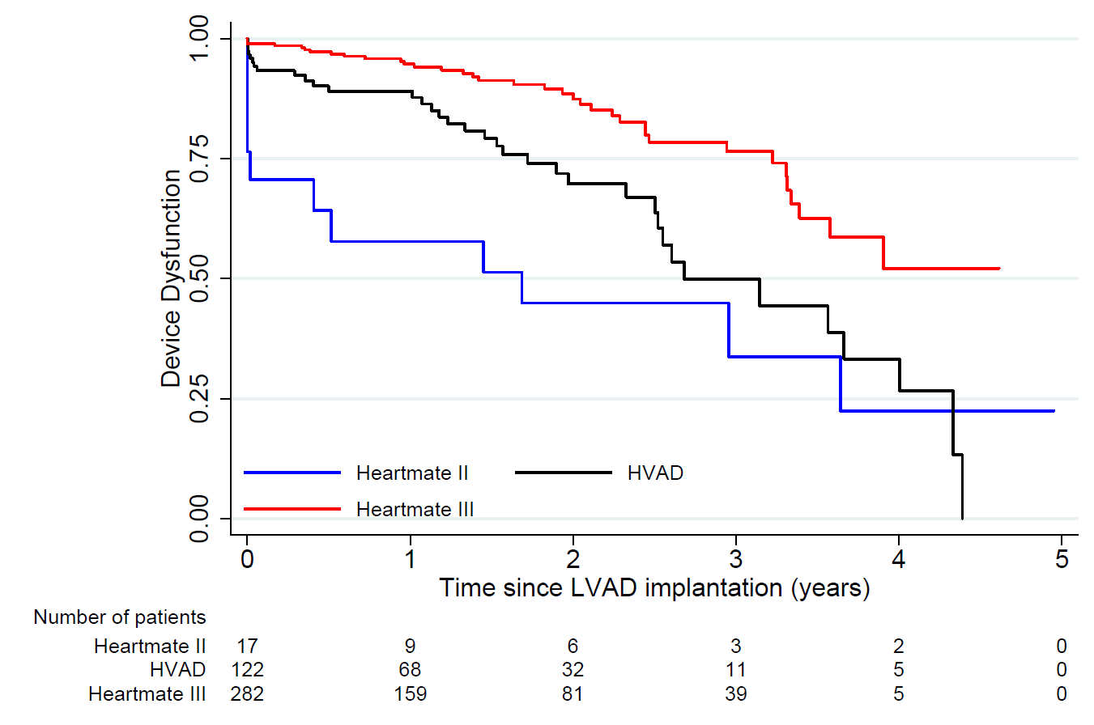

Supplementary Figure 3A – Cerebrovascular events stratified by LVAD type (overall)
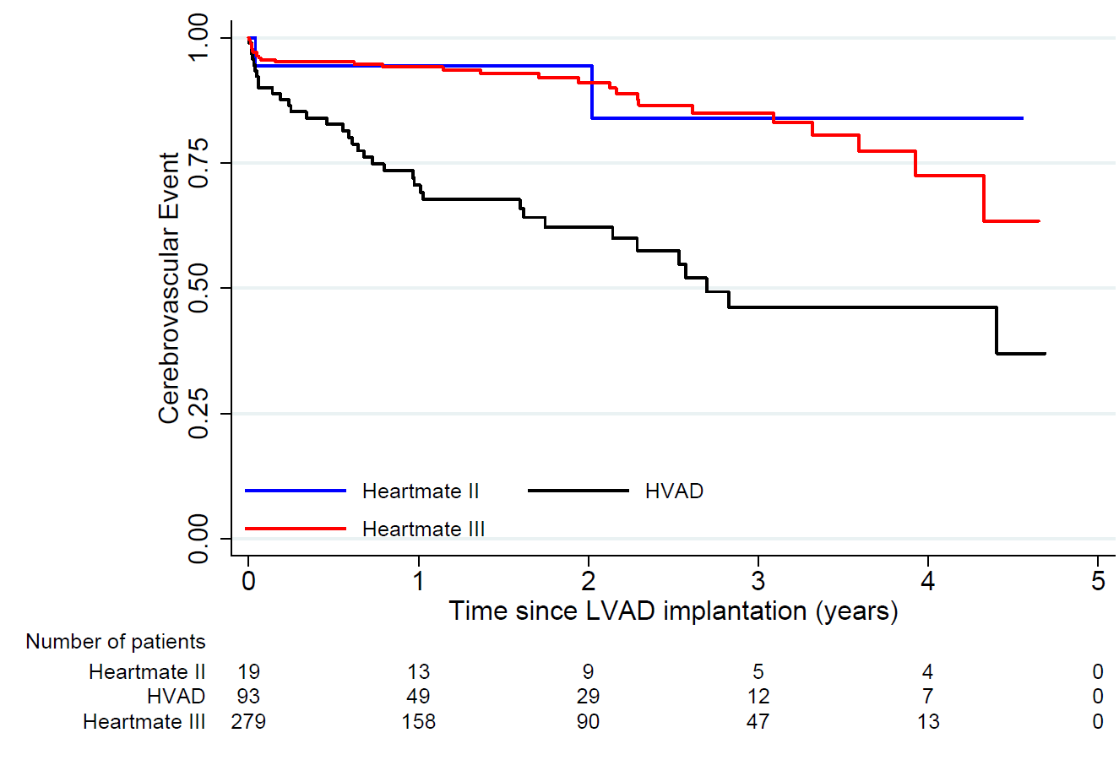
Supplementary Figure 3B – Cerebrovascular events stratified by LVAD type in BTT patients only
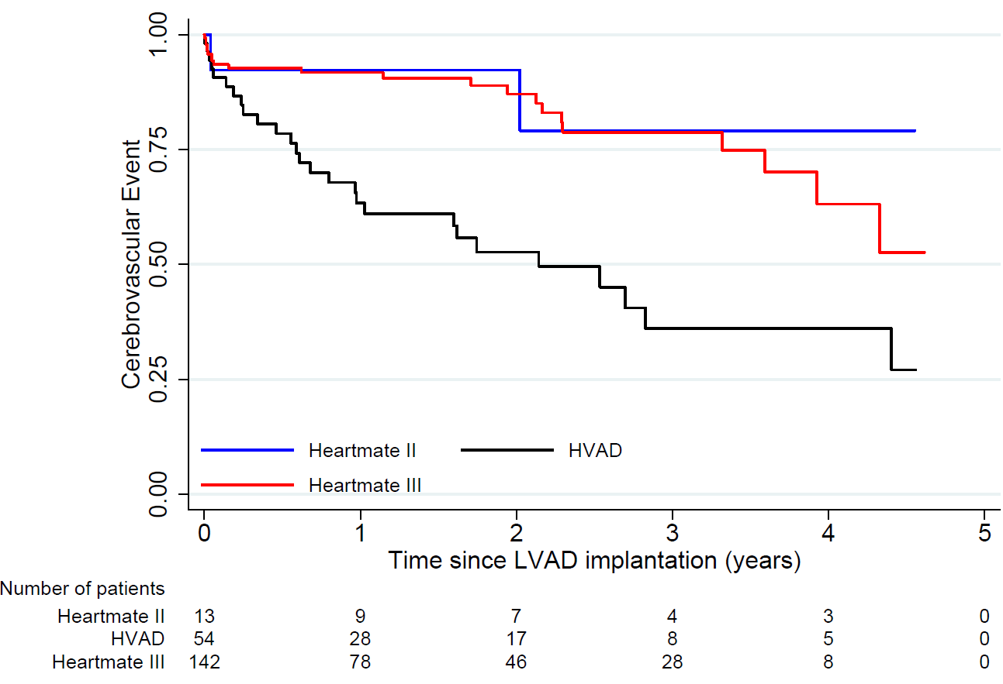

Supplementary Figure 4 – Incidence of Major Adverse Events
Major Adverse events: first occurence of either Major Bleeding, Major Infection, Cerebrovascular event and Device Dysfunction

