Supplementary material

Tables
Table S1. Search strategy and results in Ovid MEDLINE database.
1 | exp percutaneous coronary intervention/ | 48679
2 | exp acute coronary syndrome/ or exp unstable angina pectoris/ or exp myocardial infarction/ | 182948
3 | ((staged or stage* or (stage* and revascularization) or (stage* and revascularisation)).tw.) or (((non-culprit or (non and culprit)) and (revasculari* or intervention*)).tw.) or (((multivessel and revasculari*) or (multi-vessel and revasculari*) or (multi* and revasculari*)).tw.) or (((multivessel or (multi* and vessel)) and (revasculari* or intervention* or disease)).tw.) | 999335
4 | 1 and 2 and 3 | 2710
5 | limit 4 to (english language and yr="2000 - 2020") | 2219

Figures
Figure S1. PRISMA flowchart of the study selection process.
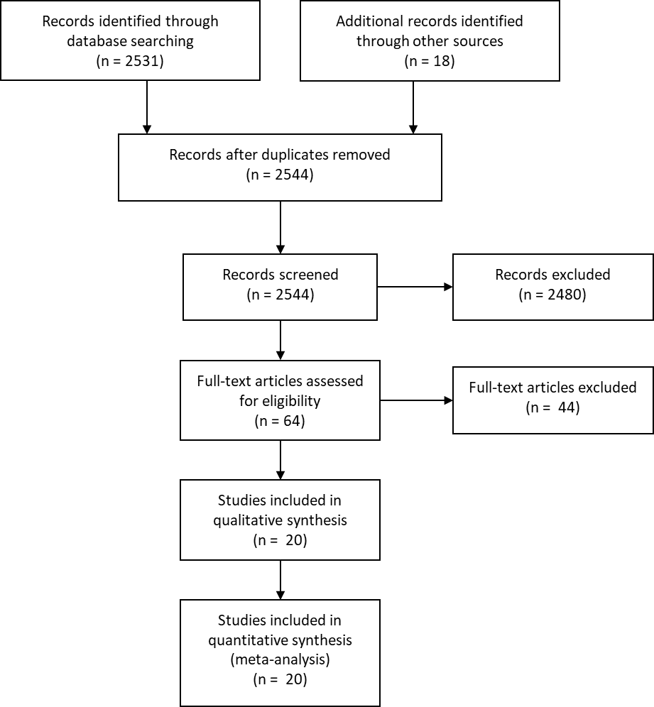

VISUAL OVERVIEW - This meta-analysis suggests similar outcomes with an immediate or staged complete revascularisation strategy in patients with acute coronary syndrome (ACS) and multivessel disease (MVD). In non-randomised studies, mortality was higher in patients who underwent immediate complete revascularisation compared to staged complete revascularisation. However, these registries were prone to important confounding bias as more patients in cardiogenic shock underwent ad hoc complete revascularization. Indeed, the increased mortality risk was no longer present when studies that also allowed cardiogenic shock were excluded.
