Supplement

Table S1. Variable selection based on forward selection--goodness-of-fit results from item-level mapping in estimation and validation samples
 | Group |  | N | Mean |  | Min, Max |  |  |  | Correlation coefficient |  | R-squared | MAE |  | MSE |  | Absolute errors<0.05
 | Estimation sample
 | Observed CHU9D |  | 674 | 0.879 |  | 0.384 |  | 1 |  | - |  | - | - |  | - |  | -
 | OLS -AIC |  | 674 | 0.879 |  | 0.607 |  | 0.980 |  | 0.62416 |  | 0.38958 | 0.06584 |  | 0.00781 |  | 51.63
 | OLS -forward selection |  | 674 | 0.879 |  | 0.630 |  | 0.984 |  | 0.62365 |  | 0.38894 | 0.06592 |  | 0.00782 |  | 51.78
 | Validation sample
 | Observed CHU9D |  | 168 | 0.872 |  | 0.464 |  | 1 |  | - |  | - | - |  | - |  | -
 | OLS -AIC |  | 168 | 0.881 |  | 0.648 |  | 0.972 |  | 0.66368 |  | 0.44047 | 0.06555 |  | 0.00772 |  | 47.62
 | OLS - forward selection |  | 168 | 0.881 |  | 0.666 |  | 0.976 |  | 0.66308 |  | 0.43968 | 0.06553 |  | 0.00773 |  | 48.21
Notes: For the total and dimension-level models, forward selection resulted in the same selected variables as the AIC-based criterion.

Table S2. PedsQL items in CYPHP mapping
 | PedsQL TM 4.0 items
3 | Participating in sports activity or exercise
4 | Lifting something heavy
5 | Taking a bath or shower by him or herself
6 | Doing chores, like picking up his or her toys/around the house
7 | Having hurts or aches
8 | Low energy level
9 | Feeling afraid or scared
10 | Feeling sad or blue
11 | Feeling angry
12 | Trouble sleeping
13 | Worrying about what will happen to him or her
14 | Getting along with other children/teens
15 | Other kids/teens not wanting to be his or her friend
17 | Not able to do things that other children/teens his or her age can do
19 | Paying attention in class
20 | Forgetting things
21 | Keeping up with school activities
23 | Missing school to go to doctor or hospital

Table S3. Assessment of multicollinearity among regressors of the CYPHP mappings
Regressor | VIF
Dimension mapping
Physical | 2.08
Emotional | 1.66
School | 2.53
Social | 2.60
Age | 1.03
Item mapping
I3 | 1.83
I4 | 1.63
I5 | 1.90
I6 | 2.07
I7 | 1.74
I8 | 1.89
I9 | 2.42
I10 | 2.48
I11 | 1.91
I12 | 1.78
I13 | 2.40
I14 | 2.21
I15 | 2.04
I17 | 1.76
I19 | 3.04
I20 | 1.94
I21 | 3.34
I23 | 1.50
Age | 1.17

Table S4. Parameter estimates from regressions assessing the relationship between the CYPHP and Sweeney mappings
1. Total scores
Parameter | Estimate | Standard Error | t Value | Pr > |t|
Intercept | 0.4800 | 0.0046 | 104.77 | <.0001
CHU9D_Sweeney_Total | 0.4972 | 0.0056 | 88.67 | <.0001
2. Dimension scores
Parameter | Estimate | Standard Error | t Value | Pr > |t|
Intercept | 0.4159 | 0.0177 | 23.55 | <.0001
CHU9D_Sweeney_Dimension | 0.5521 | 0.0208 | 26.55 | <.0001
Notes: Both regression models were estimated in the validation dataset (N=167) and had as a dependent variable the CHU-9D score resulting from the best CYPHP mapping and the Sweeney CHU-9D score as the independent variable.

Figure S1. Predicted versus observed values for the final CYPHP mappings
- Total scores

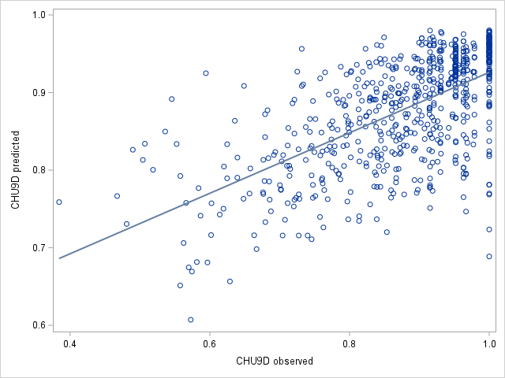
- Dimension scores
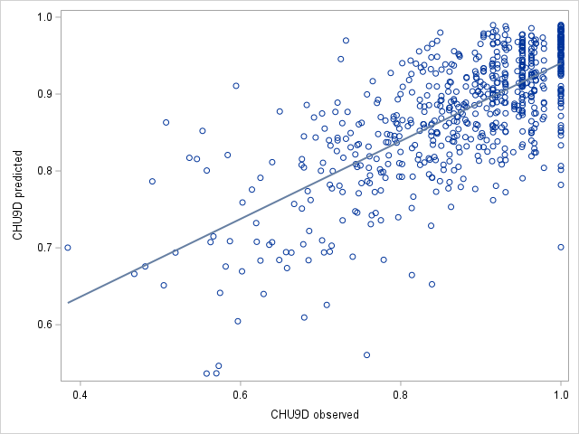
- Item scores
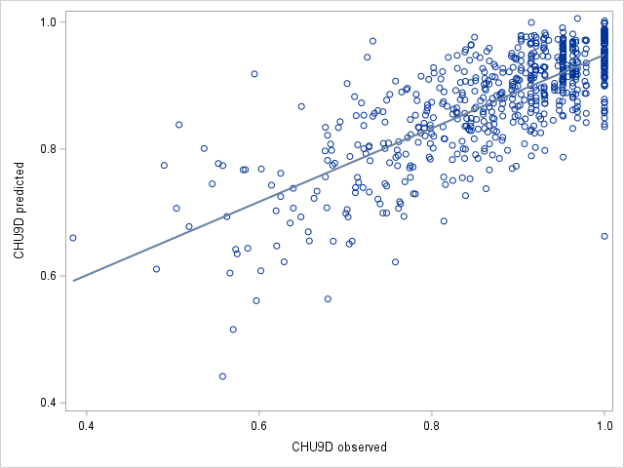
Notes: All three graphs are based on predicted and observed values from the estimation sample (N=674).
Table S5. Comparison of goodness of fit measures when age is dropped from the CYPHP dimension mapping

Group | N | Mean | Min, Max |  | Correlation coefficient | R-squared | MAE | MSE | RMSE | Absolute errors<0.05 | Average error
Estimation dataset
Observed CHU9D | 674 | 0.879 | 0.384 | 1 | - | - | - | - | - | - | -
OLS | 674 | 0.879 | 0.537 | 0.99 | 0.712 | 0.506 | 0.0589 | 0.0063 | 0.0795 | 54.45% | 0
OLS without age | 674 | 0.879 | 0.532 | 0.98 | 0.709 | 0.503 | 0.0591 | 0.0064 | 0.0798 | 54.6% | 0
Validation dataset
Observed CHU9D | 168 | 0.872 | 0.464 | 1 | - | - | - | - | - | - | -
OLS | 168 | 0.88 | 0.683 | 0.98 | 0.684 | 0.4685 | 0.0635 | 0.0073 | 0.085 | 51.19% | -0.008
OLS without age | 168 | 0.88 | 0.67 | 0.978 | 0.672 | 0.4517 | 0.064 | 0.0075 | 0.087 | 53.57% | -0.009

