Supplementary Material

Heterogeneity of Quality of Life in the Later Stages of First-episode Psychosis Recovery
Clarke E.L.ª, Allott K.^{b,c}, Anderson J.F.Iª, Gao C.X.^{b,c,d}, Filia, K.M. ^{b,c}, Killackey E.^{b,c,} Cotton S.M.^{b,c}
- Melbourne School of Psychological Sciences, The University of Melbourne, VIC 3010, Australia
- Orygen, Parkville, Melbourne VIC, Australia
- Centre for Youth Mental Health, University of Melbourne, Parkville, Melbourne VIC, Australia
- School of Public Health & Preventive Medicine, Monash University, Melbourne, Australia

Appendix 1
Pairwise correlation and item-total correlation between WHOQoL-BREF individual item data and total depression score (CESD)
Domain | Facet | Q1 | Q2 | Q3 | Q4 | Q10 | Q15 | Q16 | Q17 | Q18 | Q5 | Q6 | Q7 | Q11 | Q19 | Q26 | Q20 | Q21 | Q22 | Q8 | Q9 | Q12 | Q13 | Q14 | Q23 | Q24 | Q25 | CESD
Global items | Overall QoL (Q1) | 1.00 |  |  |  |  |  |  |  |  |  |  |  |  |  |  |  |  |  |  |  |  |  |  |  |  |  | .50
Physical Health | General Health (Q2) | .65 | 1.00 |  |  |  |  |  |  |  |  |  |  |  |  |  |  |  |  |  |  |  |  |  |  |  |  | .49
 | Pain (Q3) | -.22 | -.02 | 1.00 |  |  |  |  |  |  |  |  |  |  |  |  |  |  |  |  |  |  |  |  |  |  |  | -.08
 | Dependence on medicinal substances/medical aids (Q4) | -.12 | .05 | .02 | 1.00 |  |  |  |  |  |  |  |  |  |  |  |  |  |  |  |  |  |  |  |  |  |  | -.24
 | Energy (Q10) | .50 | .42 | -.04 | -.35 | 1.00 |  |  |  |  |  |  |  |  |  |  |  |  |  |  |  |  |  |  |  |  |  | .67
 | Mobility (Q15) | .38 | .48 | -.31 | -.18 | .60 | 1.00 |  |  |  |  |  |  |  |  |  |  |  |  |  |  |  |  |  |  |  |  | .39
 | Sleep (Q16) | .46 | .39 | .01 | .22 | .40 | .09 | 1.00 |  |  |  |  |  |  |  |  |  |  |  |  |  |  |  |  |  |  |  | .35
 | Activities of daily living (Q17) | .58 | .66 | -.20 | -.15 | .71 | .66 | .51 | 1.00 |  |  |  |  |  |  |  |  |  |  |  |  |  |  |  |  |  |  | .64
 | Work capacity (Q18) | .39 | .59 | -.21 | -.16 | .36 | .61 | .14 | .58 | 1.00 |  |  |  |  |  |  |  |  |  |  |  |  |  |  |  |  |  | .29
Psychological | Positive feelings (Q5) | .53 | .50 | -.01 | -.08 | .51 | .48 | .31 | .52 | .34 | 1.00 |  |  |  |  |  |  |  |  |  |  |  |  |  |  |  |  | .64
 | Spirituality (Q6) | .41 | .38 | -.12 | .15 | .37 | .25 | .32 | .43 | .26 | .71 | 1.00 |  |  |  |  |  |  |  |  |  |  |  |  |  |  |  | .57
 | Thinking, concentration, memory (Q7) | .18 | .32 | .04 | -.23 | .51 | .37 | .29 | .51 | .24 | .35 | .28 | 1.00 |  |  |  |  |  |  |  |  |  |  |  |  |  |  | .59
 | Body image/appearance (Q11) | .33 | .50 | .02 | -.07 | .57 | .44 | .28 | .56 | ..35 | .58 | .39 | .26 | 1.00 |  |  |  |  |  |  |  |  |  |  |  |  |  | .52
 | Self-esteem (Q19) | .65 | .64 | .03 | -.19 | .68 | .44 | .39 | .77 | .44 | .70 | .67 | .38 | .63 | 1.00 |  |  |  |  |  |  |  |  |  |  |  |  | -68
 | Negative feelings (Q26) | -.36 | -.37 | -.10 | .33 | -.59 | -.15 | -.30 | -.51 | -.19 | -.45 | -.44 | -.48 | -.37 | -.59 | 1.00 |  |  |  |  |  |  |  |  |  |  |  | -.69
Social relationships | Personal relationships (Q20) | .45 | .41 | .03 | -.28 | .60 | .40 | .30 | .51 | .25 | .62 | .35 | .31 | .40 | .56 | -.43 | 1.00 |  |  |  |  |  |  |  |  |  |  | .57
 | Sexual activity (Q21) | .39 | .34 | -.17 | -.06 | .42 | .32 | .20 | .32 | .12 | .51 | .28 | .26 | .37 | .31 | -.31 | .64 | 1.00 |  |  |  |  |  |  |  |  |  | .38
 | Social support (Q22) | .48 | .40 | -.05 | -.06 | .50 | .22 | .41 | .45 | .22 | .49 | .44 | .21 | .29 | .45 | -.40 | .62 | .51 | 1.00 |  |  |  |  |  |  |  |  | .48
Environmental | Freedom, safety and security (Q8) | .35 | .34 | -.02 | -.30 | .51 | .37 | .03 | .37 | .25 | .66 | .45 | .49 | .35 | .50 | -.41 | .56 | .40 | .48 | 1.00 |  |  |  |  |  |  |  | .57
 | Physical environment (Q9) | .32 | .37 | -.06 | -.09 | .46 | .41 | .25 | .35 | .36 | .40 | .22 | .41 | .20 | .30 | -.18 | .41 | .27 | .37 | .52 | 1.00 |  |  |  |  |  |  | .25
 | Financial resources (Q12) | .40 | .45 | .02 | -.01 | .37 | .33 | .25 | 50 | .23 | .38 | .24 | .02 | .45 | .43 | -.31 | .50 | .41 | .38 | .26 | .34 | 1.00 |  |  |  |  |  | .32
 | Opportunities for acquiring new skills (Q13) | .55 | .49 | -.22 | .05 | .33 | .46 | .25 | .38 | .41 | .45 | .36 | .12 | .41 | .41 | -.18 | .34 | .35 | .30 | .38 | .19 | .37 | 1.00 |  |  |  |  | .25
 | Participation/opportunities for leisure (Q14) | .39 | .35 | -.35 | .07 | .38 | .47 | .19 | .42 | .24 | .41 | .20 | .32 | .36 | .29 | -.12 | .44 | .52 | .25 | .34 | .40 | .48 | .49 | 1.00 |  |  |  | .30
 | Home environment (Q23) | .40 | .19 | .19 | .08 | .45 | .11 | .46 | .40 | .07 | .41 | .38 | .11 | .31 | .45 | -.17 | .52 | .23 | .47 | .28 | .38 | .22 | .44 | .37 | 1.00 |  |  | .30
 | Health and social care (Q24) | .28 | .41 | .41 | .16 | .31 | .37 | .28 | .32 | .29 | .42 | .29 | .10 | .19 | .22 | -.04 | .43 | .29 | .56 | .37 | .50 | .38 | .59 | .44 | .66 | 1.00 |  | .23
 | Transport (Q25) | .14 | .22 | .04 | .22 | .25 | .28 | .11 | .34 | .03 | .39 | .17 | .01 | .27 | .22 | .02 | .38 | .26 | .37 | .22 | .28 | .40 | .24 | .29 | .43 | .52 | 1.00 | .15

Appendix 2
Name, description and version of R packages

R Package | Description | Version
base | The R base package | 4.1.0
biotools | Tools for biometry and applied statistics in agricultural sciences | 4.2
cluster | “Finding Groups in Data”: Cluster Analysis Extended Rousseeuw et al. | 2.1.2
cluster.datasets | Cluster analysis data sets | 1.0-1
clustree | Visualise clustering at different resolutions | 0.4.3
clValid | Validation of clustering results | 0.7
corrplot | Visualisation of correlation matrix | 0.90
cowplot | streamlined plot theme and plot annotations for ggplot2 | 1.1.1
data.table | Extension of ‘data.frame’ | 1.14.0
datasets | The R datasets package | 4.1.0
dendextend | Extending ‘dendrogram’ functionality in R | 1.15.1
dplyr | A grammar of data manipulation | 1.0.7
factoextra | Extract and visualise the results of multivariate data analysis | 1.0.7
FactoMineR | Multivariate exploratory data analysis and data mining | 2.4
forcats | Tools for working with categorical variables | 0.5.1
foreign | Reading datasets | 0.8-81
GGally | Extension to ‘ggplot2’ | 2.1.2
ggfortify | Data visualisation for tools for statistical analysis | 0.4.12
ggplot2 | Create elegant data visualisations using the gramma of graphics | 3.3.5
ggpubr | ‘ggplot2’ based publication ready plots | 0.4.0
ggraph | An implementation of grammar of graphics for graphs and networks | 2.0.5
graphics | The R graphics package | 4.1.0
haven | Import and export ‘SPSS’; ‘Stata’ and ‘SAS’ files | 2.4.1
kableExtra | Construct complex table with ‘kable’ and pipe syntax | 1.3.4

R Package | Description | Version
knitr | A general-purpose package for dynamic report generation in R | 1.33
lsr | Companion to ‘Learning Statistics with R’ | 0.5
magrittr | A forward-pipe operated in R | 2.0.1
NbClust | Determining the best number of clusters in a data set | 3.0
nnet | Feed-forward neural networks and multinominal log-linear models | 7.3-16
philentropy | Similarity and distance quantification between probability functions | 0.5.0
profileR | Profile analysis of multivariate data in R | 0..3-5
psych | Procedures for psychological, psychometric, and personality research | 2.1.6
stats | The R stats package | 4.1.0
questionr | Functions to make survey processing easier | 0.7.4
readr | Read rectangular text data | 2.0.0
reshape2 | Flexibility reshape data: A reboot of the reshape package | 1.4.4
tibble | Simple data frames | 3.1.3
tidyr | Tidy messy data | 1.1.3
tidyverse | Easily install and load the ‘Tidyverse’ | 1.3.1
Notes. Descriptions are taken straight from RStudio (Version 1.4.1717).

Appendix 3
Comparison of the demographic, clinical characteristics, cognition and QoL of participants by follow-up availability
Measures | Follow-up  (N =102) | No follow-up  (N =43) | t | $$x^{2}$$ | df | p-value | Effect-size
Demographics
Age, mean (SD) | 20.25 (2.38) | 20.72 (2.37) | -.91 | - | 77.1 | . 367 | .020
Gender, male (%) | 66 (64.71) | 36 (83.72) | - | 3.24 | 1 | .072 | .149
Currently employed (%) | 19 (18.63) | 5 (11.33) | - | .63 | 1 | .429 | .066
Clinical characteristics
DUP, mean (SD) | 245.18 (421.33) | 353.75 (616.98) | -1.01 | - | 55.4 | .315 | .206
Treatment group, vocational (%) | 56 (54.90) | 16 (37.21) | - | 3.11 | 1 | .077 | .146
Positive symptoms, mean (SD) | 8.17(4.14) | 9.16 (4.65) | -1.22 | - | 71.3 | .228 | .223
Negative symptoms, mean (SD) | 25.18 (12.67) | 25.70 (11.51) | -.24 | - | 86.5 | .811 | . 043
Depressive symptoms, mean (SD) | 19.57 (11.50) | 20.86 (12.25) | -.59 | - | 74.7 | .556 | .109
Cognition
IQ, mean (SD) | 93.17 (15.12) | 91.93 (14.82) | .47 | - | 80.49 | .750 | .083
ToM, mean (SD) | 4.54 (1.29) | 4.27 (1.50) | 1.03 | - | 69.20 | . 308 | .193
Semantic verbal fluency, mean (SD) | 18.96 (6.08) | 18.12 (5.22) | .85 | - | 91.29 | .400 | .148
QoL
Physical health, mean (SD) | 65.79 (16.30) | 62.04 (15.59) | 1.30 | - | 82.4 | .196 | .235
Psychological, mean (SD) | 53.59 (19.76) | 52.81 (19.32) | .22 |  | 80.7 | .825 | .040
Social relationships, mean (SD) | 57.76 (21.34) | 56.40 (23.56) | .33 | - | 72.5 | .744 | .061
Environmental, mean (SD) | 63.60 (14.81) | 58.07 (17.98) | 1.78 | - | 67.2 | .080 | .334
Notes. DUP = duration of untreated psychosis; ToM = Theory of Mind. Measures that are in italics were taken at baseline. Effect sizes were calculated using Cohen’s d and Phi coefficient.
Appendix 4
Follow-up hierarchical agglomerative clustering dendrograms for various cluster solutions

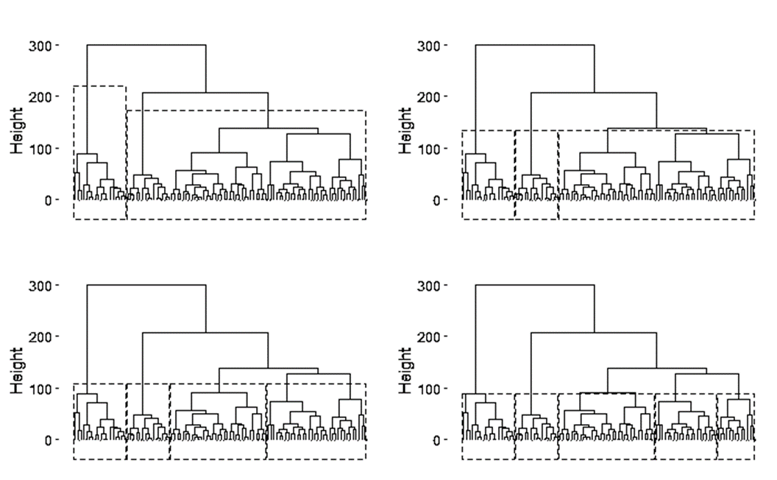

Notes. The height on the y-axes displays the distances between participants’ QoL observations and the horizontal bars indicate the point at which participants were merged into a cluster based on such distances. As the horizontal bars become wider, the distances between the grouped participants enlarges. The dashed line represents where the dendrogram would be ‘cut’ based on the relevant cluster solution.
Appendix 5
Follow-up hierarchical agglomerative clustering scree plot
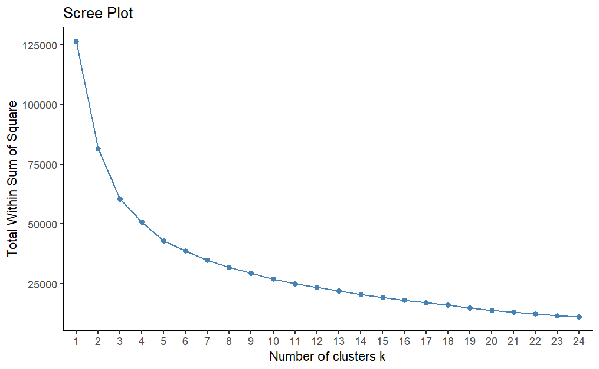

Appendix 6
One-way ANOVA results using each QoL domain as the criterion

QoL domain | Predictor | Sum of Squares | df | Mean Square | F | p-value | η²
Physical health
 | Cluster group | 7463 | 2 | 3731 | 33.4 | <.001* | .41
 | Error | 10851 | 97 | 112
Psychological
 | Cluster group | 17216 | 2 | 8608 | 140.7 | <.001* | 56
 | Error | 13647 | 97
Social relationships
 | Cluster group | 34929 | 2 | 17465 | 100.3 | <.001* | .67
 | Error | 16893 | 97 | 174
Environmental
 | Cluster group | 12604 | 2 | 6302 | 47.3 | <.001* | .49
 | Error | 12914 | 97 | 133
Notes. * p = < .001

Appendix 7
Comparison of baseline and follow-up cluster groups on each QoL domain

Cluster group | Baseline | Follow-up | t | df | p-value | Cohen’s d
 | Mean (SD) | Mean (SD)
‘Good’ cluster
Physical health | 79.25 (10.85) | 81.68 (9.92) | -.99 | 67.73 | .324 | .23
Psychological | 75.20 (9.87) | 78.90 (10.20) | -1.55 | 63.55 | .125 | .37
Social relationships* | 77.38 (13.31) | 85.75 (11.63) | -2.86 | 68.92 | .006* | .66
Environmental | 77.23 (11.01) | 80.75 (10.05) | -1.42 | 67.77 | .161 | .33
‘Intermediate’ cluster
Physical health | 65.65 (10.39) | 68.38 (10.31) | -1.38 | 101.7 | .171 | .26
Psychological* | 51.52 (11.26) | 58.16 (13.20) | -2.79 | 92.07 | .006* | .55
Social relationships* | 58.99 (13.58) | 64.93 (13.20) | -2.32 | 102.72 | .022* | . 44
Environmental* | 60.91 (11.00) | 66.27 (11.75) | -2.45 | 97.71 | .016* | .47
Poor cluster
Physical health* | 47.86 (12.04) | 57.82 (12.04) | -3.07 | 40.77 | .004* | .83
Psychological* | 33.33 (13.41) | 57.83 (10.80) | -3.00 | 49.03 | .004* | .76
Social relationships | 33.75 (17.08) | 32.94 (15.25) | .19 | 45.02 | .850 | .05
Environmental | 47.58 (12.45) | 49.11 (13.04) | -0.44 | 39.13 | .661 | .12
Notes. * = p < .05

Appendix 8
Bivariate associations between external baseline variables and follow-up cluster group membership
 | Contrast – ‘poor’ vs ‘good |  |  |  |  | Contrast – ‘intermediate’ vs ‘good’
 |  | 95% CI of OR |  |  |  |  | 95% CI of OR
Baseline Measures | OR | LCI | UCI | Wald | p | OR | LCI | UCI | Wald | p
Clinical Characteristics
DUP | 1.00 | 1.00 | 1.00 | 1.86 | .063 | 1.00 | 1.00 | 1.00 | 1.40 | .163
Positive symptoms (BPRS) | 1.27 | 1.09 | .148 | 3.06 | .002 | 1.12 | .98 | .1.27 | 1.67 | .094
Negative symptoms (SANS) | 1.02 | .98 | 1.07 | .92 | .354 | .99 | .95 | 1.03 | -.52 | .600
Depressive symptoms (CESD) | 1.08 | 1.02 | 1.14 | .03 | .004 | 1.03 | 0.98 | 1.07 | 1.12 | .262
Vocational Intervention (Yes) | 1.73 | .56 | 5.35 | 0.96 | .339 | 1.26 | .510 | 3.12 | .50 | .615
Cognition
IQ | .99 | .95 | 1.03 | -.60 | .546 | 1.00 | .97 | 1.03 | -.25 | .804
ToM | .92 | .60 | 1.42 | -.37 | .720 | .96 | .67 | 1.37 | -.22 | .824
Semantic verbal fluency | .98 | .89 | 1.07 | -.43 | .670 | 1.00 | .93 | 1.08 | -.00 | .999
Notes. BPRS = Brief Psychiatric Rating Scale – Positive Symptoms Subscale; CESD = Centre for Epidemiological Studies – Depression scale; CI = confidence interval; DUP = duration of untreated psychosis; LCI = lower confidence interval; OR = odds ratio; SANS = Scale for the Assessment of Negative Symptoms; ToM = Theory of Mind; UCI = upper confidence interval. Measures that are in italics are premorbid variables, taken at baseline.
* = p < .100

Appendix 9
Bivariate associations between external variables at follow-up and follow-up cluster group membership
 | Contrast – ‘poor’ vs ‘good |  |  |  |  | Contrast – ‘intermediate’ vs ‘good’
 |  | 95% CI of OR |  |  |  |  | 95% CI of OR
Follow-up variable | OR | LCI | UCI | Wald | p-value | OR | LCI | UCI | Wald | p-value
Clinical characteristics
Positive symptoms (BPRS)* | 1.24 | 1.07 | 1.43 | 2.85 | .004* | 1.06 | .92 | 1.22 | .78 | .438
Negative symptoms (SANS)* | 1.08 | 1.03 | 1.12 | 3.56 | < .001* | 1.03 | 1.00 | 1.07 | 1.94 | .052*
Depressive symptoms (CESD)* | 1.40 | 1.24 | 1.59 | 5.27 | < .001* | 1.24 | 1.11 | 1.38 | 3.94 | <.001*
Functioning
Employment status (No) | 1.81 | .55 | 5.91 | .98 | .329 | 1.20 | .48 | 3.03 | .47 | .694
Social/occupational functioning (SOFAS)* | .94 | .90 | .99 | -2.62 | .009* | .98 | .94 | 1.00 | -1.46 | .145
Social inclusion* | .72 | .63 | 0.82 | -4.93 | < .001* | 0.82 | .74 | .91 | -3.74 | < .001*
Notes. BPRS = Brief Psychiatric Rating Scale – Positive Symptoms Subscale; CESD = Centre for Epidemiological Studies –Depression scale; CI = confidence interval; LCI = lower confidence interval; OR = odds ratio; SANS = Scale for the Assessment of Negative Symptoms; SOFAS = Social and Occupational Functioning Assessment Scale; UCI = upper confidence interval
* = p < .100

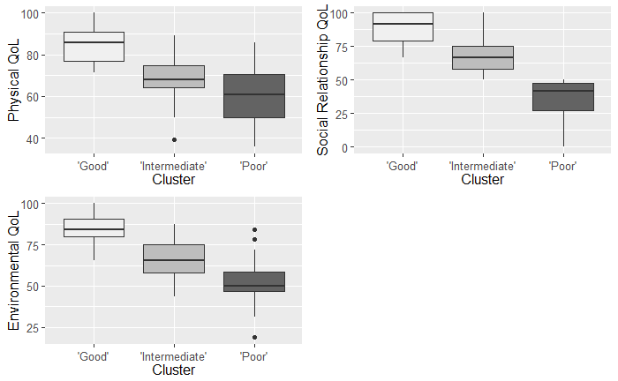
Appendix 10
QoL profiles for each cluster group at 18-months follow-up after the Psychological items were removed (sensitivity analysis)

Notes. The ‘good’ group (23%; n = 23), ‘intermediate’ (51%; n = 51) and ‘poor’ (26%; n = 26) exhibited different QoL profile

Appendix 11
One-way ANOVA results using each QoL domain as the criterion in cluster group membership with Psychological domain excluded (sensitivity analysis)
Physical health
 | Cluster group | 7472 | 2 | 3736 | 33.4 | <.001* | .41
 | Error | 10841 | 97 | 117
Social relationships
 | Cluster group | 37280 | 2 | 18640 | 124.3 | <.001* | .72
 | Error | 14543 | 97 | 150
Environmental
 | Cluster group | 12282 | 2 | 6141 | 45.0 | <.001* | .48
 | Error | 13236 | 97 | 136
Notes. * p = < .001

Appendix 12
Univariate associations between external variables and cluster group membership with Psychological domain excluded (sensitivity analysis)
 | Contrast – ‘poor’ vs ‘good |  |  |  |  | Contrast – ‘intermediate’ vs ‘good’
 |  | 95% CI of OR |  |  |  |  | 95% CI of OR
Variable | OR | LCI | UCI | Wald | p-value | OR | LCI | UCI | Wald | p-value
Clinical characteristics
DUP | 1.00 | 1.00 | 1.00 | 1.39 | .166 | 1.00 | 1.00 | 1.00 | 1.11 | .264
Treatment group | 1.73 | .54 | 5.59 | .92 | .359 | .63 | .23 | 1.70 | -.91 | .364
Baseline positive symptoms (BPRS) | 1.31 | 1.09 | 1.57 | 2.94 | .003* | 1.20 | 1.01 | 1.42 | 2.11 | 0.03*
Positive symptoms (BPRS)* | 1.34 | 1.07 | 1.68 | 1.56 | .010* | 1.19 | .96 | 1.48 | 2.58 | . 119
Baseline negative symptoms (SANS) | 1.03 | .99 | 1.08 | 1.33 | .185 | 1.01 | .97 | 1.05 | 0.35 | .723
Negative symptoms (SANS)* | 1.08 | 1.03 | 1.13 | 3.41 | .001* | 1.04 | 1.00 | 1.08 | 2.13 | .033*
Baseline depressive symptoms (CESD)* | 1.07 | 1.02 | 1.13 | 2.56 | .010* | 1.07 | .97 | 1.07 | 0.65 | .519
Follow-up depressive symptoms (CESD)* | 1.43 | 1.23 | 1.65 | 4.75 | <.001* | 1.30 | 1.13 | 1.49 | 3.76 | <.001*
Functioning
Social/occupational functioning (SOFAS)* | .93 | .88 | .97 | -3.26 | .001* | .96 | .93 | 1.00 | -2.07 | .039*
Social inclusion* | .74 | .65 | .84 | -4.47 | <.001* | .81 | .72 | .91 | -3.52 | <.001*
Employment | 2.09 | .63 | 6.90 | 1.21 | .228 | 1.19 | .44 | 3.23 | .34 | .730
Cognition
IQ, mean (SD) | .99 | .96 | 1.03 | -0.42 | .674 | .97 | .94 | 1.01 | -1.59 | .111
ToM, mean (SD) | .86 | .54 | 1.37 | -0.63 | .526 | .75 | .49 | 1.13 | -1.38 | .168
Semantic verbal fluency, mean (SD) | .98 | . 89 | 1.07 | -0.43 | .664 | .96 | .88 | 1.04 | -1.03 | .303
Notes. BPRS = Brief Psychiatric Rating Scale – Positive Symptoms Subscale; CESD = Centre for Epidemiological Studies –Depression scale; CI = confidence interval; LCI = lower confidence interval; OR = odds ratio; SANS = Scale for the Assessment of Negative Symptoms; SOFAS = Social and Occupational Functioning Assessment Scale; UCI = upper confidence interval. Measures that are in italics were taken at baseline.
* = p < .01

Appendix 13
Multivariate associations between external variables and cluster group membership with Psychological domain excluded (sensitivity analysis)
 | Contrast – ‘poor’ vs ‘good |  |  |  |  | Contrast – ‘intermediate’ vs ‘good’
 |  | 95% CI of OR |  |  |  |  | 95% CI of OR
Variable | OR | LCI | UCI | Wald | p-value | OR | LCI | UCI | Wald | p-value
Clinical characteristics
Baseline positive symptoms (BPRS) | 1.16 | .86 | 1.57 | .95 | .343 | 1.23 | .94 | 1.62 | 1.44 | .149
Positive symptoms (BPRS) | 1.03 | .81 | 1.29 | .22 | .824 | 0.98 | .79 | 1.21 | -.22 | .828
Negative symptoms (SANS)* | 1.06 | .98 | 1.15 | 1.44 | .151 | 1.02 | 1.02 | 1.09 | .71 | .477
Baseline depressive symptoms (CESD) | 1.07 | .97 | 1.16 | 1.39 | .163 | 1.00 | .92 | 1.07 | -0.13 | .895
Follow-up depressive symptoms (CESD)* | 1.37 | 1.15 | 1.63 | 3.54 | <.001* | 1.30 | 1.10 | 1.52 | 3.11 | .002*
Functioning
Social/occupational functioning (SOFAS) | 1.01 | .93 | 1.09 | 0.21 | .835 | .99 | .94 | 1.06 | -.19 | .853
Social inclusion* | .77 | .63 | .95 | -2.51 | .012* | .80 | .66 | .96 | -2.40 | .017*
Notes. BPRS = Brief Psychiatric Rating Scale – Positive Symptoms Subscale; CESD = Centre for Epidemiological Studies –Depression scale; CI = confidence interval; LCI = lower confidence interval; OR = odds ratio; SANS = Scale for the Assessment of Negative Symptoms; SOFAS = Social and Occupational Functioning Assessment Scale; UCI = upper confidence interval. Measures that are in italics were taken at baseline.
* = p < .05

