Supplemental Material
Supplemental Figure 1 Conceptual Framework for Impact of Cancer^{i}
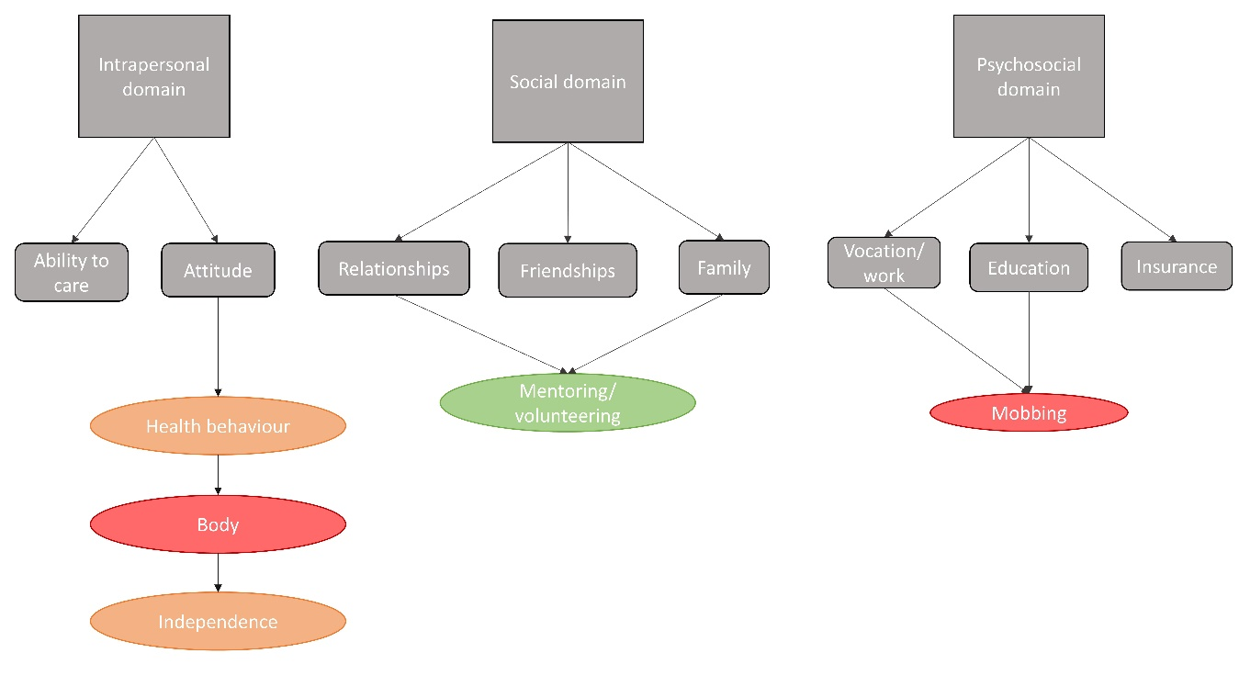
^{i}Colour represents the positivity (green), partly positive/negative (orange) or negativity (red) of survivors experience

