Supplementary material

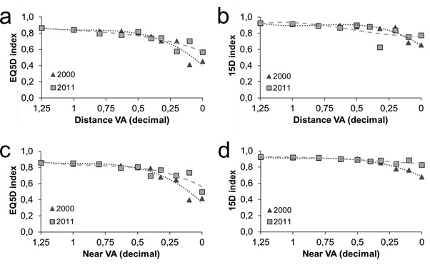Fig. S1
Age and sex adjusted HRQoL index scores in relation to habitual distance (a, b) and near (c, d) VA in both time points. The y-axis represents the mean index value, where 1 is the best possible HRQoL. The x-axis represents VA in decimal equivalents from 1.25 (excellent vision) to 0 (blind). Dotted line represents the trend line for year 2000 and dashed line for year 2011.

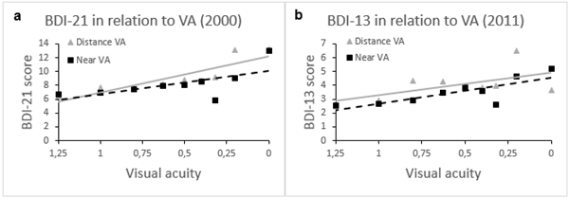

Fig. S2
Age-adjusted depression measured by BDI-questionnaire in relation to visual acuity. A: Scores from BDI-21 questionnaire in 2000. B: Scores from BDI-13 questionnaire in 2011

Table S1. Stepwise-insertion regression analysis examining the changes in EQ-5D and 15D index value between 2000 and 2011, including only statistically significant factors (p<0.05).
 | Change in EQ-5D (n=3068) |  |  | Change in 15D (n=3454)
 | B Coefficients | Beta Coefficients |  | B Coefficients | Beta Coefficients
Constant | 0.403 ** |  |  | 0.271 **
Incident heart disease | -0.034 * |  | -0.058 * | -0.016 ** |  | -0.070 **
Incident pulmonary disease | -0.028 * |  | -0.039 * | -0.025 ** |  | -0.087 **
Incident vascular disease |  |  |  | -0.013 * |  | -0.044 *
Incident musculoskeletal condition | -0.038 ** |  | -0.105 ** | -0.007 * |  | -0.049 *
Incident hypertension | -0.031 ** |  | -0.068 **
Incident diabetes |  |  |  | -0.018 ** |  | -0.067 **
Incident psychiatric disorder | -0.062 ** |  | -0.071 ** | -0.024 ** |  | -0.069 **
Incident Parkinson disease |  |  |  | -0.076 ** |  | -0.066 **
Incident cancer |  |  |  | -0.012 * |  | -0.040 *
Change in Visual acuity (VA), compared to stable VA
Distance VA declined | -0.063 ** |  | -0.092 ** | -0.032 ** |  | -0.117 **
Near VA declined | -0.027 * |  | -0.047 * | -0.012 * |  | -0.054 *
QoL index value in baseline | -0.465 ** |  | -0.421 ** | -0.293 ** |  | -0.312 **
R² | 0.193 ** |  | 0.191 ** | 0.131 ** |  | 0.128 **
VA was considered improved or declined if difference of at least 2 lines in the Snellen eye-chart was observed between the time points. The unstandardized B coefficients show the magnitude of the impact on HRQoL while the standardized Beta coefficients allow the comparison of the explanatory variables with each other. Clinically meaningfully B coefficients are bolded (≥ 0.07 for EQ-5D and ≥ 0.015 for 15D [34, 35]). It should be noted that B regression coefficients represented in the table are independent and additive, meaning that if an individual experience a e.g. decline in both near and distance VA, the HRQoL impacts of both need to be considered (added together).
* denotes statistical significance with p < 0.05
** denotes statistical significance with p < 0.001

Table S2. Stepwise-insertion regression analysis examining the change in 15D vision dimension between 2000 and 2011, including only statistically significant factors (p<0.05)
 | Beta Coefficients | Sig.
Constant | 0.679 |  | <0.001
Incident pulmonary disease | -0.042 |  | 0.003
Incident diabetes | -0.034 |  | 0.017
Change in Visual acuity (VA), compared to stable VA
Distance VA declined | -0.193 |  | <0.001
Near VA declined | -0.152 |  | <0.001
15D Vision dimension value in baseline | -0.492 |  | <0.001
Adjusted R² | 0.292 |  | <0.001
VA was considered improved or declined if difference of at least 2 lines in the Snellen eye-chart was observed between the time points. Only the standardized Beta coefficients reported to allow the comparison between the explanatory variables.

