SUPPLEMENTAL MATERIALS
Longitudinal validity and reliability of the Myeloma Patient Outcome scale was established using traditional, generalizability and Rasch psychometric methods

Christina Ramsenthaler, Wei Gao, Richard J. Siegert, Stephen A. Schey, Polly M. Edmonds, Irene J. Higginson

Supplemental Table 1 Factor loadings of the MyPOS and fit statistics for confirmatory factor analysis
Item no. | Description | Symptoms | Emotions | Support
1 | Pain | .702
2 | Shortness of breath | .560
3 | Fatigue | .753
4 | Nausea | .783
5 | Vomiting | .730
6 | Appetite loss | .710
7 | Constipation | .573
8 | Mouth problems | .527
9 | Drowsiness | .670
10 | Poor mobility | .779
11 | Diarrhoea | .458
12 | Tingling | .378
13 | Remembering | .618
14 | Anxiety |  | .813
15 | Family anxiety |  | .661
16 | Depression |  | .802
17 | At peace |  | .831
18 | Sharing feelings |  | .558
19 | Information |  | .616
20 | Practical matters |  | .533
21 | Usual activities |  | .798
22 | Hobbies |  | .791
23 | Quality time |  | .753
24 | Sex |  | .189
25 | Infections |  | .446
26 | Appearance |  | .608
27 | Finances |  | .505
28 | Illness |  | .763
29 | Coping |  | .844
30 | Advice |  |  | .766
31 | Knowledge |  |  | .969
32 | Care and respect |  |  | .883
33 | Future |  | .486
 | Variance explained | 28.1% | 7.2% | 6.9%
Confirmatory factor analysis
χ² (DWLS estimator) |  | 873.182
χ² p-value |  | <0.001
χ²/ df |  | 1.774
CFI (>0.90) |  | 0.942
TLI ( |  | 0.937
NFI (>0.95) |  | 0.873
NNFI (>0.95) |  | 0.937
RMSEA (90% CI) (<0.06) |  | 0.056 (0.050-0.063)
Abbreviations: CFI, comparative fit index; df, degrees of freedom; NFI, normal fit index; NNFI, non-normal fit index; RMSEA, root mean square error of approximation; MyPOS, Myeloma Patient Outcome Scale.
Note: Thresholds for fit indices are indicated in brackets.

Supplemental Table 2 Rasch model fit for each subscale with item and person location fit statistics

Measurement characteristic | Symptom subscale (13 items) | Emotional response subscale (17 items) | Healthcare support subscale (3 items)
Item locations
Mean (SD) | 0 (0.858) | 0 (0.348) | 0 (0.774)
Range | -1.16 to 1.92 | -0.69 to 0.41 | -0.69 to 0.83
Thresholds
Range | -2.49 to 5.62 | -2.19 to 1.86 | -3.07 to 5.28
Fit residuals: Mean (SD) | -0.102 (1.191) | 0.175 (1.66) | 0.170 (0.338)
Skewness | 0.812 | 0.353 | -0.221
Person measures
Mean (SD) | -1.824 (1.101) | -1.195 (1.058) | -4.086 (1.484)
Range | -4.89 to 0.63 | -4.33 to 0.69 | -4.74 to 8.42
Fit residuals: Mean (SD) | -0.203 (0.875) | -0.159 (1.163) | -0.183 (0.621)
Skewness | 0.345 | -0.176 | -0.146
Person separation index | 0.804 | 0.834 | 0.127
Overall fit
X² | 65.651 | 143.74 | 11.887
p-value | 0.005 | 0.001 | 0.065
RMSEA (90% CI) | 0.054 (0.038, 0.067) | 0.088 (0.074, 0.100) | 0.064 (0.049, 0.076)
Note: RMSEA was calculated according to the formula √ Max ([(X²/df)-1/(N-1)], 0) [82].
Abbreviations: CI, confidence interval; sd, standard deviation; RMSEA, root mean square error of approximation.

Supplemental Table 3 Differential item functioning for assessing reliability
 | MyPOS items | Time (uniform DIF) |  |  | Time by class interval (non-uniform DIF)
 |  | F | df | p | F | df | p
1 | Pain | 0.55 | 4 | 0.698 | 1.33 | 36 | 0.093
2 | Breathlessness | 1.85 | 4 | 0.115 | 0.82 | 36 | 0.762
3 | Fatigue | 1.40 | 4 | 0.230 | 1.05 | 36 | 0.378
4 | Nausea | 1.21 | 4 | 0.304 | 1.25 | 36 | 0.145
5 | Vomiting | 0.73 | 4 | 0.570 | 1.07 | 36 | 0.356
6 | Poor appetite | 0.35 | 4 | 0.842 | 0.89 | 36 | 0.645
7 | Constipation | 0.43 | 4 | 0.784 | 1.66 | 36 | 0.009
8 | Sore or dry mouth | 1.03 | 4 | 0.388 | 1.33 | 36 | 0.090
9 | Drowsiness | 31.09 | 4 | 0.001 | 1.22 | 36 | 0.173
10 | Poor mobility | 1.85 | 4 | 0.116 | 1.22 | 36 | 0.170
11 | Diarrhoea | 33.40 | 4 | 0.001 | 1.04 | 36 | 0.406
12 | Tingling in hands/feet | 0.73 | 4 | 0.567 | 0.86 | 36 | 0.690
13 | Difficulty remembering | 1.01 | 4 | 0.399 | 0.82 | 36 | 0.763
14 | Anxiety | 0.44 | 4 | 0.773 | 0.91 | 36 | 0.605
15 | Family anxiety | 0.95 | 4 | 0.430 | 1.02 | 36 | 0.424
16 | Depression | 0.91 | 4 | 0.454 | 0.93 | 36 | 0.585
17 | At peace | 0.41 | 4 | 0.794 | 0.96 | 36 | 0.531
18 | Sharing feelings | 0.77 | 4 | 0.540 | 1.03 | 36 | 0.419
19 | Information | 1.28 | 4 | 0.273 | 0.80 | 36 | 0.786
20 | Practical matters | 0.63 | 4 | 0.634 | 1.18 | 36 | 0.216
21 | Usual activities | 1.01 | 4 | 0.401 | 0.78 | 36 | 0.815
22 | Hobbies | 0.33 | 4 | 0.855 | 1.38 | 36 | 0.067
23 | Quality time with family and friends | 0.53 | 4 | 0.709 | 1.00 | 36 | 0.464
24 | Worry about sex life | 0.67 | 4 | 0.610 | 1.32 | 36 | 0.099
25 | Worry about infections | 3.65 | 4 | 0.005 | 0.74 | 36 | 0.860
26 | Worry about physical appearance | 0.45 | 4 | 0.771 | 0.66 | 36 | 0.933
27 | Worry about financial situation | 0.61 | 4 | 0.654 | 0.89 | 36 | 0.647
28 | Worry about illness worsening | 2.12 | 4 | 0.076 | 0.93 | 36 | 0.576
29 | Coping with illness and treatment | 2.12 | 4 | 0.075 | 0.95 | 36 | 0.538
33 | Information about future | 0.99 | 4 | 0.411 | 0.76 | 36 | 0.836
30 | Contact for advice | 0.97 | 4 | 0.420 | 0.55 | 15 | 0.909
31 | Knowledge/skill of doctors | 0.37 | 4 | 0.828 | 0.54 | 16 | 0.922
32 | Care and respect | 1.14 | 4 | 0.335 | 0.62 | 16 | 0.864
Note: Bolded values indicate significant items with differential item functioning/instability over time.
Abbreviations: df, degrees of freedom; DIF, differential item functioning; MyPOS, Myeloma Patient Outcome Scale

Supplemental Table 4 Changes in scores between baseline and assessments 2, 3, 4 and 5 for the total MyPOS score and its subscales. Presented are mean change scores and the standard deviation of changes.
 | Change TP1-TP2 |  |  |  | Change TP1-TP3 |  |  |  | Change TP1-TP4 |  |  |  | Change TP1-TP5
MyPOS Total Score
My QOL has… | n | M_{c} | SD_{c} |  | n | M_{c} | SD_{c} |  | n | M_{c} | SD_{c} |  | n | M_{c} | SD_{c}
Improved | 14 | 5.7 | 10.7 |  | 22 | 8.0 | 9.3 |  | 16 | 9.6 | 13.3 |  | 22 | 8.7 | 13.5
No change | 90 | 0 | 10.1 |  | 69 | 2.3 | 9.5 |  | 64 | 1.9 | 11.2 |  | 50 | 0.9 | 7.6
Got worse | 11 | -8.4 | 6.9 |  | 13 | 3.8 | 13.4 |  | 21 | -8.2 | 14.5 |  | 21 | -10.3 | 17.4
Missing | 84 | -7.6 | 19.7 |  | 67 | -6.2 | 9.6 |  | 49 | -3.1 | 11.5 |  | 32 | -7.5 | 11.3
Rho* | 0.33 |  |  |  | 0.40 |  |  |  | 0.40 |  |  |  | 0.45
MyPOS Symptom subscale
 | n | M_{c} | SD_{c} |  | n | M_{c} | SD_{c} |  | n | M_{c} | SD_{c} |  | n | M_{c} | SD_{c}
Improved | 15 | 2.5 | 6.9 |  | 25 | 2.8 | 5.8 |  | 20 | 2.6 | 4.3 |  | 23 | 3.3 | 6.2
No change | 116 | -0.2 | 4.2 |  | 90 | 1.0 | 3.9 |  | 74 | 1.0 | 5.0 |  | 64 | 0.2 | 3.6
Got worse | 17 | -3.5 | 4.7 |  | 17 | -2.2 | 5.2 |  | 30 | -2.5 | 5.4 |  | 26 | -2.7 | 5.3
Missing | 51 | -2.0 | 8.6 |  | 39 | -2.5 | 4.5 |  | 26 | -1.7 | 5.2 |  | 12 | -3.5 | 6.1
Rho | 0.26 |  |  |  | 0.27 |  |  |  | 0.31 |  |  |  | 0.40
MyPOS Emotional response subscale
 | n | M_{c} | SD_{c} |  | n | M_{c} | SD_{c} |  | n | M_{c} | SD_{c} |  | n | M_{c} | SD_{c}
Improved | 18 | 2.4 | 8.0 |  | 26 | 4.7 | 6.4 |  | 19 | 5.4 | 9.2 |  | 25 | 6.1 | 8.6
No change | 109 | 0.6 | 7.5 |  | 84 | 1.4 | 7.2 |  | 71 | 1.0 | 8.2 |  | 59 | 0.8 | 5.9
Got worse | 14 | -5.0 | 5.8 |  | 15 | -2.6 | 10.6 |  | 23 | -5.7 | 10.5 |  | 24 | -8.0 | 14.2
Missing | 58 | -4.2 | 10.5 |  | 46 | -2.8 | 6.3 |  | 37 | -1.6 | 8.9 |  | 17 | -3.5 | 6.1
Rho | 0.20 |  |  |  | 0.28 |  |  |  | 0.35 |  |  |  | 0.41
MyPOS Healthcare support subscale
 | n | M_{c} | SD_{c} |  | n | M_{c} | SD_{c} |  | n | M_{c} | SD_{c} |  | n | M_{c} | SD_{c}
Improved | 19 | -0.1 | 0.4 |  | 27 | 0.2 | 0.9 |  | 24 | 0 | 0.7 |  | 26 | -0.2 | 2.3
No change | 137 | 0.2 | 2.0 |  | 107 | 0.3 | 1.8 |  | 85 | 0.3 | 2.1 |  | 58 | 0.1 | 2.3
Got worse | 20 | -0.8 | 1.4 |  | 19 | -0.3 | 1.6 |  | 31 | -0.3 | 1.1 |  | 29 | -0.3 | 1.3
Missing | 23 | -0.1 | 1.4 |  | 18 | -0.2 | 0.7 |  | 10 | 0.1 | 0.5 |  | 12 | 0.1 | 0.3
Rho | 0.16 |  |  |  | 0.12 |  |  |  | 0.14 |  |  |  | 0.14
*Spearman’s Rho shows the correlation between the change scores and the anchor at each time point. The correlation between the global change rating and the baseline values were: 0.66 (Total MyPOS), 0.23 (Symptoms subscale), 0.59 (Emotional response subscale), and 0.24 (Healthcare support subscale). Abbreviations: Mc, mean change score; SDc, standard deviation of change score; QOL, quality of life; MyPOS, Myeloma Patient Outcome Scale; TP, time point.

Supplemental Figure 1 The original version of the Myeloma Patient Outcome Scale (MyPOS) before it was adapted to the IPOS format. All questions are preceded by “Over the past week…”.
1 | What are your main problems or concerns at the moment? | [Open question with three empty boxes for respondent to complete, numbered 1-3]
2 | Below is a list of symptoms, which you may or may not have experienced. For each symptom please tick one box that best describes how it has affected you over the past week: | Not at all | Slightly | Moderately | Severely | Over-whelmingly
 |  | I have not had this symptom in the past week | Little or no effect on activities or concen-tration | Some effect on activities or concen-tration | Marked effect on activities or concen-tration | Unable to think of anything  else
a | Pain
b | Fatigue or lack of energy
c | Shortness of breath
d | Diarrhoea
e | Constipation
f | Nausea (feeling like you are going to be sick)
g | Vomiting (being sick)
h | Mouth problems
i | Poor mobility
j | Tingling in the hands and / or feet
k | Difficulty remembering things
l | Please list any other symptoms not mentioned above, and tick one box to show how they have affected you over the past week: | [Three boxes beneath symptoms list for respondent to add additional symptoms, numbered 1-3]
3 | Have you been able to carry out your usual activities without help from others? | Yes, as much as I wanted | Most of the time | Sometimes | Occasionally | No, not at all
4 | Have you been able to pursue your hobbies and leisure activities?
5 | Have you been able to spend quality time with family and friends?
6 | Have you been worrying about your sex life? | No, not at all | Occasionally | Sometimes | Most of the time | Yes, always
7 | Have you been feeling depressed?
8 | Have you been feeling anxious or worried about your illness or treatment?
9 | Have you been worrying about infections?
10 | Have you been worrying about your physical appearance?
11 | Have you been worrying about your financial situation?
12 | Have you been worrying that your illness will get worse?
13 | Have you felt able to cope with your illness and treatment? | Yes, always | Most of the time | Sometimes | Occasionally | No, not at all
14 | Are you able to contact your doctors or nurses for advice if needed?
15 | Do your doctors and nurses show a good standard of knowledge skill when treating you?
16 | Do your doctors and nurses show care and respect when treating you?
17 | Do you have enough information about your illness and treatment? | Enough Information | Information received | Information received | Very little information | No information received
18 | Do you have enough information about what might happen to you in the future? | the right amount for me | but hard to understand | but would like more | and would like more | and would like information

Supplemental Figure 2 The modified version of the MyPOS after adaptation to the IPOS format.
1 | What are your main problems or concerns at the moment? | [Open question with three empty boxes for respondent to complete, numbered 1-3]
2 | Below is a list of symptoms, which you may or may not have experienced. For each symptom please tick one box that best describes how it has affected you over the past week:
a | Pain | Not at all | Slightly | Moderately  Response options – impact on activity or concentration deleted | Severely | Over-whelming-ly
b | Shortness of breath
c | Weakness or lack of energy
d | Nausea (feeling like you are going to be sick)
e | Vomiting (being sick)  Reordering and extension by general IPOS symptoms
f | Poor appetite
g | Constipation
h | Sore or dry mouth
i | Drowsiness
j | Poor mobility
k | Diarrhoea
l | Tingling in the hands and / or feet
m | Difficulty remembering things
n | Please list any other symptoms not mentioned above, and tick one box | [Three boxes beneath symptoms list for respondent to add additional symptoms, numbered 1-3]
3 | Have you been feeling anxious or worried about your illness or treatment? | No, not at all | Occasionally  Bolded items are new items from IPOS  Bolded items in italics are IPOS items that had already been part of the original MyPOS. These were moved to the second page. | Sometimes | Most of the time | Yes, always
4 | Over the past week, have any of your family or friends been anxious or worried about you?
5 | Have you been feeling depressed?
6 | Have you felt at peace? | Yes, always | Most of the time | Sometimes | Occasionally | No, not at all
7 | Have you been able to share how you are feeling with your family or friends?
8 | Have you had as much information as you wanted?
9 | Have any practical matters resulting from your illness been addressed? (such as financial or personal) | No pro-blems | Problems being addressed | Problems partly addressed | Problems hardly addressed | Problems not addressed
10 | Have you been able to carry out your usual activities without help from others? | Yes, as much as I wanted | Most of the time | Sometimes | Occasio-nally | No, not at all
11 | Have you been able to pursue your hobbies and leisure activities?
12 | Have you been able to spend quality time with family and friends?
13 | Have you been worrying about your sex life? | We would like you to answer this question whether or not you are sexually active. If you would prefer not to answer please tick here:
 | Have you been worrying about infections
14 | Have you been worrying about your physical appearance? | No, not at all | Occasionally  Remaining original MyPOS items were moved to a third page. | Sometimes | Most of the time | Yes, always
15 | Have you been worrying about your financial situation?
16 | Have you been worrying that your illness will get worse?
18 | Have you felt able to cope with your illness and treatment? | Yes, always | Most of the time | Sometimes | Occasionally | No, not at all
19 | Are you able to contact your doctors or nurses for advice if needed?
20 | Do your doctors and nurses show a good standard of knowledge skill when treating you?
21 | Do your doctors and nurses show care and respect when treating you?
22 | Do you have enough information about your illness and treatment?
Supplemental Figure 3 Item characteristic curves for all 33 MyPOS items
Item characteristic curves plot responses predicted by the Rasch model (curve) and observed responses for all the different levels of quality of life and palliative care concerns in multiple myeloma (the measurement continuum). The available responses are 0 ‘not at all‘, 1 ‘slight‘, 2 ’moderate‘, 3 ’severe‘ and 4 ‘overwhelming‘. The observed mean scores are plotted according to levels of quality of life with the participants with the lowest quality of life represented on the left-hand side and those with the highest observed level of quality of life represented on the right-hand side. Poor graphical fit to the Rasch model is apparent when the plotted observed means (dots) do not follow the continuous line. Items 12 ‘Tingling in the hands/feet‘, 24 ‘Worry about sex life’ and 33 ‘Information about future’ show a slight under-discrimination (also indicated by the positive fit residual for these items which is >2.5), in which participants with a higher level of quality of life report more difficulty with these areas than would be expected by the Rasch model, and participants with a lower quality of life report less difficulty with these items than would be expected.

1 Pain |  | 2 Breathlessness
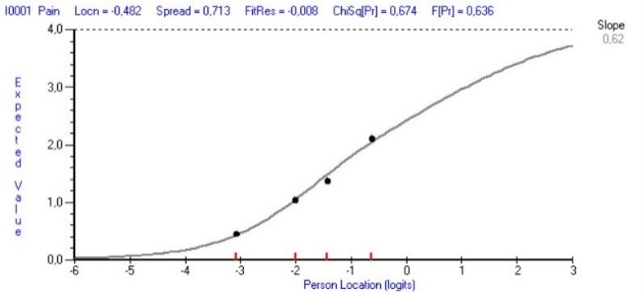 |  | 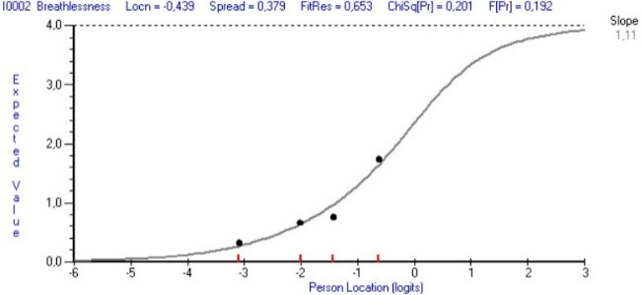
3 Fatigue |  | 4 Nausea
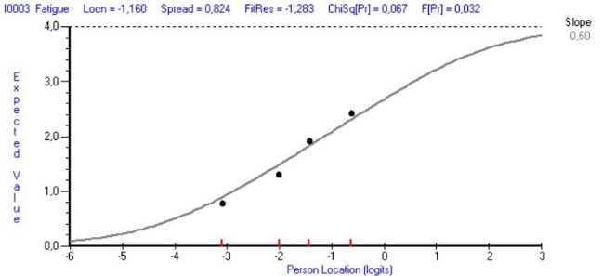 |  | 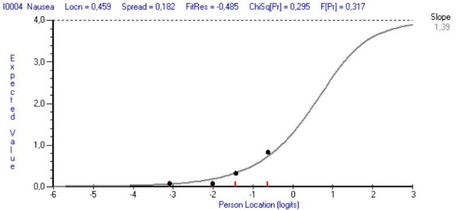
5 Vomiting |  | 6 Poor appetite
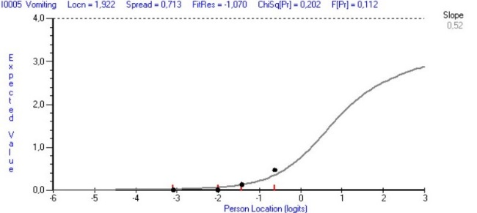 |  | 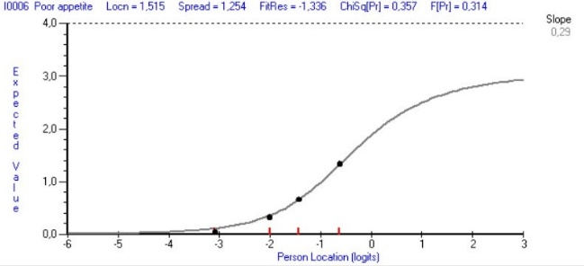
7 Constipation |  | 8 Sore or dry mouth
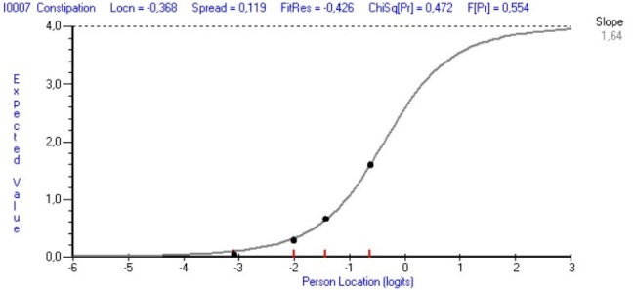 |  | 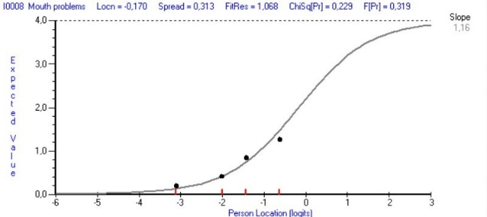
9 Drowsiness |  | 10 Poor mobility
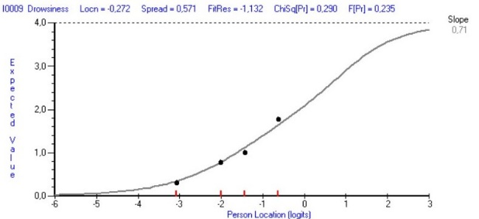 |  | 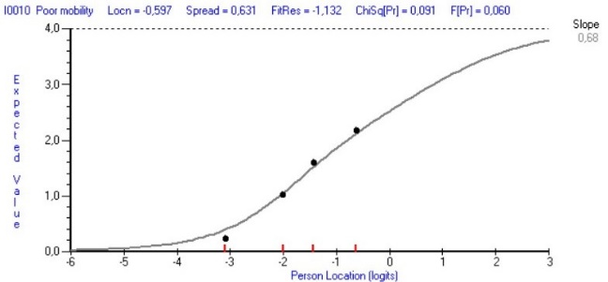
11 Diarrhoea |  | 12 Tingling in hands/feet
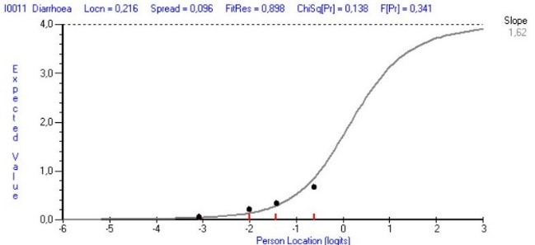 |  | 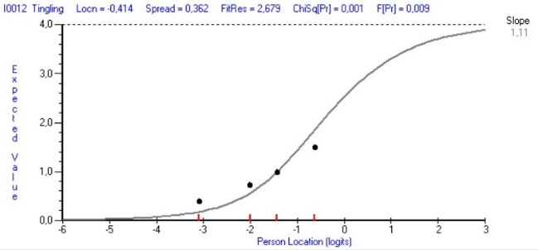
13 Difficulties remembering
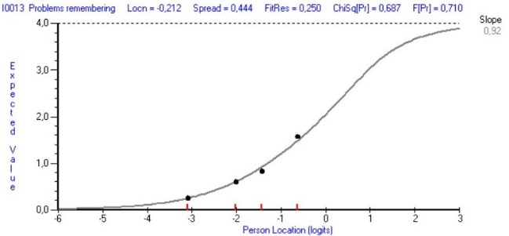
SUBSCALE EMOTIONAL FUNCTIONING
14 Anxiety | 15 Family anxiety
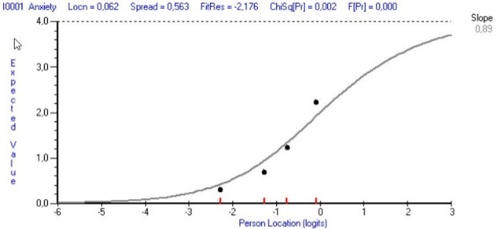 | 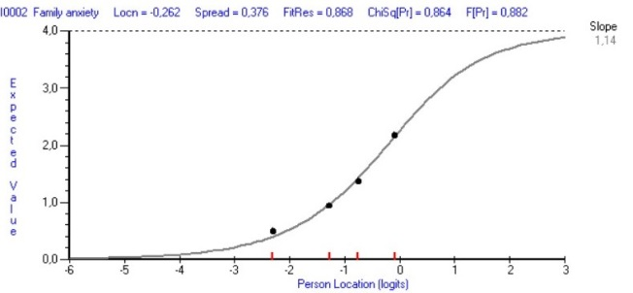
16 Depression | 17 Feeling at peace
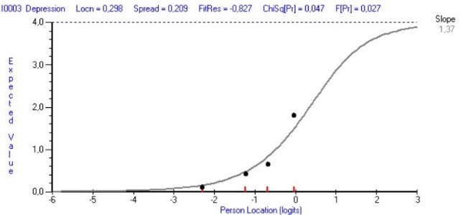 | 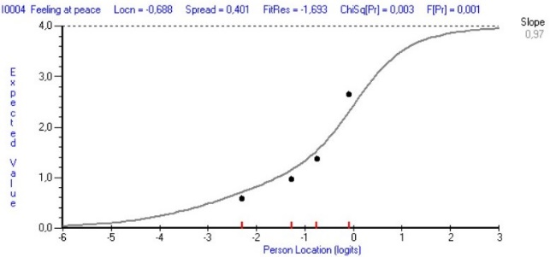
18 Sharing with family/friends | 19 Information
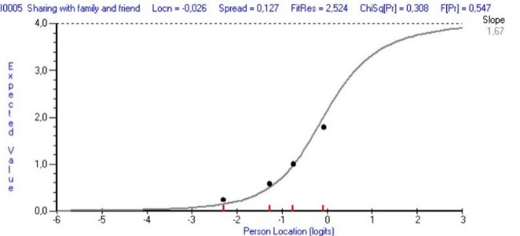 | 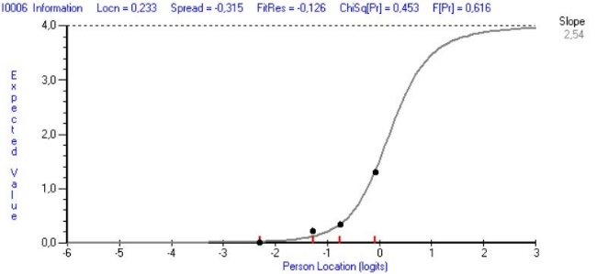
20 Practical matters | 21 Usual activities
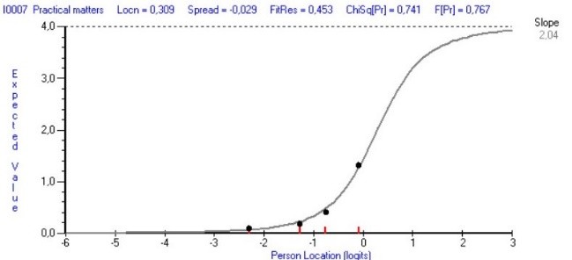 | 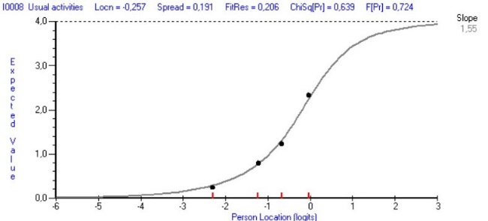
22 Hobbies | 23 Quality time
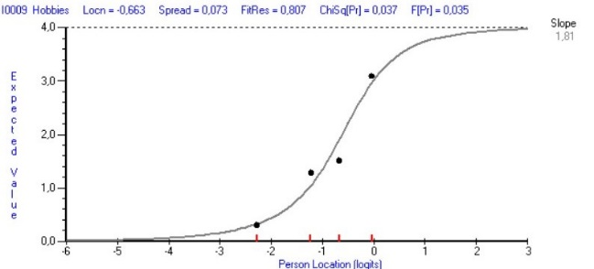 | 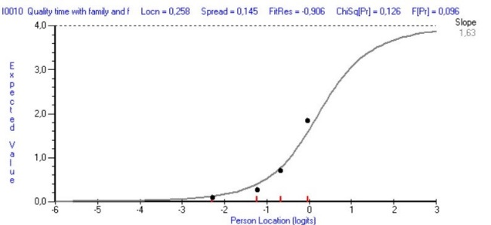
24 Worry about sex life | 25 Worry about infections
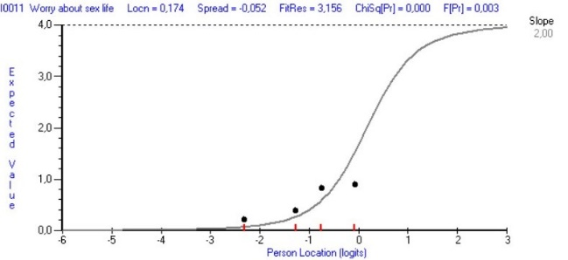 | 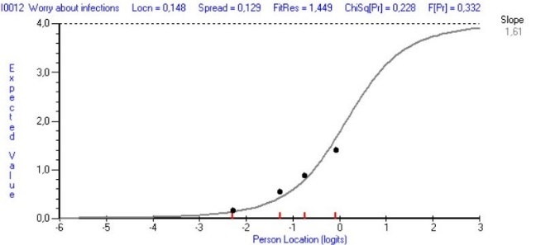
26 Worry about physical appearance | 27 Worry about finances
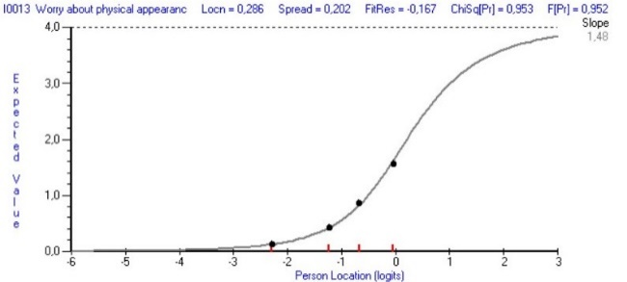 | 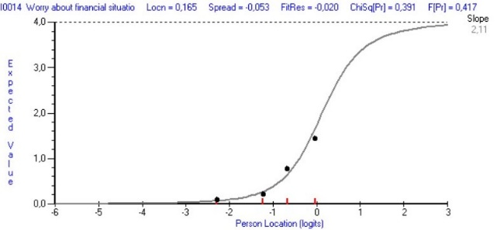
28 Worry about illness worsening | 29 Coping with illness/treatment
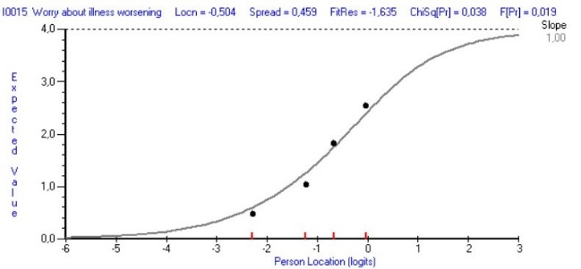 | 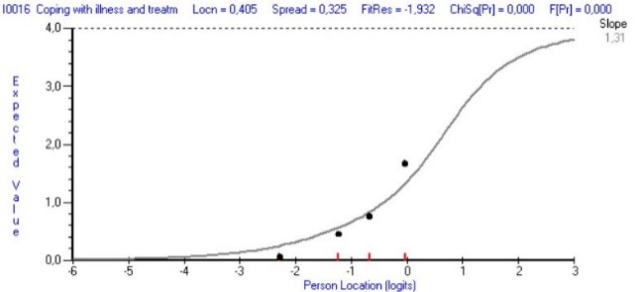
33 Information about future
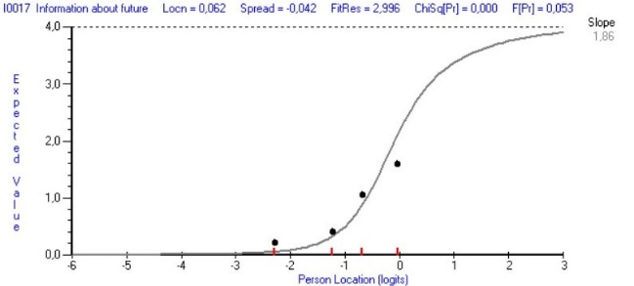
SUBSCALE HEALTHCARE SUPPORT
30 Advice from doctors/nurses | 31 Knowledge of doctors/nurses
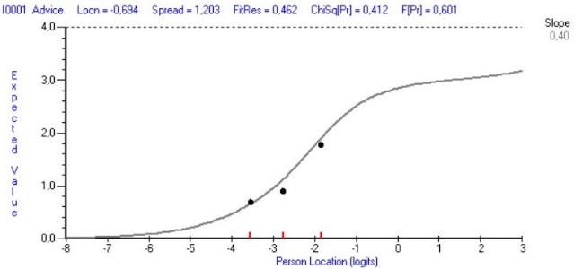 | 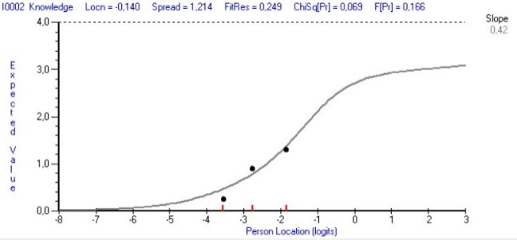
32 Doctors/nurses show care/respect
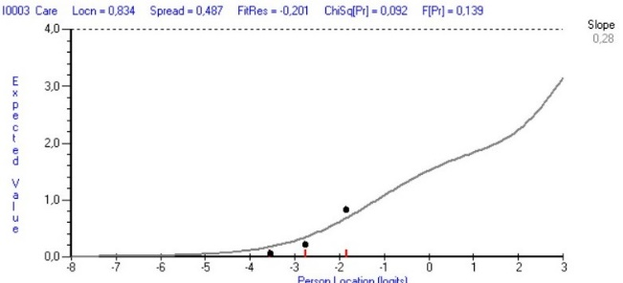

Supplemental Figure 4 Distribution (expressed in percent) of changes in scores on the total Myeloma Patient Outcome Scale for patients with multiple myeloma who report an important improvement (left-hand side) or an important deterioration (right-hand side) in their quality of life compared to those who reported no important change at time point 5. The ROC point indicates the ROC-based MID, the distribution-based MID indicates the 95% limit of error that was determined.
