Appendix 3. PRO protocol checklist scores overtime
Rebecca Mercieca-Bebber, Michael Friedlander, Peey-Sei Kok, Melanie Calvert, Derek Kyte, Martin Stockler, Madeleine T. King. The patient-reported outcome content of international ovarian cancer randomised controlled trial protocols.

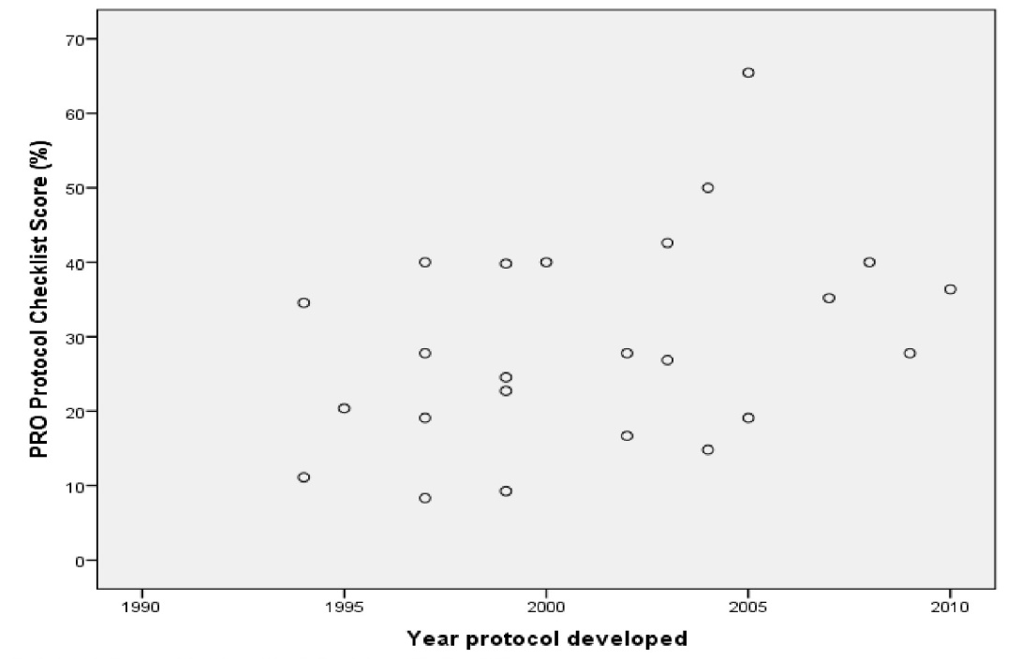
Note: year of protocol development was unclear for 2 protocols, therefore this plot includes PRO protocol checklist scores (%) for 24 ovarian cancer RCTs. There was a trend towards total PRO protocol checklist scores improving overtime, however it was not statistically significant: r =0.37, p=0.07 [95% CI -0.35, 0.68].

