Appendix A
Cronbach’s Alphas of Observed Variables per Wave
Wave | 1 | 2 | 3 | 4 | 5 | 6
Autonomy support father
Child-reported | .79 | .84 | .86 | .84 | .88 | .89
Father-reported | .84 | .85 | .86 | .87 | .85 | .89
Autonomy support mother
Child-reported | .85 | .86 | .86 | .86 | .87 | .89
Mother-reported | .85 | .87 | .86 | .89 | .89 | .90
Depressive symptoms
Child-reported | .93 | .94 | .94 | .95 | .94 | .94
Father-reported | .81 | .87 | .88 | .87 | .91 | .91
Mother-reported | .90 | .88 | .90 | .88 | .89 | .88

Appendix B
Simplified Representation of RI-CLPM
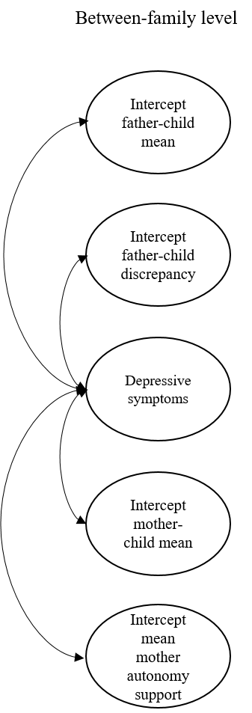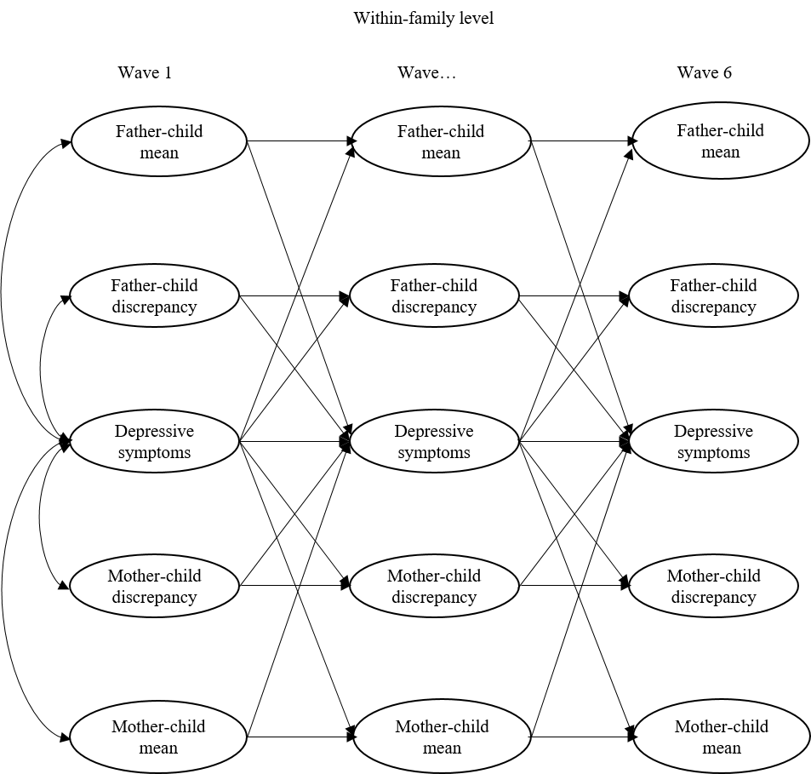
Note. Simplified representation of RI-CLPM, all possible between- and within-family associations are modelled, but not visualized. Depressive symptoms of child, father and mother are individually included in the model, but not visualized. Parent-child mean = latent variable of the average scores of parent and child report on autonomy support, parent-child discrepancy = latent difference score of parent and child report on autonomy support

Appendix C
Concurrent Correlations per Wave
Wave 1 | 1 | 2 | 3 | 4 | 5 | 6
1. Child-reported father support
2.Child-reported mother support | 0.64***
3.Father-reported support | 0.13** | 0.01
4.Mother-reported support | 0.21*** | 0.18*** | 0.19***
5.Child depressive symptoms | -0.34*** | -0.23*** | -0.12* | -0.11*
6.Father depressive symptoms | -0.03 | 0.00 | 0.06 | 0.04 | 0.06
7.Mother depressive symptoms | -0.09* | -0.07 | -0.04 | -0.03 | 0.21*** | 0.09

Wave 2 | 1 | 2 | 3 | 4 | 5 | 6
1. Child-reported father support
2.Child-reported mother support | 0.61***
3.Father-reported support | 0.22*** | 0.18***
4.Mother-reported support | 0.18*** | 0.22*** | 0.24***
5.Child depressive symptoms | -0.28*** | -0.19*** | -0.12* | -0.11*
6.Father depressive symptoms | -0.01 | 0.01 | -0.02 | 0.12* | -0.02
7.Mother depressive symptoms | -0.08 | -0.08 | -0.05 | -0.03 | 0.23*** | 0.21***

Wave 3 | 1 | 2 | 3 | 4 | 5 | 6
1. Child-reported father support
2.Child-reported mother support | 0.57***
3.Father-reported support | 0.26*** | 0.19***
4.Mother-reported support | 0.18*** | 0.14** | 0.22***
5.Child depressive symptoms | -0.28*** | -0.23*** | -0.14** | -0.05
6.Father depressive symptoms | 0.07 | 0.08 | 0.03 | 0.04 | 0.12
7.Mother depressive symptoms | -0.06 | -0.04 | 0.00 | 0.01 | 0.22*** | 0.23***

Wave 5 | 1 | 2 | 3 | 4 | 5 | 6
1. Child-reported father support
2.Child-reported mother support | 0.58***
3.Father-reported support | 0.26*** | 0.21***
4.Mother-reported support | 0.18*** | 0.12* | 0.25***
5.Child depressive symptoms | -0.22*** | -0.27*** | -0.07 | -0.05
6.Father depressive symptoms | 0.06 | 0.07 | 0.00 | 0.00 | 0.07
7.Mother depressive symptoms | 0.01 | -0.05 | -0.04 | -0.13** | 0.25*** | 0.23***
Wave 4 | 1 | 2 | 3 | 4 | 5 | 6
1. Child-reported father support
2.Child-reported mother support | 0.66***
3.Father-reported support | 0.18*** | 0.14**
4.Mother-reported support | 0.21*** | 0.17*** | 0.22***
5.Child depressive symptoms | -0.29*** | -0.24*** | -0.13* | -0.10*
6.Father depressive symptoms | 0.11* | 0.11* | 0.03 | 0.04 | 0.04
7.Mother depressive symptoms | -0.06 | -0.13** | 0.00 | -0.09 | 0.21*** | 0.12*
Wave 6 | 1 | 2 | 3 | 4 | 5 | 6
1. Child-reported father support
2.Child-reported mother support | 0.52***
3.Father-reported support | 0.23*** | 0.19***
4.Mother-reported support | 0.13** | 0.22*** | 0.16**
5.Child depressive symptoms | -0.29*** | -0.21*** | -0.10* | -0.01
6.Father depressive symptoms | 0.01 | 0.07 | 0.01 | -0.01 | 0.14
7.Mother depressive symptoms | -0.13** | -0.07 | -0.05 | -0.04 | 0.20*** | 0.21***

Note. Support = autonomy support, * p < .05, ** p < .01, *** p <.001

