Parental and pandemic burnout, internalizing symptoms, and parent-adolescent relationships: A network analysis
Supplementary materials

Figure S1
Simulation results using the estimated refitted network as true network structure. The panel shows the sensitivity (true positive rate), specificity (true negative rate) and correlation between true and estimated networks
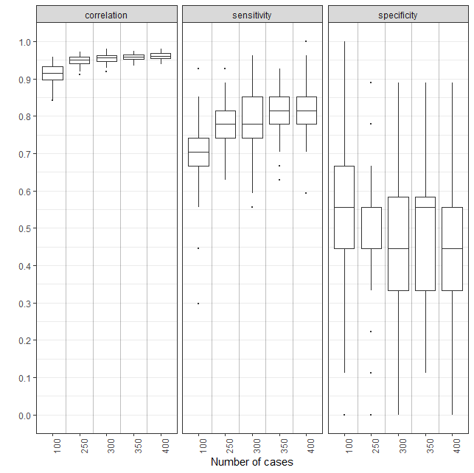

Figure S2
Bootstrapped Confidence Intervals of Estimated Weights for the Graphical Gaussian Model
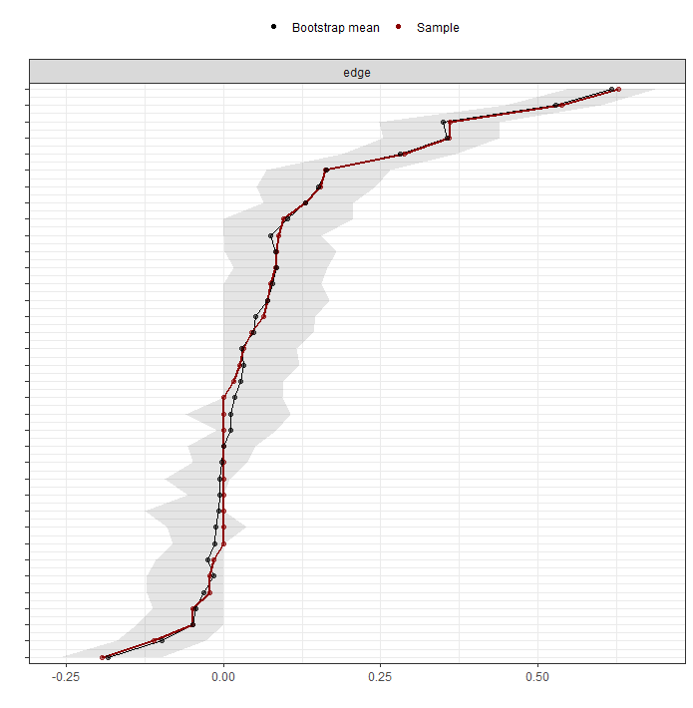
Note. The red line indicates the values from the original sample, while the dark line indicates the mean bootstrapped values. The gray area indicates the 95% confidence intervals.

Figure S3
Bootstrapped Difference Tests (α = 0.05) Between Non-zero Edge Weights in the Estimated Network

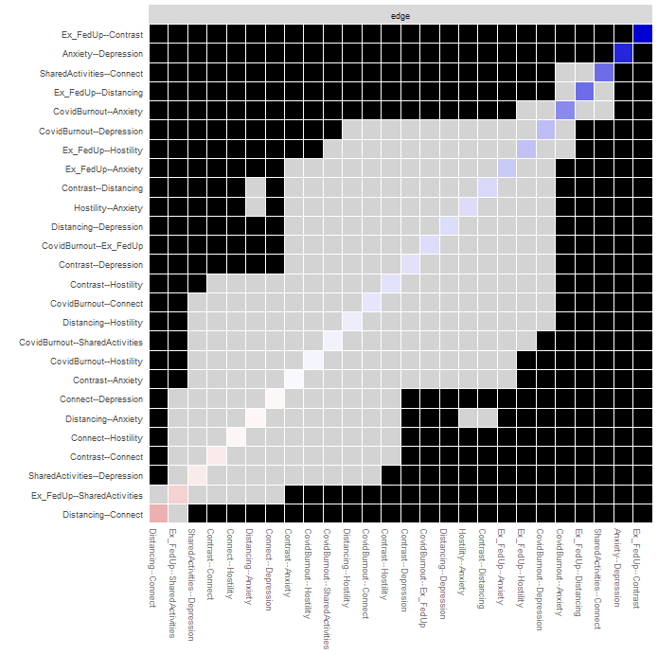
Note. Black boxes denote edges that significantly differ from one another, while gray boxes indicate edges that do not. Colored boxes indicate the weight of that edge, with a darker color indicating a larger weight. Ex_FedUp = Emotional exhaustion and feelings of being fed up; Contrast = Loss of parental accomplishment and efficacy.

Figure S4
Average Correlations Between Centrality Indices (i.e., Expected Influence and Bridge Expected Influence) of the Original Network and Network with Persons Dropped

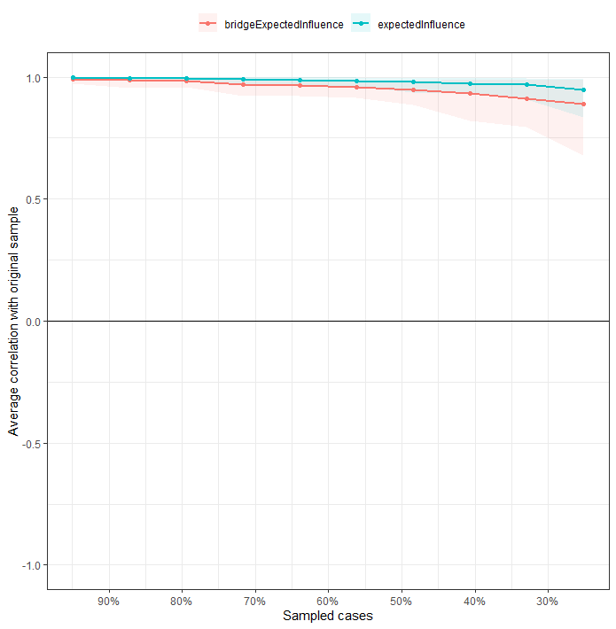

Figure S5
Bootstrapped Difference Tests Between the Expected Influence of Nodes

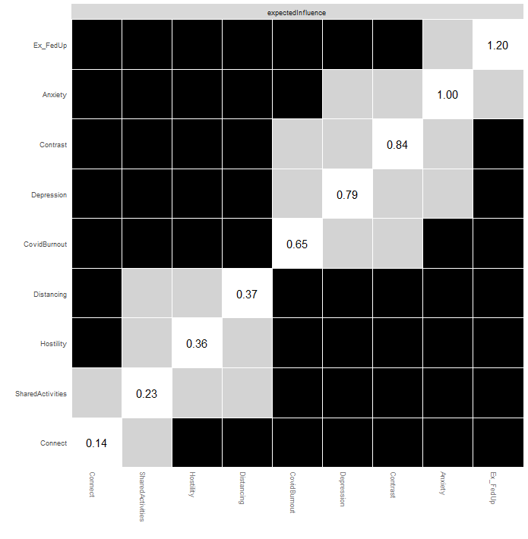
Note. Black boxes denote edges that significantly differ from one another, while gray boxes indicate edges that do not. Ex_FedUp = Emotional exhaustion and feelings of being fed up; Contrast = Loss of parental accomplishment and efficacy.

Figure S6
Bootstrapped Difference Tests Between the Bridge Expected Influence of Nodes

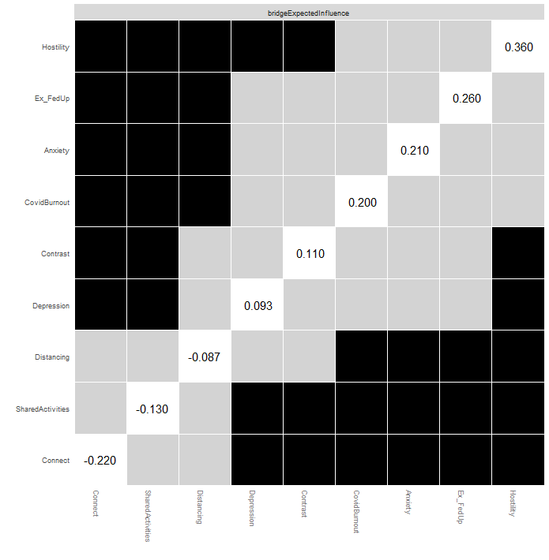

Note. Black boxes denote edges that significantly differ from one another, while gray boxes indicate edges that do not. Ex_FedUp = Emotional exhaustion and feelings of being fed up; Contrast = Loss of parental accomplishment and efficacy.

Table S1
Bridge Expected Influence of Nodes Belonging to the Particular Communities

Node | Parental burnout ↔ Parent-adolescent relationship | Pandemic burnout/parental internalizing symptoms ↔ Parent-adolescent relationship | Parental burnout ↔ Pandemic burnout/parental internalizing symptoms
Exhaustion/FedUp | .038 |  | .247
Distancing | -.194 |  | .110
Contrast | .000 |  | .086
Pandemic burnout |  | 0 | .096
Depression |  | 0 | .196
Anxiety |  | 0 | .152
Connectedness | -.194 | 0
Shared Activities | -.115 | 0
Hostility | .153 | 0

