Supporting information – Full Goal Coding Scheme
Goal specificity
Follows Scoring system of Dickson & MacLeod (2004).
*Note: Clarification from discussions between coders:
*To code as 2 (Specific): Time, Place or Location must be present – or a specific reference to individuals close to you:
e.g., “Those close to me”; “My sister”; “My parents”
*References to COVID-19, Quarantine and Lockdown count as a specific time aspect.
*To code as 1 (Moderate): The goal must be specific in the way it is operationalised:
e.g., “Reach level 7 on guitar”; “Get above 60% in Cognition and Development”; “Do HIIT training”.
Code 2 for specific: A goal response was deemed specific if it described a future aspiration with a particular target feature and also included at least one of the following aspects: place, time, or people. N.B. If the place, time, or people detail is very vague (e.g., “the world”, “sometime” or simply “people”, the goal should not be coded as specific.
Code 1 for moderate: A moderate response included a specific target feature.
Code 0 for general: A general response represented a global aspiration rather than a specific target feature or unique experience."
Examples from Dickson & MacLeod (2004):
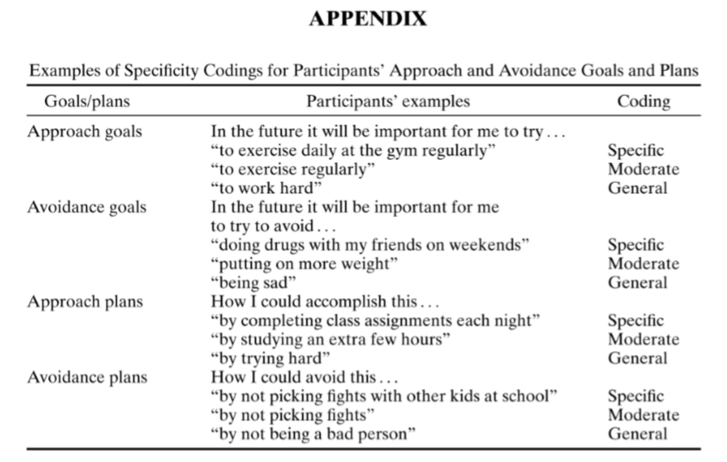
Tricky examples:
• Make friends [involves people, but “friends” is too vague – MODERATE]
• Get married at some point before I die [“before I die” relates to a time, but this is too vague, doesn’t add any information – MODERATE]
• Travel abroad [“abroad” does relate to place but it is not specific enough – MODERATE]
• Having a happy family [“family” entails people, but too vague; not clear if talking about existing family members, or some hypothetical future family – MODERATE]
• Live in another country [“another country” is too broad to be counted as a specific place – MODERATE]
• Meet new people [obviously includes “people”, but too broad – MODERATE]
• Find a job [quite vague, but more specific than a global aspiration – MODERATE]
• Get through the next month [time detail but not specific target feature – MODERATE]
• Be in a healthy marriage [target feature but not specific people detail – MODERATE]
• Find a girlfriend [“a girlfriend” is not a specific people detail – MODERATE]
• Live in Portugal [although “live” is quite vague, there is a specific place detail – SPECIFIC]
• Set up a company in Europe [“Europe” is specific enough to be counted as a place feature – SPECIFIC]
• Make some friends who also play tennis [specifies the “type” of friends – SPECIFIC]
• See my friends [“my friends” probably refers to specific people in this person’s life – SPECIFIC]
• Be good to my children [reference to specific people – SPECIFIC]
• Get a job after my degree [“after my degree” is a time detail – SPECIFIC]

