Supplemental material
a. Cross-sectional study design
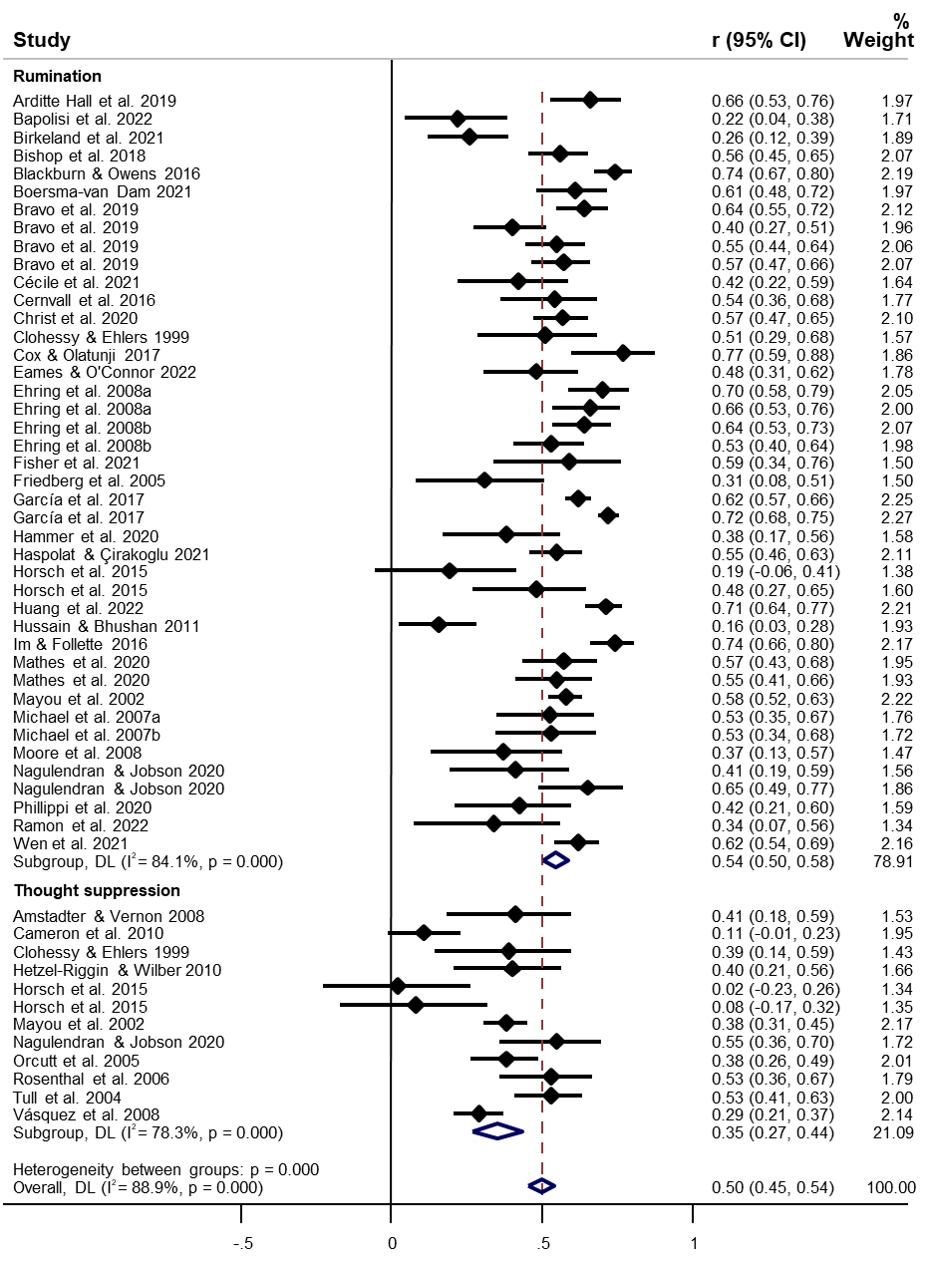

b. Longitudinal study design
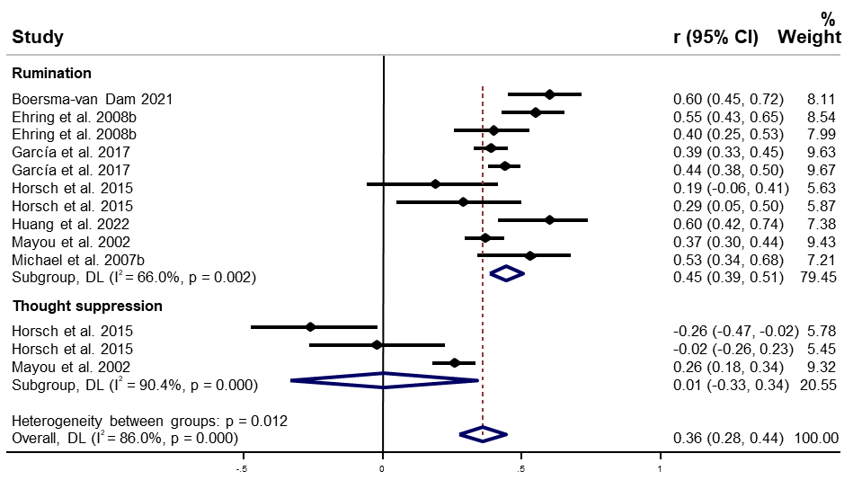
Figure S1: Forest plots by study design for TS and rumination

