Supplementary Material Online, belonging to

Jović, Agarwal, Whitehouse, and van den Berg. Harmonized phenotypes for anxiety, depression, and attention-deficit hyperactivity disorder (ADHD).
Table of Contents
Top-down approach - scales 3
Supplementary Table I 3
Supplementary Table II 4
Supplementary Table III 4
Supplementary Table IV 4
Top-down approach - figures 5
Supplementary Figure I 5
Supplementary Figure II 5
Supplementary Figure III 6
Bottom-up approach – factor analyses 6
Supplementary Table V 6
Supplementary Table VI 9
Bottom-up approach - scales 12
Supplementary Table VII 12
Supplementary Table VIII 13
Supplementary Table IX 13
Supplementary Table X 14
Supplementary Table XI 14
Supplementary Table XII 15
Supplementary Table XIII 15
Bottom-up approach - figures 16
Supplementary Figure IV 16
Supplementary Figure V 16
Supplementary Figure VI 17
Supplementary Figure VII 17
Supplementary Figure VIII 18
Test information curves – Top-down approach 19
Supplementary Figure IX 19
Supplementary Figure X 20
Scatter plots – Top-down approach 21
Supplementary Figure XI 21
Supplementary Figure XII 22
Example R code to obtain harmonized scores for anxiety/depression and ADHD based on item parameters from this study 22
Supplementary Table XVI 26

Top-down approach - scales

Supplementary Table I Original anxiety/depression scale consisting only of the CBCL items
Item | Discrimination parameter | Threshold parameter  Category 1 | Threshold parameter Category 2 | Chi-square | Degrees of Freedom | Corrected  p-value
CBCL lonely | 1.31 | -2.24 | -6.35 | 35.26 | 22 | 1.00
CBCL cries a lot | 1.23 | -2.57 | -6.21 | 24.18 | 23 | 1.00
CBCL fears might do bad | 1.27 | -2.82 | -7.96 | 16.01 | 23 | 1.00
CBCL fears has to be perfect | 0.92 | -1.28 | -4.01 | 41.31 | 38 | 1.00
CBCL feels unloved | 1.19 | -1.70 | -5.53 | 25.82 | 26 | 1.00
CBCL feels others out to get | 1.71 | -2.88 | -7.82 | 21.23 | 21 | 1.00
CBCL feels worthless | 1.91 | -2.81 | -8.27 | 33.91 | 21 | 1.00
CBCL loner | 1.07 | -2.18 | -5.72 | 16.54 | 23 | 1.00
CBCL nervous or tense | 1.54 | -2.13 | -6.14 | 32.05 | 29 | 1.00
CBCL too fearful or anxious | 1.84 | -2.94 | -7.93 | 14.06 | 21 | 1.00
CBCL feels dizzy | 1.32 | -3.70 | -9.10 | 33.12 | 22 | 1.00
CBCL feels too guilty | 1.99 | -4.32 | -10.68 | 26.52 | 22 | 1.00
CBCL overtired | 1.29 | -2.17 | -6.19 | 15.56 | 21 | 1.00
CBCL no cause aches/pains | 0.85 | -1.31 | -4.60 | 24.50 | 33 | 1.00
CBCL no cause headaches | 0.68 | -1.05 | -3.90 | 37.58 | 37 | 1.00
CBCL no cause nausea | 1.13 | -2.11 | -6.39 | 28.43 | 22 | 1.00
CBCL no cause eye problems | 0.57 | -3.81 | -5.67 | 30.95 | 17 | 0.63
CBCL no cause skin problems | 0.64 | -2.25 | -5.07 | 18.11 | 22 | 1.00
CBCL no cause stomachaches | 0.89 | -1.26 | -4.78 | 21.94 | 28 | 1.00
CBCL no cause vomiting | 0.92 | -3.23 | -7.42 | 17.29 | 21 | 1.00
CBCL refuses to talk | 1.39 | -3.28 | -7.85 | 20.90 | 23 | 1.00
CBCL secretive | 1.32 | -1.81 | -6.22 | 21.14 | 21 | 1.00
CBCL self-conscious | 1.35 | -0.29 | -3.74 | 25.47 | 36 | 1.00
CBCL shy or timid | 0.95 | -0.94 | -4.18 | 37.24 | 35 | 1.00
CBCL stares blankly | 1.44 | -3.28 | -8.60 | 19.72 | 23 | 1.00
CBCL sulks a lot | 1.23 | -1.76 | -5.25 | 46.32 | 32 | 1.00
CBCL suspicious | 1.71 | -4.05 | -9.72 | 25.13 | 23 | 1.00
CBCL lacks energy/slow | 1.27 | -3.20 | -6.74 | 17.88 | 23 | 1.00
CBCL unhappy depressed | 2.30 | -3.17 | -10.16 | 24.61 | 20 | 1.00
CBCL withdrawn | 1.92 | -3.97 | -10.63 | 30.90 | 23 | 1.00
CBCL worries | 1.95 | -1.27 | -6.23 | 36.64 | 30 | 1.00

Supplementary Table II Original anxiety/depression scale consisting only of the SDQ items
Item | discrimination parameter | threshold parameter category 1 | threshold parameter category 2 | Chi-square | Degrees of freedom | Corrected p-value
SDQ complains of illness | 0.83 | -0.82 | -3.10 | 13.83 | 10 | 0.90
SDQ often seems worried | 2.32 | -1.42 | -6.07 | 13.88 | 8 | 0.43
SDQ often unhappy/tearful | 1.55 | -2.21 | -6.54 | 15.36 | 9 | 0.41
SDQ nervous or clingy | 1.18 | -0.64 | -3.60 | 18.16 | 9 | 0.17
SDQ easily scared | 1.71 | -1.96 | -6.05 | 18.43 | 8 | 0.09

Supplementary Table III Original ADHD scale consisting of the CBCL items
Item | Discrimination parameter | Threshold parameter  Category 1 | Threshold parameter Category 2 | Chi-square | Degrees of Freedom | Corrected  p-value
CBCL acts too young | 1.42 | -1.89 | -5.67 | 16.59 | 22 | 1.00
CBCL can’t concentrate | 3.28 | -1.92 | -7.42 | 17.32 | 14 | 1.00
CBCL restless, hyperactive | 1.48 | -1.53 | -4.97 | 31.10 | 20 | 0.59
CBCL confused | 2.07 | -3.96 | -9.79 | 10.84 | 14 | 1.00
CBCL day dreams | 1.28 | -1.20 | -4.25 | 16.98 | 21 | 1.00
CBCL impulsive | 1.73 | -0.92 | -4.71 | 31.33 | 19 | 0.41
CBCL nervous or tense | 0.84 | -1.77 | -4.63 | 24.53 | 22 | 1.00
CBCL nervous movements | 0.94 | -3.60 | -5.61 | 27.70 | 21 | 1.00
CBCL poor school work | 1.96 | -2.58 | -6.81 | 20.11 | 19 | 1.00
CBCL poorly coordinated | 1.37 | -2.89 | -6.72 | 38.78 | 18 | 0.03
CBCL stares blankly | 1.59 | -3.43 | -9.31 | 16.86 | 11 | 1.00

Supplementary Table IV Original ADHD scale consisting of the SDQ items
Item | Discrimination parameter | Threshold parameter  Category 1 | Threshold parameter Category 2 | Chi-square | Degrees of Freedom | Corrected  p-value
SDQ restless | 1.97 | -0.99 | -4.60 | 15.36 | 8 | 0.26
SDQ constantly fidgeting | 1.74 | -1.26 | -4.58 | 20.23 | 8 | 0.05
SDQ easily distracted | 2.99 | 0.11 | -3.74 | 12.78 | 7 | 0.39
SDQ thinks before acting | 1.51 | 1.62 | -1.30 | 6.03 | 8 | 1.00
SDQ good attention span | 2.04 | 0.71 | -2.39 | 24.22 | 8 | 0.01

Top-down approach – figures
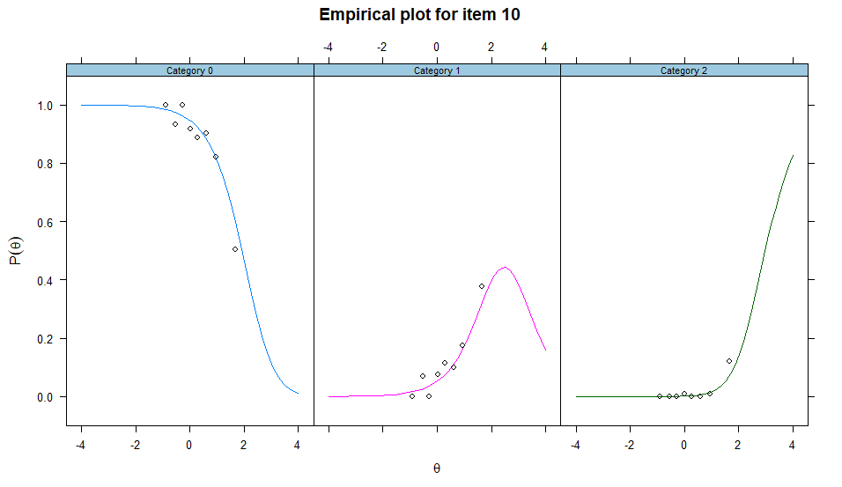
Supplementary Figure 1 Item fit curve for item 10 (“CBCL poorly coordinated”) from the original ADHD scale consisting of the CBCL items

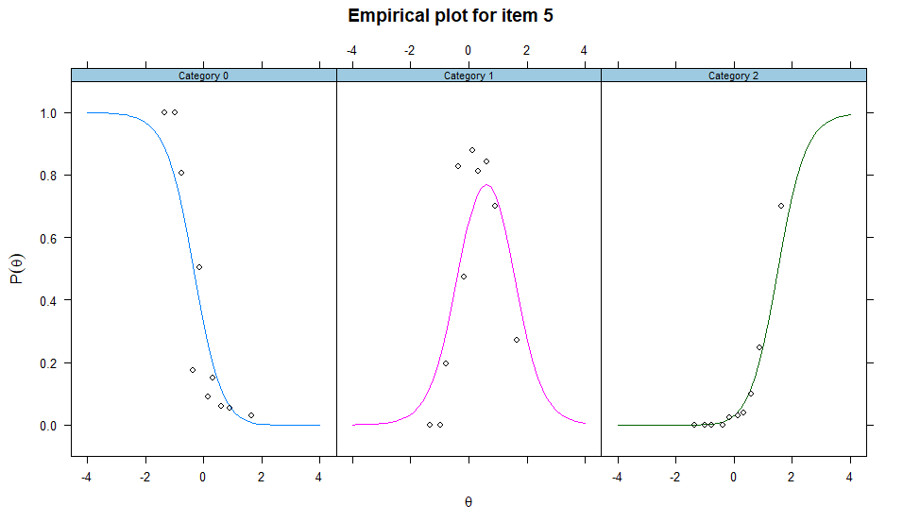
Supplementary Figure 2 Item fit curve for item 5 (“SDQ good attention span”) from the original ADHD scale consisting of the SDQ items
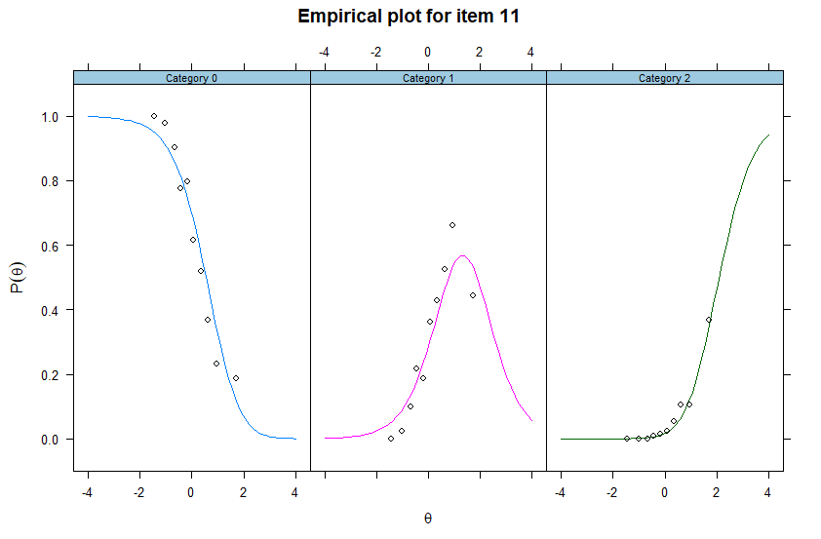Supplementary Figure 3 Item fit curve for item 11 (“SDQ restless”) from ADHD scale consisting of both CBCL and SDQ items (top-down approach)

Bottom-up approach – factor analyses

Supplementary Table V Factor analysis with two fixed factors and Promax rotation (factor loadings higher than .3 or lower than -.3)
Item | Factor 1 | Factor 2
CBCL acts too young
CBCL allergy
CBCL argues a lot | 0.575
CBCL asthma
CBCL behaves like opposite sex
CBCL bowels outside toilet
CBCL bragging | 0.478
CBCL cant concentrate | 0.505
CBCL obsessions |  | 0.410
CBCL restless, hyperactive | 0.529
CBCL too dependent |  | 0.537
CBCL lonely |  | 0.389
CBCL confused |  | 0.423
CBCL cries a lot |  | 0.353
CBCL cruel to animals | 0.440
CBCL cruel, bully | 0.661
CBCL day dreams |  | 0.336
CBCL deliberate harm | 0.365
CBCL demands attention | 0.432
CBCL destroys own things | 0.621
CBCL destroys other`s things | 0.622
CBCL disobedient at home | 0.677
CBCL disobedient at school | 0.693
CBCL doesn't eat well
CBCL doesn't get along | 0.381
CBCL doesn't feel guilty | 0.622
CBCL easily jealous
CBCL eats or drinks pica
CBCL fears animals, situations |  | 0.427
CBCL fears going to school |  | 0.392
CBCL fears might do bad |  | 0.393
CBCL fears has to be perfect |  | 0.479
CBCL feels unloved | 0.362
CBCL feels others out to get |  | 0.337
CBCL feels worthless |  | 0.488
CBCL accident prone
CBCL gets in fights | 0.576
CBCL gets teased a lot | 0.352
CBCL hangs out with trouble | 0.554
CBCL hears voices not there
CBCL impulsive | 0.621
CBCL loner |  | 0.391
CBCL lying or cheating | 0.626
CBCL bites fingernails
CBCL nervous or tense |  | 0.612
CBCL nervous movements
CBCL nightmares |  | 0.386
CBCL not liked by other kids | 0.333
CBCL constipated
CBCL too fearful or anxious |  | 0.712
CBCL feels dizzy |  | 0.345
CBCL feels too guilty |  | 0.493
CBCL overeating
CBCL overtired |  | 0.449
CBCL overweight
CBCL no cause aches/pains |  | 0.317
CBCL no cause headaches
CBCL no cause nausea |  | 0.391
CBCL no cause eye problems
CBCL no cause skin problems
CBCL no cause stomachaches |  | 0.395
CBCL no cause vomiting
CBCL no cause other symptoms
CBCL attacks people | 0.548
CBCL picks nose, etc
CBCL plays sex parts in public
CBCL plays sex parts too much
CBCL poor school work | 0.431
CBCL poorly coordinated |  | 0.322
CBCL likes older kids
CBCL likes younger kids
CBCL refuses to talk
CBCL compulsive behaviour
CBCL runs away from home | 0.425
CBCL screams a lot | 0.475
CBCL secretive |  | 0.347
CBCL sees things not there
CBCL self-conscious |  | 0.544
CBCL sets fires | 0.358
CBCL sexual problems
CBCL showing off | 0.533
CBCL shy or timid |  | 0.532
CBCL sleeps less than most
CBCL sleeps more than most
CBCL plays with bowel motions
CBCL speech problem
CBCL stares blankly |  | 0.324
CBCL steals at home | 0.425
CBCL steals outside home | 0.313
CBCL stores things up
CBCL strange behaviour
CBCL strange ideas
CBCL stubborn, sullen | 0.444
CBCL sudden change in mood | 0.362
CBCL sulks a lot |  | 0.312
CBCL suspicious
CBCL obscene language | 0.533
CBCL talks about killing self | 0.352
CBCL talks/walks in sleep
CBCL talks too much
CBCL teases a lot | 0.507
CBCL temper tantrums | 0.574
CBCL thinks sex too much
CBCL threatens people | 0.501
CBCL thumb-sucking
CBCL overly neat/clean
CBCL trouble sleeping |  | 0.325
CBCL skips school
CBCL lacks energy/slow |  | 0.437
CBCL unhappy/depressed |  | 0.464
CBCL unusually loud | 0.502
CBCL uses alcohol or drugs
CBCL vandalism | 0.488
CBCL wets self during day
CBCL wets the bed
CBCL whining
CBCL wants to be other sex
CBCL withdrawn |  | 0.389
CBCL worries |  | 0.689
CBCL any other problems
SDQ considerate of others | -0.532
SDQ restless | 0.488
SDQ complains of illness |  | 0.417
SDQ shares well | -0.353
SDQ temper tantrums | 0.514
SDQ solitary, plays alone |  | 0.316
SDQ generally obedient | -0.561
SDQ often seems worried |  | 0.632
SDQ helpful of others in need | -0.315
SDQ constantly fidgeting | 0.409
SDQ at least one good friend
SDQ often fights/bullies | 0.613
SDQ often unhappy/tearful |  | 0.395
SDQ generally liked by kids | -0.373
SDQ easily distracted | 0.438
SDQ nervous or clingy |  | 0.547
SDQ kind to younger kids | -0.332
SDQ often lies/cheats | 0.592
SDQ picked on/bullied
SDQ volunteers to help others
SDQ thinks before acting | -0.485
SDQ steals | 0.386
SDQ relates better to adults than kids
SDQ easily scared |  | 0.650
SDQ good attention span | -0.478

Supplementary Table VI Factor analysis with four fixed factors and Promax rotation (factor loadings higher than .3 or lower than -.3)
Item | Factor 1 | Factor 2 | Factor 3 | Factor 4
CBCL acts too young |  |  |  | 0.446
CBCL allergy
CBCL argues a lot |  |  | 0.632
CBCL asthma
CBCL behaves like opposite sex
CBCL bowels outside toilet
CBCL bragging |  |  | 0.399
CBCL cant concentrate |  |  |  | 0.741
CBCL obsessions | 0.351
CBCL restless, hyperactive |  |  | 0.335 | 0.523
CBCL too dependent | 0.507
CBCL lonely | 0.387
CBCL confused | 0.353
CBCL cries a lot | 0.358
CBCL cruel to animals |  | 0.487
CBCL cruel, bully |  | 0.508 | 0.317
CBCL day dreams |  |  |  | 0.401
CBCL deliberate harm |  | 0.501
CBCL demands attention |  |  | 0.412
CBCL destroys own things |  | 0.646
CBCL destroys other`s things |  | 0.602
CBCL disobedient at home |  |  | 0.649
CBCL disobedient at school |  | 0.410
CBCL doesn't eat well
CBCL doesn't get along
CBCL doesn't feel guilty |  | 0.308 | 0.412
CBCL easily jealous | 0.330 |  | 0.414
CBCL eats or drinks pica
CBCL fears animals, situations | 0.403
CBCL fears going to school | 0.372
CBCL fears might do bad | 0.376
CBCL fears has to be perfect | 0.518
CBCL feels unloved
CBCL feels others out to get | 0.336
CBCL feels worthless | 0.460
CBCL accident prone
CBCL gets in fights |  | 0.581
CBCL gets teased a lot
CBCL hangs out with trouble |  | 0.368
CBCL hears voices not there
CBCL impulsive |  |  | 0.381 | 0.425
CBCL loner | 0.362
CBCL lying or cheating |  |  | 0.422
CBCL bites fingernails
CBCL nervous or tense | 0.585
CBCL nervous movements
CBCL nightmares | 0.393
CBCL not liked by other kids
CBCL constipated | 0.305
CBCL too fearful or anxious | 0.676
CBCL feels dizzy | 0.338
CBCL feels too guilty | 0.473
CBCL overeating
CBCL overtired | 0.438
CBCL overweight
CBCL no cause aches/pains | 0.343
CBCL no cause headaches
CBCL no cause nausea | 0.400
CBCL no cause eye problems
CBCL no cause skin problems
CBCL no cause stomachaches | 0.410
CBCL no cause vomiting
CBCL no cause other symptoms
CBCL attacks people |  | 0.562
CBCL picks nose, etc
CBCL plays sex parts in public |  | 0.373
CBCL plays sex parts too much
CBCL poor school work |  |  |  | 0.477
CBCL poorly coordinated |  |  |  | 0.363
CBCL likes older kids
CBCL likes younger kids
CBCL refuses to talk |  | 0.372
CBCL compulsive behaviour
CBCL runs away from home |  | 0.573
CBCL screams a lot |  |  | 0.356
CBCL secretive | 0.361
CBCL sees things not there
CBCL self-conscious | 0.556
CBCL sets fires |  | 0.472
CBCL sexual problems |  | 0.338
CBCL showing off |  |  | 0.451
CBCL shy or timid | 0.531
CBCL sleeps less than most
CBCL sleeps more than most
CBCL plays with bowel motions
CBCL speech problem |  |  |  | 0.308
CBCL stares blankly
CBCL steals at home |  | 0.512
CBCL steals outside home |  | 0.420
CBCL stores things up
CBCL strange behaviour |  | 0.309
CBCL strange ideas
CBCL stubborn, sullen |  |  | 0.510
CBCL sudden change in mood | 0.317 |  | 0.347
CBCL sulks a lot | 0.351 |  | 0.399
CBCL suspicious
CBCL obscene language |  | 0.421
CBCL talks about killing self |  | 0.518
CBCL talks/walks in sleep
CBCL talks too much |  |  | 0.386
CBCL teases a lot |  |  | 0.452
CBCL temper tantrums |  |  | 0.553
CBCL thinks sex too much |  | 0.339
CBCL threatens people |  | 0.595
CBCL thumb-sucking
CBCL overly neat/clean | 0.301
CBCL trouble sleeping
CBCL skips school
CBCL lacks energy/slow | 0.423
CBCL unhappy/depressed | 0.476
CBCL unusually loud |  |  | 0.394
CBCL uses alcohol or drugs
CBCL vandalism |  | 0.641
CBCL wets self during day
CBCL wets the bed
CBCL whining |  |  | 0.349
CBCL wants to be other sex
CBCL withdrawn | 0.356
CBCL worries | 0.692
CBCL any other problems
SDQ considerate of others |  |  | -0.347
SDQ restless |  |  | 0.364 | 0.603
SDQ complains of illness | 0.420
SDQ shares well
SDQ temper tantrums |  |  | 0.495
SDQ solitary, plays alone
SDQ generally obedient |  |  | -0.440
SDQ often seems worried | 0.609
SDQ helpful of others in need
SDQ constantly fidgeting |  |  |  | 0.570
SDQ at least one good friend
SDQ often fights/bullies |  | 0.431
SDQ often unhappy/tearful | 0.382
SDQ generally liked by kids
SDQ easily distracted |  |  |  | 0.826
SDQ nervous or clingy | 0.502
SDQ kind to younger kids
SDQ often lies/cheats |  |  | 0.371
SDQ picked on/bullied
SDQ volunteers to help others
SDQ thinks before acting |  |  |  | -0.496
SDQ steals |  | 0.365
SDQ relates better to adults than kids
SDQ easily scared | 0.609
SDQ good attention span |  |  |  | -0.684

Bottom-up approach - scales

Supplementary Table VII Anxiety/depression scale consisting only of the CBCL items

Item | Discrimination parameter | Threshold parameter category 1 | Threshold parameter category 2 | Chi-square | Degrees of freedom | Corrected p-value
CBCL obsessions | 1.02 | -2.09 | -4.30 | 51.29 | 46 | 1.00
CBCL too dependent | 1.47 | -2.43 | -6.58 | 34.31 | 25 | 1.00
CBCL lonely | 1.36 | -2.27 | -6.43 | 33.83 | 25 | 1.00
CBCL confused | 1.71 | -3.56 | -8.29 | 18.79 | 26 | 1.00
CBCL cries a lot | 1.36 | -2.68 | -6.54 | 14.82 | 26 | 1.00
CBCL easily jealous | 1.21 | -1.12 | -4.34 | 35.06 | 42 | 1.00
CBCL fears animals, situations | 0.89 | -1.73 | -4.24 | 45.12 | 45 | 1.00
CBCL fears going to school | 1.44 | -3.73 | -7.94 | 39.30 | 26 | 1.00
CBCL fears might do bad | 1.26 | -2.82 | -7.89 | 19.16 | 26 | 1.00
CBCL fears has to be perfect | 0.93 | -1.29 | -4.03 | 43.94 | 45 | 1.00
CBCL feels others out to get | 1.74 | -2.90 | -7.86 | 27.87 | 25 | 1.00
CBCL feels worthless | 1.96 | -2.85 | -8.35 | 20.88 | 25 | 1.00
CBCL loner | 1.05 | -2.17 | -5.66 | 36.77 | 26 | 1.00
CBCL nervous or tense | 1.70 | -2.23 | -6.50 | 30.62 | 35 | 1.00
CBCL nightmares | 0.87 | -1.51 | -5.20 | 30.03 | 26 | 1.00
CBCL constipated | 0.82 | -2.55 | -5.81 | 20.90 | 26 | 1.00
CBCL too fearful or anxious | 2.17 | -3.22 | -8.82 | 21.22 | 25 | 1.00
CBCL feels dizzy | 1.26 | -3.65 | -8.85 | 20.86 | 24 | 1.00
CBCL feels too guilty | 2.04 | -4.37 | -10.78 | 29.67 | 24 | 1.00
CBCL overtired | 1.28 | -2.16 | -6.16 | 17.86 | 25 | 1.00
CBCL no cause aches/pains | 0.74 | -1.28 | -4.40 | 24.44 | 35 | 1.00
CBCL no cause nausea | 0.97 | -2.01 | -5.99 | 16.67 | 26 | 1.00
CBCL no cause stomachaches | 0.79 | -1.23 | -4.61 | 22.91 | 30 | 1.00
CBCL secretive | 1.28 | -1.78 | -6.10 | 21.86 | 24 | 1.00
CBCL self-conscious | 1.33 | -0.29 | -3.72 | 44.64 | 41 | 1.00
CBCL shy or timid | 0.93 | -0.94 | -4.14 | 51.40 | 39 | 1.00
CBCL sudden change in mood | 1.40 | -1.65 | -5.15 | 29.33 | 40 | 1.00
CBCL sulks a lot | 1.33 | -1.81 | -5.45 | 35.73 | 37 | 1.00
CBCL overly neat/clean | 0.71 | -3.01 | -4.84 | 24.32 | 31 | 1.00
CBCL lacks energy/slow | 1.31 | -3.23 | -6.82 | 32.34 | 25 | 1.00
CBCL unhappy/depressed | 2.30 | -3.16 | -10.09 | 14.26 | 22 | 1.00
CBCL withdrawn | 1.93 | -3.97 | -10.56 | 36.27 | 26 | 1.00
CBCL worries | 1.96 | -1.28 | -6.24 | 41.55 | 32 | 1.00

Supplementary Table VIII Anxiety/depression scale consisting only of the SDQ items
Items | Discrimination parameter | Threshold parameter category 1 | Threshold parameter category 2 | Chi-square | Degrees of freedom | Corrected  p-value
SDQ complains of illness | 0.83 | -0.82 | -3.10 | 13.83 | 10 | 0.90
SDQ often seems worried | 2.32 | -1.42 | -6.07 | 13.88 | 8 | 0.43
SDQ often unhappy/tearful | 1.55 | -2.21 | -6.54 | 15.36 | 9 | 0.41
SDQ nervous or clingy | 1.18 | -0.64 | -3.60 | 18.16 | 9 | 0.17
SDQ easily scared | 1.71 | -1.96 | -6.05 | 18.43 | 8 | 0.09

Supplementary Table IX - Anxiety/depression scale consisting of the CBCL and SDQ items (excluded similar items)
Items | Discrimination parameter | Threshold parameter  category 1 | Threshold parameter  category 2 | Chi-square | Degrees of freedom | Corrected  p-value
CBCL obsessions | 1.02 | -2.08 | -4.31 | 47.35 | 48 | 1.00
CBCL too dependent | 1.53 | -2.46 | -6.76 | 21.95 | 27 | 1.00
CBCL lonely | 1.32 | -2.24 | -6.36 | 33.01 | 27 | 1.00
CBCL confused | 1.62 | -3.48 | -8.07 | 30.17 | 27 | 1.00
CBCL cries a lot | 1.34 | -2.65 | -6.52 | 19.55 | 27 | 1.00
CBCL easily jealous | 1.13 | -1.09 | -4.20 | 34.65 | 44 | 1.00
CBCL fears animals, situations | 0.88 | -1.74 | -4.29 | 63.54 | 45 | 1.00
CBCL fears going to school | 1.45 | -3.75 | -8.03 | 24.43 | 26 | 1.00
CBCL fears might do bad | 1.22 | -2.79 | -7.81 | 17.16 | 27 | 1.00
CBCL fears has to be perfect | 0.87 | -1.26 | -3.93 | 47.75 | 46 | 1.00
CBCL feels others out to get | 1.61 | -2.80 | -7.55 | 35.19 | 27 | 1.00
CBCL feels worthless | 1.93 | -2.82 | -8.32 | 18.26 | 27 | 1.00
CBCL loner | 1.01 | -2.15 | -5.59 | 27.06 | 27 | 1.00
CBCL nightmares | 0.82 | -1.49 | -5.12 | 29.15 | 27 | 1.00
CBCL constipated | 0.80 | -2.54 | -5.78 | 35.21 | 26 | 1.00
CBCL too fearful or anxious | 2.10 | -3.16 | -8.70 | 28.35 | 27 | 1.00
CBCL feels dizzy | 1.28 | -3.67 | -8.98 | 40.67 | 26 | 1.00
CBCL feels too guilty | 1.89 | -4.21 | -10.33 | 23.80 | 24 | 1.00
CBCL overtired | 1.25 | -2.14 | -6.10 | 45.74 | 27 | 0.47
CBCL no cause aches/pains | 0.74 | -1.27 | -4.41 | 35.14 | 36 | 1.00
CBCL no cause nausea | 1.00 | -2.03 | -6.07 | 31.33 | 27 | 1.00
CBCL no cause stomachaches | 0.80 | -1.24 | -4.63 | 40.65 | 27 | 1.00
CBCL secretive | 1.17 | -1.73 | -5.88 | 35.13 | 26 | 1.00
CBCL self-conscious | 1.27 | -0.28 | -3.63 | 47.23 | 43 | 1.00
CBCL shy or timid | 0.99 | -0.95 | -4.23 | 48.49 | 43 | 1.00
CBCL sudden change in mood | 1.35 | -1.63 | -5.06 | 34.23 | 42 | 1.00
CBCL sulks a lot | 1.28 | -1.78 | -5.34 | 35.56 | 37 | 1.00
CBCL overly neat/clean | 0.67 | -2.99 | -4.77 | 38.92 | 30 | 1.00
CBCL lacks energy/slow | 1.29 | -3.21 | -6.78 | 40.30 | 26 | 1.00
CBCL withdrawn | 1.87 | -3.92 | -10.43 | 35.85 | 26 | 1.00
SDQ complains of illness | 0.80 | -0.82 | -3.05 | 59.05 | 48 | 1.00
SDQ often seems worried | 1.40 | -1.14 | -4.32 | 72.64 | 43 | 0.11
SDQ often unhappy/tearful | 1.31 | -2.08 | -5.87 | 25.65 | 27 | 1.00
SDQ nervous or clingy | 1.05 | -0.64 | -3.39 | 54.57 | 46 | 1.00
SDQ easily scared | 1.29 | -1.76 | -5.04 | 46.64 | 42 | 1.00

Supplementary Table X ADHD scale consisting only of the CBCL items
Items | Discrimination parameter | Threshold parameter  category 1 | Threshold parameter  category 2 | Chi-square | Degrees of freedom | Corrected  p-value
CBCL acts too young | 1.36 | -1.86 | -5.55 | 12.96 | 17 | 1.00
CBCL can`t concentrate | 4.24 | -2.32 | -9.27 | 10.47 | 10 | 1.00
CBCL restless, hyperactive | 1.55 | -1.56 | -5.12 | 36.30 | 17 | 0.03
CBCL day dreams | 1.10 | -1.15 | -3.93 | 39.52 | 18 | 0.02
CBCL impulsive | 1.70 | -0.91 | -4.66 | 18.75 | 16 | 1.00
CBCL poor school work | 1.98 | -2.59 | -6.88 | 16.28 | 14 | 0.40
CBCL poorly coordinated | 1.30 | -2.84 | -6.53 | 13.03 | 16 | 1.00
CBCL speech problem | 0.85 | -3.16 | -5.05 | 37.73 | 20 | 0.08

Supplementary Table XI ADHD scale consisting only of the CBCL items (after excluding item “CBCL day dreams”)
Items | Discrimination parameter | Threshold parameter  category 1 | Threshold parameter  category 2 | Chi-square | Degrees of freedom | Corrected  p-value
CBCL acts too young | 1.33 | -1.84 | -5.48 | 16.35 | 13 | 1.00
CBCL can`t concentrate | 3.78 | -2.12 | -8.39 | 6.41 | 8 | 1.00
CBCL restless, hyperactive | 1.66 | -1.60 | -5.35 | 32.72 | 14 | 0.02
CBCL impulsive | 1.71 | -0.91 | -4.68 | 8.76 | 13 | 1.00
CBCL poor school work | 2.06 | -2.64 | -7.08 | 8.22 | 12 | 1.00
CBCL poorly coordinated | 1.24 | -2.80 | -6.37 | 17.93 | 14 | 1.00
CBCL speech problem | 0.86 | -3.17 | -5.07 | 26.08 | 16 | 0.37
Supplementary Table XII ADHD scale consisting only of the SDQ items
Items | Discrimination  parameter | Threshold parameter  category 1 | Threshold parameter  category 2 | Chi-square | Degrees of freedom | Corrected  p-value
SDQ restless | 1.97 | -0.99 | -4.60 | 15.36 | 8 | 0.26
SDQ constantly fidgeting | 1.74 | -1.26 | -4.58 | 20.23 | 8 | 0.05
SDQ easily distracted | 2.99 | 0.11 | -3.74 | 12.78 | 7 | 0.38
SDQ thinks before acting | 1.51 | 1.62 | -1.30 | 6.03 | 8 | 1.00
SDQ good attention span | 2.04 | 0.71 | -2.39 | 24.22 | 8 | 0.01

Supplementary Table XIII Combined ADHD scale consisting of the both CBCL and SDQ items (excluded similar items)
Items | Discrimination parameter | Threshold parameter  category 1 | Threshold parameter  category 2 | Chi-square | Degrees of freedom | Corrected  p-value
CBCL acts too young | 1.22 | -1.79 | -5.25 | 17.98 | 25 | 1.00
CBCL can`t concentrate | 3.58 | -2.02 | -7.98 | 14.25 | 16 | 1.00
CBCL impulsive | 1.53 | -0.87 | -4.38 | 32.45 | 22 | 0.77
CBCL poor school work | 1.81 | -2.47 | -6.46 | 24.11 | 23 | 1.00
CBCL poorly coordinated | 1.12 | -2.72 | -6.05 | 23.79 | 21 | 1.00
CBCL speech problem | 0.75 | -3.10 | -4.80 | 38.78 | 28 | 0.93
SDQ restless | 1.52 | -0.91 | -3.90 | 33.41 | 23 | 0.82
SDQ constantly fidgeting | 1.40 | -1.17 | -4.01 | 30.62 | 25 | 1.00
SDQ easily distracted | 3.20 | 0.14 | -3.99 | 15.29 | 16 | 1.00
SDQ thinks before acting | 1.53 | 1.63 | -1.32 | 29.25 | 21 | 1.00
SDQ good attention span | 2.13 | 0.74 | -2.48 | 14.11 | 19 | 1.00

Bottom-up approach - figures

Supplementary Figure 4 Factor analysis on all of the 145 items with no rotation

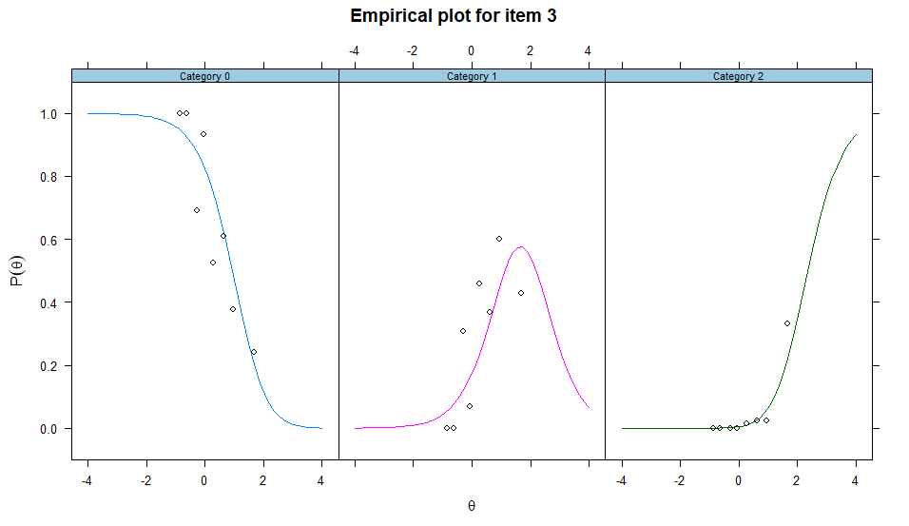
Supplementary Figure 5 Item fit curve for item 3 (“CBCL restless, hyperactive”) from ADHD scale consisting only of the CBCL items (bottom-up approach)

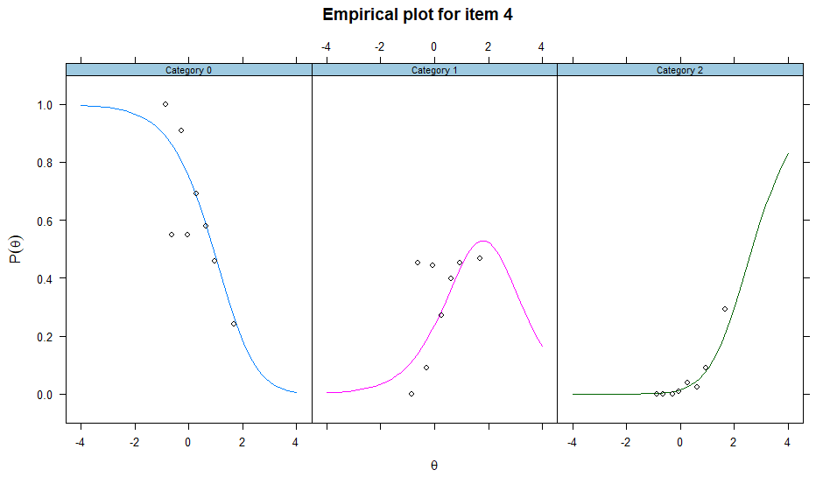
Supplementary Figure 6 Item fit curve for item 4 (“CBCL day dreams”) from ADHD scale consisting only of the CBCL items (bottom-up approach)
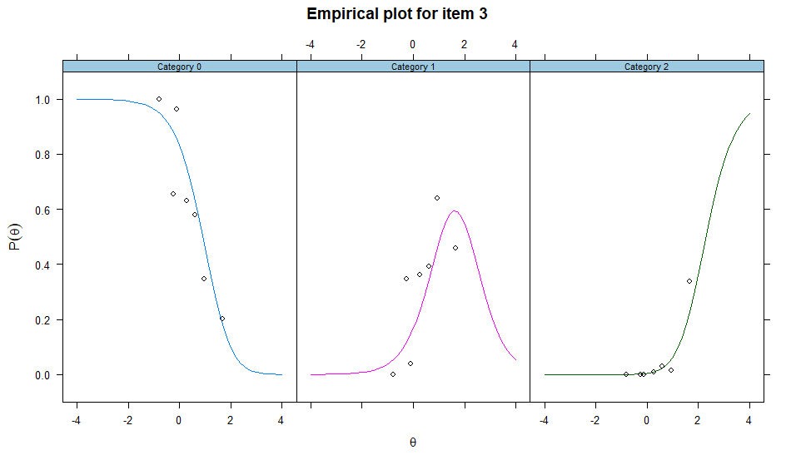
Supplementary Figure 7 Item fit curve for item 3 (“CBCL restless, hyperactive”) from ADHD scale consisting only of the CBCL items after excluding item with bad item fit (bottom-up approach)
Supplementary Figure 8 Item fit curve for item 5 (“SDQ good attention span”) from ADHD scale consisting of the SDQ items (bottom-up approach)

Test information curves – Top-down approach
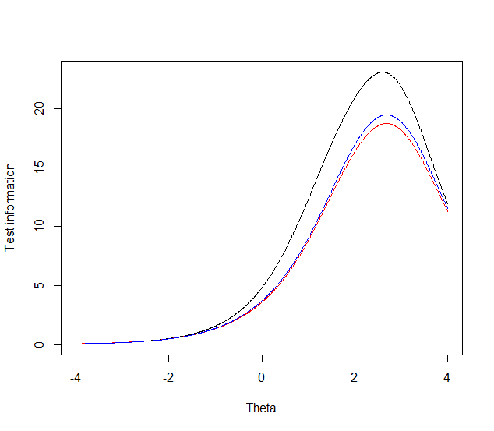
Supplementary Figure 9 Anxiety/depression CBCL items – test information curves
black line – all of 31 anxiety/depression CBCL items,
blue line – 28 anxiety/depression CBCL items using item parameters from the new model (consisted only of 28 CBCL items)
red line – 28 anxiety/depression CBCL items using item parameters from combined scale
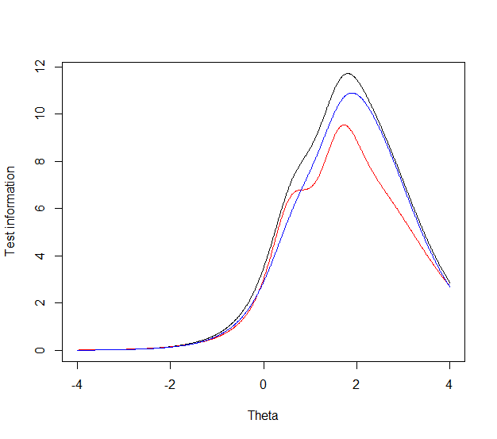
Supplementary Figure 10 ADHD CBCL items – test information curves
black line – all of 11 ADHD CBCL items,
red line – 8 ADHD CBCL items from combined scale with existing item parameters
blue line – 8 ADHD CBCL items from the combined scale using item parameters from the new model

Scatter plots – Top-down approach

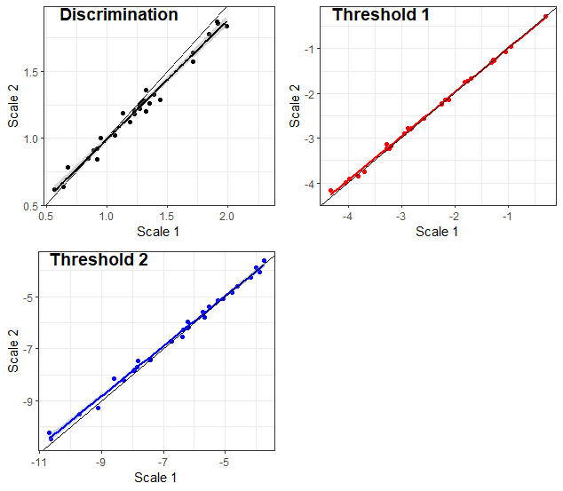

Supplementary Figure 11 Changes in anxiety/depression CBCL item parameters after combining them with SDQ items
Scale 1 – all anxiety/depression CBCL items (31 items)
Scale 2 – anxiety/depression CBCL items from the combined scale (28 items)

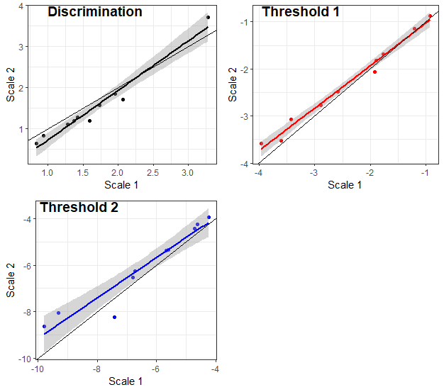
Supplementary Figure 12 Changes in ADHD CBCL item parameters after combining them with SDQ items
Scale 1 – all ADHD CBCL items (11 items)
Scale 2 – ADHD CBCL items from the combined scale (10 items)

Example R code to obtain harmonized scores for anxiety/depression and ADHD based on item parameters from this study

Example R code to obtain harmonized scores for anxiety/depression and ADHD based on item parameters from this study is presented below. The researchers only need to implement this code on their data in order to get harmonized scores.

library(mirtCAT) # Package required for obtaining harmonized scores based on existing item parameters

# Anxiety/depression - Obtain harmonized scores based on all item parameters from table III from the manuscript

# Define item parameters: a1 = discrimination parameter, d1 = threshold 1 parameter, d2 = threshold 2 parameter
# Item parameters are ordered as in table III from the manuscript

parameters <- data.frame(a1 = c(1.28, 1.21, 1.22, 0.84, 1.12, 1.57, 1.87, 1.02, 1.47, 1.78, 1.36, 1.84, 1.27, 0.85, 0.78, 1.19, 0.62, 0.64, 0.91, 0.92, 1.33, 1.20, 1.26, 1.00, 1.29, 1.18, 1.64, 1.25, 2.15, 1.86, 1.84, 0.91, 1.42, 1.33, 0.98, 1.17),

d1 = c(-2.22, -2.56, -2.79, -1.26, -1.66, -2.77, -2.78, -2.15, -2.11, -2.89, -3.75, -4.16, -2.15, -1.31, -1.07, -2.14, -3.84, -2.25, -1.27, -3.24, -3.23, -1.74, -0.28, -0.95, -3.14, -1.73, -3.98, -3.18, -3.13, -3.91, -1.26, -0.84, -1.14, -2.09, -0.63, -1.70),

d2 = c(-6.27, -6.19, -7.84, -3.89, -5.39, -7.46, -8.20, -5.60, -6.08, -7.79, -9.28, -10.22, -6.16, -4.61, -4.06, -6.55, -5.78, -5.08, -4.83, -7.44, -7.70, -5.95, -3.63, -4.27, -8.15, -5.13, -9.51, -6.70, -9.93, -10.46, -6.16, -3.21, -4.36, -5.92, -3.30, -4.80))

# Generate object and define the used model. In this study, we used General Partial Credit Model (“gpcm”)

mod <- generate.mirt_object(parameters, 'gpcm')

# Create vectors with participants` responses

Response_pattern_A <- c(0, 0, 1, 2, 1, 0, 1, 2, 2, 2, 0, 1, 1, 1, 0, 0, 0, 0, 0, 1, 1, 2, 1, 2, 1, 2, 1, 0, 1, 0, 0, NA, NA, NA, NA, NA) # Participant who filled in only CBCL items

Response_pattern_B <- c(NA, NA, NA, NA, NA, NA, NA, NA, NA, NA, NA, NA, NA, NA, NA, NA, NA, NA, NA, NA, NA, NA, NA, NA, NA, NA, NA, NA, NA, NA, NA, 1, 0, 1, 2, 2)
# Participant who filled in only SDQ items

Response_pattern_C <- c(0, 0, 1, 0, 2, 2, 1, 2, 1, 2, 0, 0, 0, 1, 1, 1, 1, 2, 0, 0, 0, 2, 1, 1, 1, 1, 2, 0, 1, 0, 0, 1, 2, 1, 0, 1) # Participant who filled in both CBCL and SDQ items

Response_pattern_D <- c(2, NA, 2, 2, 1, 2, 0, 1, 2, 1, 1, 0, 0, 1, 1, 0, 1, 2, NA, 2, 1, 2, 2, 0, 1, 0, 1, 1, 2, 1, NA, 1, 0, 1, 2, 2) # Participant who filled in both CBCL and SDQ items with some missing values

# Create a data matrix based on these vectors

responses <- rbind(Response_pattern_A, Response_pattern_B, Response_pattern_C, Response_pattern_D)

# Obtain harmonized scores for anxiety/depression using the above-defined object (“mod”) and data matrix which contains participants` responses as response patterns.

fscores(mod, response.pattern = responses)

# As a result, researchers will get harmonized scores and standard errors for these response patterns.
# Because of the high number of items in the anxiety/depression scale, the results will contain a lot of data, so we have not presented it here. Instead of that, in Supplementary Table XVI, you can find complete results related to the ADHD scale which contains a smaller number of items.

# Instead of creating vectors with participants` responses, researchers can simply import an existing database. In that case, they will use the database as response patterns.
# For example: fscores(mod, response.pattern = database)

# ADHD - Obtain harmonized scores based on all item parameters from Table IV from the manuscript

# define item parameters: a1 = discrimination parameter, d1 = threshold 1 parameter, d2 = threshold 2 parameter
# Item parameters are ordered as in table IV from the manuscript

parameters <- data.frame(a1 = c(1.28, 3.71, 1.31, 1.71, 1.11, 1.58, 0.65, 0.83, 1.84, 1.19, 1.19, 1.41, 1.34, 3.24, 1.44, 1.99),

d1 = c(-1.82, -2.07, -1.51, -3.59, -1.15, -0.88, -1.69, -3.53, -2.49, -2.77, -3.08, -0.89, -1.16, 0.15, 1.58, 0.70),

d2 = c(-5.39, -8.22, -4.80, -8.63, -3.96, -4.45, -4.26, -5.36, -6.52, -6.27, -8.05, -3.72, -3.92, -4.02, -1.28, -2.37))

# Generate object and define the used model. In this study, we have used General Partial Credit Model (“gpcm”)

mod <- generate.mirt_object(parameters, 'gpcm')

# Create vectors with participants responses

Response_pattern_A <- c(0, 1, 1, 0, 2, 1, 0, 0, 0, 0, 1, NA, NA, NA, NA, NA) # Participant who filled in only CBCL items

Response_pattern_B <- c(NA, NA, NA, NA, NA, NA, NA, NA, NA, NA, NA, 2, 0, 2, 1, 1) # Participant who filled in only SDQ items

Response_pattern_C <- c(1, 1, 2, 0, 1, 2, 1, 1, 0, 0, 0, 2, 0, 1, 1, 1) # Participant who filled in both CBCL and SDQ items

Response_pattern_D <- c(0, 2, 2, 1, 1, 2, 1, NA, 1, 1, 0, NA, 1, 2, 2, 2) # Participant who filled in both CBCL and SDQ items with some missing values

# Create a data matrix based on these vectors

responses <- rbind(Response_pattern_A, Response_pattern_B, Response_pattern_C, Response_pattern_D)

# Obtain harmonized scores for ADHD using the above-defined object (“mod”) and data matrix which contains participants` responses as response patterns. The complete results are presented in the Supplementary Table XVI.

fscores(mod, response.pattern = responses)

# Instead of creating vectors with participants` responses, researchers can simply import an existing database. In that case, they will use the database as response patterns.
# For example: fscores(mod, response.pattern = database)

Supplementary table XVI IRT illustration: Harmonized scores and their standard errors for several imaginary response patterns based on discrimination and threshold parameters of ADHD items from this study
Item | Discrimination parameter | Threshold parameter  Category 1 | Threshold parameter Category 2 | Response pattern A | Response pattern B | Response pattern C | Response pattern D
CBCL acts too young | 1.28 | -1.82 | -5.39 | 0 | NA | 1 | 0
CBCL can’t concentrate | 3.71 | -2.07 | -8.22 | 1 | NA | 1 | 2
CBCL restless, hyperactive | 1.31 | -1.51 | -4.80 | 1 | NA | 2 | 2
CBCL confused | 1.71 | -3.59 | -8.63 | 0 | NA | 0 | 1
CBCL day dreams | 1.11 | -1.15 | -3.96 | 2 | NA | 1 | 1
CBCL impulsive | 1.58 | -0.88 | -4.45 | 1 | NA | 2 | 2
CBCL nervous or tense | 0.65 | -1.69 | -4.26 | 0 | NA | 1 | 1
CBCL nervous movements | 0.83 | -3.53 | -5.36 | 0 | NA | 1 | NA
CBCL poor school work | 1.84 | -2.49 | -6.52 | 0 | NA | 0 | 1
CBCL poorly coordinated | 1.19 | -2.77 | -6.27 | 0 | NA | 0 | 1
CBCL stares blankly | 1.19 | -3.08 | -8.05 | 1 | NA | 0 | 0
SDQ restless | 1.41 | -0.89 | -3.72 | NA | 2 | 2 | NA
SDQ constantly fidgeting | 1.34 | -1.16 | -3.92 | NA | 0 | 0 | 1
SDQ easily distracted | 3.24 | 0.15 | -4.02 | NA | 2 | 1 | 2
SDQ thinks before acting | 1.44 | 1.58 | -1.28 | NA | 1 | 1 | 2
SDQ good attention span | 1.99 | 0.70 | -2.37 | NA | 1 | 1 | 2
Sum score |  |  |  | 6 | 6 | 14 | 18
Harmonized score |  |  |  | 1.07 | 1.23 | 1.22 | 2.15
Standard Error |  |  |  | .33 | .40 | .26 | .29
Note: “NA” indicates missing data.
Response pattern A – Participant who filled in only CBCL items.
Response pattern B – Participant who filled in only SDQ items.
Response pattern C – Participant who filled in both CBCL and SDQ items.
Response pattern D – Participant who filled in both CBCL and SDQ items with some missing values.

