Supplementary Material

The Role of Emotional regulation in anxiety and depression symptom interplay and expression among adolescent females

Emily McGlincheyª*, Karen Kirby^{b}, Eoin McElroy^{c} and Jamie Murphy^{b}
ª School of Psychology, Queens University Belfast, Belfast, Northern Ireland; ^{b}School of Psychology, Ulster University, Coleraine, Northern Ireland; ^{c} Department of Neuroscience, Psychology and Behaviour, University of Leicester, Leicester, England

Correspondence concerning this article should be addressed to Emily McGlinchey, School of Psychology, Queens University Belfast, Belfast, Northern Ireland
Email: e.mcglinchey@qub.ac.uk

Contents

Table OS-1. Item-level means, standard deviations and short code labels for the Patient Health Questionnaire (PHQ-9) and Generalised Anxiety Disorder Questionnaire (GAD-7)
Figure OS-1. Community Structures Identified using the Walktrap Algorithm for the Overall Network Structure of Anxiety and Depressive Symptoms
Figure OS-2. Results from tests of edge weight accuracy (for the overall network structure)
Figure OS-3. Bootstrapped difference tests between non-zero edges (for the overall network structure)
Figure OS-4. Mean correlations between centrality values of the full sample and sub samples with different degrees of persons dropped.
Figure OS-5. Association network (unique layout) for the Low Emotional Regulation Group.
Figure OS-6. Association network (unique layout) for the Intermediate Emotional Regulation Group.
Figure OS-7. Association network (unique layout) for the High Emotional Regulation Group.
Figure OS-8. Community Structures Identified using the Walktrap Algorithm for each Network Structure based on Emotional Regulation Ability (matched sample sizes)
Figure OS-9. Results from tests of edge weight accuracy (Low Emotional Ability Network Structure)
Figure OS-10. Bootstrapped difference tests between non-zero edges (for the Low Emotional Ability Network Structure)
Figure OS-11. Mean correlations between centrality values of the full sample and sub samples with different degrees of persons dropped (for the Low Emotional Regulation Network)
Figure OS-12. Results from tests of edge weight accuracy (Intermediate Emotional Ability Network Structure)
Figure OS-13. Bootstrapped difference tests between non-zero edges (for the Intermediate Emotional Ability Network Structure)
Figure OS-14. Mean correlations between centrality values of the full sample and sub samples with different degrees of persons dropped. (for the Intermediate Emotional Regulation Network)
OS-15. Additional Analyses
OS-16. R code.

Table S1. Item-level means, standard deviations and short code labels for the Patient Health Questionnaire (PHQ-9) and Generalised Anxiety Disorder Questionnaire (GAD-7)

 |  |  |  |  |  |  | Total Sample (N =615)
Item | Short Code Names |  |  | Item labels |  | Mean (SD) |  | N
PHQ- 9
Little interest or pleasure in doing things | Anhedonia |  |  | PHQ9-1 |  | 0.69 (0.84) |  | N=615
Feeling down, depressed or hopeless | Hopelessness |  |  | PHQ9-2 |  | 0.58 (.80) |  | N=615
Trouble falling asleep or staying asleep, or sleeping too much | Sleep Problems |  |  | PHQ9-3 |  | 1.00 (1.07) |  | N=615
Feeling tired or having very little energy | Tiredness |  |  | PHQ9-4 |  | 1.23 (1.04) |  | N=615
Poor appetite, weight loss or overeating | Appetite/Weight |  |  | PHQ9-5 |  | 0.68 (0.95) |  | N=615
Feeling bad about yourself or that you are a failure or have let yourself or your family down | Failure |  |  | PHQ9-6 |  | 0.62 (0.93) |  | N=615
Trouble concentrating on things | Concentration |  |  | PHQ9-7 |  | 0.60 (0.79) |  | N=615
Moving or speaking so slowly that other people could have noticed, or the opposite - being so fidgety or restless that you have been moving around a lot more than usual? |  |  |  | PHQ9-8 |  | 0.37 (0.75) |  | N=615
Thoughts that you would be better off dead or of hurting yourself in some way | Risk |  |  | PHQ9-9 |  | 0.26 (0.66) |  | N=615
GAD-7
Feeling nervous, anxious or on edge | Nervous |  |  | GAD7-1 |  | 0.82 (0.95) |  | N=615
Not being able to stop or control worrying | Control Worry |  |  | GAD7-2 |  | 0.72 (0.98) |  | N=615
Worrying too much about different things | Worrying Often |  |  | GAD7-3 |  | 1.01 (1.02) |  | N=615
Trouble relaxing | Trouble Relaxing |  |  | GAD7-4 |  | 0.61 (0.81) |  | N=615
Being so restless it is hard to sit still | Restlessness |  |  | GAD7-5 |  | 0.41 (0.77) |  | N=615
Becoming easily annoyed or irritable | Irritable |  |  | GAD7-6 |  | 0.99 (0.99) |  | N=615
Feeling afraid as if something awful might happen | Feeling Afraid |  |  | GAD7-7 |  | 0.68 (0.96) |  | N=615

Figure S1. Community Structures Identified using the Walktrap Algorithm for the Overall Network Structure of Anxiety and Depressive Symptoms (entire sample)

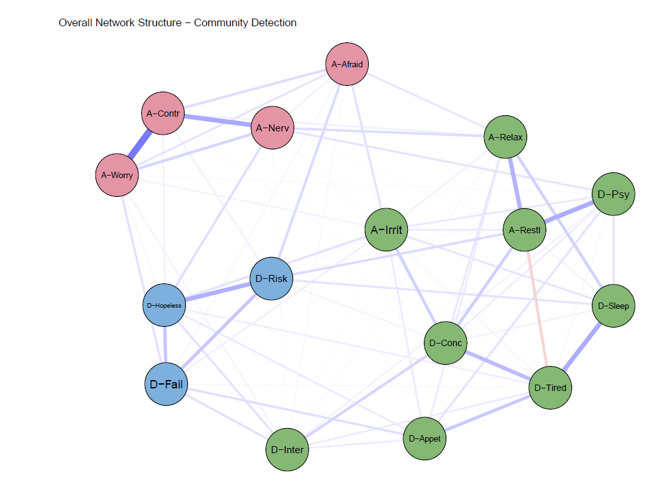

Figure S2. Results from tests of edge weight accuracy (for the overall network structure)

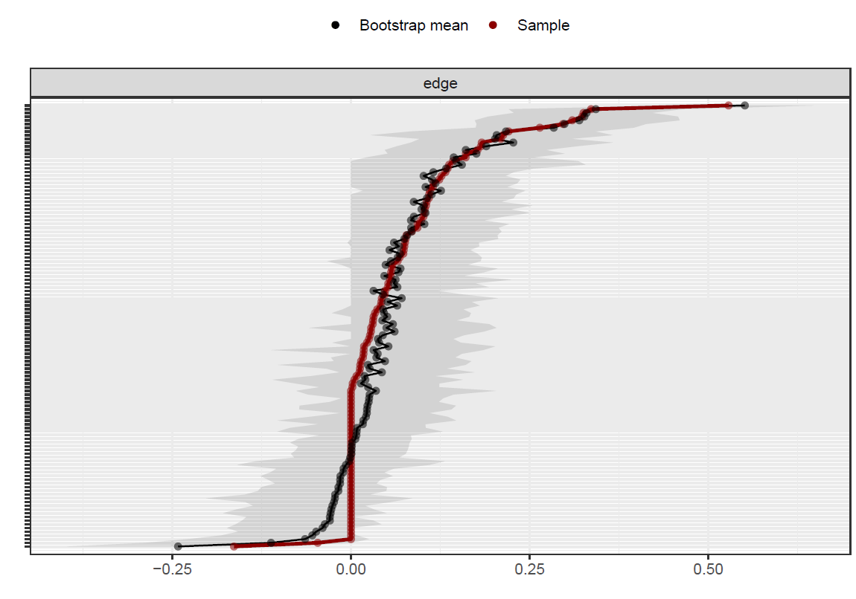

Figure S3. Bootstrapped difference tests between non-zero edges (for the full sample)

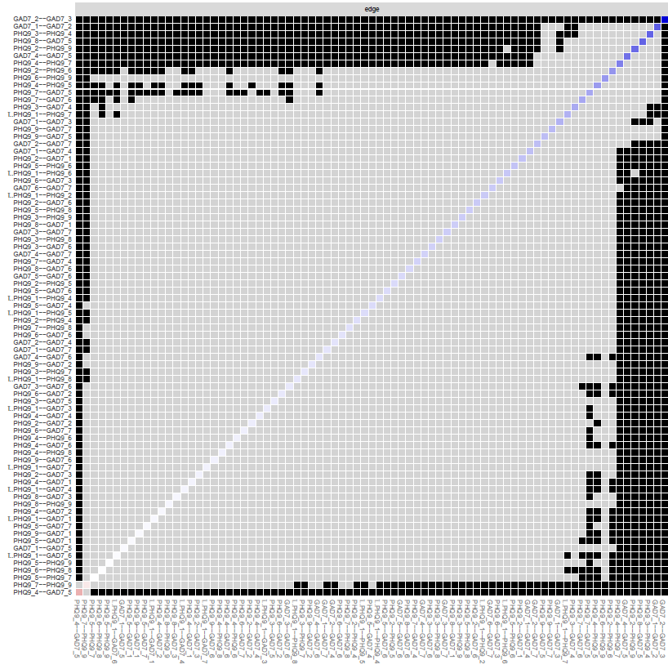

*Note: Black squares indicate significant differences between edges (ꭤ = (05), whereas grey boxes indicate no significant difference.

Figure S4. Mean correlations between centrality values of the full sample and sub samples with different degrees of persons dropped.

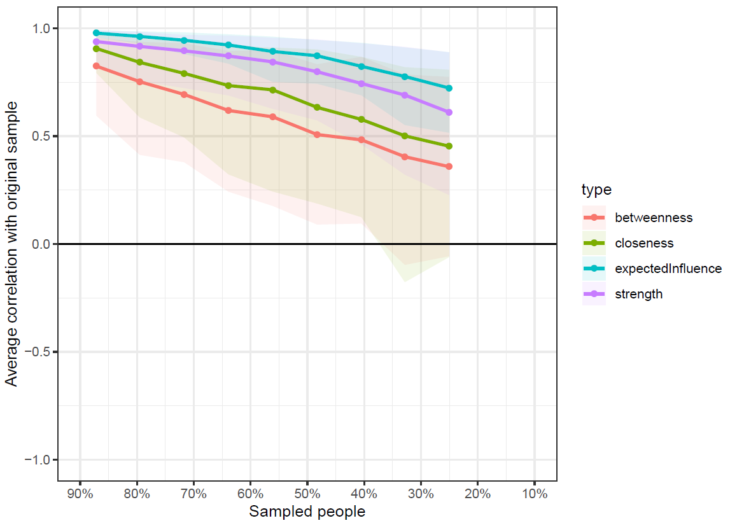

*Note: Lines reflect means and areas around the lines reflect 95% CIs.

Figure S5. Association network (unique layout) for the Low Emotional Regulation Group.

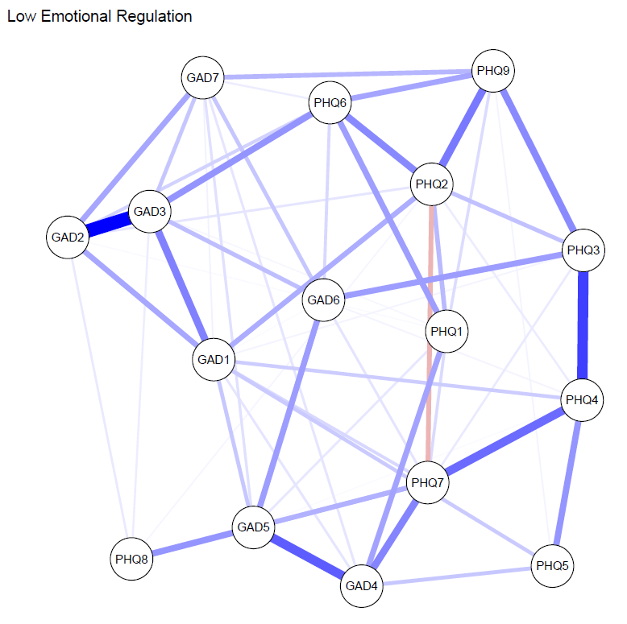

Figure S6. Association network (unique layout) for the Intermediate Emotional Regulation Group.

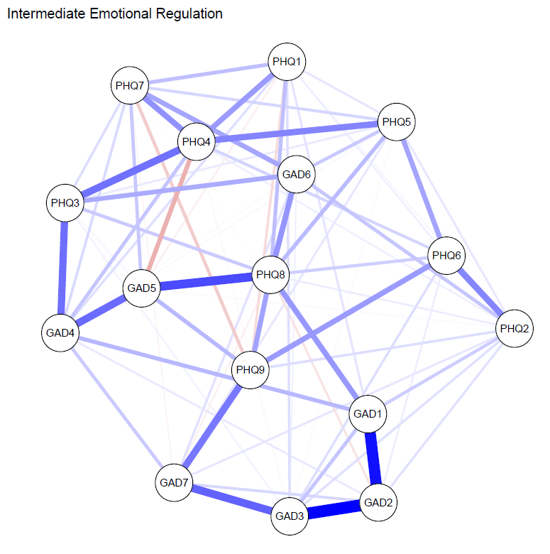

Figure S7. Association network (unique layout) for the High Emotional Regulation Group.
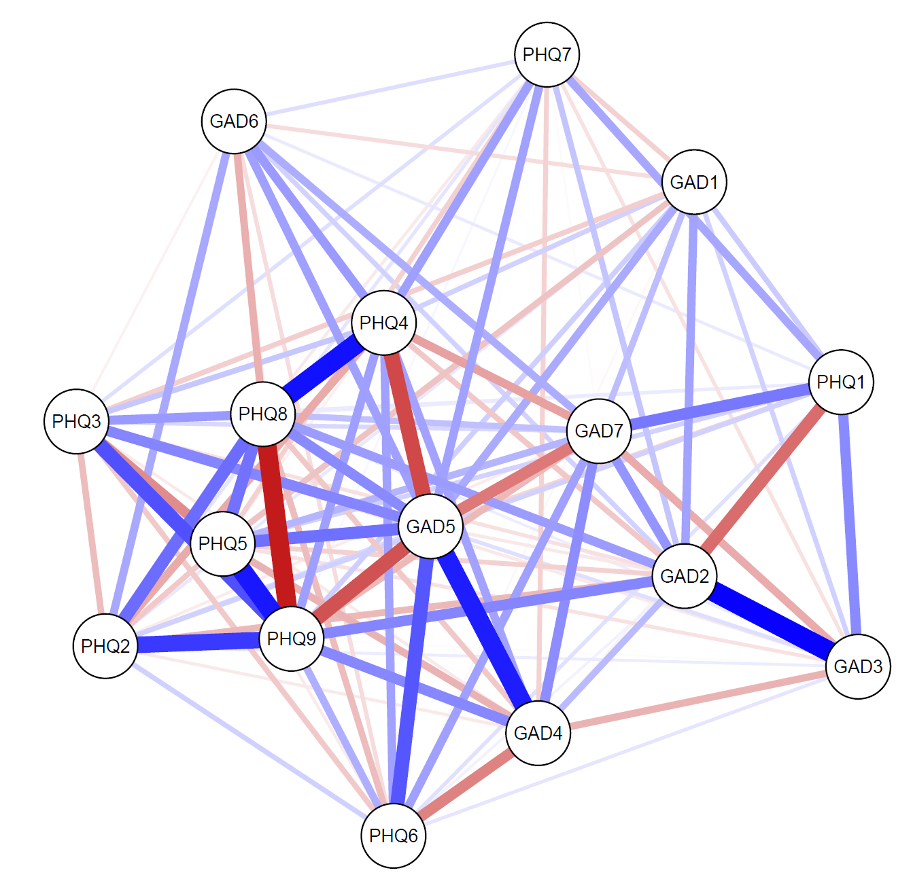

Figure S8. Community Structures Identified using the Walktrap Algorithm for each Network Structure based on Emotional Regulation Ability (matched sample sizes)
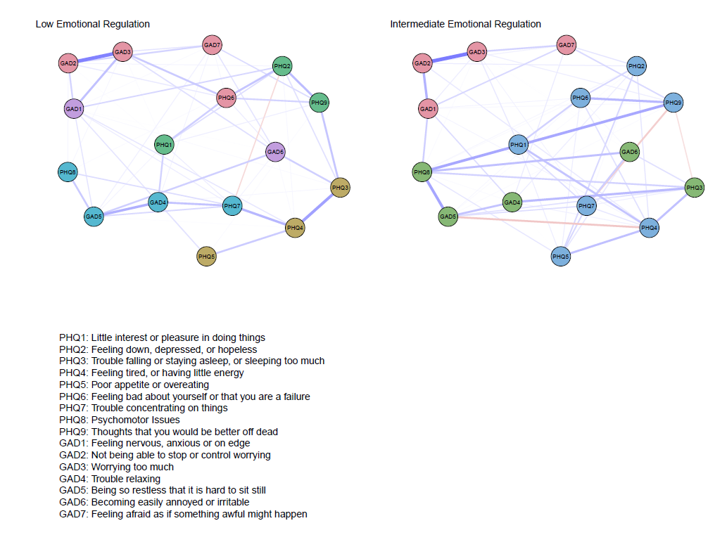

Figure S9. Results from tests of edge weight accuracy (Low Emotional Ability Network Structure)

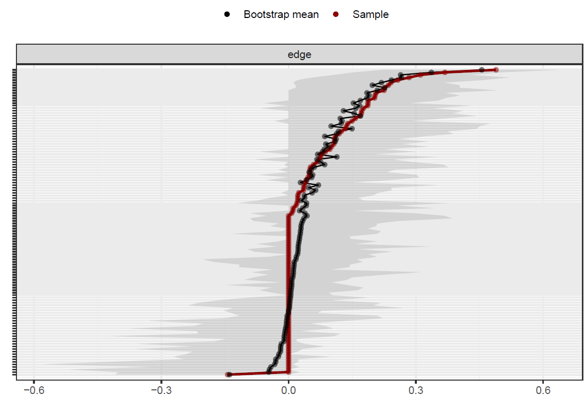
*Note: Plot of edge weights and 95% confidence intervals (CIs) calculated using bootstrapping.

Figure S10. Bootstrapped difference tests between non-zero edges (for the Low Emotional Ability Network Structure)

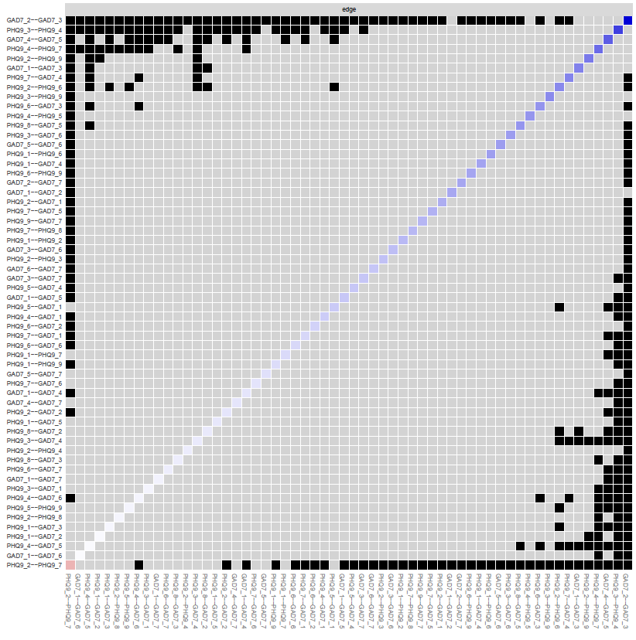
*Note: Black squares indicate significant differences between edges (ꭤ = (05), whereas grey boxes indicate no significant difference.

Figure S11. Mean correlations between centrality values of the full sample and sub samples with different degrees of persons dropped. (Low Emotional Regulation Network)

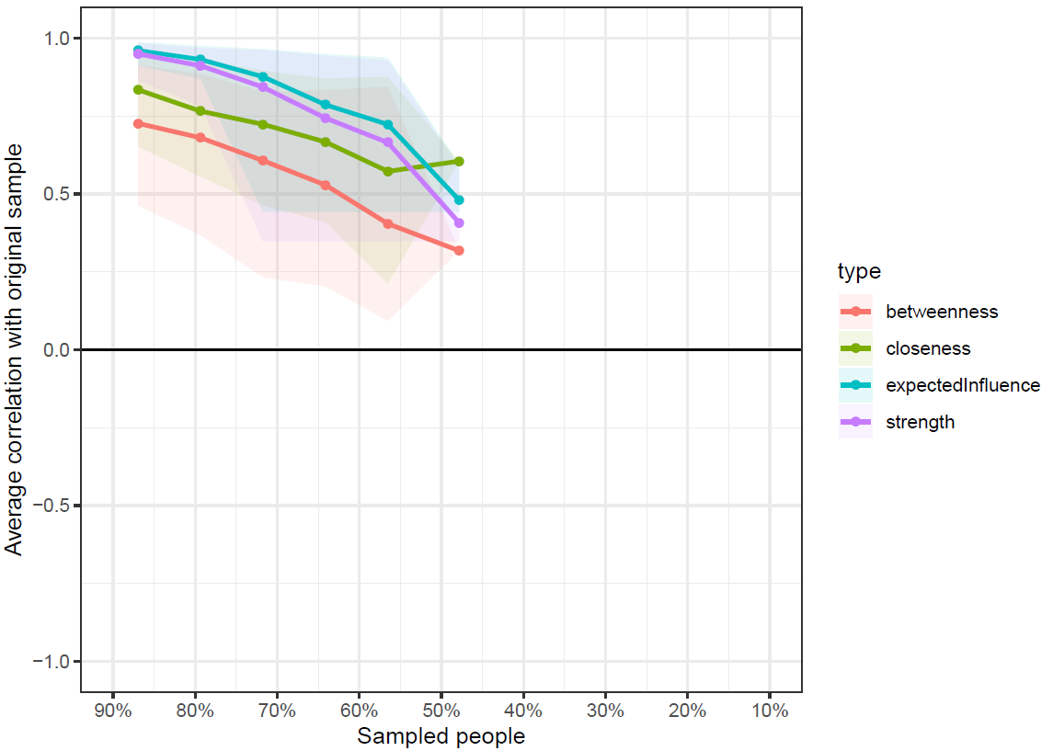
*Note: Lines reflect means and areas around the lines reflect 95% CIs.

Figure S12. Results from tests of edge weight accuracy (Intermediate Emotional Ability Network Structure)
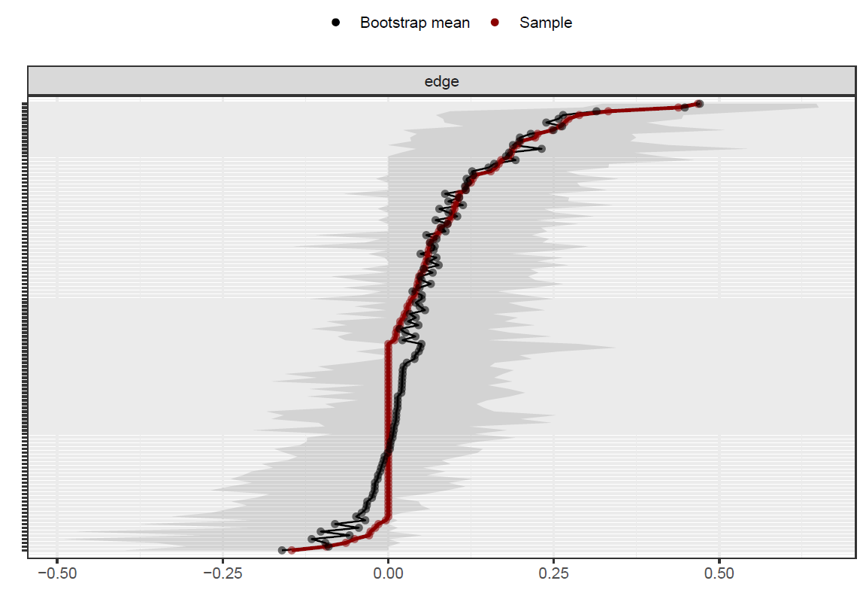

*Note: Plot of edge weights and 95% confidence intervals (CIs) calculated using bootstrapping.

Figure S13. Bootstrapped difference tests between non-zero edges (for the Intermediate Emotional Ability Network Structure)
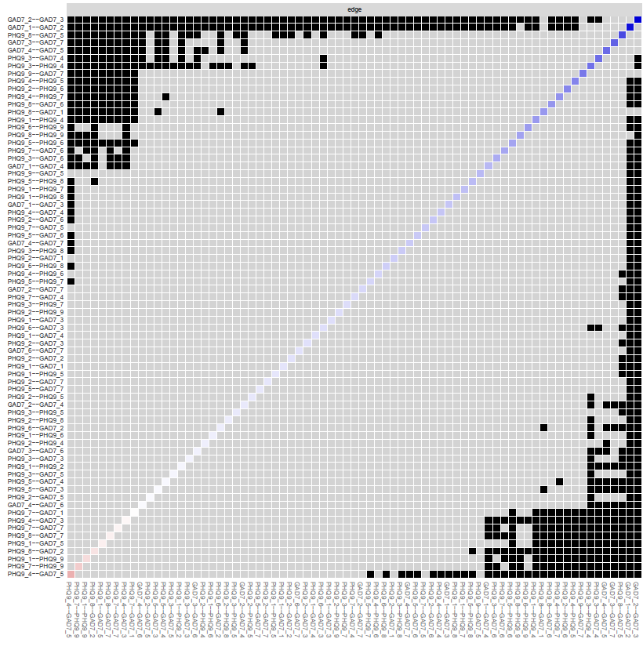

*Note: Black squares indicate significant differences between edges (ꭤ = (05), whereas grey boxes indicate no significant difference.

Figure S14. Mean correlations between centrality values of the full sample and sub samples with different degrees of persons dropped. (for the Intermediate Emotional Regulation Network)

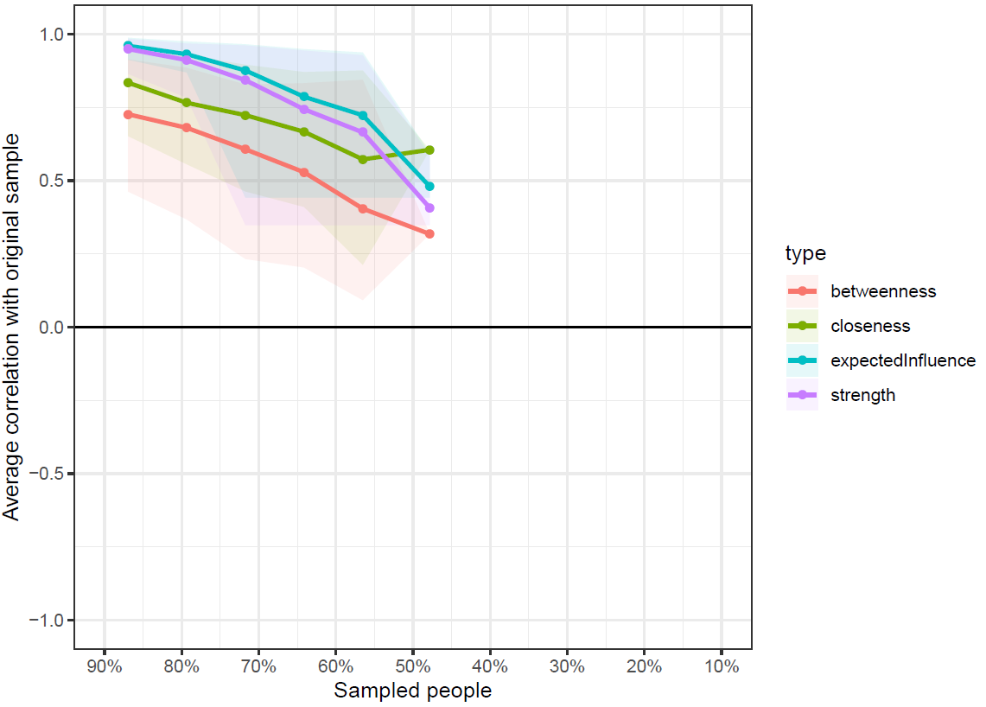

*Note: Lines reflect means and areas around the lines reflect 95% CIs.

S15. Additional Analyses

Analysis of variance, using SPSS, across all PHQ-9 and GAD-7 items was conducted in order to establish whether the items of the PHQ-9 and GAD-7 were of equal variance. As it was a primary aim of this paper to compare three groups of individuals based on ER ability (low, intermediate and high) it was important to investigate whether these groups significantly differed by age. Empirical research suggests that as one moves from childhood, to adolescence and finally adulthood emotional regulation ability improves with the maturity. Therefore it was important to establish whether the groups were based on ER ability or if was simply maturity that was captured. Therefore a one-way ANOVA was carried out using SPSS to compare if the three ER ability groups statistically differed by age. Specifically exploring whether the most proficient ER group contained significantly more older adolescents was of primary interest (i.e. 15 and above). The results of the one-way ANOVA found that age did significantly vary across the three ER groups, F(2, 603) = 9.30, p < .001. Inspection of the post hoc tests revealed which groups differed from one another based on age. Specifically there was a statistically significant difference in age between the low and high ER ability group and between high and intermediate ER ability group. However, there were no significant differences between the low and intermediate ER ability group based on age. This was not problematic however as the average age for each ER group was 13 years old or younger and are therefore are confident that it is not maturity being captured.

S16. R Code

# Load Packages #
library(qgraph)
library(bootnet)
library(networktools)
library(BaylorEdPsych)
library(ltm)
library(mvnmle)

sessionInfo() # R version 3.6.2

setwd ("________")

# Read data into R
full_dataframe<-read.csv("full_dataframe.csv")
View(full_dataframe)

# Missing data
full_dataframe[full_dataframe=="-99"]<-NA
View(full_dataframe)

#% of missing
sum(is.na(full_dataframe))
mean(is.na(full_dataframe)) # 0% missing data (gad and phq items)

#####################################################################
### Anxiety and Depression Symptom Network for the Entire Sample ####
#####################################################################

# Select items for analysis
full_dataframe2<-full_dataframe[,c(1:16)]
View(full_dataframe2)

# Names for graphs
names<-c("D-Inter","D-Hopeless", "D-Sleep", "D-Tired", "D-Appet", "D-Fail", "D-Conc",
"D-Psy", "D-Risk","A-Nerv", "A-Contr", "A-Worry", "A-Relax", "A-Restl", "A-Irrit",
"A-Afraid")
longnames <- c("Little interest or pleasure in doing things", "Feeling down, depressed, or hopeless",
"Trouble falling or staying asleep, or sleeping too much",
"Feeling tired, or having little energy", "Poor appetite or overeating",
"Feeling bad about yourself or that you are a failure",
"Trouble concentrating on things", "Psychomotor Issues","Thoughts that you would be better off dead",
"Feeling nervous, anxious or on edge", "Not being able to stop or control worrying",
"Worrying too much", "Trouble relaxing",
"Being so restless that it is hard to sit still", "Becoming easily annoyed or irritable",
"Feeling afraid as if something awful might happen")
clusters<-list("Depression Symptoms"=c(1:9), "Anxiety Symptoms"=c(10:16))

########## Regularized partial correlation network ##########

# Estimate network#
InterResults <- estimateNetwork(full_dataframe2, default="EBICglasso")

InterResults$graph #weights matrix
write.csv(InterResults$graph, "WeightsMatrix.csv")

# Plot the network
Network_Plot<-plot(InterResults, layout="spring", labels=names, vsize=6, cut=0,
border.width=1.8, border.color="black", groups=clusters,
color=c("#98fb98", "#87cefa"),
nodeNames=longnames, legend.cex=.6, negDashed=T)

# With caption
InterResults_plot<-plot(InterResults, layout="spring", labels=names, vsize=6, cut=0,
border.width=1.8, border.color="black",groups=clusters,
color=c("#98fb98", "#87cefa"),
nodeNames = longnames,legend.cex=.6, negDashed=TRUE,
title="Internalising Symptomatology", title.cex=1.3,
filename = "InterNetworkWithCaption", filetype = "pdf", width=14, height=10)

########## Centrality ##########
cen<-centrality(InterResults)
y<-cen$InExpectedInfluence
scale(y) #standardize centrality values
write.csv(as.matrix(scale(y)), "standardCentralityValues.csv")

centralityPlot(InterResults,include= c("Strength","ExpectedInfluence"),orderBy ="ExpectedInfluence")

#save to pdf#
pdf("EI_centrality.pdf", width=6, height=8)
centralityPlot(InterResults,include="ExpectedInfluence", labels = names)
dev.off()

### Network accuracy and stability ###

# Edge weight bootstrap
bootEDGE<-bootnet(InterResults, nCores = 4, nBoots = 2000, type = "nonparametric",
statistics = c("edge","strength","ExpectedInfluence", "betweenness", "closeness"))
save(bootEDGE, file = "bootEDGE.Rdata")
plot(bootEDGE, labels = FALSE, order = "sample")
# Print to pdf
pdf("bootstrappedEdges.pdf", width=7, height=5)
plot(bootEDGE, labels = FALSE, order = "sample")
dev.off()

# Case-dropping bootstrap
library("bootnet")
library("ggplot2")
bootCASE <- bootnet(InterResults, nBoots = 2000, type = "case", nCores = 4,statistics = c("edge","strength","ExpectedInfluence", "betweenness", "closeness"))
plot(bootCASE,statistics=c("ExpectedInfluence","Strength","Closeness","Betweenness"))

# Print to pdf
pdf("bootCases.pdf", width=7, height=5)
plot(bootCASE,statistics=c("ExpectedInfluence","Strength","Closeness","Betweenness"))
dev.off()

# CS-coefficents
corStability(bootCASE, statistics=c("strength","expectedInfluence","closeness","betweenness"))
# CS: betweenness = 0.05; closeness = 0.128
# strength = 0.361; EI = 0.517

### Difference tests ###

# Plot significant differences of edge weights (alpha = .05)
plot(bootEDGE, "edge", plot = "difference", onlyNonZero = TRUE, order = "sample")

# Print into pdf
pdf("SignificantEdgeWeights.pdf", width=10, height=10)
plot(bootEDGE, "edge", plot = "difference", onlyNonZero = TRUE, cex.axis = 0.3, order = "sample")
dev.off()
# Difference tests for EI centrality
plot(bootEDGE, "ExpectedInfluence", order="sample")

# Print into pdf
pdf("EI_differenceTests.pdf", width=10, height=10)
plot(bootEDGE, "ExpectedInfluence", order="sample")
dev.off()

### WalkTrap Community Detection ###
library("qgraph")
library("igraph")

ob_InterResults <- graph_from_adjacency_matrix(abs(InterResults$graph), 'undirected', weighted = TRUE, add.colnames = FALSE)
walk_InterResults <- cluster_walktrap(ob_InterResults)
communities(walk_InterResults)

pdf("Full Sample walktrap.pdf", paper ="a4r", width = 10, height =8)
par(mfrow = c(1,1))
qgraph(InterResults$graph, layout = "spring",maximum = 1, groups = communities(walk_InterResults),
legend=FALSE, vsize = 7,labels = names, palette = "pastel",
title = "Overall Network Structure - Community Detection",
posCol="blue")
dev.off()

modularity(walk_InterResults)
#modularity 0.2948) # Most likely random clustering as value is below .3 #

##################################################
##### Network Estimation based on ER ability #####
##################################################
library(haven)
full_dataframe <- read_sav("full_dataframe.sav")
View(full_dataframe)

# Names for graphs
names<-c("D-Inter","D-Hopeless", "D-Sleep", "D-Tired", "D-Appet", "D-Fail", "D-Conc",
"D-Psy", "D-Risk","A-Nerv", "A-Contr", "A-Worry", "A-Relax", "A-Restl", "A-Irrit",
"A-Afraid")
longnames <- c("Little interest or pleasure in doing things", "Feeling down, depressed, or hopeless",
"Trouble falling or staying asleep, or sleeping too much",
"Feeling tired, or having little energy", "Poor appetite or overeating",
"Feeling bad about yourself or that you are a failure",
"Trouble concentrating on things", "Psychomotor Issues","Thoughts that you would be better off dead",
"Feeling nervous, anxious or on edge", "Not being able to stop or control worrying",
"Worrying too much", "Trouble relaxing",
"Being so restless that it is hard to sit still", "Becoming easily annoyed or irritable",
"Feeling afraid as if something awful might happen")
clusters<-list("Depression Symptoms"=c(1:9), "Anxiety Symptoms"=c(10:16))

### next, create separate dataframes for each class

low_ER_frame <- full_dataframe[ which(full_dataframe$ER_class==1),] ## this will give you a subset of cases; i.e. will keep only those with an ER_class value of 0 (low ER)

int_ER_frame <- full_dataframe[ which(full_dataframe$ER_class==3),] ## this will give you a subset of cases; i.e. will keep only those with an ER_class value of 1 (intermediate ER)

high_ER_frame <- full_dataframe[ which(full_dataframe$ER_class==2),] ## this will give you a subset of cases; i.e. will keep only those with an ER_class value of 2 (high ER)

###next, keep only the variables you wish to include in the networks

low_ER_frame <- low_ER_frame [, c("PHQ9_1", "PHQ9_2", "PHQ9_3", "PHQ9_4", "PHQ9_5", "PHQ9_6", "PHQ9_7", "PHQ9_8", "PHQ9_9", "GAD7_1", "GAD7_2", "GAD7_3", "GAD7_4", "GAD7_5", "GAD7_6", "GAD7_7")]
int_ER_frame <- int_ER_frame [, c("PHQ9_1", "PHQ9_2", "PHQ9_3", "PHQ9_4", "PHQ9_5", "PHQ9_6", "PHQ9_7", "PHQ9_8", "PHQ9_9", "GAD7_1", "GAD7_2", "GAD7_3", "GAD7_4", "GAD7_5", "GAD7_6", "GAD7_7")]
high_ER_frame <- high_ER_frame [, c("PHQ9_1", "PHQ9_2", "PHQ9_3", "PHQ9_4", "PHQ9_5", "PHQ9_6", "PHQ9_7", "PHQ9_8", "PHQ9_9", "GAD7_1", "GAD7_2", "GAD7_3", "GAD7_4", "GAD7_5", "GAD7_6", "GAD7_7")]

### now you should have three clean dataframes, one for each ER class, each of which you can use to estimate networks

##### Estimate the networks for each ER group (low, intermediate and high) ######
library("bootnet")
library("qgraph")

n_low <- estimateNetwork(low_ER_frame, default="EBICglasso", corMethod="cor_auto", tuning=0.5)

# Weights matrix
n_low $graph
write.csv(n_low $graph, "n_low _WeightsMatrix.csv")

q_1 <- qgraph(n_low$graph)
centralityPlot(q_1, include = c("Strength","ExpectedInfluence"),orderBy = "ExpectedInfluence")

n_int <- estimateNetwork(int_ER_frame, default="EBICglasso", corMethod="cor_auto", tuning=0.5)

# Weights matrix
n_int$graph
write.csv(n_int$graph, "n_int _WeightsMatrix.csv")
q_1 <- qgraph(n_int$graph)
centralityPlot(q_1, include = c("Strength","ExpectedInfluence"),orderBy = "ExpectedInfluence")

n_high <- estimateNetwork(high_ER_frame, default="EBICglasso", corMethod="cor_auto", tuning=0.5) #Correlation matrix is not positive definite, therefore wasn't explored further#
q_1 <- qgraph(n_high$graph)
centralityPlot(q_1, include = c("Strength","ExpectedInfluence"),orderBy = "ExpectedInfluence")

###below I graph the networks individually
pdf("Low ER.pdf")
q_low <- qgraph(n_low$graph, layout = "spring",
legend=FALSE, vsize = 6, labels = shortnames,
title = "Low Emotional Regulation",
posCol="blue")
dev.off()

pdf("int ER.pdf")
q_int <- qgraph(n_int$graph, layout = "spring",
legend=FALSE, vsize = 6, labels = shortnames,
title = "Intermediate Emotional Regulation",
posCol="blue")
dev.off()

pdf("high ER.pdf")
q_high <- qgraph(n_high$graph, layout = "spring",
legend=FALSE, vsize = 6, labels = shortnames,
title = "High Emotional Regulation",
posCol="blue")
dev.off()

#### Below I produce one single figure wit hall 3 networks held to a consistent layout
L <- averageLayout(q_low,q_int)

pdf("Combined graphs.pdf", paper ="a4r", width = 14, height =8)
layout(t(1:2))
qgraph(n_low$graph, layout = L,maximum = 1,
legend=FALSE, vsize = 6, labels = names, color = "lightsteelblue",
title = "Low Emotional Regulation",
posCol="blue")
qgraph(n_int$graph, layout = L,maximum = 1,
legend=FALSE, vsize = 6, labels = names, color = "lightsteelblue",
title = "Intermediate Emotional Regulation",
posCol="blue")
dev.off()

###Network Stability Analysis Intermediate ER group ####
library("bootnet")
library("ggplot2")

# Edge weight bootstrap
bootint_ER<-bootnet(n_int, nCores = 4, nBoots = 1000, default = "EBICglasso", type = "nonparametric",
statistics = c("edge","strength","ExpectedInfluence", "betweenness", "closeness"))
save(bootint_ER, file = "bootint_ER.Rdata")
plot(bootint_ER, labels = FALSE, order = "sample")

# Print to pdf
pdf("bootint_ER.pdf", width=7, height=5)
plot(bootint_ER, labels = FALSE, order = "sample")
dev.off()

# Case-dropping bootstrap
int_Network_bootCASE<-bootnet(n_int, nCores = 4, nBoots = 1000,
statistics=c("ExpectedInfluence","strength","closeness","betweenness"), type = "case")

# Save case dropping bootstrap
save(int_Network_bootCASE, file = "int_Network_bootCASE.Rdata")
#load(file = "int_Network_bootCASE.Rdata")

# Plot case-dropping bootstrap
plot(int_Network_bootCASE,statistics=c("ExpectedInfluence","Strength","Closeness","Betweenness"))

pdf("int_Network_bootCASE.pdf", width=7, height=5)
plot(int_Network_bootCASE,statistics=c("ExpectedInfluence","Strength","Closeness","Betweenness"))
dev.off()

pdf("int_Network_bootCASE_EIonly.pdf", width=7, height=5)
plot(int_Network_bootCASE,statistics="ExpectedInfluence")
dev.off()

# CS-coefficents
corStability(int_Network_bootCASE, statistics=c("strength","expectedInfluence","closeness","betweenness"))
# CS: betweenness = 0.048; closeness = 0.13; strength = 0.207; EI = 0.44

# Plot significant differences of edge weights (alpha = .05) ##
plot(bootint_ER, "edge", plot = "difference", onlyNonZero = TRUE, order = "sample")

# Print significant differences of edge weights results into pdf ###
pdf("int_Network_SignificantEdgeWeights.pdf", width=10, height=10)
plot(bootint_ER, "edge", plot = "difference", onlyNonZero = TRUE, cex.axis = 0.3, order = "sample")
dev.off()

# Difference tests for EI centrality
plot(bootint_ER, "ExpectedInfluence", order="sample")

# Print into pdf
pdf("int_EI_differenceTests.pdf", width=10, height=10)
plot(bootint_ER, "ExpectedInfluence", order="sample")
dev.off()

###Network Stability Analysis Low ER group ####

library("bootnet")
library("ggplot2")
library("NetworkToolbox")

# Edge weight bootstrap
bootlow_ER<-bootnet(n_low, nCores = 4 , nBoots = 1000, default = "EBICglasso", type = "nonparametric", statistics = c("edge"))
save(bootlow_ER, file = "bootlow_ER.Rdata")
plot(bootlow_ER, labels = FALSE, order = "sample")

# Print to pdf
pdf("bootlow_ER.pdf", width=7, height=5)
plot(bootlow_ER, labels = FALSE, order = "sample")
dev.off()

# Case-dropping bootstrap
low_Network_bootCASE<-bootnet(n_low, nCores = 8, nBoots = 1000,
statistics=c("ExpectedInfluence","strength","closeness","betweenness"), type = "case")

# Save case dropping bootstrap
save(low_Network_bootCASE, file = "low_Network_bootCASE.Rdata")
#load(file = "low_Network_bootCASE.Rdata")

# Plot case-dropping bootstrap
plot(low_Network_bootCASE,statistics=c("ExpectedInfluence","Strength","Closeness","Betweenness"))

pdf("low_Network_bootCASE.pdf", width=7, height=5)
plot(low_Network_bootCASE,statistics=c("ExpectedInfluence","Strength","Closeness","Betweenness"))
dev.off()

pdf("low_Network_bootCASE_EIonly.pdf", width=7, height=5)
plot(low_Network_bootCASE,statistics="ExpectedInfluence")
dev.off()

# CS-coefficents
corStability(low_Network_bootCASE, statistics=c("strength","expectedInfluence","closeness","betweenness"))
# CS: betweenness = 0.0; closeness = 0.054; strength = 0.207; EI = 0.207

# Plot significant differences of edge weights (alpha = .05) ##
plot(bootlow_ER, "edge", plot = "difference", onlyNonZero = TRUE, order = "sample")

# Print significant differences of edge weights results into pdf ###
pdf("low_Network_SignificantEdgeWeights.pdf", width=10, height=10)
plot(bootlow_ER, "edge", plot = "difference", onlyNonZero = TRUE, cex.axis = 0.3, order = "sample")
dev.off()

############# Running the Walktrap algorithm for each ER Network ###########
library("qgraph")
library("igraph")

ob_low <- graph_from_adjacency_matrix(abs(n_low$graph), 'undirected', weighted = TRUE, add.colnames = FALSE)
walk_low <- cluster_walktrap(ob_low)
communities(walk_low)

ob_int <- graph_from_adjacency_matrix(abs(n_int$graph), 'undirected', weighted = TRUE, add.colnames = FALSE)
walk_int <- cluster_walktrap(ob_int)
communities(walk_int)

#### below I add in the walktrap comminty solution as a group.I also change the layout to a 4 panel format, 3 conatining networks, 1 panel containing a legen.

pdf("Combined graphs walktrap.pdf", paper ="a4r", width = 10, height =8)
par(mfrow = c(2,2))
qgraph(n_low$graph, layout = "spring",maximum = 1, groups = communities(walk_low),
legend=FALSE, vsize = 7,labels = shortnames, palette = "pastel",
title = "Low Emotional Regulation",
posCol="blue")
qgraph(n_int$graph, layout = "spring",maximum = 1, groups = communities(walk_int),
legend=FALSE, vsize = 7,labels = shortnames, palette = "pastel",
title = "Intermediate Emotional Regulation",
posCol="blue")

#legend below (I have set it so that the legend takes up the entire panel)
qgraph(n_int$graph, layout = "spring", legend=TRUE, vsize = 6, labels = shortnames, nodeNames=longnames, legend.cex=0.5, GLratio = 0.1, layoutScale= c(0,0),
layoutOffset= c(-10,1))
dev.off()

modularity(walk_low) #0.222
modularity(walk_int) #0.235

##### NCTs below ######
library("NetworkComparisonTest")
library("networktools")

NCT_low_int<- NCT(low_ER_frame, int_ER_frame, it=1000, binary.data=FALSE, paired=FALSE, test.edges=TRUE, edges="all", progressbar=TRUE, gamma=0.35)
NCT_low_int

##### NETWORK INVARIANCE TEST #######
####Test statistic M: 0.2260635 ########
###p-value 0.775 ######

######GLOBAL STRENGTH INVARIANCE TEST ####
#####Global strength per group: 7.049393 6.828458 #####
####Test statistic S: 0.2209348 #####
#####p-value 0.454 ##########

####Matched Sample Analysis###

#below I randomly select 92 observations from the intermediate groups, creating equal samples ... then redo all analysis ###
frame_int_m <- int_ER_frame[sample(nrow(int_ER_frame), 92), ]

#below I estimate the networks for the intermediate ER matched group
n_int_m <- estimateNetwork(frame_int_m, default="EBICglasso")

###NCTS with these matched samples
library("NetworkComparisonTest")
library("networktools")

NCT_low_int_m <- NCT(low_ER_frame, frame_int_m, it=1000, binary.data=FALSE, paired=FALSE, test.edges=TRUE, edges="all", progressbar=TRUE, gamma=0.25)
NCT_low_int_m

###NETWORK INVARIANCE TEST #######
######Test statistic M: 0.2893425 #######
#########p-value 0.498 ####

######GLOBAL STRENGTH INVARIANCE TEST ######
#######Global strength per group: 7.049393 1.4669 ######
#######Test statistic S: 5.582493 ######
#######p-value 0 ######

#below = walktrap with matched data
library("qgraph")
library("igraph")

ob_int_m <- graph_from_adjacency_matrix(abs(n_int_m$graph), 'undirected', weighted = TRUE, add.colnames = FALSE)
walk_int_m <- cluster_walktrap(ob_int_m)
communities(walk_int_m)

####below = graphs with matched samples, and walktrap colouring of nodes

pdf("Combined graphs walktrap matched.pdf", paper ="a4r", width = 10, height =8)
par(mfrow = c(2,2))
qgraph(n_low$graph, layout = L,maximum = 1, groups = communities(walk_low),
legend=FALSE, vsize = 7,labels = shortnames, palette = "pastel",
title = "Low Emotional Regulation",
posCol="blue")
qgraph(n_int_m$graph, layout = L,maximum = 1, groups = communities(walk_int_m),
legend=FALSE, vsize = 7,labels = shortnames, palette = "pastel",
title = "Intermediate Emotional Regulation",
posCol="blue")

#legend below (I have set it so that the legend takes up the entire panel)
qgraph(n_int_m$graph, layout = "spring", legend=TRUE, vsize = 6, labels = shortnames, nodeNames=longnames, legend.cex=0.5, GLratio = 0.1, layoutScale= c(0,0),
layoutOffset= c(-10,1))
dev.off()

