Loneliness and Attitudes Toward Aloneness in Belgian Adolescents: Measurement Invariance Across Language, Age, and Gender Groups
Sofie Danneel_{a,} Marlies Maes_{a}, Patricia Bijttebier_{a,} Marianne Rotsaert_{b}, Marie Delhaye_{b,} Tara Berenbaum_{b}, and Luc Goossens_{a}
KU Leuven
_{a} School Psychology and Development in Context Research Group, KU Leuven, Tiensestraat 102 box 3717, 3000 Leuven, Belgium.
_{b} Laboratory of Psychiatric Research, Université Libre de Bruxelles, Hospital Erasmus, Route de Lennik 808, CP575, 1070 Bruxelles, Belgium.
Corresponding author:
Sofie Danneel
School Psychology and Development in Context Research Group, KU Leuven, Tiensestraat 102 box 3717, 3000 Leuven, Belgium.
tel. +32 16 37 42 50
e-mail address: sofie.danneel@kuleuven.be

The Impact of Societal Changes on Feelings of Loneliness and Attitudes Toward Aloneness in Adolescence
Regarding potential cohort effects, it is often assumed that loneliness has increased throughout the past decades as a result of several societal changes, such as the economic crisis, the introduction of mobile phones, and social media usage. However, only a few studies empirically tested this hypothesis. More specifically, we are aware of only two studies that investigated whether loneliness has increased during the past years in youths. The results of these studies do not support the general idea that individuals in contemporary society are lonelier than ever before. More specifically, a study in US high school seniors found that loneliness did not increase from 1976 to 2006 (N = 77,303; Trzesniewski & Donnellan, 2010) and a study in US college students found a slight decrease in loneliness from 1991 to 2012 (N = 385,153; Clark, Loxton, & Tobin, 2015). The results of these studies seem to suggest that loneliness did not increase throughout the past decades. However, it must be emphasized that these studies were conducted in the US and that the UCLA Loneliness Scale was used to assess loneliness instead of the LACA.
To investigate the potential impact of numerous societal changes that may have impacted feelings of loneliness and attitudes toward aloneness for the combined Dutch sample that was used in the present study, cohort effects were examined as described in the LACA manual (Goossens, 2016). A set of older samples from the large Dutch data set (N = 9,676) was compared to a set of more recent samples on all four LACA subscales. The differences were rather small (i.e., Cohen’s d in absolute values always smaller than .20) and unsystematic (i.e., some ds are positive, whereas others are negative). Based on these findings, it was concluded that it was justified to merge the samples into a single norm group. In addition, we calculated the correlations between the means of the subscales for the 29 samples of the large Dutch dataset and the year of data collection. These correlations were all small and non-significant (i.e., L-Part: r = .20, p = .31; L-Peers: r = -.18, p = .34; A-Neg: r = .03, p = .87; A-Pos: r = .26, p = .17), indicating that the year of data collection is not related to mean scores on the different subscales of the LACA.
In addition, to gain more insight into possible cohort effects, we retrieved all studies published between 1987 and June 2016 that used the LACA in general population samples and that reported mean scores on peer-related loneliness (k = 42) and parent-related (k = 28) loneliness. These data were part of the MASLO project (i.e., Meta-Analytic Study of Loneliness; Maes, Qualter, Vanhalst, Van den Noortgate, & Goossens, 2017). We investigated whether there was an increase or decrease in mean scores for peer-related loneliness and parent-related loneliness from 1987 to 2016.
A graphical overview of these mean scores can be found in Figures 1 and 2 for peer-related loneliness and parent-related loneliness, respectively. These figures graphically represent the linear relationship between publication year and mean scores for these subscales. The pattern in these figures seems to suggest that peer- and parent-related loneliness did not increase over the past years, but rather remained stable. In addition, we calculated the correlation between publication year and mean scores for peer-related loneliness and parent-related loneliness. These bivariate correlations were small, that is, -.10 and .20, respectively.

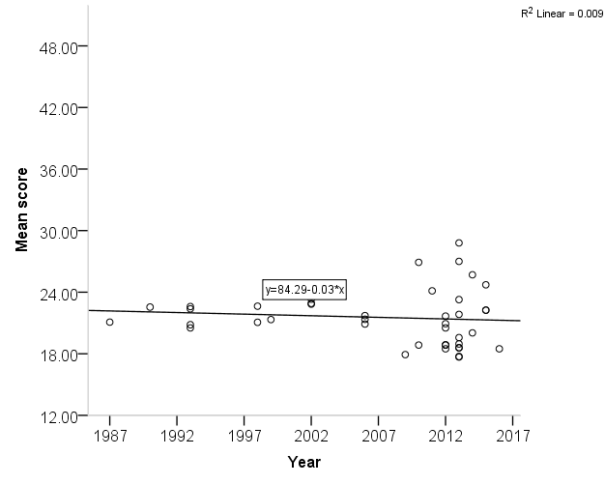

Figure 1. Mean scores for peer-related loneliness from 1987 to 2016.

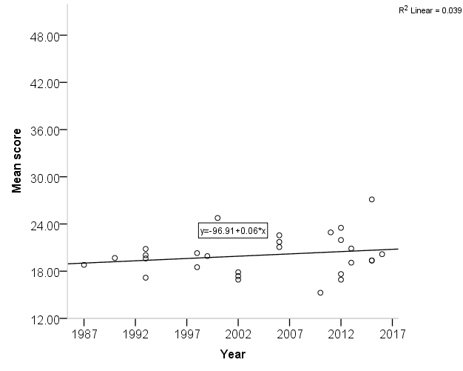
Figure 2. Mean scores for parent-related loneliness from 1987 to 2016.

References

Clark-Lempers, D. S., Lempers, J. D., & Ho, C. (1991). Early, middle, and late adolescents'

perceptions of their relationships with significant others. Journal of Adolescent

Research, 6, 296-315. doi:10.1177/074355489163003
Goossens, L. (Ed.). (2016). Leuvense Eenzaamheidsschaal voor Kinderen en
Adolescenten: Handleiding [Loneliness and Aloneness Scale for Children and Adolescents: Manual]. Leuven, Belgium: Acco.
Maes, M., Qualter, P., Vanhalst, J., Van den Noortgate, W., & Goossens, L. (2017). Gender
differences in loneliness: A meta-analysis. Unpublished manuscript, KU Leuven, Leuven, Belgium.
Trzesniewski, K. H., & Donnellan, M. B. (2010). Rethinking « Generation Me » : A study of
cohort effects from 1976-2006. Perspectives on Psychological Science, 5, 58-75. doi:10.1177/1745691609356789

