Supplementary tables and figures
Table S1
Medication List
Medication type | n (%)
Antipsychotics (i.e. Risperidone) | 7 (14)
Clonidine (i.e. Catapres) | 4 (7)
Stimulant (i.e. Methylphenidate or Lisdexamfetamine) | 5 (10)
Melatonin | 8 (16)
Serotonin reuptake inhibitors (SSRIs) (i.e. Fluoxetine or Sertraline) | 10 (20)
Notes. Parents reported medications. Average 1.6 medications per child, with a maximum of 4.

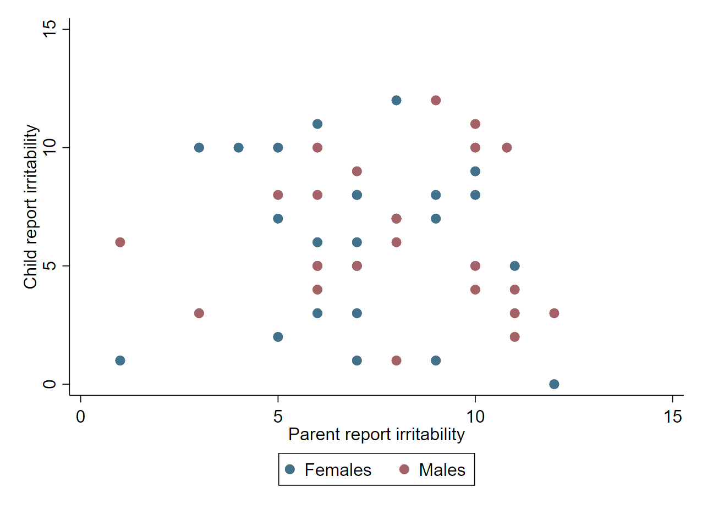
Figure S1. Scatterplot of youth irritability as self-rated by male and females and parents on the Affective Reactivity Index (ARI) scale. Scatter patterns indicated a low correlation between variables.

