Diagnosis | GP (N = 2200) | ASD (N = 220)
No diagnosis | 1994 (90.6%) | --
Social Anxiety/Social Phobia | 11(0.5%) | 66 (30%)
Schizophrenia | 2 (0.09%) | 15 (6.8%)
Other Psychosis or Psychotic Illness | 6 (0.3%) | 19 (8.6%)
Personality Disorder | 2 (0.09%) | 27 (12.3%)
Any other Phobia | 6 (0.3%) | 26 (11.8%)
Panic Attacks | 36 (1.6%) | 52 (23.6%)
OCD | 3 (0.1%) | 31 (14.1%)
Mania, Hypermania, Bipolar or Manic-depressive | 8 (0.4%) | 24 (10.9%)
Depression | 150 (6.8%) | 137 (62.3%)
Bulimia Nervosa | 0 | 14 (6.4%)
Psychological Over-eating or Binge Eating | 6 (0.3%) | 23 (10.5%)
Autism, Asperger’s or ASD | 0 | 220 (100%)
Anxiety or GAP | 82 (3.7%) | 97 (44.1%)
Anorexia Nervosa | 6 (0.3%) | 20 (9.1%)
Agoraphobia | 2 (0.09%) | 22 (10%)
ADD/ADHD | 1 (0.05%) | 19 (8.6%)

SM Table 1. In the GP sample, the majority of people with a diagnosis (N = 206) only had a single diagnosis (N = 133; 64.6%), with 14 having two diagnoses (6.8%), eight four diagnoses (3.9%), three five diagnoses (1.5%), and one person reporting nine diagnoses (0.5%). In the ASD sample, a minority only had a single diagnosis of ASD (N = 55; 25%), with 48 having two diagnoses (21.8%), 40 three diagnoses (18.2%), 23 four diagnoses (10.5%), 19 five diagnoses (8.6%), nine six diagnoses (4.1%), seven seven diagnoses (3.2%), two individuals each having eight and nine diagnoses (0.9%, respectively), three with eleven diagnoses (1.4%) and 1 individual had twelve, fourteen and fifteen diagnoses, respectively (0.5% each).

SM Figure 1. Inter-relations between sleep and cognitive measures (Beta coefficients presented; below non-significant pruning). Note: + p <.05, *p <.01, **p <.005, ***p < .001. Dotted line was non-significant and removed to create an unsaturated model.
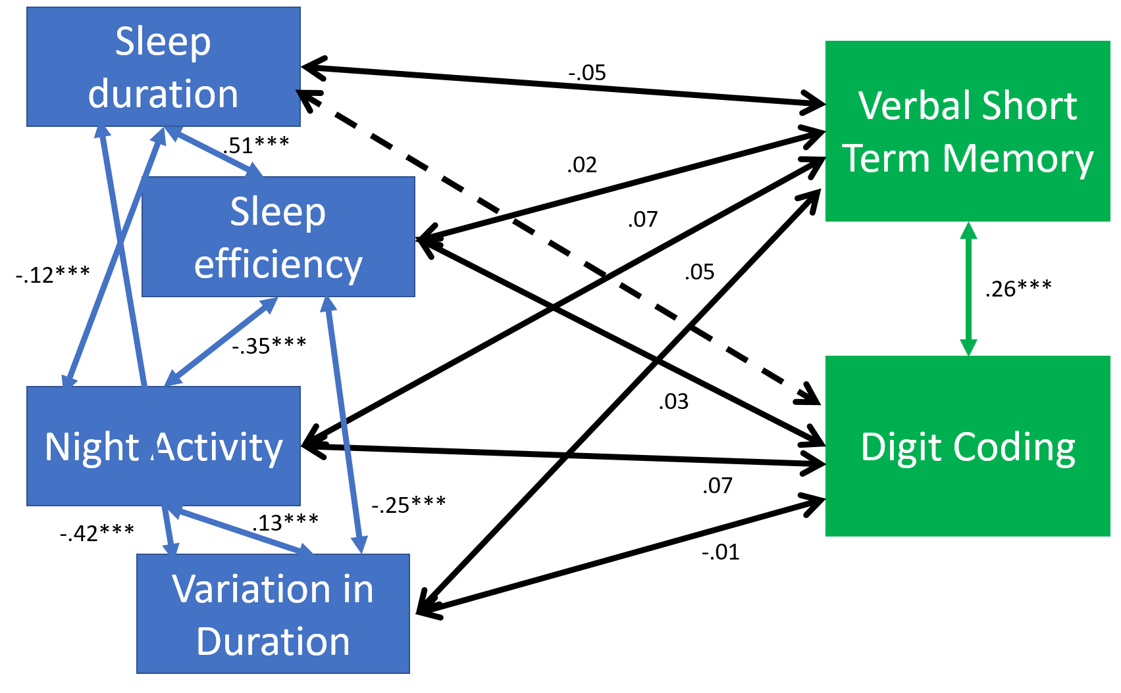

SM Figure 2. Inter-relations between sleep and educational attainment. Note: + p <.05, *p <.01, **p <.005, ***p < .001. Dotted line was non-significant and removed to create an unsaturated model.
