Title: Trajectories of Symptom Severity in Children with Autism: Variability and Turning Points through the Transition to School
Authors: Stelios Georgiades, PhD*; Peter A. Tait, PhD; Paul D. McNicholas, PhD; Eric Duku, PhD; Lonnie Zwaigenbaum, MD; Isabel M. Smith, PhD; Teresa Bennett, PhD, MD; Mayada Elsabbagh, PhD; Connor M. Kerns, PhD; Pat Mirenda, PhD; Wendy J. Ungar, PhD; Tracy Vaillancourt, PhD; Joanne Volden, PhD; Charlotte Waddell, MD; Anat Zaidman-Zait, PhD; Stephen Gentles, PhD; Peter Szatmari, MD.
Corresponding author: Stelios Georgiades, PhD, Department of Psychiatry and Behavioural Neurosciences, McMaster University, 1280 Main St. W. – MIP Suite 201A Hamilton, Ontario L8S 4K1, Canada (georgis@mcmaster.ca; 1+ 905 379 0576).
Electronic Supplementary Material – Resource 3. Temporal covariance matrix (T1 to T4) learned by the clustering model
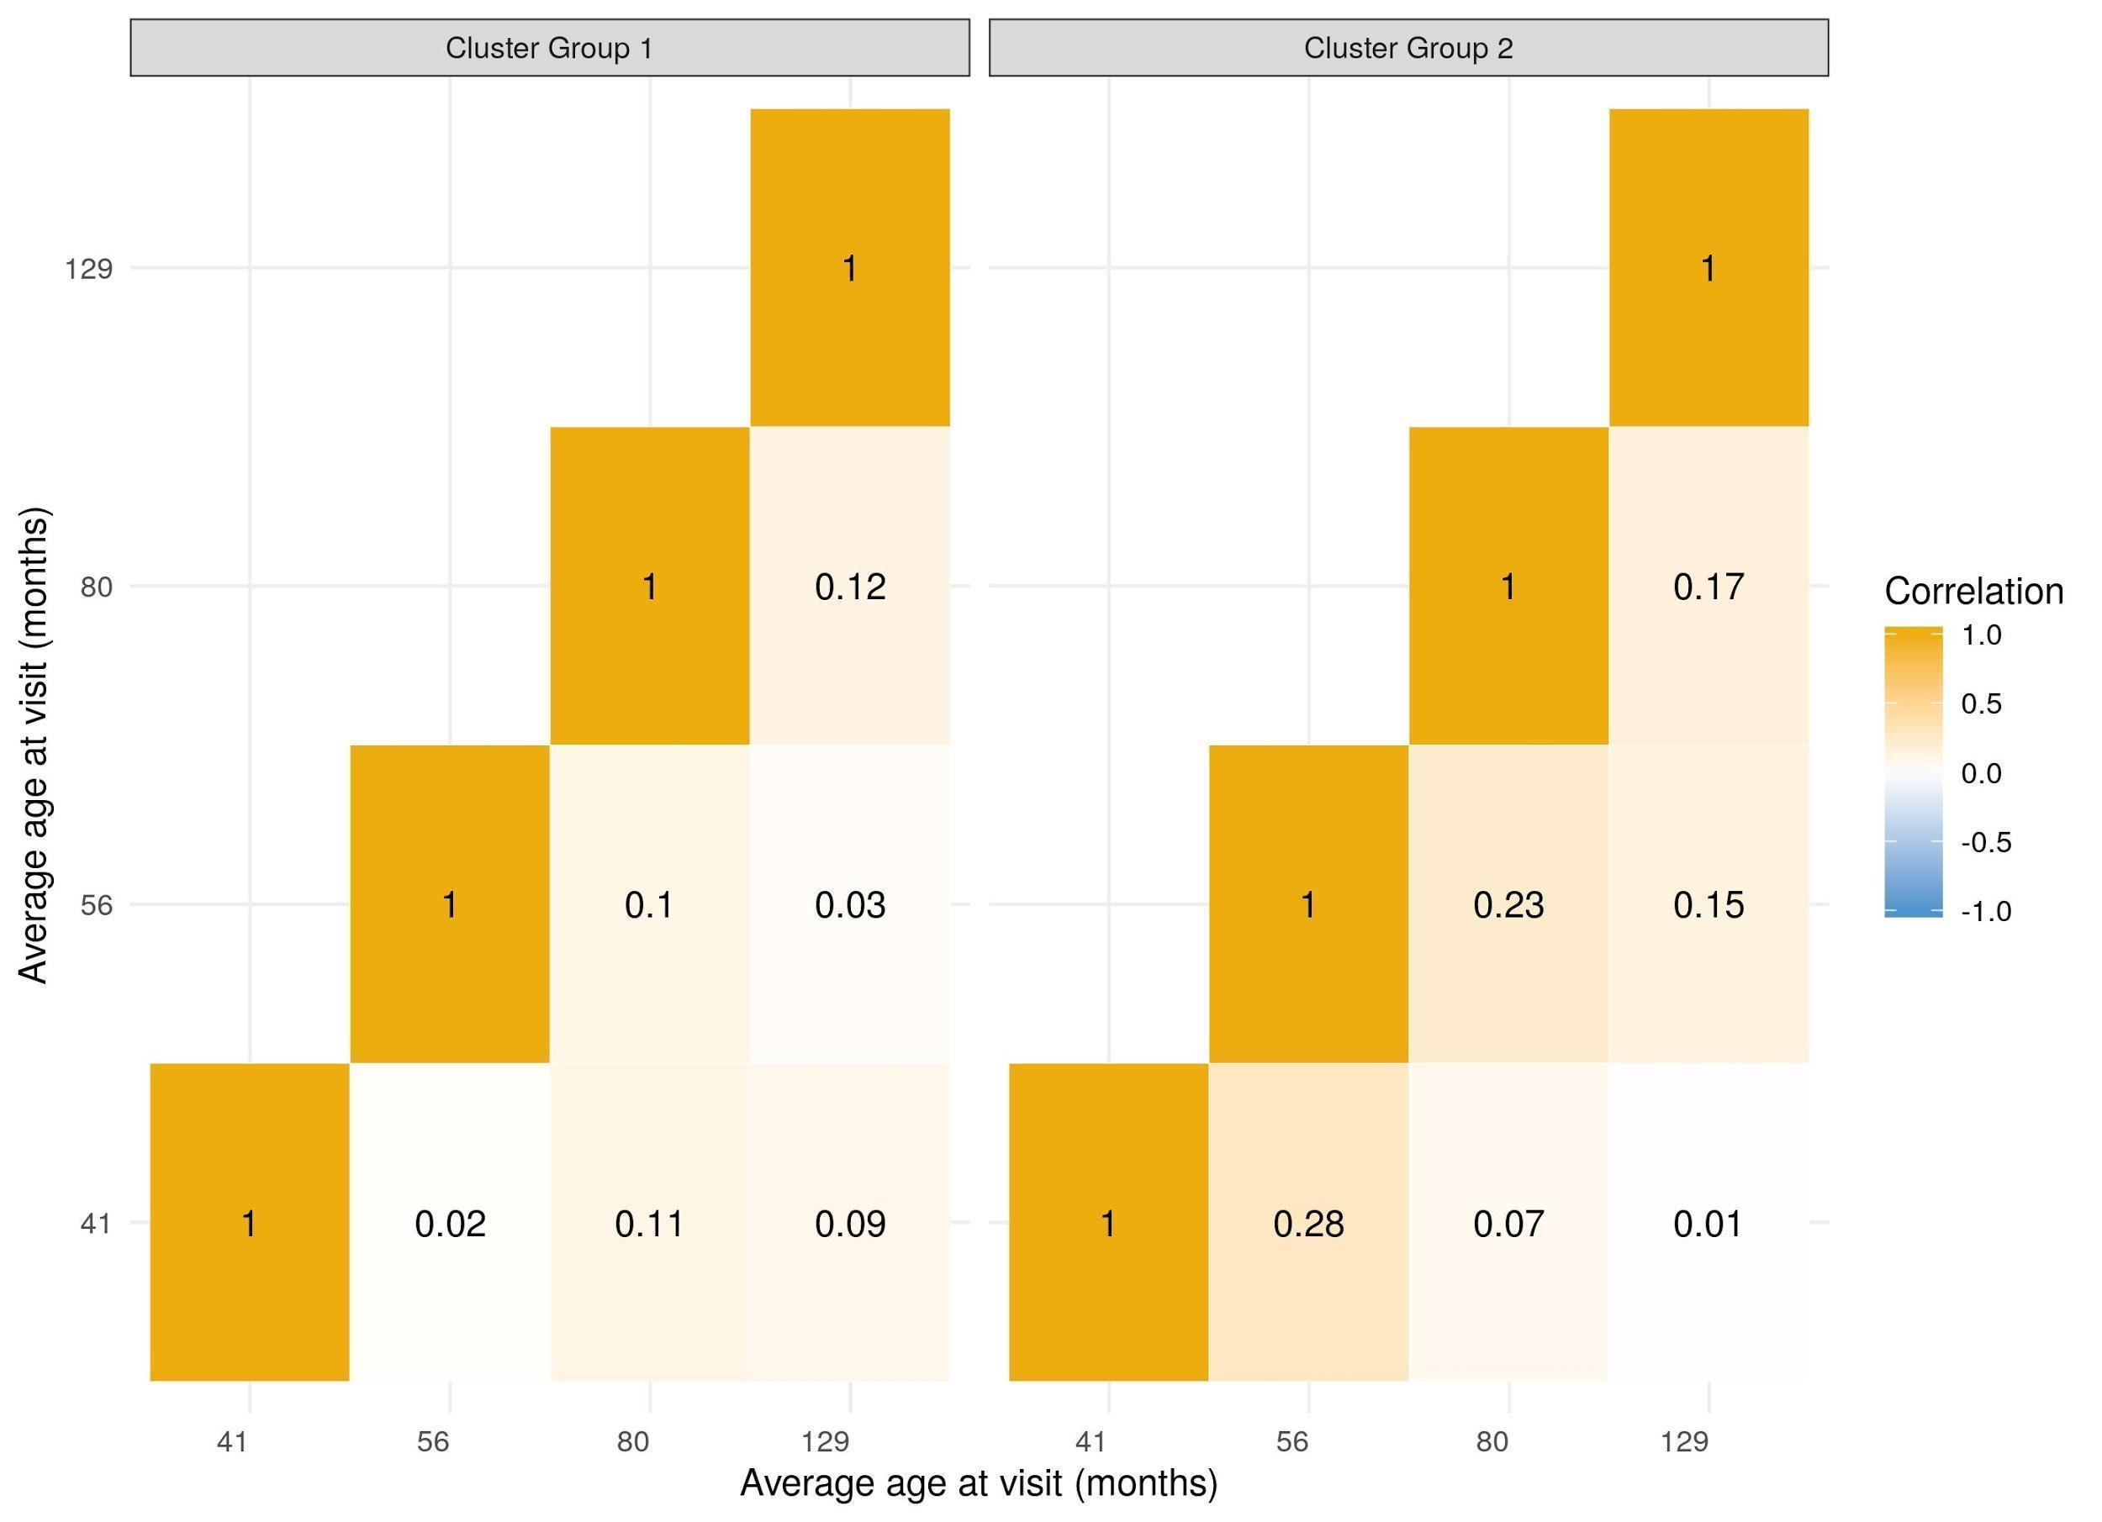
Note: Group 1: Continuously Improving Trajectory (27% of sample); Group 2: Improving then Plateauing Trajectory (73% of sample)

