Figure S1.
Dendrogram of hierarchical cluster analysis of ADOS items including the ADOS E3 anxiety item. Note the early and isolated E3 (“e3”) branch. (top)
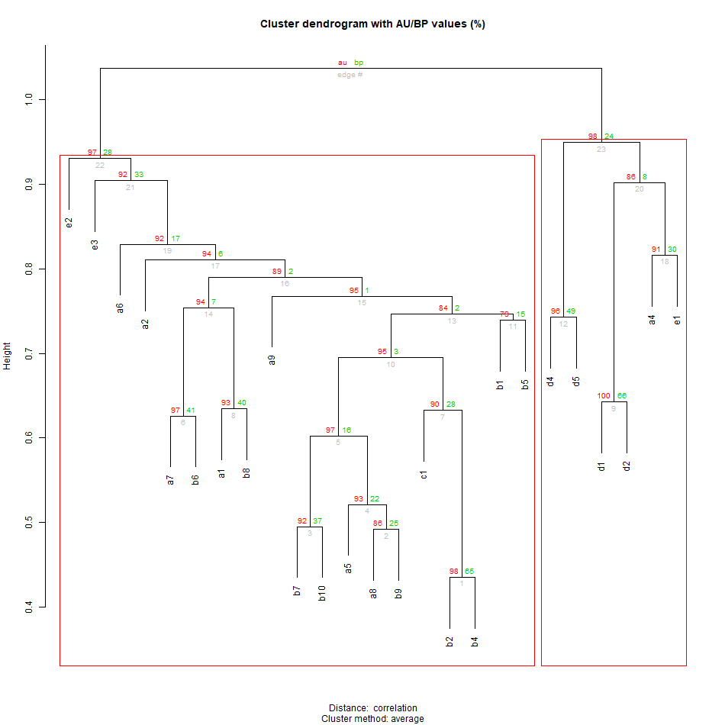

Figure S2.
Dendrogram of hierarchical cluster analysis of ADOS items including the child report RCADS total anxiety item (“RCADC”) in place of the ADOS E3 anxiety item. Note the early and isolated anxiety (RCADC) branch. (top)

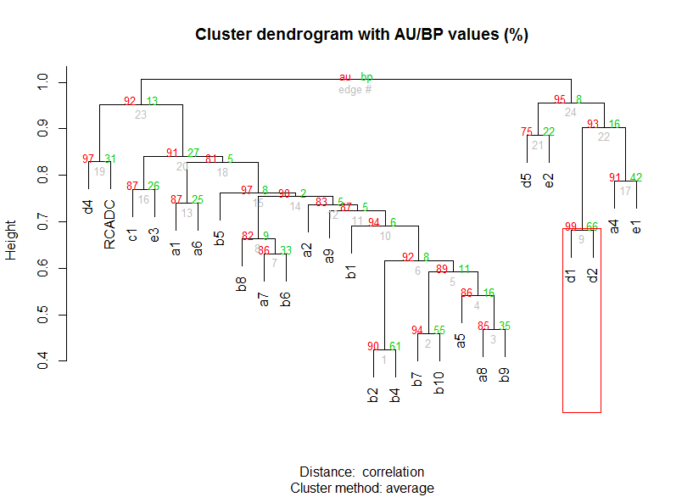

Figure S3.
Dendrogram of hierarchical cluster analysis of ADOS items including the parent report RCADS total anxiety item (“RCADS-P”) in place of the ADOS E3 anxiety item. Note the early and isolated anxiety (RCADS-P) branch. (top)

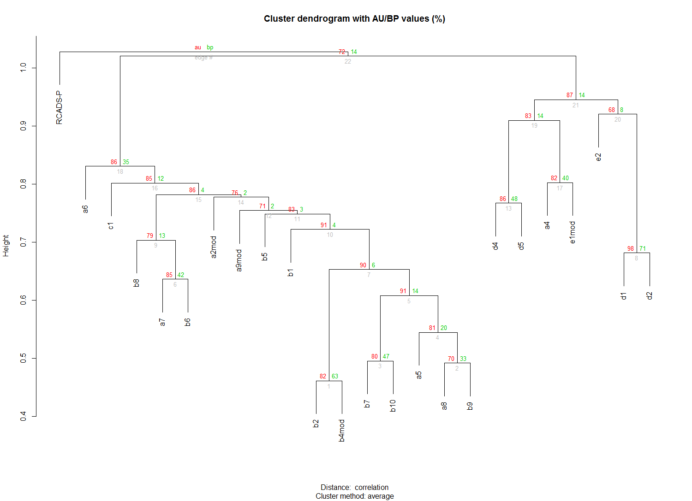

Figure S4. The Cytoscape network of ADOS Items for the ASDs group. The Anxiety Node (light blue/turquoise) is the normalized separation anxiety subscore of the child report RCADS. Please see Figure 1A for the key to node size, node color, edge width, and edge color. (top)
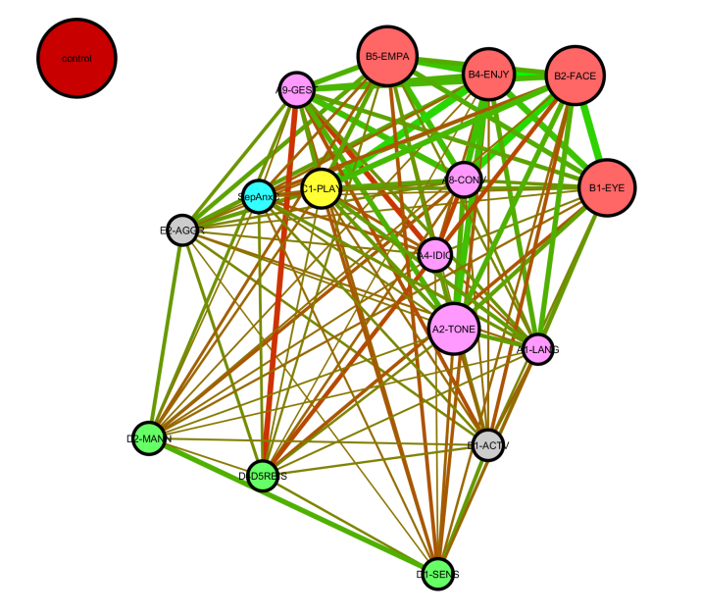

Figure S5. The Cytoscape network of ADOS Items for the ASDs group. The Anxiety Node (light blue/turquoise) is the normalized social anxiety/phobia subscore of the child report RCADS. Please see Figure 1A for the key to node size, node color, edge width, and edge color. (top)
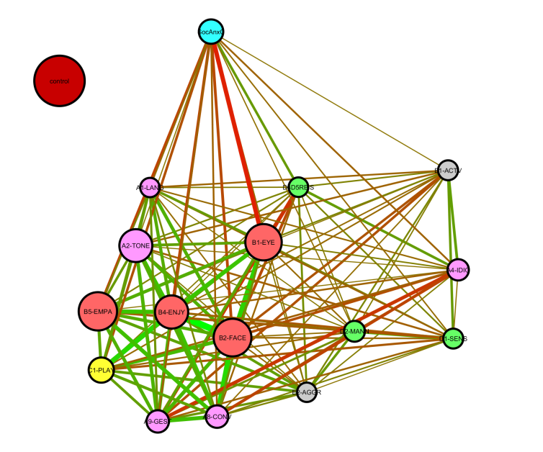

Figure S6. The Cytoscape network of ADOS Items for the ASDs group. The Anxiety Node (light blue/turquoise) is the normalized panic anxiety subscore of the child report RCADS. Please see Figure 1A for the key to node size, node color, edge width, and edge color. (top)
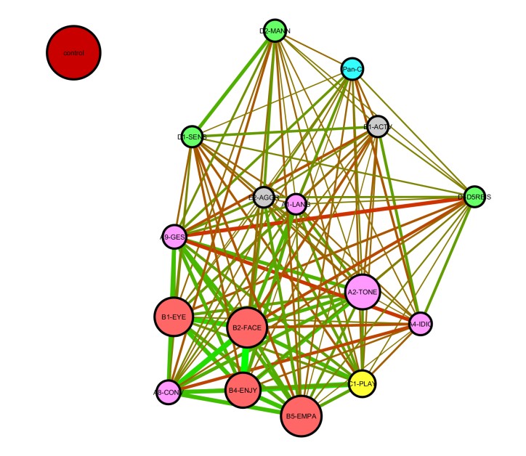

Figure S7.
The Cytoscape network of ADOS Items for the ASDs group. The Anxiety Node (light blue/turquoise) is the normalized generalized anxiety subscore of the child report RCADS. Please see Figure 1A for the key to node size, node color, edge width, and edge color. (top)

Figure S8.
The Cytoscape network of the parent report RCADS items for the ASDs group. The anxiety nodes are colored light blue/turquoise, the depression nodes are colored orange, and the OCD nodes are colored pink. The numbers within the nodes refer to the specific RCADS item represented by the node. Please see Figure 1A for the key to node size, edge width, and edge color. (top)

Figure S9.
Dendrogram of hierarchical cluster analysis of parent report RCADS items for the ASDs group. Note that letter (and number) labels here refer to RCADS anxiety (A), depression (D), and OCD (O) items. (top)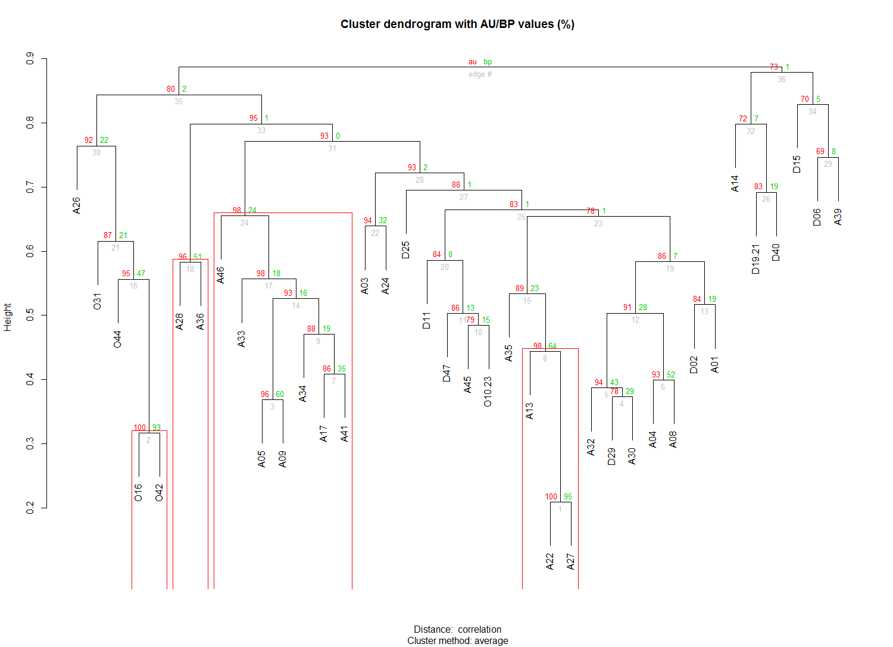

Figure S10.
Dendrogram of hierarchical cluster analysis of child report RCADS items for the ASDs group. Note that letter (and number) labels here refer to RCADS anxiety (A), depression (D), and OCD (O) items. (top)

Figure S11.
Dendrogram of hierarchical cluster analysis of parent report RCADS items for the TRIALS general population comparison group. Note that letter (and number) labels here refer to RCADS anxiety (A), depression (D), and OCD (O) items. (top)
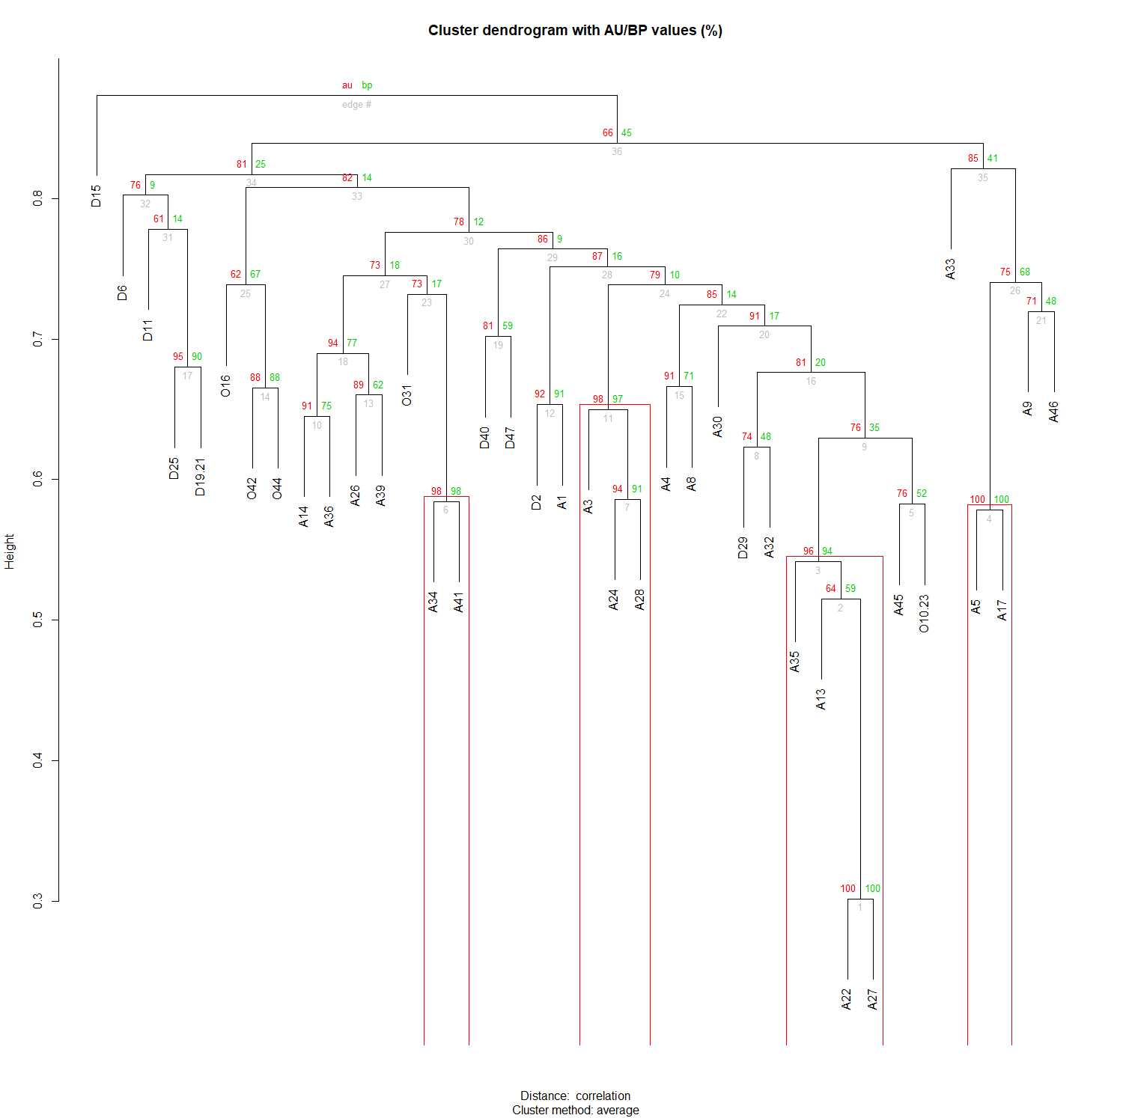
Table S12.
Subnetwork parameters for the RCADS OCD, DEPRESSION and ANXIETY subnetworks of the RCADS “all-items” networks for the ASDs and Trails general population comparison group.
Subnetwork | Clustering Coefficient | Central-  ization |  | Average  Shortest Path | Average  Neighbors | Node  Count | Density | Hetero-  Geneity
RCADS Anxiety  ASDs Child Rep. | 0.86±0.01 | 0.20 |  | 1.18±0.03 | 18.75±0.64 | 24 | 0.82 | 0.163
RCADS Depress.  ASDs Child Rep. | 0.72±0.04 | 0.23 |  | 1.306±0.05 | 5.56±0.44 | 9 | 0.69 | 0.23
RCADS OCD  ASDs Child Rep. | 1.00 | 0.00 |  | 1.00 | 4.00 | 5 | 1 | 0
RCADS Anxiety  ASDs Parent Rep. | 0.87±0.01 | 0.16 |  | 1.188±0.03 | 18.67±0.78 | 24 | 0.81 | 0.2
RCADS Depress.  ASDs Parent Rep. | 0.82±0.05 | 0.30 |  | 1.36±0.08 | 5.11±0.63 | 9 | 0.64 | 0.35
RCADS OCD  ASDs Parent Rep. | 1.00 | 0.00 |  | 1.00 | 4.00 | 5 | 1 | 0
RCADS Anxiety  TRAILS Child Rep. | 0.88±0.01 | 0.18 | 1.17±0.03 |  | 19.17±0.13 | 24 | 0.83 | 0.17
RCADS Depress.  TRAILS Child Rep. | 0.94±0.02 | 0.14 | 1.11±0.05 |  | 7.36±0.12 | 9 | 0.89 | 0.17
RCADS OCD  TRAILS Child Rep. | 1.0 | 0.0 | 1 |  | 4 | 5 | 1.0 | 0.0

