Fidelity checklist for training
Social Skill ________________ Peer Mediator(s) __________________

1. Explanation of the baseline and instructional procedure is provided Y N

2. Show peer-mediator the task analysis Y N

2. Examples and non-examples given Y N

3. Role-playing session Y N

4. Advice for handling challenges given Y N

Instructional Session Visual Schedule/Outline for Peer Mediators
Requesting More
You say: “TIME TO PRACTICE ASKING FOR MORE.”
1. Teach to turn towards me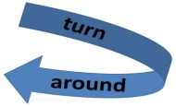
CONGRATULATE!!
2. Teach him/her to ask for more 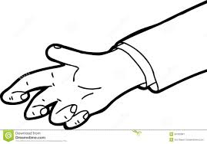
CONGRATULATE!!
3. Teach him/her to take item

CONGRATULATE!!
4. Says thank you or signs thank you

CONGRATULATE!!
5. Teach him/her to use item

CONGRATULATE!!

Respond When Invited to Join Activity
You say: “You want to play?”
- Turn towards me 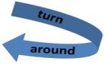

CONGRATULATE!!
- Come to me

CONGRATULATE!!
- Says or signs YES or NO 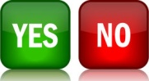

CONGRATULATE!!
- Sign or say thank you

CONGRATULATE!!
- Play with me (if said yes) or go back to seat (if said no) 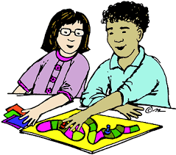or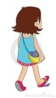

CONGRATULATE!!

Offer Assistance When Someone Needs Help
You say: “I need help.”

1. Teach to ask if I’m okay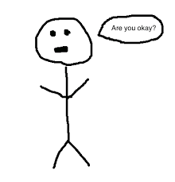
CONGRATULATE!!

2. Teach to wait for 5 seconds
CONGRATULATE!!

You say: “I need that”
3. Teach him to give it to you
CONGRATULATE!!

4. Teach to say or sign “you’re welcome”
CONGRATULATE!!

5. Teach turn to his activity 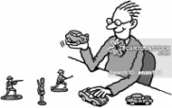
CONGRATULATE!!

Congratulate Others on a Good Job
You say: “I DID IT!”
1. Teach her to stop the activity
CONGRATULATE!!

2. Teach to turn towards me 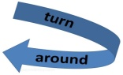
CONGRATULATE!!

3. Teach Jenny to clap for Angela
CONGRATULATE!!

4. Teach Jenny to wait for Angela to say thank you (5 sec). You say: “THANK YOU”
CONGRATULATE!!

5. Teach her to say you’re welcome or signs you’re welcome

CONGRATULATE!!

Data collection sheets used for student responses, procedure fidelity, and IOA recordings.
Name: _______________ Skill: _Requesting More
Date: _____________ Instructor: ______________Setting: ______________ Time: _________
Materials Ready: _________ Attentional Cue: ________ Task Direction: ________
Steps | Sd | Response Interval (10s) | Probe Trial (Student Response) | Consequence (None) | Sd | Instructional Trial (Student Response) | Consequence (e.g., Praise)
1. Turns towards me
2. Asks for more
3. Takes item
4. Says thank you or signs thank you
5. Uses item
Number/% correct
Number/% incorrect

Key: Check (√) indicates correct; (X) sign indicates incorrect or no response.

Name: _______________ Skill: _Respond When Invited to Join Activity
Date: _____________ Instructor: ______________Setting: _________ Time:_________
Materials Ready: _________ Attentional Cue: ________ Task Direction: ________
Steps | Sd | Response Interval (10s) | Probe Trial (Student Response) | Consequence (None) | Sd | Instructional Trial (Student Response) | Consequence (e.g., Praise)
1. Turns towards me
2. Comes to me
3. Responds to invitation like saying “yes” or “no” or shaking head
4. Says thank you or signs thank you
5. Joins you (said yes) or goes back to seat (said no)
Number/% correct
Number/% incorrect
Key: Check (√) indicates correct; (X) sign indicates incorrect or no response.

Name: _______________ Skill: _Offer Assistance When Someone Needs Help
Date: _____________ Instructor: ______________Setting: ________ Time: _________
Steps | Sd | Response Interval (10s) | Probe Trial (Student Response) | Consequence (None) | Sd | Instructional Trial (Student Response) | Consequence  (e.g., Praise)
1. Ask if I’m okay
2. Waits for me to say thank you (5 seconds)
3. Provide help
4. Responds “you’re welcome” to “thank you”
5. Returns to previous activity
Number/% correct
Number/% incorrect
Materials Ready: _________ Attentional Cue: ________ Task Direction: ________
Key: Check (√) indicates correct; (X) sign indicates incorrect or no response.

Name: _______________ Skill: _Congratulate Others on a Good Job
Date: _____________ Instructor: _____________Setting: _______ Time: _________
Materials Ready: _________ Attentional Cue: ________ Task Direction: ________
Steps | Sd | Response Interval (10s) | Probe Trial (Student Response) | Consequence (None) | Sd | Instructional Trial (Student Response) | Consequence (e.g., Praise)
1. Stops Activity
2. Turns towards me
3. Congratulates!
4. Waits for me to say thank you (5s)
5. Says “you’re welcome” or signs “you’re welcome”
Number/% correct
Number/% incorrect
Key: Check (√) indicates correct; (X) sign indicates incorrect or no response.

Peer Mediator visual schedules and collection sheets used for probe sessions.
Name: _______________ Skill: Requesting More
Date: ______ Time:____ Peer-mediator: ________________ Setting: ______________
 | Step | Circle Yes or No
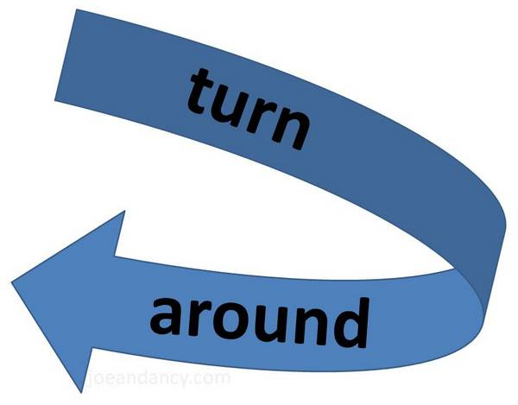 | 1. Turns towards me. | YES NO
 | 2. Asks for more. | YES NO
 | 3. Takes item. | YES NO
 | 4. Says thank you or signs thank you. | YES NO
 | 5. Uses item. | YES NO

Name: _______________ Skill: Respond When Invited to Join Activity
Date: ______ Time:____ Peer-mediator: ________________ Setting: ______________
 | Step | Circle Yes or No
 | 1. Turns towards me. | YES NO
 | 2. Comes to me. | YES NO
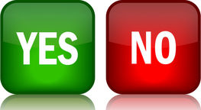 | 3. Responds to invitation like saying “yes” or “no” or shaking head. | YES NO
 | 4. Says thank you or signs thank you. | YES NO
OR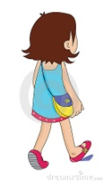 | 5. Joins you (said yes) or goes back to seat (said no). | YES NO

Name: _______________ Skill: Offer Assistance When Someone Needs Help
Date: ______ Time:____ Peer-mediator: ________________ Setting: ______________

 | Step | Circle Yes or No
 | 1. Ask if I’m okay. | YES NO
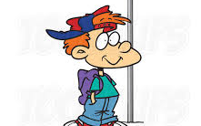 | 2. Waits for me to say thank you (5 seconds). | YES NO
 | 3. Provide help. | YES NO
 | 4. Respond “you’re welcome” to “thank you” | YES NO
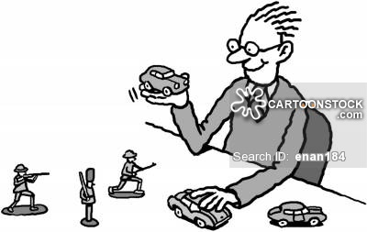 | 5. Return to previous activity. | YES NO

Name: _______________ Skill: Congratulate Others on a Good Job
Date: ______ Time:____ Peer-mediator: ________________ Setting: ______________

 | Step | Circle Yes or No
 | 1. Stops activity. | YES NO
 | 2. Turns towards me. | YES NO
 | 3. Congratulates! | YES NO
 | 4. Waits for me to say thank you (5 seconds) | YES NO
 | 5. Says you’re welcome or signs you’re welcome. | YES NO

Instructional Procedures
Respond When Invited to Join Activity
Behavioral Objective
When invited by the peer mediator, Student will perform the steps of the task analysis for responding to an invitation with 100% accuracy for 3 probe trials. The task analysis will consist of the following steps:
1. Turns towards me
2. Move to area being invited
3. Respond to invitation (e.g., “yes” or “no”)
4. Indicates thank you verbally or non-verbally
5. Join in with activity or go back to previous area

Instructional Context

Three times a day (Monday-Friday), Student’s peer mediator will work with him/her to systematically teach responding to an invitation.

Instructional Materials

The peer mediator will need an activity or materials that the student enjoys to start the session as well as reinforcement materials, if applicable.

Instructional Procedures

Each instructional trial will proceed as follows.

Attentional Cue: The peer mediator will give the general attention cue of stating Student’s name to get attention before the trial starts.

Natural Occurring Event: When teaching social skills, a task direction is often not warranted. For example, in this case teaching responding to an invitation allows the peer mediator’s interaction with the student to be a natural occurring event providing direction.

Simultaneous Prompting Procedures: The peer mediator will deliver the task direction, or in this case discriminative stimulus (e.g., “Do you want to play with me?”), first as a probe session. The peer mediator will say, “What’s next?” as necessary, and wait 10 seconds for Student to initiate each step of the task analysis. If Student fails to initiate a step, the peer mediator will end the trial.
One instructional session using a 0-second time delay interval will occur immediately following the probe session. During this instructional session, the peer mediator immediately will use a controlling prompt to assist Student in performing the correct response.
Consequence: During probe sessions, the peer mediator will not give any feedback on performance. During the instructional sessions, the peer mediator will give the selected reinforcement (e.g., descriptive praise).
Non-targeted Information
The peer mediators’ names will be used in the consequent stages of the instructional session with verbal, descriptive praise (“Carol is so proud of you!”).
Data Collection
The peer mediator will collect data during the probe sessions that occur once a day. On the data sheet, the peer mediator will circle YES for a correct response or a NO for incorrect response. The researcher will also collect data during probe and instructional sessions to be used for Student participant progress monitoring, procedural reliability, and IOA.
Maintenance
Once Student has met the criterion of 100% correct responses for 1 probe trial, reinforcement will be thinned to the end of the successfully completed task (fixed ratio of 5, or FR5). Student response to an invitation skill will continue to be monitored for the remainder of the sessions following the successful completion of each social skill and in a final maintenance probe one week following the final generalization probe.

Generalization

The peer mediators will facilitate generalization by having Students perform sessions in different settings and with different materials. Once Student has mastered all social skill tasks, a probe session in his/her residence hall and another probe session with a different peer mediator will be conducted.

Behavior Management

The peer mediator and researcher will periodically praise Student for how hard he/she is working (e.g., “You are really working hard. Your correspondent will be so proud!”)

Congratulate Others on a Good Job
Behavioral Objective
When hearing the peer mediator say he/she did a good job, Student will perform the steps of the task analysis for responding to the comment with 100% accuracy for 3 probe trials. The task analysis will consist of the following steps:
1. Stops activity
2. Turns towards me
3. Indicates a non-verbal (“claps hands”) congratulations
4. Waits approximately 5 seconds for my response (e.g., thank you)
5. Returns to activity

Instructional Context

Three times a day (Monday-Friday), Student’s peer mediator will work with him/her to systematically teach congratulating others on a good job.

Instructional Materials

The peer mediator will need two activities or sets of materials that the student enjoys to start the session as well as reinforcement materials, if applicable.

Instructional Procedures

Each instructional trial will proceed as follows.

Attentional Cue: The peer mediator will give the general attention cue of stating Student’s name to get attention before the trial starts.

Natural Occurring Event: When teaching social skills, a task direction is often not warranted. For example, in this case, teaching how to congratulate others allows the peer mediator’s interaction with the student to be a natural occurring event providing direction.

Simultaneous Prompting Procedure: The peer mediator will deliver the task direction, or in this case discriminative stimulus (e.g., “I did it!” or “I did a good job!”) first as a probe session. The peer mediator will say, “What’s next?” and appropriate statements (e.g., “thank you”) as necessary and wait 10 seconds for Student to initiate each step of the task analysis. If Student fails to initiate a step, the peer mediator will end the trial.
One instructional session using a 0-second time delay interval will occur immediately following the probe. During this instructional session, the peer mediator immediately will use a controlling prompt to assist Student in performing the correct response.
Consequence: During probe sessions, the peer mediator will not give any feedback on performance. During the instructional sessions, the peer mediator will give the selected reinforcement (e.g., descriptive praise).
Non-targeted Information
The peer mediators’ names will be used in the consequent stages of the instructional session with verbal, descriptive praise (“Carol is so proud of you!”).
Data Collection
The peer mediator will collect data during the probe sessions that occur once a day. On the data sheet, the peer mediator will circle YES for a correct response or a NO for incorrect response. The researcher will also collect data during probe and instructional sessions to be used for Student participant progress monitoring, procedural reliability, and IOA.
Maintenance

Once Student has met the criterion of 100% correct responses for 1 probe trial, reinforcement will be thinned to the end of the successfully completed task (fixed ratio of 5, or FR5). Student congratulating skills will continue to be monitored for the remainder of the sessions following the successful completion of each social skill and in a final maintenance probe one week following the final generalization probe.

Generalization

The peer mediators will facilitate generalization by having Students perform sessions in different settings and with different materials. Once Student has mastered all social skill tasks, a probe session in his/her residence hall and another probe session with a different peer mediator will be conducted.

Behavior Management

The peer mediator and researcher will periodically praise Student for how hard he/she is working (e.g., “You are really working hard. Your correspondent will be so proud!”)

Requesting Something or Requesting More
Behavioral Objective
When an opportunity to request something is presented by the peer mediator, Student will perform the steps of the task analysis for responding to the comment with 100% accuracy for 3 probe trials. The task analysis will consist of the following steps:
1. Turns toward me
2. Asks for more (e.g., puzzle piece) by pointing, verbally asking, or putting hand on object.
3. Takes item from peer mediator
4. Indicates thank you verbally or non-verbally
5. Uses requested item

Instructional Context

Three times a day (Monday-Friday), Student’s peer mediator will work with him/her to systematically teach how to appropriately request something.

Instructional Materials

The peer mediator will need one activity or set of materials that the student enjoys to start the session as well as reinforcement materials, if applicable.

Instructional Procedures

Each instructional trial will proceed as follows.

Attentional Cue: The peer mediator will give the general attention cue of stating Student’s name to get attention before the trial starts.

Natural Occurring Event: When teaching social skills, a task direction is often not warranted. For example, in this case, teaching how to request something may allow the peer mediator’s interaction with the student to be a natural occurring event providing direction.

Simultaneous Prompting Procedure: The peer mediator will deliver the task direction (i.e., “It’s time to practice asking for more”) first as a probe session. The peer mediator will say, “What’s next?” and wait 10 seconds for Student to initiate each step of the task analysis. If Student fails to initiate a step, the peer mediator will end the trial.
One instructional session using a 0-second time delay interval will occur following the probe. During this instructional session, the peer mediator immediately will use a controlling prompt to assist Student in performing the correct response.
Consequence: During probe sessions, the peer mediator will not give any feedback on performance. During the instructional sessions, the peer mediator will give the selected reinforcement (e.g., descriptive praise).
Non-targeted Information
The peer mediators’ names will be used in the consequent stages of the instructional session with verbal, descriptive praise (“Carol is so proud of you!”).
Data Collection
The peer mediator will collect data during the probe sessions that occur once a day. On the data sheet, the peer mediator will circle YES for a correct response or a NO for incorrect response. The researcher will also collect data during probe and instructional sessions to be used for Student participant progress monitoring, procedural reliability, and IOA.
Maintenance

Once Student has met the criterion of 100% correct responses for 1 probe trial, reinforcement will be thinned to the end of the successfully completed task (fixed ratio of 5, or FR5). Student requesting skills will continue to be monitored for the remainder of the sessions following the successful completion of each social skill and in a final maintenance probe one week following the final generalization probe.

Generalization

The peer mediators will facilitate generalization by having Students perform sessions in different settings and with different materials. Once Student has mastered all social skill tasks, a probe session in his/her residence hall and another probe session with a different peer mediator will be conducted.

Behavior Management

The peer mediator and researcher will periodically praise Student for how hard he/she is working (e.g., “You are really working hard. Your correspondent will be so proud!”)

Offer to Assist When Someone Needs Help
Behavioral Objective
When an opportunity to assist the peer mediator is presented, Student will perform the steps of the task analysis for responding to the comment with 100% accuracy for 3 probe trials. The task analysis will consist of the following steps:
1. Asking if the peer mediator is okay
2. Waiting approximately five seconds for response
3. Provide needed assistance
4. Respond “your welcome” to “thank you”
5. Return to previous activity

Instructional Context

Three times a day (Monday-Friday), Student’s peer mediator will work with him/her to systematically teach how to offer assistance when someone needs help.

Instructional Materials

The peer mediator will need one activity or set of materials that the student enjoys to start the session as well as reinforcement materials, if applicable.

Instructional Procedures

Each instructional trial will proceed as follows.

Attentional Cue: The peer mediator will give the general attention cue of stating Student’s name to get attention before the trial starts.

Natural Occurring Event: When teaching social skills, a task direction is often not warranted. For example, in this case, teaching how to help others allows the peer mediator’s interaction with the student to be a natural occurring event providing direction.

Simultaneous Prompting Procedure: The peer mediator will deliver the task direction, or in this case discriminative stimulus (e.g., “I need help!”), first as the probe session. The peer mediator will say, “What’s next” or provide appropriate statements (e.g., “I need that”) and wait 10 seconds for Student to initiate each step of the task analysis. If Student fails to initiate a step, the peer-mediator will end the trial.
One instructional session using a 0-second time delay interval will occur following the probe. During this instructional session, the peer mediator immediately will use a controlling prompt to assist Student in performing the correct response.
Consequence: During probe sessions, the peer mediator will not give any feedback on performance. During the instructional sessions, the peer mediator will give the selected reinforcement (e.g., descriptive praise).
Non-targeted Information
The peer mediators’ names will be used in the consequent stages of the instructional session with verbal, descriptive praise (“Carol is so proud of you!”).
Data Collection
The peer mediator will collect data during the probe sessions that occur once a day. On the data sheet, the peer mediator will circle YES for a correct response or a NO for incorrect response. The researcher will also collect data during probe and instructional sessions to be used for Student participant progress monitoring, procedural reliability, and IOA.
Maintenance

Once Student has met the criterion of 100% correct responses for 1 probe trial, reinforcement will be thinned to the end of the successfully completed task (fixed ratio of 5, or FR5). Student helping skills will continue to be monitored for the remainder of the sessions following the successful completion of each social skill and in a final maintenance probe one week following the final generalization probe.

Generalization

The peer mediators will facilitate generalization by having Students perform sessions in different settings and with different materials. Once Student has mastered all social skill tasks, a probe session in his/her residence hall and another probe session with a different peer mediator will be conducted.

Behavior Management

The peer mediator and researcher will periodically praise Student for how hard he/she is working (e.g., “You are really working hard. Your correspondent will be so proud!”)

