Supplementary Material

Figure S1. Distribution of the ADHD outcome scales in ABCD (CBCL) and GUI (SDQ) colored by group (low= below 50th percentile; moderate= 50th-79th percentile; high=80th-89th percentile; very high= 90th percentile +).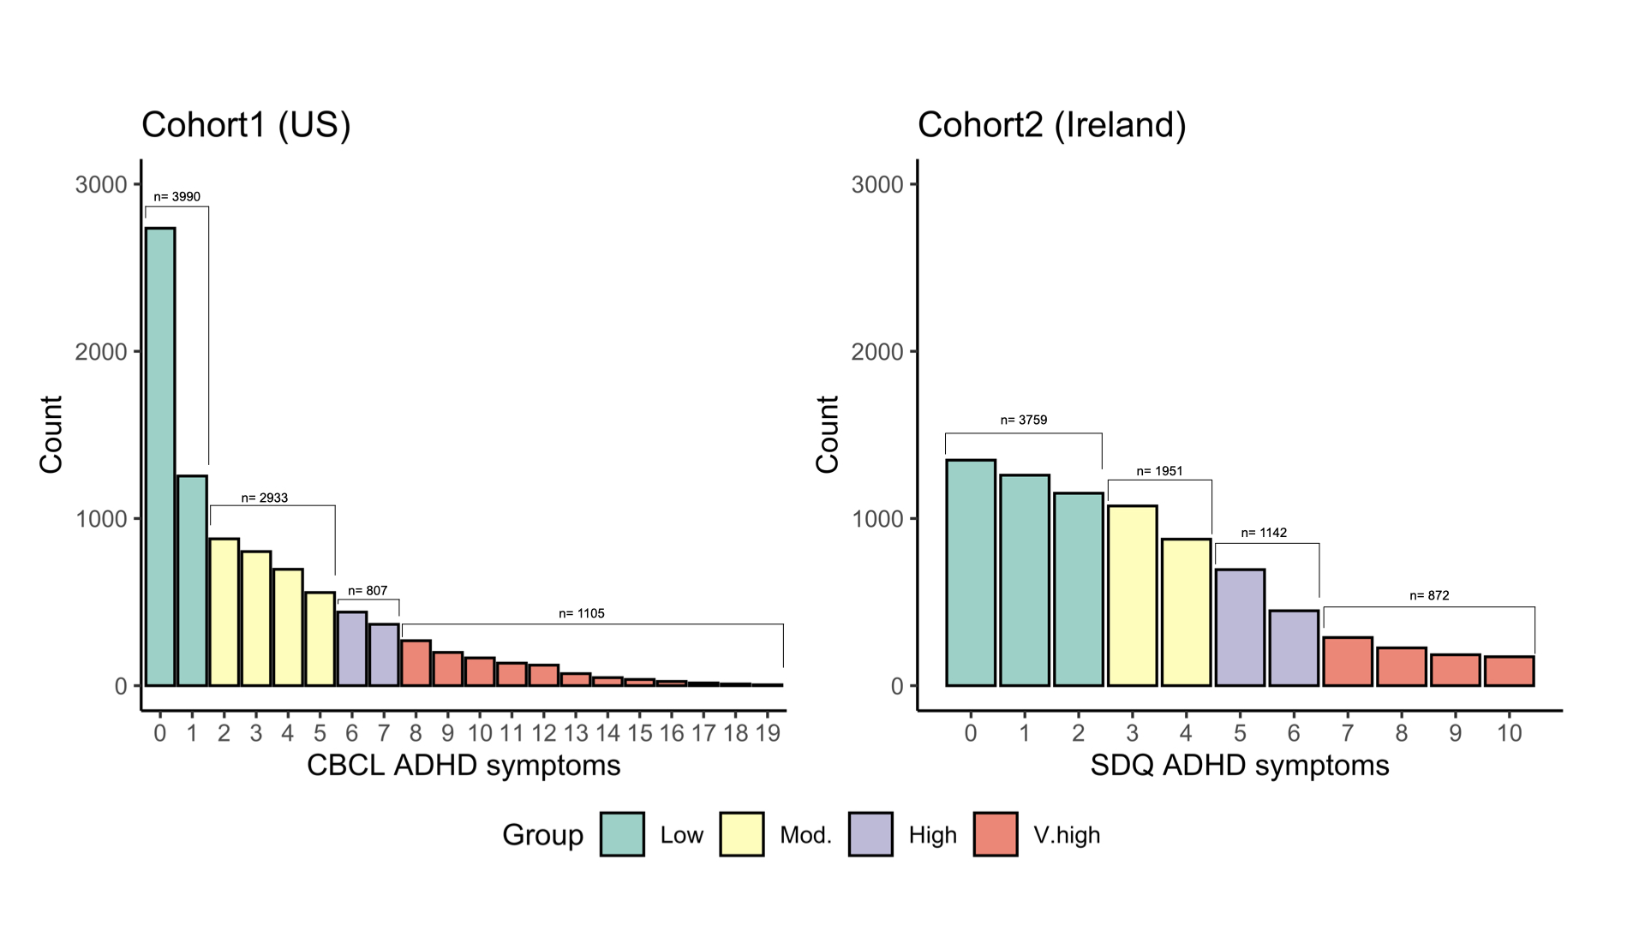

Table S1. Constituent items in each outcome scale.
ABCD (CBCL) “…describes your child now or within the past 6 months…” | GUI (SDQ) “…on the basis of the child’s behavior over the last 6 months or this school year”
1. Acts too young for his/her age | 1. Restless, overactive, cannot stay still for long
2. Fails to finish things he/she started | 2. Constantly fidgeting or squirming
3. Can’t concentrate, can’t pay attention for long | 3. Easily distracted, concentration wanders
4. Can't sit still, restless or hyperactive | 4. Thinks things out before acting (R)
5. Confused or seems to be in a fog | 5. Sees tasks through to the end, good attention span (R)
6. Daydreams or gets lost in his/her thoughts
7. Impulsive or acts without thinking
8. Poor school work
9. Inattentive or easily distracted
10. Stares blankly
R = Reverse coded

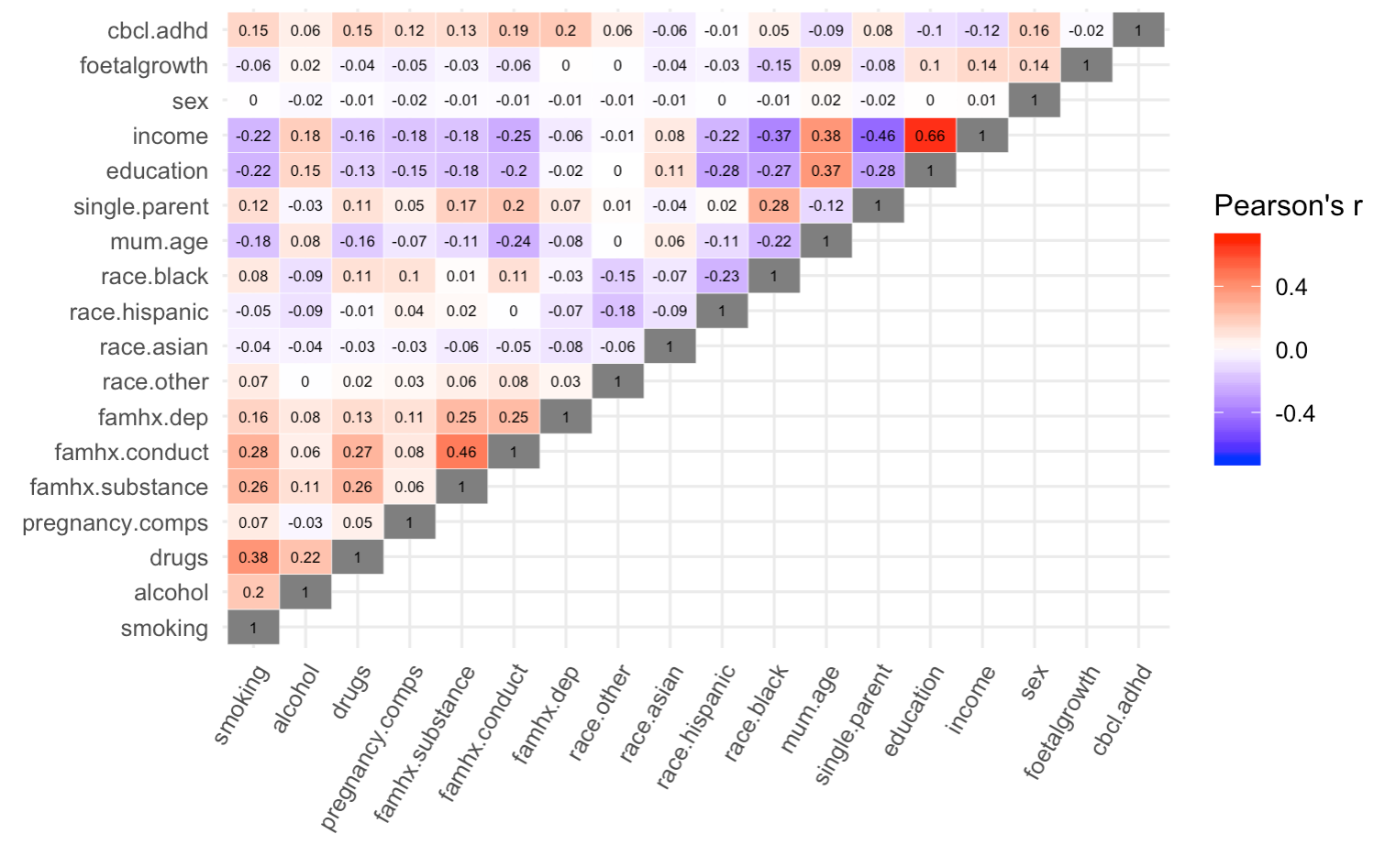
Figure S2. Pearson’s correlation heat-map for variables included in ABCD (US) analysis

Figure S3. Pearson’s correlation heat-map for variables included in GUI (Ireland) analysis.
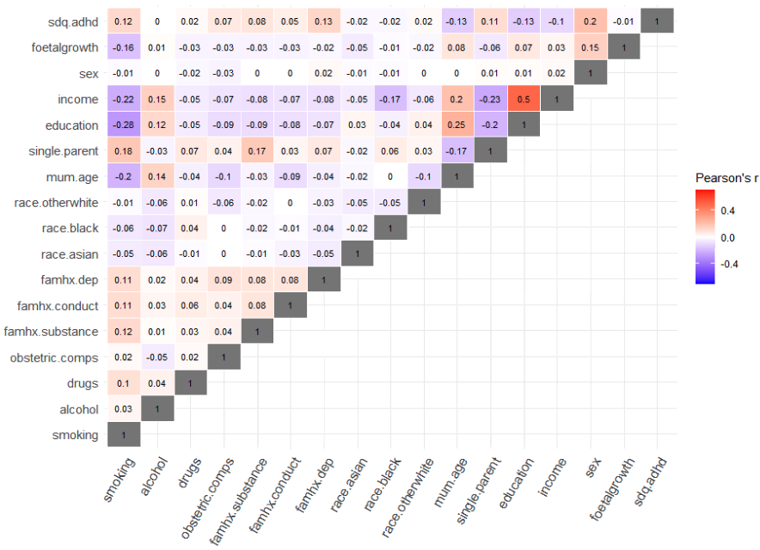
pregnancy.comps

Table S2. Change in the fetal growth effect on ADHD symptoms due to sequential control for other factors (M1-4) when outcome is represented as linear (top) Vs as ordinal groups (bottom).
 |  | M0* | M1 | M2 | M3 | M4 | Total % change
 |  |  | + SES & demographics | + Family psychiatric history | + Pregnancy complications | + Maternal substance-use
Linear Outcome (ADHD scale; log transformed)
ABCD (US) | Fetal growth effect (B, p) | 0.063 | 0.047 | 0.044 | 0.039 | 0.036
 |  | <.001 | .02 | .03 | .05 | .08
 | B change | — | 0.016 | 0.003 | 0.005 | 0.003
 | % of baseline | — | 25.4% | 4.8% | 7.9% | 4.8% | 43%
GUI (Ireland) | Fetal growth effect (B, p) | 0.075 | 0.059 | 0.055 | 0.053 | 0.036
 |  | <.001 | .001 | .002 | .003 | .05
 | B change | — | 0.016 | 0.004 | 0.002 | 0.017
 | % of baseline | — | 21.3% | 5.3% | 2.7% | 22.7% | 52%
Cohort Average | % of baseline |  | 23.4% | 5.0% | 5.3% | 13.7% | 47%
Ordinal group outcome (low, moderate, high or very high symptoms)
ABCD (US) | Fetal growth effect (B, p) | 0.131 | 0.090 | 0.085 | 0.072 | 0.065
 |  | .002 | .04 | .06 | .11 | .16
 | B change | — | 0.041 | 0.005 | 0.013 | 0.007
 | % of baseline | — | 31.3% | 3.8% | 9.9% | 5.3% | 50%
GUI (Ireland) | Fetal growth effect (B, p) | 0.185 | 0.147 | 0.135 | 0.129 | 0.091
 |  | <.001 | .005 | .01 | .01 | .12
 | B change | — | 0.038 | 0.012 | 0.006 | 0.038
 | % of baseline | — | 20.5% | 6.5% | 3.2% | 20.5% | 51%
Cohort Average | % of baseline |  | 25.9% | 5.2% | 6.6% | 12.9% | 51%
*Baseline model M0: fetal growth + sex
SES: socioeconomic status

Figure S4. Breakdown of association between fetal growth and odds of higher group membership (low, moderate, high and very high symptoms). Grey portion shows unexplained fetal growth effect.
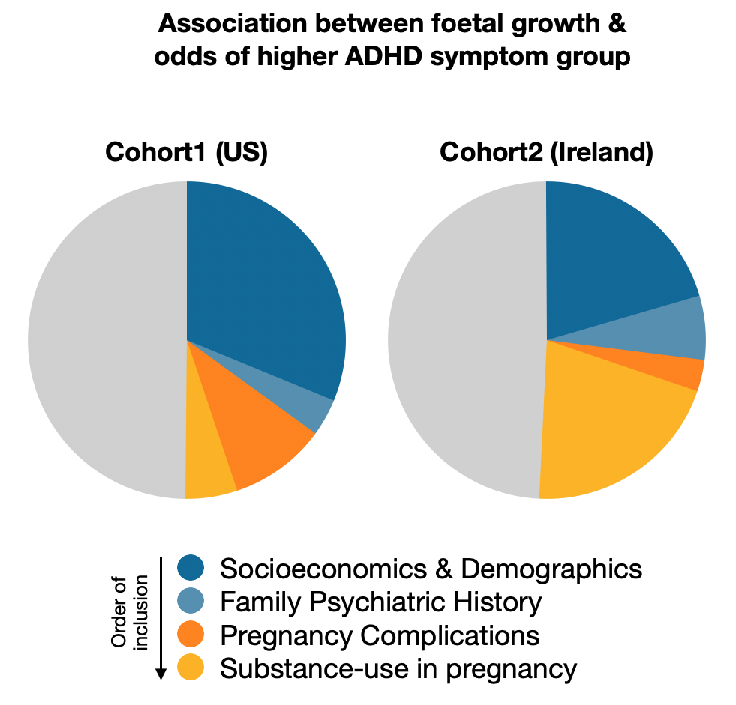

Table S3. Results of linear modelling in ABCD (US)
 | Dependent variable: Log-transformed ADHD symptoms (CBCL)
 | baseline | +SES/Demo | +famhx | +complications | +substances
Restricted Fetal Growth | 0.063 (0.019) | 0.047 (0.020) | 0.044 (0.020) | 0.039 (0.020) | 0.036 (0.020)
 | t = 3.409 | t = 2.376 | t = 2.219 | t = 1.952 | t = 1.775
 | p = 0.0007 | p = 0.018 | p = 0.027 | p = 0.051 | p = 0.076
Male sex | 0.297 (0.019) | 0.295 (0.020) | 0.297 (0.020) | 0.300 (0.020) | 0.302 (0.020)
 | t = 15.702 | t = 14.946 | t = 15.201 | t = 15.347 | t = 15.194
 | p = 0.000 | p = 0.000 | p = 0.000 | p = 0.000 | p = 0.000
Asian |  | -0.263 (0.068) | -0.174 (0.068) | -0.174 (0.068) | -0.154 (0.068)
 |  | t = -3.896 | t = -2.556 | t = -2.561 | t = -2.263
 |  | p = 0.0001 | p = 0.011 | p = 0.011 | p = 0.024
Black |  | -0.016 (0.034) | 0.025 (0.035) | 0.010 (0.035) | 0.008 (0.036)
 |  | t = -0.468 | t = 0.712 | t = 0.280 | t = 0.217
 |  | p = 0.640 | p = 0.477 | p = 0.780 | p = 0.829
Hispanic |  | -0.057 (0.027) | -0.008 (0.027) | -0.013 (0.027) | 0.003 (0.028)
 |  | t = -2.099 | t = -0.299 | t = -0.482 | t = 0.097
 |  | p = 0.036 | p = 0.765 | p = 0.630 | p = 0.924
Other race/ethnicity |  | 0.113 (0.033) | 0.107 (0.033) | 0.097 (0.033) | 0.106 (0.034)
 |  | t = 3.397 | t = 3.199 | t = 2.927 | t = 3.096
 |  | p = 0.001 | p = 0.002 | p = 0.004 | p = 0.002
Income |  | -0.024 (0.006) | -0.018 (0.006) | -0.015 (0.006) | -0.017 (0.006)
 |  | t = -4.026 | t = -2.918 | t = -2.497 | t = -2.765
 |  | p = 0.0001 | p = 0.004 | p = 0.013 | p = 0.006
Education |  | -0.014 (0.011) | -0.010 (0.011) | -0.006 (0.011) | -0.005 (0.011)
 |  | t = -1.285 | t = -0.980 | t = -0.601 | t = -0.487
 |  | p = 0.199 | p = 0.327 | p = 0.549 | p = 0.627
Single-parent |  | 0.060 (0.028) | 0.006 (0.029) | 0.010 (0.029) | 0.001 (0.029)
 |  | t = 2.111 | t = 0.211 | t = 0.353 | t = 0.046
 |  | p = 0.035 | p = 0.833 | p = 0.724 | p = 0.964
Maternal age |  | -0.007(0.002) | -0.004 (0.002) | -0.004(0.002) | -0.003 (0.002)
 |  | t = -4.018 | t = -2.119 | t = -2.171 | t = -1.596
 |  | p = 0.0001 | p = 0.035 | p = 0.030 | p = 0.111
Parental depression/anxiety |  |  | 0.264 (0.021) | 0.248 (0.021) | 0.237 (0.022)
 |  |  | t = 12.354 | t = 11.614 | t = 10.844
 |  |  | p = 0.000 | p = 0.000 | p = 0.000
Parental conduct problems |  |  | 0.206 (0.034) | 0.197 (0.034) | 0.159 (0.035)
 |  |  | t = 6.032 | t = 5.755 | t = 4.512
 |  |  | p = 0.000 | p = 0.000 | p = 0.00001
Familial substance-use |  |  | 0.037 (0.028) | 0.036 (0.028) | -0.001 (0.029)
 |  |  | t = 1.327 | t = 1.268 | t = -0.044
 |  |  | p = 0.185 | p = 0.205 | p = 0.966
Total pregnancy Complications |  |  |  | 0.086 (0.012) | 0.086 (0.012)
 |  |  |  | t = 7.106 | t = 7.014
 |  |  |  | p = 0.000 | p = 0.000
Smoking in pregnancy |  |  |  |  | 0.061 (0.033)
 |  |  |  |  | t = 1.836
 |  |  |  |  | p = 0.067
Alcohol in pregnancy |  |  |  |  | 0.098 (0.023)
 |  |  |  |  | t = 4.239
 |  |  |  |  | p = 0.00003
Drugs in pregnancy |  |  |  |  | 0.197 (0.042)
 |  |  |  |  | t = 4.704
 |  |  |  |  | p = 0.00001
Observations | 8358 | 7486 | 7310 | 7293 | 6974
R² | 0.029 | 0.048 | 0.082 | 0.087 | 0.096
Adjusted R² | 0.029 | 0.047 | 0.080 | 0.086 | 0.094

Table S4. Results of ordinal logistic modelling in ABCD (US)
 | Dependent variable: ADHD symptom group (low, moderate, high, very high)
 | baseline | +SES+Demo | +famhx | +complications | +substances
Restricted Fetal Growth | 0.131(0.040) | 0.090(0.044) | 0.085(0.045) | 0.072(0.045) | 0.065(0.046)
 | t = 3.228 | t = 2.037 | t = 1.895 | t = 1.593 | t = 1.392
 | p = 0.002 | p = 0.042 | p = 0.059 | p = 0.112 | p = 0.164
Male sex | 0.621(0.042) | 0.629(0.044) | 0.648(0.045) | 0.655(0.045) | 0.668(0.047)
 | t = 14.854 | t = 14.162 | t = 14.315 | t = 14.421 | t = 14.344
 | p = 0.000 | p = 0.000 | p = 0.000 | p = 0.000 | p = 0.000
Asian |  | -0.499(0.157) | -0.290(0.163) | -0.297(0.163) | -0.259(0.164)
 |  | t = -3.176 | t = -1.781 | t = -1.825 | t = -1.580
 |  | p = 0.002 | p = 0.075 | p = 0.068 | p = 0.115
Black |  | -0.023(0.077) | 0.069(0.080) | 0.038(0.080) | 0.041(0.082)
 |  | t = -0.293 | t = 0.870 | t = 0.477 | t = 0.501
 |  | p = 0.770 | p = 0.385 | p = 0.634 | p = 0.617
Hispanic |  | -0.129(0.061) | -0.007(0.063) | -0.021(0.063) | 0.016(0.065)
 |  | t = -2.097 | t = -0.104 | t = -0.333 | t = 0.241
 |  | p = 0.037 | p = 0.918 | p = 0.739 | p = 0.810
Other race/ethnicity |  | 0.275(0.074) | 0.267(0.075) | 0.250(0.076) | 0.266(0.079)
 |  | t = 3.733 | t = 3.541 | t = 3.295 | t = 3.381
 |  | p = 0.0002 | p = 0.0004 | p = 0.001 | p = 0.001
Income |  | -0.058(0.013) | -0.041(0.014) | -0.037(0.014) | -0.040(0.014)
 |  | t = -4.335 | t = -3.035 | t = -2.680 | t = -2.849
 |  | p = 0.00002 | p = 0.003 | p = 0.008 | p = 0.005
Education |  | -0.030(0.024) | -0.025(0.024) | -0.015(0.025) | -0.010(0.025)
 |  | t = -1.239 | t = -1.023 | t = -0.631 | t = -0.396
 |  | p = 0.216 | p = 0.307 | p = 0.529 | p = 0.693
Single-parent |  | 0.082(0.063) | -0.029(0.065) | -0.027(0.065) | -0.049(0.067)
 |  | t = 1.310 | t = -0.454 | t = -0.421 | t = -0.731
 |  | p = 0.191 | p = 0.650 | p = 0.674 | p = 0.465
Maternal age |  | -0.015(0.004) | -0.009(0.004) | -0.009(0.004) | -0.006(0.004)
 |  | t = -3.916 | t = -2.161 | t = -2.201 | t = -1.475
 |  | p = 0.0001 | p = 0.031 | p = 0.028 | p = 0.141
Parental depression/anxiety |  |  | 0.595(0.049) | 0.566 (0.049) | 0.536 (0.050)
 |  |  | t = 12.263 | t = 11.583 | t = 10.674
 |  |  | p = 0.000 | p = 0.000 | p = 0.000
Parental conduct problems |  |  | 0.470 (0.076) | 0.455(0.077) | 0.375(0.080)
 |  |  | t = 6.145 | t = 5.916 | t = 4.681
 |  |  | p = 0.000 | p = 0.000 | p = 0.00001
Familial substance-use |  |  | 0.063(0.064) | 0.057(0.064) | -0.027(0.067)
 |  |  | t = 0.992 | t = 0.893 | t = -0.411
 |  |  | p = 0.322 | p = 0.373 | p = 0.681
Total pregnancy Complications |  |  |  | 0.188(0.028) | 0.190(0.028)
 |  |  |  | t = 6.808 | t = 6.710
 |  |  |  | p = 0.000 | p = 0.000
Smoking in pregnancy |  |  |  |  | 0.179(0.075)
 |  |  |  |  | t = 2.382
 |  |  |  |  | p = 0.018
Alcohol in pregnancy |  |  |  |  | 0.194(0.054)
 |  |  |  |  | t = 3.614
 |  |  |  |  | p = 0.0004
Drugs in pregnancy |  |  |  |  | 0.446(0.095)
 |  |  |  |  | t = 4.690
 |  |  |  |  | p = 0.00001
Observations | 8358 | 7486 | 7310 | 7293 | 6974

Table S5. Results of linear modelling in GUI (Ireland)
 | Dependent variable: Log-transformed ADHD symptoms (SDQ)
 | baseline | +SES/Demo | +famhx | +complications | +substances
Restricted Fetal Growth | 0.075 (0.017) | 0.059 (0.018) | 0.055 (0.018) | 0.053 (0.018) | 0.036 (0.018)
 | t = 4.387 | t = 3.337 | t = 3.109 | t = 2.997 | t = 1.982
 | p < 0.001 | p = 0.001 | p = 0.002 | p = 0.003 | p = 0.048
Male sex | 0.273 (0.016) | 0.270 (0.017) | 0.266 (0.017) | 0.267 (0.017) | 0.262 (0.017)
 | t = 16.966 | t = 16.210 | t = 16.974 | t = 16.129 | t = 15.684
 | p < 0.001 | p < 0.001 | p < 0.001 | p < 0.001 | p < 0.001
Asian |  | -0.060 (0.058) | -0.034 (0.058) | -0.032 (0.058) | -0.035 (0.060)
 |  | t = -1.033 | t = -0.579 | t = -0.548 | t = -0.572
 |  | p = 0.302 | p = 0.563 | p = 0.584 | p = 0.568
Black |  | -0.119 (0.059) | -0.082 (0.058) | -0.081 (0.058) | -0.072 (0.060)
 |  | t = -2.034 | t = -1.400 | t = -1.396 | t = -1.205
 |  | p = 0.043 | p = 0.162 | p = 0.163 | p = 0.229
Non-Irish White |  | 0.039 (0.028) | 0.051 (0.027) | 0.056 (0.028) | 0.061 (0.028)
 |  | t = 1.421 | t = 1.847 | t = 2.029 | t = 2.176
 |  | p = 0.156 | p = 0.065 | p = 0.043 | p = 0.03
Income |  | -0.009 (0.003) | -0.007 (0.003) | -0.007 (0.003) | -0.007 (0.004)
 |  | t = -2.644 | t = -1.994 | t = -1.949 | t = -1.990
 |  | p = 0.009 | p = 0.047 | p = 0.052 | p = 0.047
Education |  | -0.040 (0.008) | -0.037 (0.008) | -0.036 (0.008) | -0.033 (0.008)
 |  | t = -4.992 | t = -4.670 | t = -4.506 | t = -3.998
 |  | p < 0.001 | p < 0.001 | p < 0.001 | p < 0.001
Single-parent |  | -0.113 (0.027) | -0.092 (0.027) | -0.091 (0.027) | -0.073 (0.028)
 |  | t = -4.208 | t = -3.375 | t = -3.363 | t = -2.650
 |  | p < 0.001 | p = 0.001 | p = 0.001 | p = 0.009
Maternal age |  | -0.014 (0.002) | -0.013 (0.002) | -0.013 (0.002) | -0.013 (0.002)
 |  | t = -8.221 | t = -8.071 | t = -7.896 | t = -7.536
 |  | p < 0.001 | p < 0.001 | p < 0.001 | p < 0.001
Parental depression/anxiety |  |  | 0.143 (0.018) | 0.138 (0.018) | 0.132 (0.018)
 |  |  | t = 8.166 | t = 7.873 | t = 7.446
 |  |  | p < 0.001 | p < 0.001 | p < 0.001
Parental conduct problems |  |  | 0.035 (0.023) | 0.034 (0.023) | 0.029 (0.023)
 |  |  | t = 1.504 | t = 1.478 | t = 1.237
 |  |  | p = 0.133 | p = 0.140 | p = 0.217
Familial substance-use |  |  | 0.174 (0.061) | 0.162 (0.06) | 0.132 (0.063)
 |  |  | t = 2.856 | t = 2.644 | t = 2.110
 |  |  | p = 0.005 | p = 0.009 | p = 0.035
Total pregnancy Complications |  |  |  | 0.029 (0.009) | 0.033 (0.010)
 |  |  |  | t = 3.044 | t = 3.437
 |  |  |  | p = 0.003 | p = 0.001
Smoking in pregnancy |  |  |  |  | 0.099 (0.025)
 |  |  |  |  | t = 3.988
 |  |  |  |  | p < 0.001
Alcohol in pregnancy |  |  |  |  | 0.045 (0.020)
 |  |  |  |  | t = 2.194
 |  |  |  |  | p = 0.029
Drugs in pregnancy |  |  |  |  | 0.071 (0.084)
 |  |  |  |  | t = 0.840
 |  |  |  |  | p = 0.402
Observations | 7627 | 6920 | 6918 | 6916 | 6731
R² | 0.037 | 0.067 | 0.078 | 0.079 | 0.083
Adjusted R² | 0.037 | 0.066 | 0.077 | 0.078 | 0.081

Table S6. Results of ordinal logistic modelling in GUI (Ireland)
 | Dependent variable: ADHD symptom group (low, moderate, high, very high)
 | baseline | +SES+Demo | +famhx | +complications | +substances
Restricted Fetal Growth | 0.185 (0.046) | 0.147 (0.049) | 0.135 (0.050) | 0.129 (0.050) | 0.091 (0.051)
 | t = 4.010 | t = 2.978 | t = 2.729 | t = 2.609 | t = 1.789
 | p < 0.001 | p = 0.003 | p = 0.007 | p = 0.01 | p = 0.074
Male sex | 0.740 (0.044) | 0.753 (0.047) | 0.755 (0.047) | 0.758 (0.047) | 0.749 (0.047)
 | t = 16.828 | t = 16.195 | t = 16.176 | t = 16.240 | t = 15.798
 | p < 0.001 | p < 0.001 | p < 0.001 | p < 0.001 | p < 0.001
Asian |  | -0.307 (0.161) | -0.232 (0.163) | -0.227 (0.163) | -0.190 (0.170)
 |  | t = -1.909 | t = -1.424 | t = -1.397 | t = -1.114
 |  | p = 0.057 | p = 0.155 | p = 0.163 | p = 0.266
Black |  | -0.186 (0.159) | -0.185 (0.159) | -0.082 (0.159) | -0.069 (0.164)
 |  | t = -1.169 | t = -0.535 | t = -0.515 | t = -0.422
 |  | p = 0.243 | p = 0.593 | p = 0.607 | p = 0.674
Non-Irish White |  | 0.072 (0.075) | 0.106 (0.075) | 0.120 (0.076) | 0.125 (0.078)
 |  | t = 0.956 | t = 1.401 | t = 1.591 | t = 1.609
 |  | p = 0.339 | p = 0.162 | p = 0.112 | p = 0.108
Income |  | -0.02 (0.010) | -0.014 (0.010) | -0.014 (0.010) | -0.014 (0.010)
 |  | t = -2.117 | t = -1.476 | t = -1.440 | t = -1.452
 |  | p = 0.035 | p = 0.141 | p = 0.150 | p = 0.147
Education |  | -0.108 (0.022) | -0.101 (0.022) | -0.097 (0.022) | -0.092 (0.023)
 |  | t = -4.855 | t = -4.534 | t = -4.348 | t = -4.013
 |  | p < 0.001 | p < 0.001 | p < 0.001 | p < 0.001
Single-parent |  | -0.317 (0.073) | -0.254 (0.075) | -0.251 (0.074) | -0.208 (0.076)
 |  | t = -4.320 | t = -3.413 | t = -3.380 | t = -2.745
 |  | p < 0.001 | p = 0.001 | p = 0.001 | p = 0.007
Maternal age |  | -0.033 (0.005) | -0.032 (0.005) | -0.032 (0.005) | -0.032 (0.005)
 |  | t = -7.191 | t = -7.064 | t = -6.914 | t = -6.639
 |  | p < 0.001 | p < 0.001 | p < 0.001 | p < 0.001
Parental depression/anxiety |  |  | 0.380 (0.049) | 0.367 (0.049) | 0.362 (0.050)
 |  |  | t = 7.825 | t = 7.537 | t = 7.305
 |  |  | p < 0.001 | p < 0.001 | p < 0.001
Parental conduct problems |  |  | 0.087 (0.063) | 0.087 (0.063) | 0.077 (0.065)
 |  |  | t = 1.374 | t = 1.370 | t = 1.198
 |  |  | p = 0.170 | p = 0.171 | p = 0.231
Familial substance-use |  |  | 0.556 (0.167) | 0.533 (0.169) | 0.456 (0.175)
 |  |  | t = 3.325 | t = 3.163 | t = 2.607
 |  |  | p = 0.001 | p = 0.002 | p = 0.010
Total pregnancy Complications |  |  |  | 0.079 (0.026) | 0.088 (0.027)
 |  |  |  | t = 2.990 | t = 3.277
 |  |  |  | p = 0.003 | p = 0.002
Smoking in pregnancy |  |  |  |  | 0.233 (0.069)
 |  |  |  |  | t = 3.398
 |  |  |  |  | p = 0.001
Alcohol in pregnancy |  |  |  |  | 0.104 (0.057)
 |  |  |  |  | t = 1.817
 |  |  |  |  | p = 0.07
Drugs in pregnancy |  |  |  |  | 0.114 (0.221)
 |  |  |  |  | t = 0.518
 |  |  |  |  | p = 0.605
Observations | 7627 | 6920 | 6918 | 6916 | 6731

Further details on familial factors

Household Income
ABCD, the primary respondent was asked: “What is your total combined family income for the past 12 months? This should include income (before taxes and deductions) from all sources, wages, rent from properties, social security, disability and/or veteran's benefits, unemployment benefits, workman's compensation, help from relative (include child payments and alimony), and so on.”. Ten income brackets were provided as outcomes: <$5,000; $5,000-11,999; $12,000-15,999; $16,000-24,999; $25,000-34,999; $35,000-49,999; $50,000-74,999; $75,000-99,999; $100,000-199,999; $200,000+. Household income in ABCD therefore refers to the household income bracket reflecting income from all sources (and before deductions).

In GUI, the primary respondant was asked “If you added up all the income sources from ALL household members what would be the total household net income, i.e. after deductions for tax and PRSI [social insurance] only? Include income from all sources and from all household members”. This figure was subsequently equivalized i.e. divided by the number of people living in the household and made into deciles. An equivalence scale was used to assign a “weight” to each household member (weight of 1 to the first adult in the household, 0.66 to each subsequent adult aged 14+ and 0.33 to each child <14 years). Household income in GUI therefore refers to the household equivalised income from all sources (and after deductions) in deciles.

Household income was treated as a continuous fixed effect in the analysis.

Parental Education
The dominance criterion was applied to education status of both parents, such that the highest education level achieved (of either parent) becomes the education status of the household. If there was missing data on the highest education level attained for one parent, the household education status became the education level of the other parent. This variable was treated as a continuous fixed effect in the analysis, in line with the assumption that parental educational level would be linearly related to the quality of the child’s mental health.

The 21 levels of education originally in ABCD (US) were simplified into 5 levels: (1) Incomplete Schooling (grades 1-12 without graduation); (2) High School Degree/GED (includes partial college); (3) Associate Degree (occupational/academic); (4) Bachelor or Professional Degree; (5) Postgraduate Degree (e.g. Masters, Doctorate).

The 13 levels of education originally recorded in GUI (Ireland) were simplified into 5 levels: (1) Incomplete Schooling (no formal education/primary only/lower secondary e.g. Junior Certificate); (2) Secondary School Degree (e.g.upper secondary graduation e.g. Leaving Certificate/technical or vocational qualification/both); (3) Non-degree Qualification (4) Primary/Professional Degree (or both); (5) Postgraduate Cert, Diploma or Degree.

Single-parenthood
In ABCD, single-parenthood was established by the question “do you have a partner?” to the primary respondent (most often the mother) and partner was defined as anyone who helps in raising the child or has helped for more than 2 years. This person had to be involved 40% or more of the child’s daily activities and could be a spouse, boyfriend/girlfriend, relative or friend of the parent.

In GUI, single-parenthood was established by the question “Do you have a resident spouse / partner” to the primary caregiver (most often the mother). This variable was cross-validated with another variable created by the data processors indicating whether the household was a one-parent or two-parent household (hhtype4).

Family Psychiatric History
In ABCD, primary respondent was asked whether either biological parent had ever experienced (1) depression “suffered from depression, that is, have they felt so low for a period of at least two weeks that they hardly ate or slept or couldn't work or do whatever they usually do?” or (2) problems with nerves “had any other problems with their nerves, or had a nervous breakdown?”. “Parental depression/anxiety” was endorsed if either parent reported either condition. Similarly, “parental conduct issues” was endorsed if either parent was reported to match the following description “the kind of person who never holds a job for long, or gets into fights, or gets into trouble with the police from time to time, or had any trouble with the law as a child or an adult?”.

In GUI, both parents were asked whether they had been treated by a medical professional for clinical depression, anxiety or “nerves”. They were asked a maximum of 4 times across the various waves of data collection (at child age: 9 months, 3, 5 and 9 years). If either parent said yes at any of these waves, the “parental depression/anxiety” variable was endorsed for this household. The same aggregation of data across these waves was performed for a more accurate reading of lifetime parental conduct issues “trouble with the [police] other than for traffic offences”. Data on substance-use issues in the family was available at two waves (child ages 5 and 9). Endorsement of this item at either timepoint resulted in an endorsement of this variable.

Table S7. Cohort-specific definitions for each aspect of family psychiatric history (parent-reported)
 | ABCD Definition | % Yes (n) | GUI Definition | % Yes (n)
Parental depression/anxiety | At least one parent has suffered from depression, had problems with nerves or had a nervous breakdown (lifetime) | 34% (3295) | At least one parent has been treated for clinical depression, anxiety, nerves of phobias (lifetime) | 34% (2694)
Parental conduct issues | At least one parent is the type of person who doesn’t hold a job for long, gets into fights, has had trouble with the police or with the law (lifetime) | 14% (1314) | At least one parent has been in trouble with the Gardaí (Irish police) or police in another country, other than for traffic offences (lifetime) | 15% (1192)
Familial substance-use issues | At least one member of the immediate family (biological parents or full-siblings) has a history of drug/alcohol-related problems (lifetime) | 20% (1966) | Study child has experienced alcoholism or drug-use within the immediate family (child’s lifetime) | 2% (161)

Maternal smoking in pregnancy

Table S8. Timing and frequency of maternal smoking during pregnancy for both cohorts
ABCD
 | Before knowing of pregnancy | After knowing of pregnancy
% smoked (n) | 12.3% (1087) | 4.3% (383)
Cigarettes per day
Min-Max | 0-50 | 1-30
Mean | 8.24 | 7.53
Standard Deviation | 6.27 | 5.70
GUI
 | Trimester 1 | Trimester 2 | Trimester 3
% smoked (n) | 13.5% (1045) | 12.3% (951) | 12.1% (938)
Cigarettes per day
Min-Max | 1-56 | 1-45 | 1-60
Mean | 9.09 | 9.11 | 8.99
Standard Deviation | 6.51 | 6.44 | 6.64

Figure S5. Distributions of fetal growth in the ABCD and GUI samples. Fetal growth is measured in kilograms (KGs) from the average birth weight for one’s gestational age. Also indicated are SGA and LGA groups defined as 2 standard deviations below and above the mean birth weight for one’s gestational age respectively.
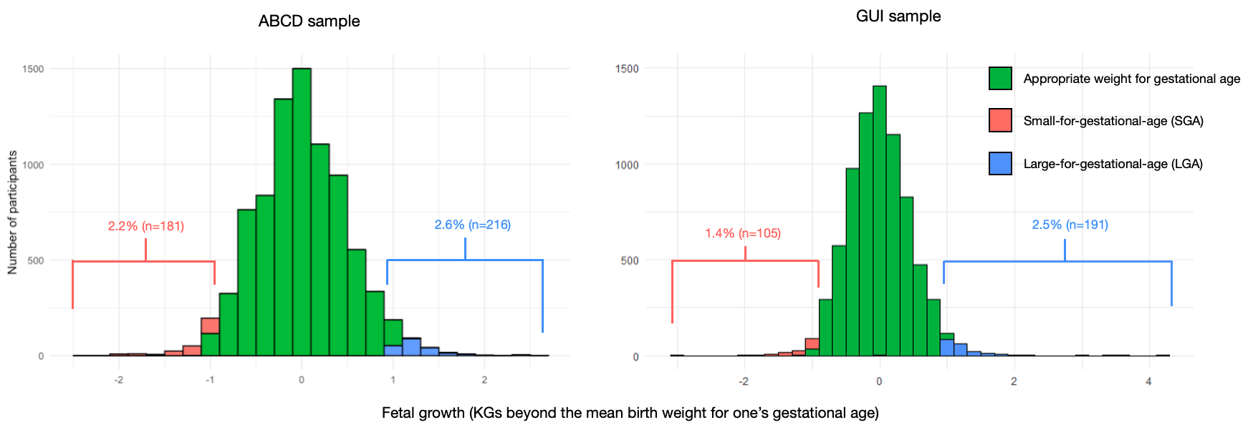

Figure S6. Fetal growth in ABCD and GUI samples compared to World Health Organisation (WHO) norms. WHO fetal growth curve refers to the median of 10 high-middle income countries (singleton pregnancies only), extracted from data in Kiserud et al. (2017)*.

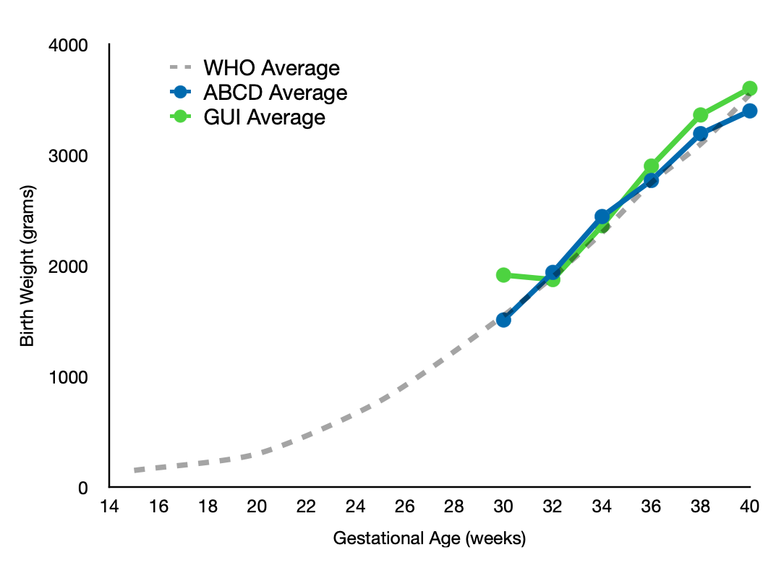

*Kiserud, T., Piaggio, G., Carroli, G., Widmer, M., Carvalho, J., Neerup Jensen, L., Giordano, D., Cecatti, J. G., Abdel Aleem, H., & Talegawkar, S. A. (2017). The World Health Organization fetal growth charts: a multinational longitudinal study of ultrasound biometric measurements and estimated fetal weight. PLoS medicine, 14(1), e1002220.

