Supplementary Materials
The Influence of Static and Dynamic Intrapersonal Factors on Longitudinal Patterns of Peer Victimization through Mid-adolescence: A Latent Transition Analysis
John D. Haltigan & Tracy Vaillancourt
Corresponding Author: Tracy Vaillancourt, tracy.vaillancourt@uottawa.ca

Detailed Information Regarding the Unconditional Latent Transition Model
Prevalence rates of the victimization latent classes at each time point based on the unconditional latent transition model are presented in Table S1. Comparing these prevalence rates with those depicted in Figure S1 (see below), obtained from the separate latent class analyses conducted at each time point, the strong convergence between the two types of analyses are apparent, supporting the two-class latent structure of peer victimization across time and the notion that latent classes from subsequent time points were not influencing latent class solutions from earlier time points.
Detailed Information Regarding Model Specifications of the Latent Transition Model with Covariates
Within the latent transition analysis framework, each covariate was modeled as a moderator of the relations between contiguous latent categorical variables. In the case of child sex, the covariate was referred to as a time invariant covariate. Parent-perceived pubertal timing and parent-reported child internalizing symptoms were time varying covariates since their values change across occasions of measurement. These primary latent transition models tested whether, conditional on one’s latent victimization class status at time t, did the probability of transitioning to another latent victimization class at time t + 1 vary as a function of the covariate.
Given the computational complexity of estimating latent transition models with covariates influencing the transition probabilities across six waves of data, separate latent transition models were estimated for each covariate (i.e., child sex, parent-reported perceived pubertal timing, and parent-reported child internalizing symptoms). Syntax used to estimate these latent transition models was adapted from both the original version of the Mplus user manual example 8.13 (Muthén & Muthén, 2012), as well as technical web note (for the case of the perceived puberty and internalizing symptoms covariates) available at the Mplus website (Muthén & Asparouhov, 2011). Covariates at each time point were modeled simultaneously in each of the latent transition models. In addition to providing information pertinent to how covariates influenced the prevalence rates of victimization latent classes at each time point, these models also informed whether each of the covariates affected the probability of transitioning from one victimization class to another across each of the six time points. For all latent transition covariate models, inclusion of the covariate did not materially alter the pattern of latent victimization class prevalences observed in the unconditional latent transition model (i.e., the latent victimization classes remained empirically defined by the peer victimization indicators only and were not altered with inclusion of the covariate; note again that latent classes in the unconditional model where unchanged from the separate cross-sectional LCA models), and thus we did not implement the manual three-step approach to mixture modeling with covariates and distal outcomes (Asparouhov & Muthén, 2014; Nylund-Gibson, Grimm, Quirk, & Furlong, 2014) given the number of waves present in the data.

Table S1.
Descriptive Statistics for the Five Binary Peer Victimization Survey Items for Grade 5, Grade 6, Grade 7, Grade 8, and Grade 9, and Grade 10.
Item | Grade 5 |  | Grade 6 |  | Grade 7 |  | Grade 8 |  | Grade 9 |  | Grade 10
 | N | Prop | N | Prop | N | Prop | N | Prop | N | Prop | N | Prop
1 | 642 | 0.63 | 599 | 0.57 | 546 | 0.54 | 505 | 0.54 | 487 | 0.45 | 451 | 0.42
2 | 642 | 0.48 | 598 | 0.30 | 546 | 0.24 | 508 | 0.24 | 489 | 0.13 | 452 | 0.11
3 | 645 | 0.66 | 598 | 0.63 | 548 | 0.60 | 507 | 0.60 | 489 | 0.50 | 453 | 0.46
4 | 644 | 0.67 | 600 | 0.56 | 546 | 0.48 | 508 | 0.48 | 488 | 0.38 | 453 | 0.36
5 | 645 | 0.16 | 600 | 0.14 | 547 | 0.17 | 506 | 0.20 | 489 | 0.17 | 452 | 0.14
Note. Descriptive statistics reflect valid listwise ns for each victimization item at each time point. Prop = proportion. Item 1 = How often have you been bullied at school; Item 2 = How often have you been physically bullied by being hit, kicked, shoved, etc.?; Item 3 = How often have you been verbally bullied by insults, put downs, or threats at school?; Item 4 = How often have you been bullied by exclusion (being left out), rumors, or someone getting others not to like you?; Item 5 = How often have other students bullied you on the computer by using text messages, the computer or email messages/pictures to threaten you or make you look bad?
Table S2.
Size of Victimization Classes Based on the Latent Transition Model Without Covariates.
Class | Grade 5 | Grade 6 | Grade 7 | Grade 8 | Grade 9 | Grade 10
LV | 184 (26%) | 257 (37%) | 285 (41%) | 286 (41%) | 341 (49%) | 374 (54%)
EV | 513 (74%) | 440 (63%) | 412 (59%) | 411 (59%) | 356 (51%) | 323 (46%)
Note. LV = low victimization class; EV = elevated victimization class.

Figure S1. Conditional item probability plot for the two-class peer victimization model for fifth through tenth grade. Class size information is presented in the legend.
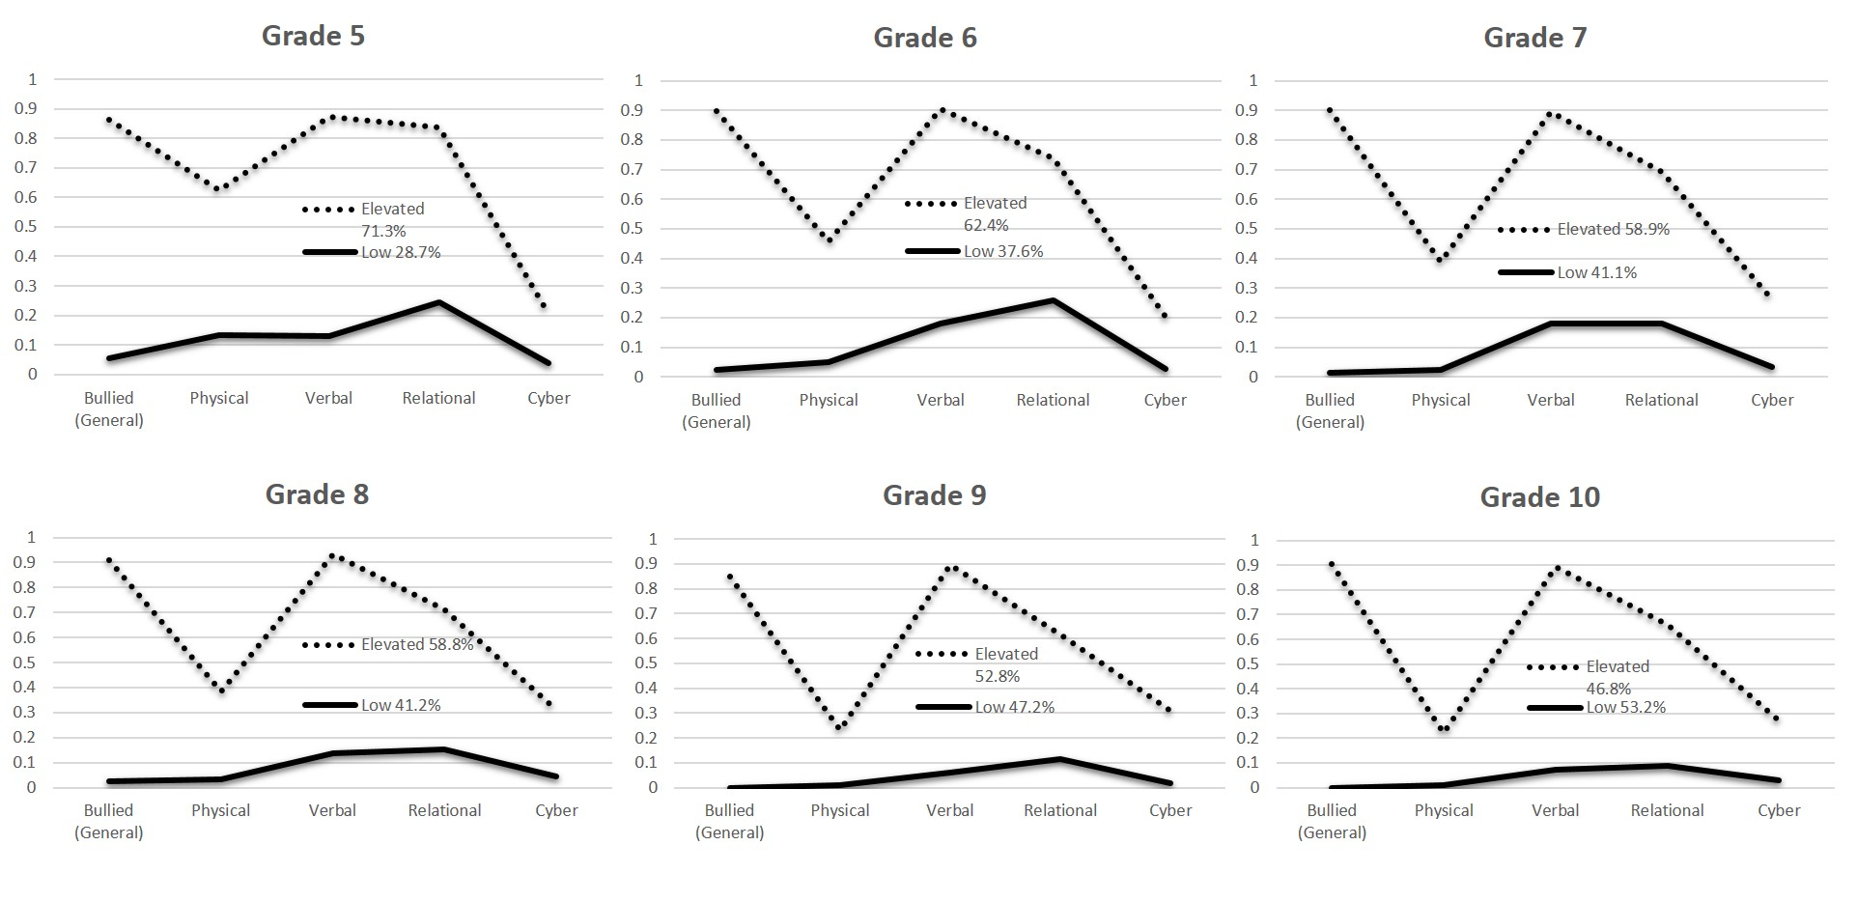

Supplemental References
Asparouhov, T., & Muthén, B. (2014). Auxiliary variables in mixture modeling: Three-step approaches using Mplus. Structural Equation Modeling: A Multidisciplinary Journal, 21, 329-341. doi: 10.1080/10705511.2014.915181
Muthén, B. O., & Asparouhov, T. (2011). LTA in Mplus: Transition probabilities influenced by covariates. Mplus Web Notes: No. 13. Available at www.statmodel.net
Nylund-Gibson, K., Grimm, R., Quirk, M., & Furlong, M. (2014). A latent transition mixture model using the three-step specification. Structural Equation Modeling: A Multidisciplinary Journal, 21, 1-16. doi: 10.1080/10705511.2014.915375

