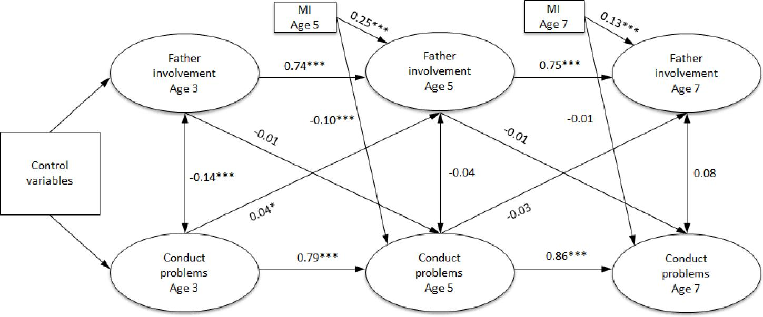
Supplementary Figure 1. Cross-lagged model of father involvement and conduct problems.
Control variables (measured at age 9 months) are family poverty, paternal education, maternal and paternal psychological distress, mother-reported quality of the inter-parental relationship, and child’s sibship size, temperament, gender and ethnicity (Mixed, Indian, Pakistani/Bangladeshi, Black or ‘Other’ compared to White). MI = mother involvement. Regression coefficients are standardised.

