Table 1
Experience Sampling items administered to participants, translated from Romanian
Anxiety
In the last 4 hours, you…
Experienced excessive worry
Found difficult to control worry once it started
Felt restless, keyed up or on edge
Were easily fatigued
Had difficulties concentrating or mind going blank
Were irritable
Felt muscle tension
Last night, you had trouble falling asleep or didn't feel rested after sleep.
Depression
In the last 4 hours, did it happen for you to have…
Little interest or pleasure in doing things
Feeling down, depressed, or hopeless.
Trouble falling or staying asleep or sleeping too much.
Feeling tired or having little energy.
Poor appetite or overeating
Negative feelings about yourself - or that you are a failure or have let yourself or your family down
Trouble concentrating on things, such as reading the newspaper or watching television
Moving or speaking so slowly that other people could have noticed. Or the opposite being so fidgety or restless that you have been moving around a lot more than usual
Thoughts that you would be better off dead or of hurting yourself
Thoughts
In the last 4 hours, how often did you have these thoughts…
There's something wrong with me.
I don't think I can go on like this.
I don't like myself.
I’m no good.
Nobody likes me.
I am alone.
What if I get sick?
Something awful is going to happen.
Life isn’t worth living.
Nobody cares about me.
I can't stand it anymore.
I will never make it.
Something has to change.

Principal component analysis
We administered Cognition Checklist (CCL) and Automatic Thoughts Questionnaire (ATQ) to a sample of 135 undergraduate students to perform a preliminary analysis and reduce the number of items. This was done to a obtain a small number of items reflecting Negative Automatic Thoughts, that would be adequate in number for the Experience Sampling context but would also have an adequate representation of the variability of the content of Negative Automatic Thoughts. As a first step, we performed an Exploratory Factor Analysis which returned two factors. The first factor explained 54.98% of the variance, and the second explained 33.12%. Next, we applied a principal component analysis for each identified factor to analyse the correlation of items’ residuals. The resulting groups of items are presented in Table 2. After determining which items’ residuals are significantly correlated, we formulated a new item that would represent the essence of items included in each group. To determine which items are correlated, we visually explored the proximity of items in the standardized residual plots presented in Figures 1 and 2 and followed the highest standardized residual correlations presented in Table 3.
Table 2
Principal Component Analysis and resulted ESM items
ESM items | Item nr. | Symbol* | Questionnaire items | Factor loadings
 |  |  |  | 1 | 2
What if I get sick? | CCL15 | 1 | What if I get sick and become an invalid? |  | 0.71
 | CCL19 | 4 | I am not a healthy person. | 0.39 | 0.37
There's something wrong with me. | CCL4 | F | I'm a social failure. | 0.81
 | CCL21 | E | There's something very wrong with me. | 0.73
 | ATQ12 | C | There must be something wrong with me. | 0.78
 | ATQ14 | D | It’s just not worth it. | 0.76
Nobody cares about me. | CCL5 | O | I don't deserve to be loved. | 0.83
 | CCL12 | k | No one cares whether I live or die. | 0.54
Nobody likes me. | CCL3 | c | I'll never be as good as other people are. | 0.7
 | CCL6 | d | People don't respect me anymore. | 0.75
 | CCL10 | e | I'm worse off than they are. | 0.73
 | CCL14 | g | I have become physically unattractive. | 0.71
I don’t think I can go on like this. | CCL26 | G | I'm losing my mind. | 0.65
 | ATQ2 | H | I don’t think I can go on. | 0.8
 | ATQ4 | I | Nothing feels good anymore. | 0.8
Something has to change. | ATQ11 | n | Something has to change. | 0.56
I can’t stand this anymore. | ATQ5 | B | I can’t stand this anymore. | 0.81
I'm no good. | CCL1 | j | I'm worthless. | 0.9
 | CCL2 | l | I'm not worthy of other people's attention or affection. | 0.89
 | CCL13 | P | Nothing ever works out for me anymore. | 0.89
 | ATQ1 | m | I’m no good. | 0.92
 | ATQ8 | p | I’m worthless. | 0.85
 | ATQ13 | o | My future is bleak. | 0.67
I’ll never make it. | CCL7 | i | I will never overcome my problems. | 0.75
 | CCL18 | f | I might be trapped. | 0.53
 | ATQ6 | N | I can’t get started. | 0.9
 | ATQ9 | J | I’ll never make it. | 0.78
 | ATQ10 | h | I feel so helpless. | 0.7
 | ATQ15 | M | I can’t finish anything. | 0.84
I don't like myself. | ATQ3 | K | I’m so disappointed in myself. | 0.93
 | ATQ7 | L | What’s wrong with me? | 0.77
Something awful is going to happen. | CCL16 | 2 | I am going to be injured. | 0.37 | 0.4
 | CCL17 | 3 | What if no one reaches me in time to help? |  | 0.57
 | CCL20 | 5 | I'm going to have an accident. |  | 0.85
 | CCL22 | 6 | Something might happen that will ruin my appearance. |  | 0.71
 | CCL23 | 7 | I am going to have a heart attack. |  | 0.79
 | CCL24 | 8 | Something awful is going to happen. |  | 0.89
 | CCL25 | 9 | Something will happen to someone I care about. |  | 0.72
I am alone. | CCL8 | b | I've lost the only friends I've had. | 0.59
 | CCL11 | a | There's no one left to help me. | 0.62
Life isn't worth living. | CCL9 | A | Life isn't worth living. | 0.75
Note. * Symbol used to represent the item on the scatterplot of standardised residuals.

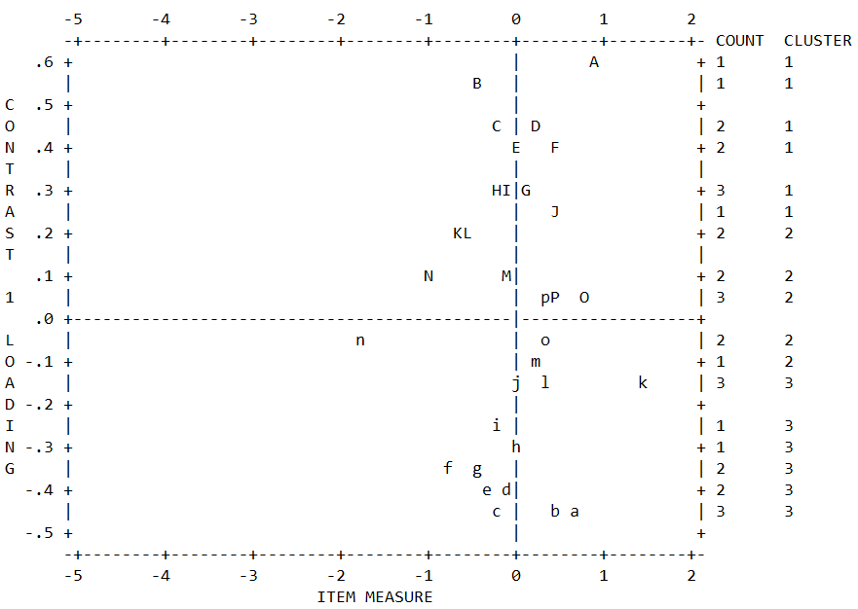
Figure 1. Scatterplot of association of standardised residuals after extracting the first contrast from items that loaded on the first factor
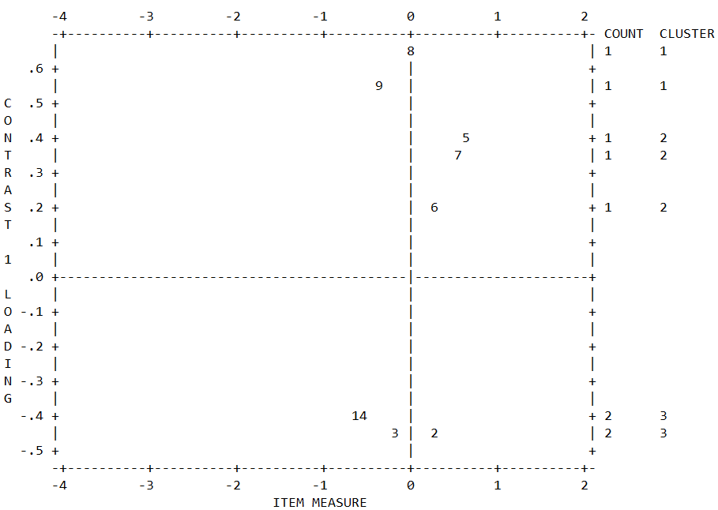
Figure 2. Scatterplot of association of standardised residuals after extracting the first contrast from items that loaded on the second factor

Table 3
Largest standardised residual correlations
x | y | Factor | r
CCL3 | CCL10 | 1 | 0.49
CCL11 | CCL12 | 1 | 0.42
ATQ8 | ATQ9 | 1 | 0.36
ATQ1 | ATQ3 | 1 | 0.35
CCL9 | ATQ14 | 1 | 0.35
ATQ2 | ATQ5 | 1 | 0.35
CCL1 | ATQ8 | 1 | 0.34
CCL2 | CCL5 | 1 | 0.34
CCL5 | ATQ8 | 1 | 0.32
CCL8 | CCL11 | 1 | 0.32
ATQ4 | ATQ5 | 1 | 0.32
CCL21 | ATQ12 | 1 | 0.31
CCL6 | CCL11 | 1 | 0.3
CCL2 | CCL12 | 1 | 0.29
ATQ8 | ATQ11 | 1 | -0.36
CCL3 | ATQ5 | 1 | -0.32
CCL6 | ATQ8 | 1 | -0.32
CCL1 | ATQ4 | 1 | -0.31
CCL5 | ATQ11 | 1 | -0.3
CCL21 | ATQ10 | 1 | -0.29
CCL24 | CCL25 | 2 | 0.15
CCL16 | CCL24 | 2 | -0.34
CCL15 | CCL23 | 2 | -0.26
CCL19 | CCL25 | 2 | -0.24
CCL17 | CCL25 | 2 | -0.24
CCL19 | CCL20 | 2 | -0.24
CCL16 | CCL25 | 2 | -0.23
CCL17 | CCL20 | 2 | -0.23
CCL17 | CCL22 | 2 | -0.22
CCL15 | CCL19 | 2 | -0.21
CCL19 | CCL23 | 2 | -0.21
CCL17 | CCL24 | 2 | -0.2
CCL19 | CCL24 | 2 | -0.2
CCL15 | CCL22 | 2 | -0.19
CCL15 | CCL20 | 2 | -0.19
CCL15 | CCL25 | 2 | -0.17
CCL22 | CCL23 | 2 | -0.17
CCL23 | CCL25 | 2 | -0.16
CCL16 | CCL23 | 2 | -0.15
CCL15 | CCL24 | 2 | -0.15

Analysis of within-subject variances of items
In table 4 are presented descriptive statistics for all variables initially included in the experiences sampling. We selected an item pool which will best represent the DSM-5 conceptualisation of Major Depression and Generalized Anxiety. However, several measurements were not included in the analysis due to different reasons. Sleep disturbance was not included due to its incompatibility with the idea of momentary assessment. Sleeping problems were assessed by asking participants each time the same question regarding their sleep quality during the last night. Including this variable in the analysis would have helped identify potential influences that sleeping problems could have on depressive and anxious symptoms. However, including this variable would have also meant that we assume possible predictions of current states on past night sleep quality. Additionally, items assessing fatigability and concentration difficulties were averaged to avoid redundancies.
Table 4
Descriptive statistics before removal of participants
Name | Node | Content | Mean | Wp SD | n_{pre} | n_{post} | Q
Symptom
Excessive worry | Exc | A | 1.36 | 0.48 | 15 | 4 | 2
Difficulties controlling worry | DCW | A | 1.29 | 0.43 | 21 | 6 | 2
Restlessness | Res | A | 1.43 | 0.53 | 10 | 2 | 2
Fatigability | Fat | A/D | 1.60 | 0.54 | 2 | 0 | 1
Difficulty concentrating | DiC | A/D | 1.44 | 0.45 | 7 | 2 | 1
Irritability | Iri | A | 1.43 | 0.56 | 4 | 0 | 1
Muscle tension | Mus | A | 1.34 | 0.41 | 22 | 11 | 2
Sleep disturbance | - | A | 1.62 | 0.61 | 3 | 1 | 1
Anhedonia | Anh | D | 1.57 | 0.58 | 6 | 0 | 1
Depressed mood | Dep | D | 1.44 | 0.55 | 8 | 0 | 1
Decrease or increase in appetite | App | D | 1.48 | 0.54 | 9 | 3 | 1
Worthlessness | Wor | D | 1.20 | 0.30 | 45 | 18 | 3
Psychomotor agitation or retardation | Psy | D | 1.15 | 0.23 | 55 | 30 | 3
Suicidal ideation | Sui | D | 1.10 | 0.17 | 74 | 45 | 4
Thoughts
There's something wrong with me | T1 | A/D | 1.27 | 0.37 | 27 | 4 | 2
I don’t think I can go on like this | T2 | A/D | 1.27 | 0.37 | 35 | 12 | 2
I don't like myself | T3 | D | 1.26 | 0.35 | 38 | 15 | 3
I'm no good | T4 | D | 1.20 | 0.28 | 55 | 29 | 4
Nobody likes me | T5 | D | 1.14 | 0.21 | 70 | 40 | 4
I am alone | T6 | D | 1.23 | 0.33 | 46 | 23 | 3
What if I get sick? | T7 | A | 1.16 | 0.25 | 45 | 25 | 3
Something awful is going to happen | T8 | A | 1.19 | 0.30 | 40 | 16 | 3
Life isn't worth living | T9 | D | 1.09 | 0.15 | 83 | 55 | 4
Nobody cares about me | T10 | D | 1.13 | 0.20 | 70 | 41 | 4
I can’t stand this anymore | T11 | D | 1.30 | 0.40 | 39 | 13 | 3
I’ll never make it | T12 | D | 1.21 | 0.27 | 57 | 30 | 4
Something has to change | T13 | D | 1.46 | 0.53 | 11 | 0 | 2
Note. n=145. Wp SD = Within-person standard deviation; A = anxious; D = depressive; n_{pre} = number of cases with 0 variance before removal of participants; n_{post} = number of cases with 0 variance after removal of participant; Q = quantile of variables with zero variance before removal of participants

