Supplemental Material
for
A Response Surface Analysis of the Relationship of Aversive and Appetitive Appearance-Related Comparisons with Depression, Well-Being, and Self-Esteem

Part A: Supplemental Material for the main analyses
Table s1.
Descriptive statistics for predictor pairs
Predictors | Outliers | n | Av. > App. | Av. = App. | Av. < App.
Aversive and appetitive comparison frequency | 6 | 1106 | 50% | 36% | 14%
Aversive und appetitive comparison discrepancy | 7 | 1105 | 57% | 33% | 9%
Aversive und appetitive comparison affective impact | 45 | 1067 | 48% | 36% | 16%

Note. Av. = aversive; app = appetitive. Data pairs are unequal when their scores differ at least by 0.5 z-scores.

Table s2
Model selection
Model | k | AIC_{c} | ΔAIC_{c} | Akaike weight | Evidence ratio | CFI | R² | p_{Modell} | R²_{adj}
 |  |  |  |  | Depression
Frequency
SRR | 5 | 6748.85 | 0.00 | .31 | - | 1.00 | 0.2479 | < .001 | 0.2459
SRRR | 6 | 6748.94 | 0.09 | .30 | 1.05 | 1.00 | 0.2492 | < .001 | 0.2465
SRSQD | 5 | 6749.25 | 0.40 | .26 | 1.22 | 1.00 | 0.2477 | < .001 | 0.2456
full | 7 | 6750.72 | 1.87 | .12 | 2.54 | 1.00 | 0.2494 | < .001 | 0.2460
IA | 5 | 6756.80 | 7.95 | .01 | 53.16 | 0.97 | 0.2425 | < .001 | 0.2404
additive | 4 | 6756.88 | 8.02 | .01 | 55.25 | 0.97 | 0.2411 | < .001 | 0.2397
onlyx2 | 4 | 6760.36 | 11.51 | .00 | 315.53 | 0.96 | 0.2387 | < .001 | 0.2373
onlyx | 3 | 6769.69 | 20.84 | .00 | 33529.48 | 0.93 | 0.2308 | < .001 | 0.2301
RR | 4 | 6794.92 | 46.06 | .00 | 1.00530E+10 | 0.85 | 0.2145 | < .001 | 0.2131
SSQD | 4 | 6836.15 | 87.30 | .00 | 9.03929E+18 | 0.72 | 0.1847 | < .001 | 0.1832
SQD | 3 | 6894.41 | 145.55 | .00 | 4.04399E+31 | 0.53 | 0.1390 | < .001 | 0.1382
null | 2 | 7057.94 | 309.09 | .00 | 1.31203E+67 | 0.00 | 0.0000 | - | 0.0000
onlyy | 3 | 7058.49 | 309.63 | .00 | 1.72328E+67 | 0.00 | 0.0013 | .227 | 0.0004
onlyy2 | 4 | 7058.96 | 310.11 | .00 | 2.18623E+67 | 0.00 | 0.0027 | .224 | 0.0009
Discrepancy
IA | 5 | 6889.65 | 0.00 | .43 | - | 0.99 | 0.1402 | < .001 | 0.1378
full | 7 | 6890.61 | 0.96 | .27 | 1.62 | 1.00 | 0.1426 | < .001 | 0.1387
SRRR | 6 | 6892.40 | 2.75 | .11 | 3.96 | 0.98 | 0.1396 | < .001 | 0.1365
SRR | 5 | 6892.45 | 2.80 | .11 | 4.06 | 0.98 | 0.1380 | < .001 | 0.1356
SRSQD | 5 | 6894.26 | 4.62 | .04 | 10.06 | 0.97 | 0.1366 | < .001 | 0.1342
additive | 4 | 6894.31 | 4.67 | .04 | 10.31 | 0.96 | 0.1349 | < .001 | 0.1334
onlyx | 3 | 6908.93 | 19.28 | .00 | 15393.55 | 0.86 | 0.1218 | < .001 | 0.1210
onlyx2 | 4 | 6910.25 | 20.60 | .00 | 29753.72 | 0.86 | 0.1224 | < .001 | 0.1208
RR | 4 | 6917.47 | 27.83 | .00 | 1103260.40 | 0.82 | 0.1166 | < .001 | 0.1150
SSQD | 4 | 6932.90 | 43.26 | .00 | 2.473732E+9 | 0.72 | 0.1042 | < .001 | 0.1026
SQD | 3 | 6966.51 | 76.86 | .00 | 4.90288E+16 | 0.52 | 0.0749 | < .001 | 0.0740
null | 2 | 7050.47 | 160.82 | .00 | 8.36104E+34 | 0.00 | 0.0000 | - | 0.0000
onlyy | 3 | 7052.37 | 162.72 | .00 | 2.15980E+35 | 0.00 | 0.0001 | .737 | -0.0008
onlyy2 | 4 | 7054.38 | 164.73 | .00 | 5.90394E+35 | 0.00 | 0.0001 | .944 | -0.0017
Affective impact
onlyx2 | 4 | 6440.97 | 0.00 | .35 | - | 1.00 | 0.2770 | < .001 | 0.2757
SRRR | 6 | 6441.44 | 0.47 | .28 | 1.26 | 1.00 | 0.2795 | < .001 | 0.2767
SRSQD | 5 | 6442.37 | 1.40 | .17 | 2.01 | 1.00 | 0.2775 | < .001 | 0.2754
full | 7 | 6443.46 | 2.49 | .10 | 3.48 | 1.00 | 0.2795 | < .001 | 0.2760
onlyx | 3 | 6444.88 | 3.91 | .05 | 7.06 | 0.98 | 0.2730 | < .001 | 0.2723
additive | 4 | 6446.47 | 5.50 | .02 | 15.64 | 0.98 | 0.2733 | < .001 | 0.2719
IA | 5 | 6447.04 | 6.07 | .02 | 20.82 | 0.98 | 0.2743 | < .001 | 0.2722
SRR | 5 | 6447.30 | 6.33 | .01 | 23.73 | 0.98 | 0.2741 | < .001 | 0.2720
SSQD | 4 | 6494.86 | 53.88 | .00 | 5.02056E+11 | 0.84 | 0.2394 | < .001 | 0.2380
RR | 4 | 6506.83 | 65.85 | .00 | 1.99549E+14 | 0.81 | 0.2308 | < .001 | 0.2294
SQD | 3 | 6572.72 | 131.75 | .00 | 4.05977E+28 | 0.61 | 0.1801 | < .001 | 0.1793
onlyy | 3 | 6771.85 | 330.88 | .00 | 7.06720E+71 | 0.03 | 0.0112 | < .001 | 0.0102
onlyy2 | 4 | 6773.59 | 332.62 | .00 | 1.68575E+72 | 0.03 | 0.0114 | .002 | 0.0095
null | 2 | 6781.76 | 340.79 | .00 | 1.00491E+74 | 0.00 | 0.0000 | - | 0.0000
 | Psychological Well-being
Frequency
full | 7 | 9093.75 | 0.00 | .45 | - | 1.00 | 0.1939 | < .001 | 0.1903
SRRR | 6 | 9095.82 | 2.07 | .16 | 2.81 | 0.99 | 0.1909 | < .001 | 0.1880
additive | 4 | 9095.93 | 2.18 | .15 | 2.98 | 0.98 | 0.1879 | < .001 | 0.1864
IA | 5 | 9096.87 | 3.13 | .09 | 4.78 | 0.98 | 0.1887 | < .001 | 0.1865
SRSQD | 5 | 9096.93 | 3.18 | .09 | 4.91 | 0.98 | 0.1886 | < .001 | 0.1864
SRR | 5 | 9097.93 | 4.19 | .06 | 8.11 | 0.97 | 0.1879 | < .001 | 0.1857
SSQD | 4 | 9124.17 | 30.42 | .00 | 4027440.74 | 0.86 | 0.1669 | < .001 | 0.1654
onlyx | 3 | 9136.00 | 42.25 | .00 | 1.496443E+9 | 0.80 | 0.1564 | < .001 | 0.1556
onlyx2 | 4 | 9137.94 | 44.20 | .00 | 3.953714E+9 | 0.80 | 0.1565 | < .001 | 0.1549
RR | 4 | 9179.86 | 86.11 | .00 | 4.99494E+18 | 0.62 | 0.1239 | < .001 | 0.1223
SQD | 3 | 9216.17 | 122.42 | .00 | 3.83363E+26 | 0.46 | 0.0930 | < .001 | 0.0922
onlyy | 3 | 9320.05 | 226.30 | .00 | 1.38380E+49 | 0.01 | 0.0037 | .044 | 0.0028
onlyy2 | 4 | 9322.06 | 228.32 | .00 | 3.78679E+49 | 0.01 | 0.0037 | .132 | 0.0019
null | 2 | 9322.09 | 228.35 | .00 | 3.84314E+49 | 0.00 | 0.0000 | - | 0.0000
Discrepancy
full | 7 | 9143.45 | 0.00 | .93 | - | 1.00 | 0.1481 | < .001 | 0.1443
SRSQD | 5 | 9149.78 | 6.32 | .04 | 23.59 | 0.95 | 0.1401 | < .001 | 0.1378
SRRR | 6 | 9151.45 | 8.00 | .02 | 54.55 | 0.95 | 0.1404 | < .001 | 0.1373
IA | 5 | 9153.95 | 10.50 | .00 | 190.38 | 0.93 | 0.1369 | < .001 | 0.1345
additive | 4 | 9155.11 | 11.66 | .00 | 339.99 | 0.91 | 0.1344 | < .001 | 0.1328
SRR | 5 | 9156.40 | 12.95 | .00 | 648.64 | 0.91 | 0.1349 | < .001 | 0.1326
SSQD | 4 | 9175.03 | 31.57 | .00 | 7182203.66 | 0.80 | 0.1186 | < .001 | 0.1170
onlyx2 | 4 | 9188.40 | 44.95 | .00 | 5.761164E+9 | 0.72 | 0.1079 | < .001 | 0.1063
onlyx | 3 | 9189.58 | 46.12 | .00 | 1.03654E+10 | 0.71 | 0.1053 | < .001 | 0.1045
RR | 4 | 9200.75 | 57.29 | .00 | 2.76275E+12 | 0.65 | 0.0979 | < .001 | 0.0962
SQD | 3 | 9227.36 | 83.90 | .00 | 1.65853E+18 | 0.49 | 0.0742 | < .001 | 0.0734
onlyy | 3 | 9309.68 | 166.23 | .00 | 1.24851E+36 | 0.01 | 0.0026 | .091 | 0.0017
onlyy2 | 4 | 9310.17 | 166.72 | .00 | 1.59484E+36 | 0.01 | 0.0040 | .113 | 0.0021
null | 2 | 9310.53 | 167.08 | .00 | 1.90541E+36 | 0.00 | 0.0000 | - | 0.0000
Affective impact
full | 7 | 8741.13 | 0.00 | .69 | - | 1.00 | 0.1821 | < .001 | 0.1782
SRRR | 6 | 8742.77 | 1.64 | .31 | 2.27 | 0.99 | 0.1793 | < .001 | 0.1762
IA | 5 | 8758.93 | 17.80 | .00 | 7344.83 | 0.90 | 0.1651 | < .001 | 0.1628
SSQD | 4 | 8759.30 | 18.17 | .00 | 8832.02 | 0.90 | 0.1632 | < .001 | 0.1617
SRSQD | 5 | 8760.29 | 19.16 | .00 | 14462.00 | 0.90 | 0.1641 | < .001 | 0.1617
additive | 4 | 8761.18 | 20.05 | .00 | 22541.30 | 0.89 | 0.1618 | < .001 | 0.1602
SRR | 5 | 8761.31 | 20.18 | .00 | 24116.10 | 0.89 | 0.1632 | < .001 | 0.1609
onlyx2 | 4 | 8785.13 | 44.00 | .00 | 3.579294E+9 | 0.77 | 0.1427 | < .001 | 0.1410
onlyx | 3 | 8796.09 | 54.96 | .00 | 8.58846E+11 | 0.72 | 0.1321 | < .001 | 0.1313
RR | 4 | 8844.80 | 103.68 | .00 | 3.25703E+22 | 0.49 | 0.0932 | < .001 | 0.0914
SQD | 3 | 8845.61 | 104.48 | .00 | 4.85943E+22 | 0.48 | 0.0908 | < .001 | 0.0899
onlyy2 | 4 | 8886.79 | 145.66 | .00 | 4.27009E+31 | 0.29 | 0.0566 | < .001 | 0.0548
onlyy | 3 | 8888.22 | 147.09 | .00 | 8.70973E+31 | 0.28 | 0.0536 | < .001 | 0.0527
null | 2 | 8944.72 | 203.59 | .00 | 1.62071E+44 | 0.00 | 0.0000 | - | 0.0000
 | Self-esteem
Frequency
full | 7 | 6867.89 | 0 | .49 | - | 1.00 | 0.3076 | < .001 | 0.3044
SRRR | 6 | 6869.37 | 1.48 | .23 | 2.10 | 0.99 | 0.3054 | < .001 | 0.3029
IA | 5 | 6870.99 | 3.10 | .10 | 4.72 | 0.99 | 0.3031 | < .001 | 0.3012
SRSQD | 5 | 6872.12 | 4.23 | .06 | 8.30 | 0.98 | 0.3024 | < .001 | 0.3005
additive | 4 | 6872.14 | 4.25 | .06 | 8.38 | 0.98 | 0.3011 | < .001 | 0.2998
SRR | 5 | 6872.20 | 4.31 | .06 | 8.62 | 0.98 | 0.3023 | < .001 | 0.3004
SSQD | 4 | 6901.02 | 33.13 | .00 | 15621933.49 | 0.91 | 0.2826 | < .001 | 0.2813
onlyx | 3 | 6974.27 | 106.38 | .00 | 1.26021E+23 | 0.72 | 0.2321 | < .001 | 0.2314
onlyx2 | 4 | 6974.75 | 106.86 | .00 | 1.60249E+23 | 0.73 | 0.2332 | < .001 | 0.2318
RR | 4 | 7016.89 | 149.00 | .00 | 2.26348E+32 | 0.62 | 0.2034 | < .001 | 0.2019
SQD | 3 | 7058.24 | 190.35 | .00 | 2.16114E+41 | 0.52 | 0.1715 | < .001 | 0.1708
onlyy | 3 | 7250.74 | 382.85 | .00 | 1.36569E+83 | 0.04 | 0.0140 | < .001 | 0.0131
onlyy2 | 4 | 7252.75 | 384.86 | .00 | 3.72082E+83 | 0.03 | 0.0140 | < .001 | 0.0122
null | 2 | 7264.33 | 396.44 | .00 | 1.22020E+86 | 0.00 | 0.0000 | - | 0.0000
Discrepancy
Full | 7 | 6996.22 | 0.00 | .91 | - | 1.00 | 0.2183 | < .001 | 0.2147
SRSQD | 5 | 7001.99 | 5.77 | .05 | 17.94 | 0.97 | 0.2113 | < .001 | 0.2091
SRRR | 6 | 7002.79 | 6.57 | .03 | 26.76 | 0.97 | 0.2122 | < .001 | 0.2093
IA | 5 | 7005.98 | 9.77 | .01 | 132.06 | 0.96 | 0.2084 | < .001 | 0.2063
Additive | 4 | 7012.17 | 15.95 | .00 | 2907.76 | 0.93 | 0.2025 | < .001 | 0.2011
SRR | 5 | 7013.10 | 16.89 | .00 | 4642.26 | 0.93 | 0.2033 | < .001 | 0.2011
SSQD | 4 | 7023.14 | 26.92 | .00 | 701624.81 | 0.89 | 0.1946 | < .001 | 0.1931
RR | 4 | 7099.00 | 102.79 | .00 | 2.09000E+22 | 0.60 | 0.1373 | < .001 | 0.1358
onlyx2 | 4 | 7101.73 | 105.51 | .00 | 8.15857E+22 | 0.59 | 0.1352 | < .001 | 0.1336
onlyx | 3 | 7103.56 | 107.34 | .00 | 2.03750E+23 | 0.58 | 0.1322 | < .001 | 0.1314
SQD | 3 | 7117.69 | 121.47 | .00 | 2.38403E+26 | 0.53 | 0.1210 | < .001 | 0.1202
onlyy | 3 | 7242.32 | 246.10 | .00 | 2.75326E+53 | 0.06 | 0.0161 | < .001 | 0.0152
onlyy2 | 4 | 7244.21 | 247.99 | .00 | 7.10022E+53 | 0.06 | 0.0162 | < .001 | 0.0144
null | 2 | 7258.22 | 262.00 | .00 | 7.81597E+56 | 0.00 | 0.0000 | - | 0.0000
Affect
full | 7 | 6575.58 | 0.00 | .69 | - | 1.00 | 0.3112 | < .001 | 0.3079
SRRR | 6 | 6577.18 | 1.59 | .31 | 2.22 | 0.99 | 0.3088 | < .001 | 0.3062
SRSQD | 5 | 6586.21 | 10.62 | .00 | 202.72 | 0.97 | 0.3016 | < .001 | 0.2996
SRR | 5 | 6590.98 | 15.40 | .00 | 2209.29 | 0.96 | 0.2985 | < .001 | 0.2965
additive | 4 | 6592.00 | 16.42 | .00 | 3676.98 | 0.95 | 0.2965 | < .001 | 0.2951
IA | 5 | 6592.33 | 16.75 | .00 | 4334.60 | 0.95 | 0.2976 | < .001 | 0.2956
SSQD | 4 | 6598.26 | 22.68 | .00 | 84140.43 | 0.93 | 0.2923 | < .001 | 0.2910
onlyx2 | 4 | 6614.30 | 38.71 | .00 | 2.550187E+8 | 0.89 | 0.2816 | < .001 | 0.2802
onlyx | 3 | 6624.96 | 49.38 | .00 | 5.27185E+10 | 0.86 | 0.2729 | < .001 | 0.2722
RR | 4 | 6725.75 | 150.17 | .00 | 4.06560E+32 | 0.61 | 0.2021 | < .001 | 0.2006
SQD | 3 | 6747.35 | 171.76 | .00 | 1.98466E+37 | 0.55 | 0.1842 | < .001 | 0.1834
onlyy2 | 4 | 6898.22 | 322.63 | .00 | 1.14628E+70 | 0.17 | 0.0616 | < .001 | 0.0598
onlyy | 3 | 6900.72 | 325.14 | .00 | 4.01151E+70 | 0.16 | 0.0576 | < .001 | 0.0567
null | 2 | 6961.77 | 386.18 | .00 | 7.22355E+83 | 0.00 | 0.0000 | - | 0.0000

Note. k = Number of Parameter; AIC_{c} = Akaike-Information Criterion; AIC_{c} = Difference of the AIC_{c} of the respective model compared to the AIC_{c} of the best fitting model. Akaike weigth = Probability that the model is the best model; Evidence ratio = Ratio of the Akaike weight in comparison to the best fitting model. Indicates how much more likely the best fitting model is (with compared to this model); CFI = Comparative fit index; SRMR = R²adj = explained variance adjusted for the number of parameters.
Model names. Models are sorted with decreasing complexity (Schönbrodt, n.d.). Full = Full Polynomial Model; SRRR = Shifted and Rotated Rising Ridge Model; SRSQD = Shifted and Rotated Squared Difference Model; SRR = Shifted Rising Ridge Model; SSQD = Shifted Squared Difference Model; RR = Rising Ridge Model; SQD = Basic Squared Difference Model; Additive = Additives Modell; IA = Interaction-Only-Model; Onlyx2 / Onlyy2 = model with squared predictors; Onlyx / Onlyy = Model with only one predictor; null = null model.

Table s3
Test for independence of residuals, normal distribution, homoscedasticity, and multicollinearity of the full model.
 | Independence of residuals |  |  | Normal distribution |  |  | Homoscedasticity |  |  |  |  |  |  |  | Multi-collinearity
 | DW | p |  | W | p |  | BP |  | df |  | p |  |  |  | VIF_{max}
 | Depression
Frequency | 2.04 | .514 |  | 0.977 | < .001 |  |  | 7.23 |  | 5 |  | .204 |  |  |  | 2.26
Discrepancy | 2.03 | .626 |  | 0.974 | < .001 |  |  | 17.97 |  | 5 |  | .003 |  |  |  | 2.36
Affective impact | 1.95 | .447 |  | 0.982 | < .001 |  |  | 25.17 |  | 5 |  | < .001 |  |  |  | 3.59
 | Psychological Well-being
Frequency | 1.97 | .616 |  | 0.998 | .155 |  |  | 5.09 |  | 5 |  | .405 |  |  |  | 2.26
Discrepancy | 1.96 | .493 |  | 0.996 | .014 |  |  | 8.03 |  | 5 |  | .154 |  |  |  | 2.36
Affective impact | 1.99 | .863 |  | 0.999 | .828 |  |  | 22.19 |  | 5 |  | < .001 |  |  |  | 3.59
 | Self-Esteem
Frequency | 1.93 | .251 |  | 0.997 | .075 |  |  | 13.45 |  | 5 |  | .019 |  |  |  | 2.26
Discrepancy | 1.94 | .349 |  | 0.997 | .045 |  |  | 25.49 |  | 5 |  | < .001 |  |  |  | 2.36
Affective impact | 2.02 | .781 |  | 0.997 | .063 |  |  | 11.03 |  | 5 |  | .051 |  |  |  | 3.59

Note. DW = Durbin-Watson-Test to test Independence of residuals, W = Shapiro-Wilk-Test to test normality. BP = Breusch-Pagan-Test to test homoscedasticity. VIF = Variance-Inflation-Factor; p < .05 for the first three tests and VIF > 5 indicate a violation of the tested properties and are bolded.

Table s4
Regression- and Response Surface Parameter of the full polynomial models
Parameter | Estimate | SE | 95%-CI lower bound |  |  | 95%-CI upper bound |  |  |  |  | p
 | Depression
Frequency
b0 | 15.27 | 0.23 | 14.82 |  |  | 15.73 |  |  |  |  | < .001
b1 | 2.43 | 0.22 | 2.00 |  |  | 2.86 |  |  |  |  | < .001
b2 | -0.42 | 0.24 | -0.91 |  |  | 0.07 |  |  |  |  | .092
b3 | 0.44 | 0.14 | 0.15 |  |  | 0.72 |  |  |  |  | .003
b4 | -0.50 | 0.22 | -0.92 |  |  | -0.08 |  |  |  |  | .021
b5 | 0.04 | 0.23 | -0.40 |  |  | 0.48 |  |  |  |  | .874
a1 | 2.01 | 0.24 | 1.54 |  |  | 2.47 |  |  |  |  | < .001
a2 | -0.03 | 0.25 | -0.54 |  |  | 0.47 |  |  |  |  | .901
a3 | 2.85 | 0.40 | 2.05 |  |  | 3.63 |  |  |  |  | < .001
a4 | 0.97 | 0.40 | 0.19 |  |  | 1.76 |  |  |  |  | .016
a5 | 0.40 | 0.28 | -0.15 |  |  | 0.96 |  |  |  |  | .160
Discrepancy
b0 | 15.46 | 0.24 | 15.00 |  |  | 15.92 |  |  |  |  | < .001
b1 | 2.36 | 0.25 | 1.84 |  |  | 2.87 |  |  |  |  | < .001
b2 | -0.43 | 0.34 | -1.11 |  |  | 0.25 |  |  |  |  | .218
b3 | -0.10 | 0.19 | -0.48 |  |  | 0.29 |  |  |  |  | .612
b4 | -0.78 | 0.28 | -1.34 |  |  | -0.24 |  |  |  |  | .006
b5 | 0.52 | 0.32 | -0.12 |  |  | 1.15 |  |  |  |  | .105
a1 | 1.94 | 0.31 | 1.31 |  |  | 2.56 |  |  |  |  | < .001
a2 | -0.36 | 0.30 | -0.95 |  |  | 0.24 |  |  |  |  | .238
a3 | 2.79 | 0.52 | 1.77 |  |  | 3.84 |  |  |  |  | < .001
a4 | 1.19 | 0.53 | 0.14 |  |  | 2.28 |  |  |  |  | .026
a5 | -0.62 | 0.41 | -1.41 |  |  | 0.18 |  |  |  |  | .133
Affective Impact
b0 | 15.93 | 0.26 | 15.42 |  |  | 16.43 |  |  |  |  | < .001
b1 | 5.12 | 0.44 | 4.25 |  |  | 5.97 |  |  |  |  | < .001
b2 | -0.37 | 0.52 | -1.38 |  |  | 0.67 |  |  |  |  | .476
b3 | -0.92 | 0.37 | -1.67 |  |  | -0.23 |  |  |  |  | .008
b4 | -1.44 | 0.99 | -3.57 |  |  | 0.30 |  |  |  |  | .108
b5 | -0.56 | 1.39 | -3.30 |  |  | 2.18 |  |  |  |  | .659
a1 | 4.76 | 0.68 | 3.34 |  |  | 6.09 |  |  |  |  | < .001
a2 | -2.91 | 1.92 | -7.03 |  |  | 0.58 |  |  |  |  | .106
a3 | 5.49 | 0.67 | 4.14 |  |  | 6.78 |  |  |  |  | < .001
a4 | -0.04 | 1.55 | -3.03 |  |  | 3.06 |  |  |  |  | .998
a5 | -0.36 | 1.43 | -3.23 |  |  | 2.49 |  |  |  |  | .827
 | Psychological Well-Being
Frequency
b0 | 88.94 | 0.65 | 87.66 |  |  | 90.22 |  |  |  |  | < .001
b1 | -7.66 | 0.65 | -8.97 |  |  | -6.42 |  |  |  |  | < .001
b2 | 3.52 | 0.67 | 2.24 |  |  | 4.85 |  |  |  |  | < .001
b3 | 0.83 | 0.41 | 0.05 |  |  | 1.67 |  |  |  |  | .037
b4 | 0.52 | 0.57 | -0.65 |  |  | 1.61 |  |  |  |  | .385
b5 | -1.34 | 0.63 | -2.58 |  |  | -0.08 |  |  |  |  | .038
a1 | -4.14 | 0.67 | -5.46 |  |  | -2.80 |  |  |  |  | < .001
a2 | 0.01 | 0.70 | -1.34 |  |  | 1.41 |  |  |  |  | .992
a3 | -11.19 | 1.14 | -13.49 |  |  | -9.01 |  |  |  |  | < .001
a4 | -1.03 | 1.04 | -3.01 |  |  | 1.09 |  |  |  |  | .346
a5 | 2.17 | 0.82 | 0.53 |  |  | 3.81 |  |  |  |  | .009
Discrepancy
b0 | 89.34 | 0.68 | 88.01 |  |  | 90.66 |  |  |  |  | < .001
b1 | -7.52 | 0.78 | -9.11 |  |  | -5.99 |  |  |  |  | < .001
b2 | 2.48 | 0.93 | 0.68 |  |  | 4.32 |  |  |  |  | .008
b3 | 1.47 | 0.57 | 0.37 |  |  | 2.61 |  |  |  |  | .010
b4 | 1.32 | 0.80 | -0.34 |  |  | 2.83 |  |  |  |  | .119
b5 | -2.62 | 0.84 | -4.29 |  |  | -0.95 |  |  |  |  | .002
a1 | -5.03 | 0.81 | -6.65 |  |  | -3.46 |  |  |  |  | < .001
a2 | 0.16 | 0.84 | -1.52 |  |  | 1.77 |  |  |  |  | .840
a3 | -10.00 | 1.51 | -13.04 |  |  | -7.08 |  |  |  |  | < .001
a4 | -2.48 | 1.50 | -5.36 |  |  | 0.64 |  |  |  |  | .119
a5 | 4.09 | 1.11 | 1.91 |  |  | 6.28 |  |  |  |  | .001
Affective impact
b0 | 88.55 | 0.76 | 87.06 |  |  | 90.04 |  |  |  |  | < .001
b1 | -10.67 | 1.36 | -13.32 |  |  | -7.91 |  |  |  |  | < .001
b2 | 8.11 | 1.56 | 5.08 |  |  | 11.21 |  |  |  |  | < .001
b3 | 4.56 | 1.12 | 2.43 |  |  | 6.86 |  |  |  |  | < .001
b4 | 6.48 | 2.90 | 1.10 |  |  | 12.72 |  |  |  |  | .016
b5 | -5.89 | 4.21 | -13.96 |  |  | 2.66 |  |  |  |  | .173
a1 | -2.56 | 2.21 | -6.85 |  |  | 1.94 |  |  |  |  | .272
a2 | 5.15 | 5.79 | -5.75 |  |  | 17.44 |  |  |  |  | .350
a3 | -18.77 | 1.92 | -22.68 |  |  | -15.02 |  |  |  |  | < .001
a4 | -7.80 | 4.60 | -16.74 |  |  | 1.40 |  |  |  |  | .093
a5 | 10.45 | 4.35 | 1.73 |  |  | 18.94 |  |  |  |  | .018
 | Self-esteem
Frequency
b0 | 29.20 | 0.24 | 28.73 |  |  | 29.67 |  |  |  |  | < .001
b1 | -3.52 | 0.23 | -3.96 |  |  | -3.07 |  |  |  |  | < .001
b2 | 1.95 | 1.95 | 1.45 |  |  | 2.44 |  |  |  |  | < .001
b3 | 0.18 | 0.18 | -0.13 |  |  | 0.48 |  |  |  |  | .238
b4 | 0.44 | 0.44 | 0.04 |  |  | 0.85 |  |  |  |  | .032
b5 | -0.62 | -0.62 | -1.09 |  |  | -0.15 |  |  |  |  | .010
a1 | -1.57 | 0.25 | -2.06 |  |  | -1.09 |  |  |  |  | < .001
a2 | 0.00 | 0.26 | -0.51 |  |  | 0.51 |  |  |  |  | .998
a3 | -5.47 | 0.40 | -6.27 |  |  | -4.66 |  |  |  |  | < .001
a4 | -0.87 | 0.38 | -1.63 |  |  | -0.13 |  |  |  |  | .022
a5 | 0.80 | 0.31 | 0.19 |  |  | 1.41 |  |  |  |  | .011
Discrepancy
b0 | 29.16 | 0.26 | 28.66 |  |  | 29.66 |  |  |  |  | < .001
b1 | -3.44 | 0.28 | -3.99 |  |  | -2.88 |  |  |  |  | < .001
b2 | 1.92 | 0.34 | 1.23 |  |  | 2.59 |  |  |  |  | < .001
b3 | 0.61 | 0.21 | 0.19 |  |  | 1.03 |  |  |  |  | .004
b4 | 0.70 | 0.33 | 0.06 |  |  | 1.35 |  |  |  |  | .034
b5 | -0.88 | 0.33 | -1.53 |  |  | -0.22 |  |  |  |  | .009
a1 | -1.53 | 0.30 | -2.14 |  |  | -0.94 |  |  |  |  | < .001
a2 | 0.44 | 0.33 | -0.22 |  |  | 1.06 |  |  |  |  | .197
a3 | -5.36 | 0.54 | -6.44 |  |  | -4.28 |  |  |  |  | < .001
a4 | -0.97 | 0.63 | -2.22 |  |  | 0.28 |  |  |  |  | .125
a5 | 1.49 | 0.40 | 0.71 |  |  | 2.27 |  |  |  |  | < .001
Affective impact
b0 | 28.81 | 0.27 | 28.28 |  |  | 29.35 |  |  |  |  | < .001
b1 | -5.86 | 0.48 | -6.77 |  |  | -4.91 |  |  |  |  | < .001
b2 | 2.83 | 0.56 | 1.75 |  |  | 3.98 |  |  |  |  | < .001
b3 | 1.58 | 0.39 | 0.84 |  |  | 2.38 |  |  |  |  | < .001
b4 | 1.60 | 1.05 | -0.31 |  |  | 3.84 |  |  |  |  | .103
b5 | -2.48 | 1.52 | -5.52 |  |  | 0.52 |  |  |  |  | .111
a1 | -3.03 | 0.79 | -4.56 |  |  | -1.40 |  |  |  |  | < .001
a2 | 0.70 | 2.18 | -3.37 |  |  | 5.35 |  |  |  |  | .749
a3 | -8.70 | 0.68 | -10.04 |  |  | -7.39 |  |  |  |  | < .001
a4 | -2.51 | 1.55 | -5.67 |  |  | 0.53 |  |  |  |  | .102
a5 | 4.06 | 1.57 | 0.99 |  |  | 7.19 |  |  |  |  | .009

Note. SE = Standard error; CI = confidence interval; b₀ = Intercept; b₁ = aversive comparison component; b₂ = appetitive comparison component; b₃ = squared aversive comparison component; b₄ = interaction term aversive and appetitive aversive comparison component; b₅ = squared appetitive aversive comparison component. CIs and p-values are based on a bootstrap procedure with 10.000 iterations expect for the Intercept.

Part B: Supplemental Material for the analyses without outliers
Table s5
Descriptive statistics for predictor pairs
Predictors | n | Av. > App. | Av. = App. | Av. < App.
Aversive and appetitive Frequency | 1112 | 49% | 37% | 14%
Aversive and appetitive Discrepancy | 1112 | 57% | 34% | 9%
Aversive and appetitive affective impact | 1112 | 45% | 36% | 19%

Note. Av. = aversive; app = appetitive. Data pairs are unequal when their scores differ at least by 0.5 z-scores.

Table s6
Test for independence of residuals, normal distribution, homoscedasticity, and multicollinearity of the full model.
 | Independence of residuals |  |  | Normal distribution |  |  | Homoscedasticity |  |  |  |  |  |  |  | Multicollinearity
 | DW | p |  | W | p |  | BP |  | df |  | p |  |  |  | VIF_{max}
 | Depression
Frequency | 2.04 | .499 |  | 0.978 | < .001 |  |  | 7.95 |  | 5 |  | .159 |  |  |  | 2.23
Discrepancy | 2.03 | .577 |  | 0.975 | < .001 |  |  | 21.06 |  | 5 |  | < .001 |  |  |  | 2.37
Affective impact | 1.98 | .695 |  | 0.981 | < .001 |  |  | 29.42 |  | 5 |  | < .001 |  |  |  | 3.20
 | Psychological Well-Being
Frequency | 1.96 | .511 |  | 0.998 | .133 |  |  | 5.32 |  | 5 |  | .379 |  |  |  | 2.23
Discrepancy | 1.95 | .442 |  | 0.996 | .011 |  |  | 8.21 |  | 5 |  | .145 |  |  |  | 2.37
Affective impact | 1.99 | .822 |  | 0.999 | .816 |  |  | 20.04 |  | 5 |  | .001 |  |  |  | 3.20
 | Self-Esteem
Frequency | 1.93 | .268 |  | 0.997 | .070 |  |  | 14.15 |  | 5 |  | .015 |  |  |  | 2.23
Discrepancy | 1.94 | .295 |  | 0.997 | .041 |  |  | 26.32 |  | 5 |  | < .001 |  |  |  | 2.37
Affective impact | 1.997 | .964 |  | 0.997 | .026 |  |  | 11.72 |  | 5 |  | .039 |  |  |  | 3.20
Note. DW = Durbin-Watson-Test to test Independence of residuals, W = Shapiro-Wilk-Test to test normality. BP = Breusch-Pagan-Test to test homoscedasticity. VIF = Variance-Inflation-Factor; p < .05 for the first three tests and VIF > 5 indicate a violation of the tested properties and are bolded.

Table s7
Model selection (including outliers)
Model | k | AIC_{c} | ΔAIC_{c} | Akaike Weight | Evidence ratio | CFI | R² | p_{Modell} | R²_{adj}
 |  |  |  |  | Depression
Frequency
SRR | 5 | 6790.03 | 0.00 | .31 | - | 1.00 | 0.2488 | < .001 | 0.2468
SRRR | 6 | 6790.20 | 0.17 | .29 | 1.09 | 1.00 | 0.2500 | < .001 | 0.2473
SRSQD | 5 | 6790.26 | 0.23 | .28 | 1.12 | 1.00 | 0.2486 | < .001 | 0.2466
full | 7 | 6792.08 | 2.05 | .11 | 2.79 | 1.00 | 0.2501 | < .001 | 0.2467
additive | 4 | 6798.48 | 8.45 | .00 | 68.51 | 0.97 | 0.2417 | < .001 | 0.2403
IA | 5 | 6799.80 | 9.77 | .00 | 132.10 | 0.97 | 0.2422 | < .001 | 0.2401
onlyx2 | 4 | 6799.81 | 9.78 | .00 | 132.80 | 0.97 | 0.2408 | < .001 | 0.2394
onlyx | 3 | 6809.55 | 19.52 | .00 | 17365.21 | 0.93 | 0.2327 | < .001 | 0.2320
RR | 4 | 6835.23 | 45.19 | .00 | 6.515472E+9 | 0.85 | 0.2162 | < .001 | 0.2148
SSQD | 4 | 6886.99 | 96.95 | .00 | 1.13101E+21 | 0.69 | 0.1789 | < .001 | 0.1774
SQD | 3 | 6941.56 | 151.53 | .00 | 8.02982E+32 | 0.51 | 0.1360 | < .001 | 0.1352
onlyy | 3 | 7101.32 | 311.29 | .00 | 3.93439E+67 | 0.01 | 0.0025 | .095 | 0.0016
null | 2 | 7102.10 | 312.07 | .00 | 5.81655E+67 | 0.00 | 0.0000 | - | 0.0000
onlyy2 | 4 | 7103.33 | 313.30 | .00 | 1.07724E+68 | 0.00 | 0.0025 | .248 | 0.0007
Discrepancy
full | 7 | 6939.41 | 0.00 | .39 | - | 1.00 | 0.1439 | < .001 | 0.1400
SRRR | 6 | 6939.85 | 0.43 | .32 | 1.24 | 0.99 | 0.1420 | < .001 | 0.1389
SRR | 5 | 6941.51 | 2.10 | .14 | 2.86 | 0.98 | 0.1392 | < .001 | 0.1368
IA | 5 | 6942.73 | 3.32 | .07 | 5.25 | 0.97 | 0.1382 | < .001 | 0.1359
additive | 4 | 6943.61 | 4.20 | .05 | 8.17 | 0.96 | 0.1360 | < .001 | 0.1344
SRSQD | 5 | 6944.56 | 5.15 | .03 | 13.11 | 0.96 | 0.1368 | < .001 | 0.1345
onlyx | 3 | 6956.44 | 17.03 | .00 | 4985.84 | 0.87 | 0.1244 | < .001 | 0.1236
onlyx2 | 4 | 6958.00 | 18.58 | .00 | 10841.12 | 0.87 | 0.1247 | < .001 | 0.1231
RR | 4 | 6965.04 | 25.63 | .00 | 367856.16 | 0.83 | 0.1192 | < .001 | 0.1176
SSQD | 4 | 6989.17 | 49.76 | .00 | 6.38896E+10 | 0.69 | 0.0998 | < .001 | 0.0982
SQD | 3 | 7020.47 | 81.06 | .00 | 3.99056E+17 | 0.49 | 0.0725 | < .001 | 0.0716
null | 2 | 7102.10 | 162.68 | .00 | 2.12118E+35 | 0.00 | 0.0000 | - | 0.0000
onlyy | 3 | 7103.32 | 163.91 | .00 | 3.90947E+35 | 0.00 | 0.0007 | 0.375 | -0.0002
onlyy2 | 4 | 7103.78 | 164.37 | .00 | 4.92446E+35 | 0.00 | 0.0021 | 0.311 | 0.0003
Affective impact
onlyx2 | 4 | 6750.84 | 0.00 | .33 | - | 0.99 | 0.2735 | < .001 | 0.2722
full | 7 | 6751.29 | 0.46 | .26 | 1.26 | 1.00 | 0.2771 | < .001 | 0.2739
SRRR | 6 | 6751.89 | 1.06 | .19 | 1.70 | 1.00 | 0.2754 | < .001 | 0.2728
SRSQD | 5 | 6752.80 | 1.96 | .12 | 2.67 | 0.99 | 0.2735 | < .001 | 0.2716
onlyx | 3 | 6754.40 | 3.57 | .05 | 5.95 | 0.98 | 0.2698 | < .001 | 0.2692
IA | 5 | 6756.37 | 5.54 | .02 | 15.93 | 0.98 | 0.2712 | < .001 | 0.2692
additive | 4 | 6756.42 | 5.58 | .02 | 16.28 | 0.98 | 0.2698 | < .001 | 0.2685
SRR | 5 | 6758.38 | 7.55 | .01 | 43.52 | 0.97 | 0.2699 | < .001 | 0.2679
SSQD | 4 | 6816.35 | 65.51 | .00 | 1.68362E+14 | 0.81 | 0.2294 | < .001 | 0.2280
RR | 4 | 6853.11 | 102.27 | .00 | 1.61553E+22 | 0.71 | 0.2035 | < .001 | 0.2021
SQD | 3 | 6917.39 | 166.55 | .00 | 1.46444E+36 | 0.52 | 0.1546 | < .001 | 0.1538
onlyy2 | 4 | 7089.79 | 338.95 | .00 | 4.00681E+73 | 0.04 | 0.0146 | < .001 | 0.0128
onlyy | 3 | 7091.01 | 340.18 | .00 | 7.39048E+73 | 0.03 | 0.0117 | < .001 | 0.0108
null | 2 | 7102.10 | 351.26 | .00 | 1.88569E+76 | 0.00 | 0.0000 | - | 0.0000
 | Psychological Well-being
Häufigkeit
full | 7 | 9141.44 | 0.00 | .39 | - | 1.00 | 0.1928 | < .001 | 0.1891
SRRR | 6 | 9142.42 | 0.99 | .24 | 1.64 | 0.99 | 0.1906 | < .001 | 0.1877
IA | 5 | 9143.63 | 2.20 | .13 | 3.00 | 0.98 | 0.1882 | < .001 | 0.1860
additive | 4 | 9143.72 | 2.29 | .12 | 3.14 | 0.98 | 0.1867 | < .001 | 0.1852
SRSQD | 5 | 9144.80 | 3.37 | .07 | 5.39 | 0.98 | 0.1874 | < .001 | 0.1852
SRR | 5 | 9145.70 | 4.26 | .05 | 8.43 | 0.97 | 0.1867 | < .001 | 0.1845
SSQD | 4 | 9171.62 | 30.19 | .00 | 3590077.053 | 0.86 | 0.1660 | < .001 | 0.1645
onlyx | 3 | 9187.46 | 46.03 | .00 | 9878884548 | 0.79 | 0.1525 | < .001 | 0.1518
onlyx2 | 4 | 9189.06 | 47.62 | .00 | 21921740132 | 0.78 | 0.1528 | < .001 | 0.1513
RR | 4 | 9229.73 | 88.29 | .00 | 1.48573E+19 | 0.61 | 0.1213 | < .001 | 0.1197
SQD | 3 | 9263.44 | 122.01 | .00 | 3.11335E+26 | 0.46 | 0.0926 | < .001 | 0.0918
onlyy | 3 | 9367.07 | 225.64 | .00 | 9.9244E+48 | 0.01 | 0.0040 | .036 | 0.0031
onlyy2 | 4 | 9369.06 | 227.62 | .00 | 2.67867E+49 | 0.01 | 0.0040 | .110 | 0.0022
null | 2 | 9369.47 | 228.03 | .00 | 3.28789E+49 | 0.00 | 0.0000 | - | 0.0000
Discrepancy
full | 7 | 9201.67 | 0.00 | .98 | - | 1.00 | 0.1478 | < .001 | 0.1440
SRRR | 6 | 9210.32 | 8.64 | .01 | 75.35 | 0.94 | 0.1396 | < .001 | 0.1365
IA | 5 | 9213.72 | 12.05 | .00 | 413.02 | 0.92 | 0.1354 | < .001 | 0.1331
additive | 4 | 9214.03 | 12.36 | .00 | 481.88 | 0.91 | 0.1336 | < .001 | 0.1320
SRSQD | 5 | 9215.01 | 13.34 | .00 | 787.69 | 0.91 | 0.1344 | < .001 | 0.1321
SRR | 5 | 9215.27 | 13.60 | .00 | 896.26 | 0.91 | 0.1342 | < .001 | 0.1319
SSQD | 4 | 9237.53 | 35.86 | .00 | 61245785.55 | 0.77 | 0.1151 | < .001 | 0.1135
onlyx2 | 4 | 9245.28 | 43.60 | .00 | 2.942180E+9 | 0.73 | 0.1089 | < .001 | 0.1073
onlyx | 3 | 9247.31 | 45.64 | .00 | 8.151092E+9 | 0.71 | 0.1057 | < .001 | 0.1048
RR | 4 | 9258.38 | 56.71 | .00 | 2.06611E+12 | 0.65 | 0.0983 | < .001 | 0.0967
SQD | 3 | 9287.96 | 86.29 | .00 | 5.46136E+18 | 0.48 | 0.0724 | < .001 | 0.0715
onlyy2 | 4 | 9369.04 | 167.37 | .00 | 2.20761E+36 | 0.01 | 0.0040 | .109 | 0.0022
null | 2 | 9369.47 | 167.80 | .00 | 2.73441E+36 | 0.00 | 0.0000 | - | 0.0000
onlyy | 3 | 9369.81 | 168.14 | .00 | 3.23965E+36 | 0.00 | 0.0015 | .197 | 0.0006
Affective Impact
full | 7 | 9142.38 | 0.00 | .91 | - | 1.00 | 0.1921 | < .001 | 0.1884
SRRR | 6 | 9147.06 | 4.68 | .09 | 10.38 | 0.98 | 0.1872 | < .001 | 0.1843
SRSQD | 5 | 9153.59 | 11.21 | .00 | 271.25 | 0.94 | 0.1809 | < .001 | 0.1787
IA | 5 | 9157.42 | 15.04 | .00 | 1846.27 | 0.93 | 0.1781 | < .001 | 0.1759
additive | 4 | 9162.38 | 20.00 | .00 | 22023.23 | 0.90 | 0.1729 | < .001 | 0.1714
SSQD | 4 | 9162.50 | 20.11 | .00 | 23316.32 | 0.90 | 0.1728 | < .001 | 0.1713
SRR | 5 | 9164.40 | 22.01 | .00 | 60282.45 | 0.90 | 0.1729 | < .001 | 0.1707
Onlyx2 | 4 | 9196.22 | 53.84 | .00 | 4.90414E+11 | 0.75 | 0.1474 | < .001 | 0.1458
onlyx | 3 | 9203.79 | 61.41 | .00 | 2.16481E+13 | 0.72 | 0.1400 | < .001 | 0.1392
SQD | 3 | 9287.23 | 144.84 | .00 | 2.83219E+31 | 0.36 | 0.0730 | < .001 | 0.0721
RR | 4 | 9287.92 | 145.54 | .00 | 4.01007E+31 | 0.36 | 0.0741 | < .001 | 0.0724
onlyy2 | 4 | 9293.68 | 151.29 | .00 | 7.12336E+32 | 0.34 | 0.0693 | < .001 | 0.0676
onlyy | 3 | 9296.86 | 154.48 | .00 | 3.50888E+33 | 0.32 | 0.0649 | < .001 | 0.0641
null | 2 | 9369.47 | 227.09 | .00 | 2.04721E+49 | 0.00 | 0.0000 | - | 0.0000
 | Self-Esteem
Frequency
Full | 7 | 6902.52 | 0.00 | .61 | - | 1.00 | 0.3070 | < .001 | 0.3039
SRRR | 6 | 6903.93 | 1.41 | .30 | 2.03 | 0.99 | 0.3049 | < .001 | 0.3024
SRR | 5 | 6908.61 | 6.09 | .03 | 21.01 | 0.98 | 0.3007 | < .001 | 0.2988
Additive | 4 | 6909.14 | 6.62 | .02 | 27.43 | 0.98 | 0.2991 | < .001 | 0.2978
IA | 5 | 6909.26 | 6.75 | .02 | 29.15 | 0.98 | 0.3003 | < .001 | 0.2984
SRSQD | 5 | 6909.68 | 7.16 | .02 | 35.92 | 0.98 | 0.3000 | < .001 | 0.2981
SSQD | 4 | 6942.32 | 39.80 | .00 | 4.395331E+8 | 0.89 | 0.2778 | < .001 | 0.2765
Onlyx | 3 | 7009.63 | 107.11 | .00 | 1.81679E+23 | 0.72 | 0.2314 | < .001 | 0.2307
onlyx2 | 4 | 7010.45 | 107.94 | .00 | 2.74412E+23 | 0.72 | 0.2322 | < .001 | 0.2308
RR | 4 | 7051.01 | 148.49 | .00 | 1.75870E+32 | 0.62 | 0.2037 | < .001 | 0.2023
SQD | 3 | 7094.36 | 191.84 | .00 | 4.55354E+41 | 0.51 | 0.1705 | < .001 | 0.1698
Onlyy | 3 | 7289.10 | 386.58 | .00 | 8.79992E+83 | 0.03 | 0.0118 | < .001 | 0.0109
onlyy2 | 4 | 7290.32 | 387.80 | .00 | 1.62175E+84 | 0.03 | 0.0125 | < .001 | 0.0107
Null | 2 | 7300.26 | 397.75 | .00 | 2.34175E+86 | 0.00 | 0.0000 | - | 0.0000
Discrepancy
Full | 7 | 7036.84 | 0.00 | .99 | - | 1.00 | 0.2181 | < .001 | 0.2145
SRSQD | 5 | 7047.43 | 10.59 | .00 | 199.06 | 0.95 | 0.2077 | < .001 | 0.2055
SRRR | 6 | 7048.83 | 11.99 | .00 | 400.99 | 0.95 | 0.2081 | < .001 | 0.2053
IA | 5 | 7052.80 | 15.96 | .00 | 2916.59 | 0.93 | 0.2039 | < .001 | 0.2017
Additive | 4 | 7054.50 | 17.67 | .00 | 6853.82 | 0.92 | 0.2012 | < .001 | 0.1997
SRR | 5 | 7055.33 | 18.50 | .00 | 10380.28 | 0.92 | 0.2020 | < .001 | 0.1999
SSQD | 4 | 7069.76 | 32.92 | .00 | 14086946.56 | 0.87 | 0.1902 | < .001 | 0.1887
RR | 4 | 7138.80 | 101.96 | .00 | 1.37984E+22 | 0.61 | 0.1383 | < .001 | 0.1367
onlyx2 | 4 | 7140.42 | 103.58 | .00 | 3.10510E+22 | 0.60 | 0.1370 | < .001 | 0.1355
Onlyx | 3 | 7142.58 | 105.74 | .00 | 9.15610E+22 | 0.59 | 0.1338 | < .001 | 0.1330
SQD | 3 | 7161.48 | 124.64 | .00 | 1.16032E+27 | 0.52 | 0.1189 | < .001 | 0.1181
onlyy2 | 4 | 7287.84 | 251.00 | .00 | 3.19152E+54 | 0.05 | 0.0147 | < .001 | 0.0129
onlyy | 3 | 7288.65 | 251.81 | .00 | 4.79615E+54 | 0.05 | 0.0122 | < .001 | 0.0113
null | 2 | 7300.26 | 263.42 | .00 | 1.59149E+57 | 0.00 | 0.0000 | - | 0.0000
Affect
full | 7 | 6877.54 | 0.00 | .95 | - | 1.00 | 0.3224 | < .001 | 0.3194
SRRR | 6 | 6883.66 | 6.12 | .04 | 21.34 | 0.98 | 0.3174 | < .001 | 0.3150
SRSQD | 5 | 6892.42 | 14.88 | .00 | 1702.22 | 0.96 | 0.3108 | < .001 | 0.3089
IA | 5 | 6895.63 | 18.09 | .00 | 8476.92 | 0.95 | 0.3088 | < .001 | 0.3069
additive | 4 | 6895.81 | 18.27 | .00 | 9262.91 | 0.95 | 0.3074 | < .001 | 0.3062
SRR | 5 | 6897.55 | 20.01 | .00 | 22113.48 | 0.95 | 0.3076 | < .001 | 0.3057
SSQD | 4 | 6911.25 | 33.71 | .00 | 20902729.26 | 0.91 | 0.2977 | < .001 | 0.2965
onlyx2 | 4 | 6921.49 | 43.94 | .00 | 3.487383E+9 | 0.89 | 0.2912 | < .001 | 0.2900
onlyx | 3 | 6930.81 | 53.27 | .00 | 3.69240E+11 | 0.87 | 0.2840 | < .001 | 0.2833
RR | 4 | 7104.67 | 227.13 | .00 | 2.09180E+49 | 0.46 | 0.1643 | < .001 | 0.1628
SQD | 3 | 7124.30 | 246.76 | .00 | 3.82489E+53 | 0.41 | 0.1479 | < .001 | 0.1471
onlyy2 | 4 | 7218.51 | 340.97 | .00 | 1.09609E+74 | 0.20 | 0.0742 | < .001 | 0.0726
onlyy | 3 | 7224.61 | 347.07 | .00 | 2.31799E+75 | 0.18 | 0.0675 | < .001 | 0.0666
null | 2 | 7300.26 | 422.72 | .00 | 6.20522E+91 | 0.00 | 0.0000 | - | 0.0000
Note. k = Number of Parameter; AIC_{c} = Akaike-Information Criterion; AIC_{c} = Difference of the AIC_{c} of the respective model compared to the AIC_{c} of the best fitting model. Akaike weight = Probability that the model is the best model; Evidence ratio = Ratio of the Akaike weight in comparison to the best fitting model. Indicates how much more likely the best fitting model is (with compared to this model); CFI = Comparative fit index; SRMR = R²adj = explained variance adjusted for the number of parameters.
Model names. Models are sorted with decreasing complexity (Schönbrodt, n.d.). Full = Full Polynomial Model; SRRR = Shifted and Rotated Rising Ridge Model; SRSQD = Shifted and Rotated Squared Difference Model; SRR = Shifted Rising Ridge Model; SSQD = Shifted Squared Difference Model; RR = Rising Ridge Model; SQD = Basic Squared Difference Model; Additive = Additives Modell; IA = Interaction-Only-Model; Onlyx2 / Onlyy2 = model with squared predictors; Onlyx / Onlyy = Model with only one predictor; null = null model.

Table s8
Regression- and Response Surface Parameter of the full polynomial models
Parameter | Estimate | SE | 95%-CI lower bound |  |  | 95%-CI upper bound |  |  | p
 | Depression
Frequency
b0 | 15.19 | 0.23 | 14.73 |  |  |  | 15.64 |  | < .001
b1 | 2.47 | 0.22 | 2.04 |  |  |  | 2.90 |  | < .001
b2 | -0.33 | 0.24 | -0.81 |  |  |  | 0.12 |  | .157
b3 | 0.44 | 0.15 | 0.15 |  |  |  | 0.72 |  | .003
b4 | -0.46 | 0.21 | -0.88 |  |  |  | -0.05 |  | .030
b5 | 0.19 | 0.22 | -0.26 |  |  |  | 0.61 |  | .403
a1 | 2.14 | 0.23 | 1.66 |  |  |  | 2.56 |  | < .001
a2 | 0.17 | 0.24 | -0.38 |  |  |  | 0.58 |  | .536
a3 | 2.79 | 0.39 | 2.04 |  |  |  | 3.58 |  | < .001
a4 | 1.09 | 0.40 | 0.29 |  |  |  | 1.86 |  | .008
a5 | 0.24 | 0.27 | -0.29 |  |  |  | 0.80 |  | .346
Discrepancy
b0 | 15.37 | 0.24 | 14.90 |  |  |  | 15.82 |  | < .001
b1 | 2.43 | 0.25 | 1.91 |  |  |  | 2.93 |  | < .001
b2 | -0.28 | 0.34 | -0.97 |  |  |  | 0.37 |  | .397
b3 | -0.11 | 0.19 | -0.48 |  |  |  | 0.26 |  | .580
b4 | -0.70 | 0.27 | -1.28 |  |  |  | -0.17 |  | .010
b5 | 0.74 | 0.32 | 0.08 |  |  |  | 1.33 |  | .026
a1 | 2.15 | 0.30 | 1.53 |  |  |  | 2.72 |  | < .001
a2 | -0.08 | 0.29 | -0.69 |  |  |  | 0.43 |  | .765
a3 | 2.70 | 0.51 | 1.68 |  |  |  | 3.74 |  | < .001
a4 | 1.33 | 0.53 | 0.26 |  |  |  | 2.41 |  | .015
a5 | -0.85 | 0.41 | -1.61 |  |  |  | -0.02 |  | .045
Affective impact
b0 | 15.78 | 0.24 | 15.32 |  |  |  | 16.24 |  | < .001
b1 | 5.18 | 0.40 | 4.40 |  |  |  | 5.95 |  | < .001
b2 | -0.25 | 0.43 | -1.10 |  |  |  | 0.58 |  | .541
b3 | -0.94 | 0.34 | -1.62 |  |  |  | -0.29 |  | .005
b4 | -1.29 | 0.86 | -3.10 |  |  |  | 0.30 |  | .112
b5 | 0.61 | 0.78 | -0.99 |  |  |  | 2.07 |  | .472
a1 | 4.93 | 0.60 | 3.73 |  |  |  | 6.06 |  | <.001
a2 | -1.61 | 1.48 | -4.78 |  |  |  | 1.08 |  | .231
a3 | 5.44 | 0.58 | 4.33 |  |  |  | 6.54 |  | <.001
a4 | 0.96 | 0.85 | -0.74 |  |  |  | 2.70 |  | .260
a5 | -1.55 | 0.86 | -3.18 |  |  |  | 0.20 |  | .083
 | Psychological Well-Being
Frequency
b0 | 88.71 | 0.64 | 87.46 |  |  |  | 89.97 |  | <.001
b1 | -7.53 | 0.64 | -8.83 |  |  | -6.29 |  |  | < .001
b2 | 3.68 | 0.65 | 2.41 |  |  | 4.95 |  |  | < .001
b3 | 0.84 | 0.41 | 0.04 |  |  | 1.65 |  |  | .039
b4 | 0.69 | 0.56 | -0.47 |  |  | 1.78 |  |  | .251
b5 | -1.01 | 0.57 | -2.19 |  |  | 0.07 |  |  | .067
a1 | -3.84 | 0.63 | -5.13 |  |  | -2.64 |  |  | < .001
a2 | 0.51 | 0.64 | -0.92 |  |  | 1.63 |  |  | .464
a3 | -11.21 | 1.12 | -13.44 |  |  | -9.01 |  |  | < .001
a4 | -0.87 | 1.00 | -2.83 |  |  | 1.18 |  |  | .398
a5 | 1.85 | 0.77 | 0.38 |  |  | 3.39 |  |  | .014
Discrepancy
b0 | 89.24 | 0.67 | 87.94 |  |  | 90.55 |  |  | < .001
b1 | -7.51 | 0.77 | -9.11 |  |  | -6.04 |  |  | < .001
b2 | 2.41 | 0.92 | 0.60 |  |  | 4.27 |  |  | .012
b3 | 1.47 | 0.57 | 0.39 |  |  | 2.64 |  |  | .007
b4 | 1.35 | 0.79 | -0.31 |  |  | 2.81 |  |  | .120
b5 | -2.58 | 0.83 | -4.31 |  |  | -1.01 |  |  | .001
a1 | -5.09 | 0.80 | -6.71 |  |  | -3.60 |  |  | < .001
a2 | 0.24 | 0.78 | -1.42 |  |  | 1.63 |  |  | .804
a3 | -9.92 | 1.51 | -13.02 |  |  | -7.01 |  |  | < .001
a4 | -2.46 | 1.50 | -5.29 |  |  | 0.70 |  |  | .124
a5 | 4.05 | 1.10 | 1.99 |  |  | 6.33 |  |  | < .001
Affective Impact
b0 | 88.29 | 0.68 | 86.96 |  |  | 89.61 |  |  | < .001
b1 | -10.29 | 1.22 | -12.73 |  |  | -7.90 |  |  | < .001
b2 | 8.63 | 1.25 | 6.18 |  |  | 11.12 |  |  | < .001
b3 | 4.01 | 1.05 | 2.04 |  |  | 6.21 |  |  | < .001
b4 | 6.72 | 2.43 | 2.17 |  |  | 11.76 |  |  | .004
b5 | -2.34 | 1.92 | -6.30 |  |  | 1.39 |  |  | .230
a1 | -1.67 | 1.85 | -5.31 |  |  | 1.88 |  |  | .363
a2 | 8.39 | 3.88 | 0.97 |  |  | 16.48 |  |  | .027
a3 | -18.92 | 1.64 | -22.24 |  |  | -15.68 |  |  | < .001
a4 | -5.05 | 2.55 | -10.30 |  |  | -0.03 |  |  | .049
a5 | 6.34 | 2.17 | 2.21 |  |  | 10.89 |  |  | .001
 | Self-Esteem
Frequency
b0 | 29.23 | 0.23 | 28.78 |  |  | 29.67 |  |  | < .001
b1 | -3.52 | 0.22 | -3.95 |  |  | -3.07 |  |  | < .001
b2 | 1.88 | 0.24 | 1.41 |  |  | 2.34 |  |  | < .001
b3 | 0.18 | 0.15 | -0.12 |  |  | 0.48 |  |  | .239
b4 | 0.44 | 0.20 | 0.07 |  |  | 0.84 |  |  | .021
b5 | -0.70 | 0.21 | -1.10 |  |  | -0.28 |  |  | .002
a1 | -1.64 | 0.23 | -2.09 |  |  | -1.19 |  |  | < .001
a2 | -0.08 | 0.21 | -0.48 |  |  | 0.37 |  |  | .712
a3 | -5.40 | 0.40 | -6.18 |  |  | -4.59 |  |  | < .001
a4 | -0.96 | 0.37 | -1.71 |  |  | -0.25 |  |  | .008
a5 | 0.88 | 0.28 | 0.32 |  |  | 1.43 |  |  | .002
Discrepancy
b0 | 29.24 | 0.25 | 28.76 |  |  | 29.72 |  |  | < .001
b1 | -3.51 | 0.27 | -4.07 |  |  | -2.98 |  |  | < .001
b2 | 1.76 | 0.33 | 1.12 |  |  | 2.42 |  |  | < .001
b3 | 0.62 | 0.21 | 0.20 |  |  | 1.05 |  |  | .004
b4 | 0.62 | 0.32 | -0.03 |  |  | 1.26 |  |  | .060
b5 | -1.09 | 0.29 | -1.64 |  |  | -0.49 |  |  | < .001
a1 | -1.76 | 0.28 | -2.31 |  |  | -1.20 |  |  | < .001
a2 | 0.16 | 0.26 | -0.35 |  |  | 0.71 |  |  | .524
a3 | -5.27 | 0.54 | -6.36 |  |  | -4.22 |  |  | < .001
a4 | -1.09 | 0.62 | -2.31 |  |  | 0.20 |  |  | .090
a5 | 1.71 | 0.36 | 0.98 |  |  | 2.40 |  |  | < .001
Affective Impact
b0 | 28.78 | 0.24 | 28.30 |  |  | 29.25 |  |  | < .001
b1 | -5.91 | 0.44 | -6.78 |  |  | -5.05 |  |  | < .001
b2 | 3.07 | 0.45 | 2.17 |  |  | 3.98 |  |  | < .001
b3 | 1.43 | 0.36 | 0.75 |  |  | 2.19 |  |  | < .001
b4 | 1.30 | 0.91 | -0.38 |  |  | 3.20 |  |  | .134
b5 | -1.60 | 0.76 | -3.12 |  |  | -0.04 |  |  | .045
a1 | -2.84 | 0.66 | -4.13 |  |  | -1.52 |  |  | < .001
a2 | 1.13 | 1.51 | -1.74 |  |  | 4.26 |  |  | .432
a3 | -8.98 | 0.59 | -10.18 |  |  | -7.78 |  |  | < .001
a4 | -1.46 | 0.90 | -3.30 |  |  | 0.29 |  |  | .102
a5 | 3.03 | 0.83 | 1.33 |  |  | 4.72 |  |  | < .001
Note. SE = Standard error; CI = confidence interval; b₀ = Intercept; b₁ = aversive comparison component; b₂ = appetitive comparison component; b₃ = squared aversive comparison component; b₄ = interaction term aversive and appetitive aversive comparison component; b₅ = squared appetitive aversive comparison component. CIs and p-values are based on a bootstrap procedure with 10.000 iterations expect for the Intercept.

Part C: Supplemental Material for the analyses separately for women and men
Table s9
Descriptive statistics for predictor pairs
 | Women |  |  |  |  |  | Men
Predictors | Outlier | n | Av. > App. | Av. = App. | Av. < App. |  | Outlier | n | Av. > App. | Av. = App. | Av. < App.
Aversive and appetitive comparisons frequency | 2 | 477 | 57% | 30% | 13% |  | 3 | 618 | 44% | 41% | 13%
Aversive und appetitive comparisons discrepancy | 3 | 476 | 64% | 27% | 9% |  | 2 | 619 | 52% | 38% | 10%
Aversive and appetitive comparison affective impact | 17 | 462 | 53% | 33% | 13% |  | 48 | 573 | 41% | 38% | 21%

Note. Av. = aversive; app = appetitive. Data pairs are unequal when their scores differ at least by 0.5 z-scores.

Table s10
Test for independence of residuals, normal distribution, homoscedasticity, and multicollinearity of the full model.
 | Women |  |  |  |  |  |  |  |  |  |  |  | Men
 | Independence |  |  | Normal distribution |  |  | Homoscedasticity |  |  |  | Multicollinearity |  |  | Independence |  |  | Normal distribution |  |  | Homoscedasticity |  |  |  | Multicollinearity
 | DW | p |  | W | p |  | BP | df | p |  | VIF_{max} |  |  | DW | p |  | W | p |  | BP | df | p |  | VIF_{max}
 | Depression
Frequency | 1.95 | .560 |  | 0.977 | < .001 |  | 3.96 | 5 | .555 |  | 2.60 |  |  | 1.98 | .794 |  | 0.976 | < .001 |  | 6.50 | 5 | .261 |  | 1.90
Discrepancy | 1.92 | .373 |  | 0.974 | < .001 |  | 9.32 | 5 | .097 |  | 2.36 |  |  | 1.96 | .600 |  | 0.973 | < .001 |  | 13.13 | 5 | .022 |  | 2.33
Affective Impact | 1.94 | .514 |  | 0.985 | < .001 |  | 24.22 | 5 | < .001 |  | 4.17 |  |  | 1.85 | .079 |  | 0.971 | < .001 |  | 10.72 | 5 | .057 |  | 2.67
 | Psychological Well-Being
Frequency | 2.03 | .748 |  | 0.996 | .324 |  | 5.90 | 5 | .316 |  | 2.60 |  |  | 2.05 | .567 |  | 0.997 | .272 |  | 7.65 | 5 | .176 |  | 1.90
Discrepancy | 2.01 | .874 |  | 0.994 | .063 |  | 3.37 | 5 | .643 |  | 2.36 |  |  | 2.02 | .810 |  | 0.995 | .058 |  | 9.72 | 5 | .084 |  | 2.33
Affective Impact | 2.10 | .272 |  | 0.996 | .310 |  | 9.58 | 5 | .088 |  | 4.17 |  |  | 1.96 | .630 |  | 0.997 | .331 |  | 11.35 | 5 | .045 |  | 2.70
 | Self-Esteem
Frequency | 1.99 | .880 |  | 0.996 | .345 |  | 4.69 | 5 | .454 |  | 2.60 |  |  | 1.96 | .576 |  | 0.997 | .373 |  | 12.07 | 5 | .034 |  | 1.90
Discrepancy | 1.99 | .939 |  | 0.996 | .513 |  | 8.30 | 5 | .141 |  | 2.36 |  |  | 1.97 | .689 |  | 0.996 | .164 |  | 24.76 | 5 | < .001 |  | 2.33
Affective Impact | 1.95 | .602 |  | 0.99 | .016 |  | 6.51 | 5 | .259 |  | 4.17 |  |  | 2.01 | .898 |  | 0.996 | .182 |  | 3.88 | 5 | .567 |  | 2.70

Note. DW = Durbin-Watson-Test, W = Shapiro-Wilk-Test. BP = Breusch-Pagan-Test. VIF = Variance-Inflation-Factor; p < .05 for the first three tests and VIF > 5 indicate a violation of the tested properties and are bolded.
Table s11
Model selection separately for women and men
Women |  |  |  |  |  |  |  |  |  | Men
Model | k | AIC_{c} | ΔAIC_{c} | Evidence ratio | CFI | p_{Modell} | R²_{adj} |  |  | Model |  |  | k |  | AIC_{c} |  | ΔAIC_{c} |  |  | Evidence ratio |  |  | CFI |  |  | p_{Modell} |  |  | R²_{adj}
Depression
Frequency
onlyx2 | 4 | 2965.28 | 0.00 | - | 1.00 | < .001 | 0.2093 |  |  | SRSQD |  |  | 5 |  | 3692.34 |  | 0.00 |  |  | - |  |  | 1.00 |  |  | < .001 |  |  | 0.2669
onlyx | 3 | 2965.77 | 0.49 | 1.28 | 1.00 | < .001 | 0.2067 |  |  | SRRR |  |  | 6 |  | 3693.30 |  | 0.96 |  |  | 1.62 |  |  | 1.00 |  |  | < .001 |  |  | 0.2670
SRSQD | 5 | 2966.56 | 1.28 | 1.90 | 1.00 | < .001 | 0.2088 |  |  | SRR |  |  | 5 |  | 3694.78 |  | 2.44 |  |  | 3.39 |  |  | 0.99 |  |  | < .001 |  |  | 0.2640
additive | 4 | 2966.64 | 1.36 | 1.97 | 1.00 | < .001 | 0.2070 |  |  | full |  |  | 7 |  | 3695.34 |  | 3.00 |  |  | 4.48 |  |  | 1.00 |  |  | < .001 |  |  | 0.2658
SRR | 5 | 2966.81 | 1.53 | 2.15 | 1.00 | < .001 | 0.2084 |  |  | additive |  |  | 4 |  | 3706.59 |  | 14.25 |  |  | 1242.37 |  |  | 0.92 |  |  | < .001 |  |  | 0.2486
SRRR | 6 | 2968.09 | 2.81 | 4.08 | 1.00 | < .001 | 0.2080 |  |  | IA |  |  | 5 |  | 3706.92 |  | 14.58 |  |  | 1466.35 |  |  | 0.93 |  |  | < .001 |  |  | 0.2494
IA | 5 | 2968.38 | 3.11 | 4.73 | 1.00 | < .001 | 0.2058 |  |  | onlyx2 |  |  | 4 |  | 3709.77 |  | 17.44 |  |  | 6110.37 |  |  | 0.91 |  |  | < .001 |  |  | 0.2447
full | 7 | 2970.07 | 4.79 | 10.97 | 1.00 | < .001 | 0.2065 |  |  | onlyx |  |  | 3 |  | 3723.59 |  | 31.25 |  |  | 6.120992E+6 |  |  | 0.83 |  |  | < .001 |  |  | 0.2264
RR | 4 | 2976.28 | 11.00 | 245.13 | 0.92 | < .001 | 0.1908 |  |  | RR |  |  | 4 |  | 3734.51 |  | 42.18 |  |  | 1.440064E+9 |  |  | 0.78 |  |  | < .001 |  |  | 0.2139
SSQD | 4 | 3004.13 | 38.85 | 2.730413E+8 | 0.66 | < .001 | 0.1422 |  |  | SSQD |  |  | 4 |  | 3739.24 |  | 46.90 |  |  | 1.52840E+10 |  |  | 0.75 |  |  | < .001 |  |  | 0.2078
SQD | 3 | 3019.45 | 54.18 | 5.80788E+11 | 0.51 | < .001 | 0.1122 |  |  | SQD |  |  | 3 |  | 3781.64 |  | 89.30 |  |  | 2.45996E+19 |  |  | 0.53 |  |  | < .001 |  |  | 0.1502
null | 2 | 3075.22 | 109.94 | 7.45659E+23 | 0.00 | - | 0.0000 |  |  | null |  |  | 2 |  | 3881.18 |  | 188.84 |  |  | 1.01501E+41 |  |  | 0.00 |  |  | - |  |  | 0.0000
onlyy | 3 | 3076.79 | 111.51 | 1.63845E+24 | 0.00 | .503 | -0.0012 |  |  | onlyy |  |  | 3 |  | 3882.90 |  | 190.56 |  |  | 2.40066E+41 |  |  | 0.00 |  |  | .586 |  |  | -0.0011
onlyy2 | 4 | 3078.55 | 113.27 | 3.94409E+24 | 0.00 | .696 | -0.0027 |  |  | onlyy2 |  |  | 4 |  | 3884.84 |  | 192.50 |  |  | 6.33728E+41 |  |  | 0.00 |  |  | .827 |  |  | -0.0026
Discrepancy
IA | 5 | 3026.28 | 0.00 | - | 0.99 | < .001 | 0.0926 |  |  | SRR |  |  | 5 |  | 3785.94 |  | 0.00 |  |  | - |  |  | 1.00 |  |  | < .001 |  |  | 0.1590
additive | 4 | 3027.40 | 1.12 | 1.75 | 0.95 | < .001 | 0.0885 |  |  | SRRR |  |  | 6 |  | 3787.03 |  | 1.09 |  |  | 1.73 |  |  | 1.00 |  |  | < .001 |  |  | 0.1589
SRRR | 6 | 3027.60 | 1.32 | 1.94 | 0.99 | < .001 | 0.0920 |  |  | IA |  |  | 5 |  | 3788.11 |  | 2.17 |  |  | 2.95 |  |  | 0.99 |  |  | < .001 |  |  | 0.1560
full | 7 | 3028.07 | 1.79 | 2.45 | 1.00 | < .001 | 0.0932 |  |  | additive |  |  | 4 |  | 3788.37 |  | 2.43 |  |  | 3.37 |  |  | 0.97 |  |  | < .001 |  |  | 0.1543
SRSQD | 5 | 3028.59 | 2.31 | 3.17 | 0.94 | < .001 | 0.0882 |  |  | full |  |  | 7 |  | 3788.74 |  | 2.80 |  |  | 4.05 |  |  | 1.00 |  |  | < .001 |  |  | 0.1580
onlyx2 | 4 | 3028.81 | 2.52 | 3.53 | 0.92 | < .001 | 0.0858 |  |  | SRSQD |  |  | 5 |  | 3789.12 |  | 3.18 |  | 4.90 |  |  | 0.98 |  |  | < .001 |  |  | 0.1547
SRR | 5 | 3028.87 | 2.59 | 3.65 | 0.94 | < .001 | 0.0876 |  |  | onlyx |  |  | 3 |  | 3802.74 |  | 16.80 |  | 4449.21 |  |  | 0.83 |  |  | < .001 |  |  | 0.1330
onlyx | 3 | 3028.99 | 2.71 | 3.87 | 0.89 | < .001 | 0.0834 |  |  | RR |  |  | 4 |  | 3803.91 |  | 17.97 |  | 7977.82 |  |  | 0.83 |  |  | < .001 |  |  | 0.1328
RR | 4 | 3034.75 | 8.47 | 68.95 | 0.79 | < .001 | 0.0743 |  |  | onlyx2 |  |  | 4 |  | 3804.57 |  | 18.63 |  | 11096.32 |  |  | 0.82 |  |  | < .001 |  |  | 0.1319
SSQD | 4 | 3039.32 | 13.03 | 676.34 | 0.69 | < .001 | 0.0654 |  |  | SSQD |  |  | 4 |  | 3809.24 |  | 23.30 |  | 114756.45 |  |  | 0.78 |  |  | < .001 |  |  | 0.1253
SQD | 3 | 3047.80 | 21.51 | 46933.98 | 0.49 | < .001 | 0.0465 |  |  | SQD |  |  | 3 |  | 3831.53 |  | 45.59 |  | 7.944742E+9 |  |  | 0.56 |  |  | < .001 |  |  | 0.0917
null | 2 | 3069.44 | 43.16 | 2.350787E+9 | 0.00 | - | 0.0000 |  |  | null |  |  | 2 |  | 3890.06 |  | 104.12 |  | 4.05934E+22 |  |  | 0.00 |  |  | - |  |  | 0.0000
onlyy | 3 | 3071.34 | 45.06 | 6.085264E+9 | 0.00 | .726 | -0.0019 |  |  | onlyy |  |  | 3 |  | 3891.95 |  | 106.01 |  | 1.04582E+23 |  |  | 0.00 |  |  | .722 |  |  | -0.0014
onlyy2 | 4 | 3073.30 | 47.02 | 1.61920E+10 | 0.00 | .905 | -0.0038 |  |  | onlyy2 |  |  | 4 |  | 3893.89 |  | 107.95 |  | 2.75860E+23 |  |  | 0.00 |  |  | .899 |  |  | -0.0029
Affective impact
onlyx2 | 4 | 2836.67 | 0.00 | - | 1.00 | < .001 | 0.2712 |  |  | full |  |  | 7 |  | 3409.04 |  | 0.00 |  | - |  |  | 1.00 |  |  | < .001 |  |  | 0.2117
onlyx | 3 | 2837.51 | 0.84 | 1.52 | 1.00 | < .001 | 0.2682 |  |  | SRRR |  |  | 6 |  | 3410.19 |  | 1.15 |  | 1.78 |  |  | 0.98 |  |  | < .001 |  |  | 0.2087
SRSQD | 5 | 2838.15 | 1.48 | 2.10 | 1.00 | < .001 | 0.2705 |  |  | IA |  |  | 5 |  | 3412.71 |  | 3.67 |  | 6.27 |  |  | 0.96 |  |  | < .001 |  |  | 0.2037
SRR | 5 | 2839.02 | 2.35 | 3.23 | 1.00 | < .001 | 0.2691 |  |  | onlyx2 |  |  | 4 |  | 3416.68 |  | 7.64 |  | 45.67 |  |  | 0.92 |  |  | < .001 |  |  | 0.1967
additive | 4 | 2839.10 | 2.43 | 3.37 | 1.00 | < .001 | 0.2673 |  |  | SRSQD |  |  | 5 |  | 3417.99 |  | 8.96 |  | 88.04 |  |  | 0.92 |  |  | < .001 |  |  | 0.1963
SRRR | 6 | 2840.19 | 3.51 | 5.79 | 1.00 | < .001 | 0.2689 |  |  | onlyx |  |  | 3 |  | 3418.73 |  | 9.69 |  | 127.05 |  |  | 0.90 |  |  | < .001 |  |  | 0.1924
IA | 5 | 2841.04 | 4.37 | 8.89 | 0.99 | < .001 | 0.2659 |  |  | additive |  |  | 4 |  | 3420.31 |  | 11.27 |  | 280.31 |  |  | 0.89 |  |  | < .001 |  |  | 0.1916
full | 7 | 2841.68 | 5.01 | 12.26 | 1.00 | < .001 | 0.2682 |  |  | SRR |  |  | 5 |  | 3421.69 |  | 12.65 |  | 557.83 |  |  | 0.89 |  |  | < .001 |  |  | 0.1911
SSQD | 4 | 2855.62 | 18.95 | 13021.74 | 0.88 | < .001 | 0.2406 |  |  | SSQD |  |  | 4 |  | 3437.36 |  | 28.32 |  | 1413302.53 |  |  | 0.77 |  |  | < .001 |  |  | 0.1672
RR | 4 | 2866.00 | 29.33 | 2338451.74 | 0.81 | < .001 | 0.2234 |  |  | RR |  |  | 4 |  | 3448.26 |  | 39.22 |  | 3.283891E+8 |  |  | 0.69 |  |  | < .001 |  |  | 0.1511
SQD | 3 | 2893.34 | 56.67 | 2.01913E+12 | 0.61 | < .001 | 0.1742 |  |  | SQD |  |  | 3 |  | 3467.09 |  | 58.05 |  | 4.02888E+12 |  |  | 0.54 |  |  | < .001 |  |  | 0.1212
onlyy | 3 | 2971.96 | 135.28 | 2.37923E+29 | 0.07 | .001 | 0.0210 |  |  | onlyy |  |  | 3 |  | 3538.53 |  | 129.49 |  | 1.31242E+28 |  |  | 0.02 |  |  | .064 |  |  | 0.0043
onlyy2 | 4 | 2973.95 | 137.28 | 6.45500E+29 | 0.06 | .010 | 0.0190 |  |  | null |  |  | 2 |  | 3539.95 |  | 130.91 |  | 2.67139E+28 |  |  | 0.00 |  |  | - |  |  | 0.0000
null | 2 | 2980.75 | 144.08 | 1.93364E+31 | 0.00 | - | 0.0000 |  |  | onlyy2 |  |  | 4 |  | 3540.21 |  | 131.17 |  | 3.04385E+28 |  |  | 0.01 |  |  | .152 |  |  | 0.0031
Psychological Well-Being
Frequency
SRRR | 6 | 3926.37 | 0.00 | - | 1.00 | < .001 | 0.1996 |  |  | SRRR |  |  | 6 |  | 5062.70 |  | 0.00 |  | - |  |  | 1.00 |  |  | < .001 |  |  | 0.2015
SRR | 5 | 3927.00 | 0.64 | 1.37 | 0.99 | < .001 | 0.1967 |  |  | SRSQD |  |  | 5 |  | 5063.34 |  | 0.64 |  | 1.38 |  |  | 0.99 |  |  | < .001 |  |  | 0.1993
additive | 4 | 3927.02 | 0.65 | 1.38 | 0.98 | < .001 | 0.1950 |  |  | full |  |  | 7 |  | 5063.54 |  | 0.84 |  | 1.52 |  |  | 1.00 |  |  | < .001 |  |  | 0.2018
full | 7 | 3928.38 | 2.02 | 2.74 | 1.00 | < .001 | 0.1979 |  |  | additive |  |  | 4 |  | 5064.70 |  | 2.00 |  | 2.72 |  |  | 0.97 |  |  | < .001 |  |  | 0.1962
SRSQD | 5 | 3928.46 | 2.09 | 2.85 | 0.98 | < .001 | 0.1943 |  |  | SRR |  |  | 5 |  | 5066.10 |  | 3.40 |  | 5.47 |  |  | 0.97 |  |  | < .001 |  |  | 0.1958
IA | 5 | 3928.47 | 2.10 | 2.86 | 0.98 | < .001 | 0.1943 |  |  | IA |  |  | 5 |  | 5066.24 |  | 3.54 |  | 5.87 |  |  | 0.97 |  |  | < .001 |  |  | 0.1956
SSQD | 4 | 3935.07 | 8.70 | 77.66 | 0.91 | < .001 | 0.1813 |  |  | onlyx |  |  | 3 |  | 5087.76 |  | 25.06 |  | 276512.38 |  |  | 0.80 |  |  | < .001 |  |  | 0.1643
onlyx | 3 | 3942.69 | 16.33 | 3508.08 | 0.82 | < .001 | 0.1663 |  |  | onlyx2 |  |  | 4 |  | 5088.28 |  | 25.58 |  | 359099.81 |  |  | 0.80 |  |  | < .001 |  |  | 0.1650
onlyx2 | 4 | 3943.59 | 17.22 | 5492.43 | 0.83 | < .001 | 0.1665 |  |  | SSQD |  |  | 4 |  | 5090.29 |  | 27.59 |  | 979340.86 |  |  | 0.79 |  |  | < .001 |  |  | 0.1623
RR | 4 | 3945.67 | 19.30 | 15519.89 | 0.81 | < .001 | 0.1629 |  |  | RR |  |  | 4 |  | 5134.82 |  | 72.12 |  | 4.57761E+15 |  |  | 0.47 |  |  | < .001 |  |  | 0.0997
SQD | 3 | 3957.97 | 31.61 | 7299752.68 | 0.68 | < .001 | 0.1391 |  |  | SQD |  |  | 3 |  | 5161.68 |  | 98.99 |  | 3.12238E+21 |  |  | 0.27 |  |  | < .001 |  |  | 0.0581
onlyy | 3 | 4025.12 | 98.75 | 2.78165E+21 | 0.04 | .021 | 0.0090 |  |  | null |  |  | 2 |  | 5197.67 |  | 134.97 |  | 2.03286E+29 |  |  | 0.00 |  |  | - |  |  | 0.0000
onlyy2 | 4 | 4025.69 | 99.32 | 3.69637E+21 | 0.05 | .034 | 0.0100 |  |  | onlyy |  |  | 3 |  | 5199.14 |  | 136.44 |  | 4.25012E+29 |  |  | 0.00 |  |  | .461 |  |  | -0.0007
null | 2 | 4028.41 | 102.04 | 1.44133E+22 | 0.00 | - | 0.0000 |  |  | onlyy2 |  |  | 4 |  | 5200.56 |  | 137.86 |  | 8.63621E+29 |  |  | 0.00 |  |  | .564 |  |  | -0.0014
Discrepancy
full | 7 | 3959.10 | 0.00 | - | 1.00 | < .001 | 0.1307 |  |  | SRRR |  |  | 6 |  | 5096.97 |  | 0.00 |  | - |  |  | 0.99 |  |  | < .001 |  |  | 0.1696
SRRR | 6 | 3960.25 | 1.15 | 1.78 | 0.97 | < .001 | 0.1267 |  |  | additive |  |  | 4 |  | 5097.29 |  | 0.33 |  | 1.18 |  |  | 0.97 |  |  | < .001 |  |  | 0.1664
SRR | 5 | 3968.43 | 9.33 | 106.11 | 0.83 | < .001 | 0.1096 |  |  | full |  |  | 7 |  | 5097.36 |  | 0.39 |  | 1.22 |  |  | 1.00 |  |  | < .001 |  |  | 0.1704
additive | 4 | 3968.60 | 9.51 | 115.87 | 0.81 | < .001 | 0.1073 |  |  | IA |  |  | 5 |  | 5097.73 |  | 0.76 |  | 1.47 |  |  | 0.98 |  |  | < .001 |  |  | 0.1672
SRSQD | 5 | 3968.83 | 9.73 | 129.80 | 0.82 | < .001 | 0.1088 |  |  | SRSQD |  |  | 5 |  | 5098.26 |  | 1.29 |  | 1.91 |  |  | 0.97 |  |  | < .001 |  |  | 0.1665
IA | 5 | 3969.79 | 10.69 | 209.82 | 0.81 | < .001 | 0.1070 |  |  | SRR |  |  | 5 |  | 5099.33 |  | 2.36 |  | 3.25 |  |  | 0.96 |  |  | < .001 |  |  | 0.1650
SSQD | 4 | 3974.46 | 15.36 | 2164.38 | 0.72 | < .001 | 0.0963 |  |  | SSQD |  |  | 4 |  | 5115.65 |  | 18.68 |  | 11359.54 |  |  | 0.82 |  |  | < .001 |  |  | 0.1413
RR | 4 | 3975.74 | 16.64 | 4102.94 | 0.70 | < .001 | 0.0939 |  |  | onlyx |  |  | 3 |  | 5122.39 |  | 25.42 |  | 331103.61 |  |  | 0.75 |  |  | < .001 |  |  | 0.1305
onlyx | 3 | 3977.23 | 18.13 | 8646.17 | 0.67 | < .001 | 0.0890 |  |  | onlyx2 |  |  | 4 |  | 5122.62 |  | 25.65 |  | 371859.86 |  |  | 0.75 |  |  | < .001 |  |  | 0.1316
onlyx2 | 4 | 3978.24 | 19.14 | 14325.37 | 0.67 | < .001 | 0.0891 |  |  | RR |  |  | 4 |  | 5140.69 |  | 43.72 |  | 3.113832E+9 |  |  | 0.60 |  |  | < .001 |  |  | 0.1058
SQD | 3 | 3984.07 | 24.97 | 264822.59 | 0.56 | < .001 | 0.0759 |  |  | SQD |  |  | 3 |  | 5162.11 |  | 65.14 |  | 1.39953E+14 |  |  | 0.40 |  |  | < .001 |  |  | 0.0728
onlyy2 | 4 | 4013.86 | 54.76 | 7.78607E+11 | 0.13 | .005 | 0.0183 |  |  | null |  |  | 2 |  | 5207.90 |  | 110.93 |  | 1.22544E+24 |  |  | 0.00 |  |  | - |  |  | 0.0000
onlyy | 3 | 4020.21 | 61.11 | 1.86083E+13 | 0.02 | .121 | 0.0030 |  |  | onlyy |  |  | 3 |  | 5209.51 |  | 112.54 |  | 2.73608E+24 |  |  | 0.00 |  |  | .521 |  |  | -0.0010
null | 2 | 4020.60 | 61.50 | 2.26189E+13 | 0.00 | - | 0.0000 |  |  | onlyy2 |  |  | 4 |  | 5211.48 |  | 114.51 |  | 7.32846E+24 |  |  | 0.00 |  |  | .792 |  |  | -0.0025
Affective Impact
full | 7 | 3808.25 | 0.00 | - | 1.00 | < .001 | 0.1853 |  |  | full |  |  | 7 |  | 4668.53 |  | 0.00 |  | - |  |  | 1.00 |  |  | < .001 |  |  | 0.2175
IA | 5 | 3808.60 | 0.35 | 1.19 | 0.97 | < .001 | 0.1810 |  |  | SRRR |  |  | 6 |  | 4669.63 |  | 1.10 |  | 1.73 |  |  | 0.98 |  |  | < .001 |  |  | 0.2145
SRRR | 6 | 3809.59 | 1.34 | 1.95 | 0.97 | < .001 | 0.1811 |  |  | IA |  |  | 5 |  | 4673.24 |  | 4.70 |  | 10.50 |  |  | 0.95 |  |  | < .001 |  |  | 0.2082
SSQD | 4 | 3813.34 | 5.09 | 12.72 | 0.91 | < .001 | 0.1707 |  |  | SSQD |  |  | 4 |  | 4675.89 |  | 7.35 |  | 39.51 |  |  | 0.93 |  |  | < .001 |  |  | 0.2031
additive | 4 | 3813.74 | 5.49 | 15.55 | 0.91 | < .001 | 0.1699 |  |  | additive |  |  | 4 |  | 4675.94 |  | 7.40 |  | 40.52 |  |  | 0.93 |  |  | < .001 |  |  | 0.2030
SRR | 5 | 3815.16 | 6.91 | 31.60 | 0.90 | < .001 | 0.1692 |  |  | SRR |  |  | 5 |  | 4677.92 |  | 9.38 |  | 109.12 |  |  | 0.92 |  |  | < .001 |  |  | 0.2017
SRSQD | 5 | 3815.38 | 7.13 | 35.30 | 0.90 | < .001 | 0.1689 |  |  | SRSQD |  |  | 5 |  | 4677.97 |  | 9.44 |  | 112.05 |  |  | 0.92 |  |  | < .001 |  |  | 0.2016
onlyx | 3 | 3819.57 | 11.32 | 286.90 | 0.84 | < .001 | 0.1575 |  |  | onlyx2 |  |  | 4 |  | 4705.82 |  | 37.28 |  | 1.246915E+8 |  |  | 0.71 |  |  | < .001 |  |  | 0.1603
onlyx2 | 4 | 3820.44 | 12.19 | 444.03 | 0.84 | < .001 | 0.1578 |  |  | onlyx |  |  | 3 |  | 4706.80 |  | 38.26 |  | 2.036425E+8 |  |  | 0.70 |  |  | < .001 |  |  | 0.1574
SQD | 3 | 3829.69 | 21.44 | 45283.95 | 0.73 | < .001 | 0.1389 |  |  | SQD |  |  | 3 |  | 4747.69 |  | 79.16 |  | 1.54294E+17 |  |  | 0.41 |  |  | < .001 |  |  | 0.0950
RR | 4 | 3829.84 | 21.59 | 48717.52 | 0.74 | < .001 | 0.1405 |  |  | RR |  |  | 4 |  | 4749.12 |  | 80.58 |  | 3.14849E+17 |  |  | 0.40 |  |  | < .001 |  |  | 0.0944
onlyy2 | 4 | 3877.43 | 69.18 | 1.05029E+15 | 0.24 | < .001 | 0.0472 |  |  | onlyy |  |  | 3 |  | 4764.88 |  | 96.35 |  | 8.34664E+20 |  |  | 0.28 |  |  | < .001 |  |  | 0.0675
onlyy | 3 | 3878.38 | 70.13 | 1.69003E+15 | 0.22 | < .001 | 0.0432 |  |  | onlyy2 |  |  | 4 |  | 4765.86 |  | 97.32 |  | 1.35900E+21 |  |  | 0.29 |  |  | < .001 |  |  | 0.0676
null | 2 | 3897.74 | 89.48 | 2.69924E+19 | 0.00 | - | 0.0000 |  |  | null |  |  | 2 |  | 4803.89 |  | 135.36 |  | 2.47312E+29 |  |  | 0.00 |  |  | - |  |  | 0.0000
Self-Esteem
Frequency
SRRR | 6 | 2954.10 | 0.00 | - | 1.00 | < .001 | 0.3313 |  |  |  | full |  | 7 |  | 3851.51 |  | 0.00 |  | - |  |  | 1.00 |  |  | < .001 |  |  | 0.2832
SRR | 5 | 2955.97 | 1.87 | 2.55 | 0.99 | < .001 | 0.3272 |  |  |  | SRSQD |  | 5 |  | 3852.72 |  | 1.21 |  | 1.83 |  |  | 0.98 |  |  | < .001 |  |  | 0.2794
full | 7 | 2956.14 | 2.04 | 2.78 | 1.00 | < .001 | 0.3299 |  |  |  | IA |  | 5 |  | 3853.58 |  | 2.06 |  | 2.81 |  |  | 0.98 |  |  | < .001 |  |  | 0.2784
additive | 4 | 2957.20 | 3.10 | 4.71 | 0.98 | < .001 | 0.3240 |  |  |  | SRRR |  | 6 |  | 3853.63 |  | 2.11 |  | 2.88 |  |  | 0.98 |  |  | < .001 |  |  | 0.2796
SRSQD | 5 | 2958.17 | 4.07 | 7.65 | 0.98 | < .001 | 0.3241 |  |  |  | additive |  | 4 |  | 3855.93 |  | 4.41 |  | 9.07 |  |  | 0.96 |  |  | < .001 |  |  | 0.2745
IA | 5 | 2958.81 | 4.71 | 10.52 | 0.98 | < .001 | 0.3232 |  |  |  | SRR |  | 5 |  | 3857.22 |  | 5.71 |  | 17.33 |  |  | 0.96 |  |  | < .001 |  |  | 0.2742
SSQD | 4 | 2978.55 | 24.45 | 203702.55 | 0.87 | < .001 | 0.2930 |  |  |  | SSQD |  | 4 |  | 3868.21 |  | 16.69 |  | 4210.50 |  |  | 0.90 |  |  | < .001 |  |  | 0.2599
onlyx2 | 4 | 2982.96 | 28.86 | 1848938.44 | 0.84 | < .001 | 0.2865 |  |  |  | onlyx |  | 3 |  | 3925.12 |  | 73.61 |  | 9.63400E+15 |  |  | 0.62 |  |  | < .001 |  |  | 0.1872
onlyx | 3 | 2983.75 | 29.65 | 2749280.84 | 0.83 | < .001 | 0.2837 |  |  |  | onlyx2 |  | 4 |  | 3927.08 |  | 75.57 |  | 2.56539E+16 |  |  | 0.62 |  |  | < .001 |  |  | 0.1860
RR | 4 | 2993.32 | 39.22 | 3.284416E+8 | 0.79 | < .001 | 0.2708 |  |  |  | RR |  | 4 |  | 3960.44 |  | 108.92 |  | 4.48709E+23 |  |  | 0.46 |  |  | < .001 |  |  | 0.1408
SQD | 3 | 3023.45 | 69.35 | 1.14593E+15 | 0.63 | < .001 | 0.2216 |  |  |  | SQD |  | 3 |  | 3974.11 |  | 122.60 |  | 4.18770E+26 |  |  | 0.38 |  |  | < .001 |  |  | 0.1201
onlyy | 3 | 3137.64 | 183.54 | 7.18094E+39 | 0.03 | .012 | 0.0110 |  |  |  | onlyy |  | 3 |  | 4043.97 |  | 192.46 |  | 6.19715E+41 |  |  | 0.04 |  |  | .001 |  |  | 0.0148
onlyy2 | 4 | 3137.73 | 183.63 | 7.50442E+39 | 0.03 | .017 | 0.0130 |  |  |  | onlyy2 |  | 4 |  | 4045.63 |  | 194.11 |  | 1.41662E+42 |  |  | 0.04 |  |  | .005 |  |  | 0.0138
null | 2 | 3141.91 | 187.81 | 6.06907E+40 | 0.00 | - | 0.0000 |  |  |  | null |  | 2 |  | 4052.19 |  | 200.67 |  | 3.76500E+43 |  |  | 0.00 |  |  | - |  |  | 0.0000
Discrepancy
full | 7 | 3034.09 | 0.00 | - | 1.00 | < .001 | 0.2019 |  |  |  | SRRR |  | 6 |  | 3909.04 |  | 0.00 |  | - |  |  | 0.99 |  |  | < .001 |  |  | 0.2200
SRRR | 6 | 3038.20 | 4.10 | 7.79 | 0.95 | < .001 | 0.1932 |  |  |  | full |  | 7 |  | 3909.11 |  | 0.07 |  | 1.04 |  |  | 1.00 |  |  | < .001 |  |  | 0.2212
SRSQD | 5 | 3041.33 | 7.24 | 37.26 | 0.91 | < .001 | 0.1861 |  |  |  | IA |  | 5 |  | 3910.89 |  | 1.85 |  | 2.52 |  |  | 0.98 |  |  | < .001 |  |  | 0.2164
IA | 5 | 3042.74 | 8.65 | 75.50 | 0.90 | < .001 | 0.1836 |  |  |  | additive |  | 4 |  | 3914.15 |  | 5.11 |  | 12.87 |  |  | 0.95 |  |  | < .001 |  |  | 0.2109
additive | 4 | 3043.69 | 9.59 | 121.16 | 0.88 | < .001 | 0.1802 |  |  |  | SRR |  | 5 |  | 3916.10 |  | 7.06 |  | 34.11 |  |  | 0.94 |  |  | < .001 |  |  | 0.2097
SRR | 5 | 3043.76 | 9.67 | 125.57 | 0.89 | < .001 | 0.1819 |  |  |  | SRSQD |  | 5 |  | 3916.12 |  | 7.07 |  | 34.36 |  |  | 0.94 |  |  | < .001 |  |  | 0.2097
SSQD | 4 | 3050.52 | 16.43 | 3688.04 | 0.82 | < .001 | 0.1684 |  | SSQD |  |  | 4 |  | 3919.20 |  | 10.16 |  | 160.75 |  |  | 0.91 |  |  | < .001 |  |  | 0.2044
RR | 4 | 3064.53 | 30.43 | 4061693.45 | 0.69 | < .001 | 0.1436 |  | onlyx2 |  |  | 4 |  | 3978.43 |  | 69.39 |  | 1.16935E+15 |  |  | 0.53 |  |  | < .001 |  |  | 0.1246
onlyx2 | 4 | 3067.33 | 33.24 | 16526852.94 | 0.66 | < .001 | 0.1385 |  | onlyx |  |  | 3 |  | 3979.20 |  | 70.16 |  | 1.71650E+15 |  |  | 0.52 |  |  | < .001 |  |  | 0.1220
onlyx | 3 | 3067.68 | 33.59 | 19656149.44 | 0.65 | < .001 | 0.1360 |  | RR |  |  | 4 |  | 3980.95 |  | 71.90 |  | 4.10802E+15 |  |  | 0.52 |  |  | < .001 |  |  | 0.1210
SQD | 3 | 3074.84 | 40.75 | 7.059982E+8 | 0.58 | < .001 | 0.1229 |  | SQD |  |  | 3 |  | 3987.99 |  | 78.94 |  | 1.38637E+17 |  |  | 0.46 |  |  | < .001 |  |  | 0.1095
onlyy2 | 4 | 3128.31 | 94.22 | 2.88279E+20 | 0.09 | .003 | 0.0207 |  | onlyy |  |  | 3 |  | 4050.49 |  | 141.45 |  | 5.19230E+30 |  |  | 0.06 |  |  | .001 |  |  | 0.0149
onlyy | 3 | 3130.63 | 96.54 | 9.17599E+20 | 0.06 | .006 | 0.0138 |  | onlyy2 |  |  | 4 |  | 4051.94 |  | 142.90 |  | 1.07095E+31 |  |  | 0.06 |  |  | .005 |  |  | 0.0142
null | 2 | 3136.24 | 102.15 | 1.51611E+22 | 0.00 |  | 0.0000 |  | null |  |  | 2 |  | 4058.74 |  | 149.70 |  | 3.20700E+32 |  |  | 0.00 |  |  |  |  |  | 0.0000
Affective Impact
full | 7 | 2845.32 | 0.00 | - | 1.00 | < .001 | 0.3487 |  | full |  |  | 7 |  | 3548.86 |  | 0.00 |  | - |  |  | 1.00 |  |  | < .001 |  |  | 0.2828
SRRR | 6 | 2846.30 | 0.98 | 1.63 | 0.99 | < .001 | 0.3458 |  | SRRR |  |  | 6 |  | 3549.78 |  | 0.92 |  | 1.59 |  |  | 0.99 |  |  | < .001 |  |  | 0.2804
SRSQD | 5 | 2848.50 | 3.18 | 4.90 | 0.97 | < .001 | 0.3412 |  | IA |  |  | 5 |  | 3550.62 |  | 1.76 |  | 2.41 |  |  | 0.98 |  |  | < .001 |  |  | 0.2780
additive | 4 | 2848.89 | 3.57 | 5.95 | 0.97 | < .001 | 0.3392 |  | SRSQD |  |  | 5 |  | 3553.04 |  | 4.18 |  | 8.09 |  |  | 0.97 |  |  | < .001 |  |  | 0.2750
IA | 5 | 2849.19 | 3.88 | 6.94 | 0.97 | < .001 | 0.3402 |  | additive |  |  | 4 |  | 3554.17 |  | 5.32 |  | 14.26 |  |  | 0.96 |  |  | < .001 |  |  | 0.2722
onlyx2 | 4 | 2849.99 | 4.67 | 10.33 | 0.96 | < .001 | 0.3376 |  | SSQD |  |  | 4 |  | 3555.03 |  | 6.17 |  | 21.91 |  |  | 0.95 |  |  | < .001 |  |  | 0.2711
SRR | 5 | 2850.74 | 5.42 | 15.01 | 0.96 | < .001 | 0.3380 |  | SRR |  |  | 5 |  | 3555.83 |  | 6.97 |  | 32.65 |  |  | 0.95 |  |  | < .001 |  |  | 0.2714
onlyx | 3 | 2851.64 | 6.32 | 23.60 | 0.95 | < .001 | 0.3338 |  | onlyx |  |  | 3 |  | 3585.04 |  | 36.18 |  | 71935593.57 |  |  | 0.79 |  |  | < .001 |  |  | 0.2306
SSQD | 4 | 2860.40 | 15.08 | 1881.05 | 0.91 | < .001 | 0.3225 |  | onlyx2 |  |  | 4 |  | 3585.56 |  | 36.70 |  | 93025961.59 |  |  | 0.79 |  |  | < .001 |  |  | 0.2312
RR | 4 | 2888.03 | 42.71 | 1.88548E+09 | 0.77 | < .001 | 0.2808 |  | RR |  |  | 4 |  | 3644.69 |  | 95.83 |  | 6.45362E+20 |  |  | 0.48 |  |  | < .001 |  |  | 0.1477
SQD | 3 | 2907.96 | 62.64 | 3.99763E+13 | 0.66 | < .001 | 0.2474 |  | SQD |  |  | 3 |  | 3645.99 |  | 97.13 |  | 1.23727E+21 |  |  | 0.47 |  |  | < .001 |  |  | 0.1442
onlyy2 | 4 | 3013.89 | 168.57 | 4.01774E+36 | 0.13 | < .001 | 0.0555 |  | onlyy |  |  | 3 |  | 3695.05 |  | 146.19 |  | 5.55517E+31 |  |  | 0.21 |  |  | < .001 |  |  | 0.0677
onlyy | 3 | 3017.08 | 171.76 | 1.98475E+37 | 0.11 | < .001 | 0.0469 |  | onlyy2 |  |  | 4 |  | 3696.43 |  | 147.57 |  | 1.10772E+32 |  |  | 0.21 |  |  | < .001 |  |  | 0.0671
null | 2 | 3038.23 | 192.92 | 7.77980E+41 | 0.00 | - | 0.0000 |  | null |  |  | 2 |  | 3734.20 |  | 185.34 |  | 1.76583E+40 |  |  | 0.00 |  |  | - |  |  | 0.0000
Note. k = Number of Parameter; AIC_{c} = Akaike-Information Criterion; AIC_{c} = Difference of the AIC_{c} of the respective model compared to the AIC_{c} of the best fitting model. Akaike weight = Probability that the model is the best model; Evidence ratio = Ratio of the Akaike weight in comparison to the best fitting model. Indicates how much more likely the best fitting model is (with compared to this model); CFI = Comparative fit index; SRMR = R²adj = explained variance adjusted for the number of parameters.
Model names. Models are sorted with decreasing complexity (Schönbrodt, n.d.). Full = Full Polynomial Model; SRRR = Shifted and Rotated Rising Ridge Model; SRSQD = Shifted and Rotated Squared Difference Model; SRR = Shifted Rising Ridge Model; SSQD = Shifted Squared Difference Model; RR = Rising Ridge Model; SQD = Basic Squared Difference Model; Additive = Additives Modell; IA = Interaction-Only-Model; Onlyx2 / Onlyy2 = model with squared predictors; Onlyx / Onlyy = Model with only one predictor; null = null model.

Table s12
Regression- and Response Surface Parameter of the full polynomial models separately for men and women
 | Women |  |  |  |  |  |  |  |  |  |  | Men
Parameter | Estimator | SE | 95%-CI  lower bound |  | 95%-CI  upper bound |  |  | p |  |  |  | Estimator |  | SE |  | 95%-CI  lower bound |  |  | 95%-CI  upper bound |  |  | p
 | Depression
Frequency
b0 | 15.81 | 0.39 | 15.06 |  | 16.57 |  |  | < .001 |  |  |  | 14.63 |  | 0.27 |  | 14.10 |  |  | 15.17 |  |  | < .001
b1 | 2.32 | 0.36 | 1.59 |  | 2.99 |  |  | < .001 |  |  |  | 2.5 |  | 0.27 |  | 1.96 |  |  | 3.03 |  |  | < .001
b2 | -0.05 | 0.38 | -0.82 |  | 0.72 |  |  | .931 |  |  |  | -0.68 |  | 0.30 |  | -1.28 |  |  | -0.09 |  |  | .023
b3 | 0.34 | 0.21 | -0.07 |  | 0.77 |  |  | .108 |  |  |  | 0.73 |  | 0.19 |  | 0.35 |  |  | 1.09 |  |  | < .001
b4 | -0.31 | 0.35 | -1.03 |  | 0.36 |  |  | .345 |  |  |  | -0.71 |  | 0.24 |  | -1.21 |  |  | -0.22 |  |  | .004
b5 | -0.03 | 0.31 | -0.70 |  | 0.58 |  |  | .932 |  |  |  | 0.15 |  | 0.29 |  | -0.41 |  |  | 0.73 |  |  | .601
a1 | 2.27 | 0.37 | 1.50 |  | 2.98 |  |  | < .001 |  |  |  | 1.82 |  | 0.29 |  | 1.25 |  |  | 2.38 |  |  | < .001
a2 | 0.00 | 0.40 | -0.83 |  | 0.76 |  |  | .965 |  |  |  | 0.17 |  | 0.30 |  | -0.43 |  |  | 0.76 |  |  | .568
a3 | 2.36 | 0.64 | 1.07 |  | 3.59 |  |  | .001 |  |  |  | 3.18 |  | 0.49 |  | 2.21 |  |  | 4.17 |  |  | < .001
a4 | 0.63 | 0.62 | -0.61 |  | 1.88 |  |  | .301 |  |  |  | 1.59 |  | 0.44 |  | 0.71 |  |  | 2.48 |  |  | < .001
a5 | 0.37 | 0.37 | -0.36 |  | 1.14 |  |  | .311 |  |  |  | 0.58 |  | 0.39 |  | -0.20 |  |  | 1.33 |  |  | .148
Discrepancy
b0 | 16.36 | 0.38 | 15.61 |  | 17.11 |  |  | < .001 |  |  |  | 14.67 |  | 0.29 |  | 14.10 |  |  | 15.24 |  |  | < .001
b1 | 2.37 | 0.41 | 1.49 |  | 3.19 |  |  | < .001 |  |  |  | 2.35 |  | 0.33 |  | 1.69 |  |  | 3.03 |  |  | < .001
b2 | -0.17 | 0.58 | -1.35 |  | 0.99 |  |  | .779 |  |  |  | -0.62 |  | 0.42 |  | -1.47 |  |  | 0.21 |  |  | .140
b3 | -0.42 | 0.31 | -1.02 |  | 0.23 |  |  | .197 |  |  |  | 0.14 |  | 0.25 |  | -0.35 |  |  | 0.65 |  |  | .572
b4 | -0.72 | 0.44 | -1.62 |  | 0.15 |  |  | .109 |  |  |  | -0.84 |  | 0.35 |  | -1.57 |  |  | -0.12 |  |  | .020
b5 | 0.47 | 0.54 | -0.58 |  | 1.52 |  |  | .385 |  |  |  | 0.63 |  | 0.40 |  | -0.17 |  |  | 1.41 |  |  | .114
a1 | 2.20 | 0.60 | 0.99 |  | 3.39 |  |  | < .001 |  |  |  | 1.74 |  | 0.36 |  | 1.03 |  |  | 2.45 |  |  | < .001
a2 | -0.66 | 0.52 | -1.66 |  | 0.40 |  |  | .224 |  |  |  | -0.07 |  | 0.38 |  | -0.81 |  |  | 0.68 |  |  | .833
a3 | 2.53 | 0.81 | 0.87 |  | 4.13 |  |  | .005 |  |  |  | 2.97 |  | 0.67 |  | 1.65 |  |  | 4.35 |  |  | < .001
a4 | 0.77 | 0.85 | -0.88 |  | 2.56 |  |  | .378 |  |  |  | 1.60 |  | 0.66 |  | 0.29 |  |  | 3.07 |  |  | .018
a5 | -0.89 | 0.68 | -2.23 |  | 0.46 |  |  | .196 |  |  |  | -0.50 |  | 0.52 |  | -1.51 |  |  | 0.53 |  |  | .352
Affective Impact
b0 | 16.15 | 0.38 | 15.39 |  | 16.90 |  |  | < .001 |  |  |  | 15.60 |  | 0.35 |  | 14.92 |  |  | 16.28 |  |  | < .001
b1 | 5.15 | 0.61 | 3.95 |  | 6.33 |  |  | < .001 |  |  |  | 3.97 |  | 0.61 |  | 2.79 |  |  | 5.23 |  |  | < .001
b2 | -0.71 | 0.67 | -2.02 |  | 0.67 |  |  | .292 |  |  |  | -1.04 |  | 0.78 |  | -2.54 |  |  | 0.58 |  |  | .206
b3 | -0.77 | 0.48 | -1.79 |  | 0.11 |  |  | .084 |  |  |  | -2.22 |  | 0.84 |  | -3.85 |  |  | -0.60 |  |  | .008
b4 | -0.29 | 1.24 | -3.12 |  | 1.89 |  |  | .766 |  |  |  | -5.57 |  | 1.49 |  | -8.45 |  |  | -2.50 |  |  | .001
b5 | -1.63 | 1.95 | -5.60 |  | 2.33 |  |  | .384 |  |  |  | 0.72 |  | 1.97 |  | -3.07 |  |  | 4.84 |  |  | .696
a1 | 4.43 | 0.93 | 2.58 |  | 6.23 |  |  | < .001 |  |  |  | 2.94 |  | 1.00 |  | 1.03 |  |  | 5.06 |  |  | .002
a2 | -2.69 | 2.66 | -8.66 |  | 2.23 |  |  | .272 |  |  |  | -7.06 |  | 2.67 |  | -12.12 |  |  | -1.53 |  |  | .014
a3 | 5.86 | 0.88 | 4.10 |  | 7.53 |  |  | < .001 |  |  |  | 5.01 |  | 0.99 |  | 3.05 |  |  | 6.95 |  |  | < .001
a4 | -2.10 | 2.03 | -6.06 |  | 2.11 |  |  | .309 |  |  |  | 4.07 |  | 2.46 |  | -0.71 |  |  | 9.01 |  |  | .101
a5 | 0.86 | 2.02 | -3.30 |  | 4.89 |  |  | .654 |  |  |  | -2.94 |  | 2.19 |  | -7.46 |  |  | 1.22 |  |  | .165
 | Psychological Well-Being
Frequency
b0 | 91.55 | 0.98 | 89.63 |  | 93.48 |  |  | < .001 |  |  |  | 87.05 |  | 0.86 |  | 85.36 |  |  | 88.73 |  |  | < .001
b1 | -6.69 | 0.99 | -8.67 |  | -4.67 |  |  | < .001 |  |  |  | -8.59 |  | 0.87 |  | -10.37 |  |  | -6.94 |  |  | < .001
b2 | 2.57 | 1.04 | 0.44 |  | 4.61 |  |  | .021 |  |  |  | 4.03 |  | 0.86 |  | 2.35 |  |  | 5.75 |  |  | < .001
b3 | -0.05 | 0.56 | -1.18 |  | 1.08 |  |  | .938 |  |  |  | 1.54 |  | 0.69 |  | 0.20 |  |  | 2.94 |  |  | .024
b4 | 1.17 | 0.84 | -0.55 |  | 2.90 |  |  | .180 |  |  |  | 0.04 |  | 0.84 |  | -1.78 |  |  | 1.60 |  |  | .963
b5 | -1.98 | 0.76 | -3.56 |  | -0.45 |  |  | .013 |  |  |  | -0.94 |  | 0.89 |  | -2.66 |  |  | 0.87 |  |  | .309
a1 | -4.12 | 1.03 | -6.19 |  | -2.05 |  |  | < .001 |  |  |  | -4.56 |  | 0.87 |  | -6.28 |  |  | -2.81 |  |  | < .001
a2 | -0.86 | 1.08 | -3.08 |  | 1.31 |  |  | .435 |  |  |  | 0.63 |  | 0.90 |  | -1.12 |  |  | 2.46 |  |  | .484
a3 | -9.26 | 1.75 | -12.76 |  | -5.70 |  |  | < .001 |  |  |  | -12.62 |  | 1.50 |  | -15.73 |  |  | -9.79 |  |  | < .001
a4 | -3.19 | 1.36 | -5.96 |  | -0.45 |  |  | .025 |  |  |  | 0.56 |  | 1.58 |  | -2.36 |  |  | 4.07 |  |  | .729
a5 | 1.93 | 0.99 | -0.06 |  | 3.97 |  |  | .057 |  |  |  | 2.48 |  | 1.26 |  | 0.02 |  |  | 5.01 |  |  | .048
Discrepancy
b0 | 91.06 | 1.02 | 89.06 |  | 93.06 |  |  | < .001 |  |  |  | 88.37 |  | 0.87 |  | 86.66 |  |  | 90.08 |  |  | < .001
b1 | -7.06 | 1.21 | -9.69 |  | -4.65 |  |  | < .001 |  |  |  | -8.56 |  | 1.05 |  | -10.85 |  |  | -6.61 |  |  | < .001
b2 | 0.28 | 1.43 | -2.51 |  | 3.17 |  |  | .824 |  |  |  | 3.97 |  | 1.19 |  | 1.66 |  |  | 6.47 |  |  | .001
b3 | 1.33 | 0.88 | -0.42 |  | 3.12 |  |  | .141 |  |  |  | 1.43 |  | 0.78 |  | 0.02 |  |  | 3.19 |  |  | .047
b4 | 1.89 | 1.21 | -0.57 |  | 4.26 |  |  | .130 |  |  |  | 0.78 |  | 1.10 |  | -1.87 |  |  | 2.68 |  |  | .551
b5 | -4.56 | 1.19 | -6.96 |  | -2.16 |  |  | < .001 |  |  |  | -1.38 |  | 1.14 |  | -3.59 |  |  | 1.01 |  |  | .260
a1 | -6.78 | 1.46 | -9.64 |  | -3.86 |  |  | < .001 |  |  |  | -4.60 |  | 0.96 |  | -6.59 |  |  | -2.69 |  |  | < .001
a2 | -1.34 | 1.39 | -4.23 |  | 1.40 |  |  | .338 |  |  |  | 0.84 |  | 1.03 |  | -1.26 |  |  | 2.86 |  |  | .435
a3 | -7.34 | 2.22 | -11.99 |  | -2.96 |  |  | .001 |  |  |  | -12.53 |  | 2.04 |  | -16.92 |  |  | -8.82 |  |  | < .001
a4 | -5.11 | 2.15 | -9.39 |  | -0.80 |  |  | .021 |  |  |  | -0.73 |  | 2.11 |  | -4.34 |  |  | 4.59 |  |  | .796
a5 | 5.89 | 1.60 | 2.72 |  | 9.13 |  |  | < .001 |  |  |  | 2.81 |  | 1.50 |  | -0.11 |  |  | 5.79 |  |  | .060
Affective Impact
b0 | 89.91 | 1.12 | 87.73 |  | 92.10 |  |  | < .001 |  |  |  | 87.78 |  | 1.03 |  | 85.76 |  |  | 89.79 |  |  | < .001
b1 | -8.72 | 1.97 | -12.61 |  | -4.76 |  |  | < .001 |  |  |  | -11.29 |  | 1.95 |  | -15.10 |  |  | -7.33 |  |  | < .001
b2 | 3.34 | 2.19 | -1.18 |  | 7.69 |  |  | .136 |  |  |  | 12.45 |  | 2.44 |  | 7.72 |  |  | 17.34 |  |  | < .001
b3 | 2.65 | 1.43 | -0.05 |  | 5.64 |  |  | .054 |  |  |  | 6.73 |  | 2.20 |  | 2.55 |  |  | 11.31 |  |  | .003
b4 | 9.64 | 3.71 | 2.83 |  | 18.06 |  |  | .005 |  |  |  | 11.79 |  | 4.61 |  | 2.76 |  |  | 21.06 |  |  | .011
b5 | -4.41 | 5.99 | -16.37 |  | 8.07 |  |  | .494 |  |  |  | -5.89 |  | 6.20 |  | -18.41 |  |  | 6.57 |  |  | .359
a1 | -5.38 | 3.10 | -11.55 |  | 0.98 |  |  | .094 |  |  |  | 1.17 |  | 3.48 |  | -5.74 |  | 8.09 |  |  |  | .728
a2 | 7.88 | 7.94 | -6.97 |  | 25.65 |  |  | .296 |  |  |  | 12.63 |  | 9.19 |  | -5.46 |  | 31.32 |  |  |  | .173
a3 | -12.06 | 2.78 | -17.44 |  | -6.44 |  |  | < .001 |  |  |  | -23.74 |  | 2.73 |  | -29.28 |  | -18.59 |  |  |  | < .001
a4 | -11.40 | 6.33 | -24.21 |  | 1.02 |  |  | .071 |  |  |  | -10.95 |  | 6.64 |  | -23.81 |  | 2.70 |  |  |  | .108
a5 | 7.07 | 6.17 | -5.48 |  | 19.57 |  |  | .272 |  |  |  | 12.61 |  | 6.59 |  | -0.33 |  | 26.08 |  |  |  | .058
 | Self-Esteem
Frequency
b0 | 29.77 | 0.38 | 29.03 |  | 30.50 |  | < .001 |  |  |  | 28.84 |  | 0.31 |  | 28.23 |  |  | 29.44 |  |  | < .001
b1 | -3.42 | 0.37 | -4.14 |  | -2.64 |  | < .001 |  |  |  | -3.55 |  | 0.29 |  | -4.12 |  |  | -2.97 |  |  | < .001
b2 | 1.22 | 0.40 | 0.42 |  | 2.01 |  | .004 |  |  |  | 2.32 |  | 0.31 |  | 1.71 |  |  | 2.93 |  |  | < .001
b3 | -0.08 | 0.22 | -0.54 |  | 0.34 |  | .694 |  |  |  | 0.46 |  | 0.23 |  | -0.02 |  |  | 0.92 |  |  | .061
b4 | 0.45 | 0.33 | -0.18 |  | 1.14 |  | .160 |  |  |  | 0.52 |  | 0.26 |  | -0.01 |  |  | 1.05 |  |  | .051
b5 | -0.89 | 0.31 | -1.50 |  | -0.27 |  | .008 |  |  |  | -0.61 |  | 0.35 |  | -1.29 |  |  | 0.08 |  |  | .083
a1 | -2.20 | 0.39 | -2.96 |  | -1.40 |  | < .001 |  |  |  | -1.22 |  | 0.31 |  | -1.83 |  |  | -0.61 |  |  | < .001
a2 | -0.52 | 0.40 | -1.31 |  | 0.30 |  | .210 |  |  |  | 0.37 |  | 0.33 |  | -0.30 |  |  | 1.04 |  |  | .274
a3 | -4.64 | 0.67 | -5.96 |  | -3.26 |  | < .001 |  |  |  | -5.87 |  | 0.52 |  | -6.88 |  |  | -4.83 |  |  | < .001
a4 | -1.43 | 0.59 | -2.62 |  | -0.30 |  | .014 |  |  |  | -0.67 |  | 0.51 |  | -1.71 |  |  | 0.34 |  |  | .186
a5 | 0.81 | 0.38 | 0.03 |  | 1.56 |  | .041 |  |  |  | 1.07 |  | 0.48 |  | 0.09 |  |  | 2.02 |  |  | .031
Discrepancy
b0 | 29.24 | 0.41 | 28.44 |  | 30.04 |  | < .001 |  |  |  | 29.15 |  | 0.32 |  | 28.52 |  |  | 29.78 |  |  | < .001
b1 | -3.52 | 0.47 | -4.47 |  | -2.60 |  | < .001 |  |  |  | -3.52 |  | 0.34 |  | -4.23 |  |  | -2.86 |  |  | < .001
b2 | 0.88 | 0.56 | -0.23 |  | 2.04 |  | .126 |  |  |  | 2.52 |  | 0.38 |  | 1.77 |  |  | 3.31 |  |  | < .001
b3 | 0.66 | 0.35 | -0.06 |  | 1.37 |  | .070 |  |  |  | 0.65 |  | 0.27 |  | 0.10 |  |  | 1.21 |  |  | .022
b4 | 0.92 | 0.55 | -0.18 |  | 1.99 |  | .103 |  |  |  | 0.58 |  | 0.38 |  | -0.22 |  |  | 1.33 |  |  | .150
b5 | -1.49 | 0.50 | -2.49 |  | -0.49 |  | .003 |  |  |  | -0.54 |  | 0.38 |  | -1.31 |  |  | 0.24 |  |  | .162
a1 | -2.63 | 0.54 | -3.72 |  | -1.58 |  | < .001 |  |  |  | -1.00 |  | 0.34 |  | -1.68 |  |  | -0.33 |  |  | .003
a2 | 0.08 | 0.49 | -0.94 |  | 1.04 |  | .897 |  |  |  | 0.69 |  | 0.41 |  | -0.12 |  |  | 1.48 |  |  | .088
a3 | -4.40 | 0.88 | -6.23 |  | -2.65 |  | < .001 |  |  |  | -6.04 |  | 0.64 |  | -7.38 |  |  | -4.83 |  |  | < .001
a4 | -1.75 | 1.07 | -3.86 |  | 0.41 |  | .104 |  |  |  | -0.47 |  | 0.70 |  | -1.87 |  |  | 1.07 |  |  | .515
a5 | 2.15 | 0.59 | 0.95 |  | 3.32 |  | .001 |  |  |  | 1.19 |  | 0.51 |  | 0.19 |  |  | 2.20 |  |  | .020
Affective Impact
b0 | 29.17 | 0.40 | 28.39 |  | 29.95 |  | < .001 |  |  |  | 28.74 |  | 0.40 |  | 27.96 |  |  | 29.52 |  |  | < .001
b1 | -5.80 | 0.68 | -7.11 |  | -4.43 |  | < .001 |  |  |  | -5.30 |  | 0.70 |  | -6.73 |  |  | -3.94 |  |  | < .001
b2 | 0.91 | 0.79 | -0.66 |  | 2.48 |  | .250 |  |  |  | 4.76 |  | 0.82 |  | 3.08 |  |  | 6.37 |  |  | < .001
b3 | 1.18 | 0.49 | 0.28 |  | 2.20 |  | .011 |  |  |  | 2.08 |  | 0.87 |  | 0.40 |  |  | 3.84 |  |  | .015
b4 | 1.90 | 1.34 | -0.42 |  | 5.01 |  | .120 |  |  |  | 4.66 |  | 1.71 |  | 1.11 |  |  | 7.98 |  |  | .009
b5 | -3.01 | 2.16 | -7.21 |  | 1.54 |  | .192 |  |  |  | -1.70 |  | 2.12 |  | -6.01 |  |  | 2.49 |  |  | .411
a1 | -4.89 | 1.11 | -7.03 |  | -2.64 |  | < .001 |  |  |  | -0.55 |  | 1.18 |  | -2.99 |  |  | 1.71 |  |  | .649
a2 | 0.06 | 2.96 | -5.34 |  | 6.75 |  | .964 |  |  |  | 5.04 |  | 3.26 |  | -1.59 |  |  | 11.54 |  |  | .136
a3 | -6.71 | 0.97 | -8.60 |  | -4.77 |  | < .001 |  |  |  | -10.06 |  | 0.98 |  | -12.03 |  |  | -8.15 |  |  | < .001
a4 | -3.74 | 2.10 | -7.92 |  | 0.45 |  | .081 |  |  |  | -4.28 |  | 2.46 |  | -9.07 |  |  | 0.63 |  |  | .088
a5 | 4.19 | 2.25 | -0.47 |  | 8.56 |  | .078 |  |  |  | 3.77 |  | 2.26 |  | -0.67 |  |  | 8.37 |  |  | .094
Note. SE = Standard error; CI = confidence interval; b₀ = Intercept; b₁ = aversive comparison component; b₂ = appetitive comparison component; b₃ = squared aversive comparison component; b₄ = interaction term aversive and appetitive aversive comparison component; b₅ = squared appetitive aversive comparison component. CIs and p-values are based on a bootstrap procedure with 10.000 iterations expect for the Intercept

Figure s1
Response Surface Plots for aversive and appetitive comparisons as predictor variables and depressive symptoms as outcome variable.
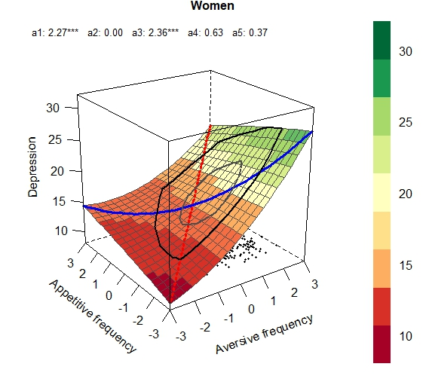 | 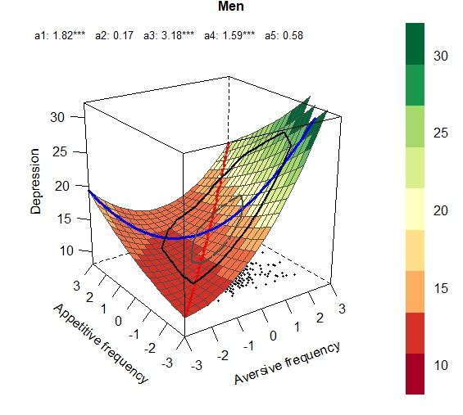
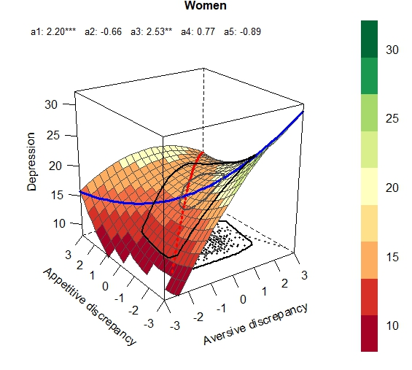 | 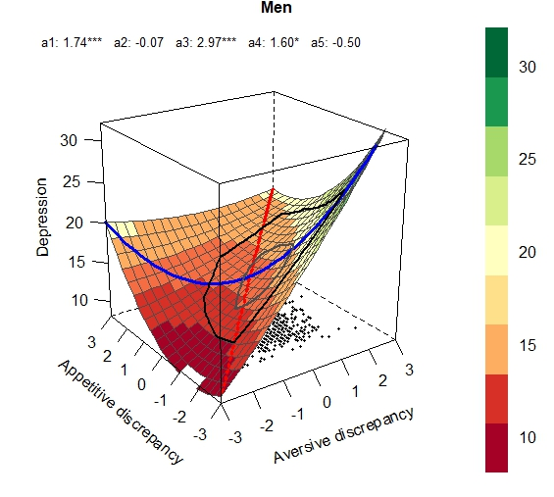
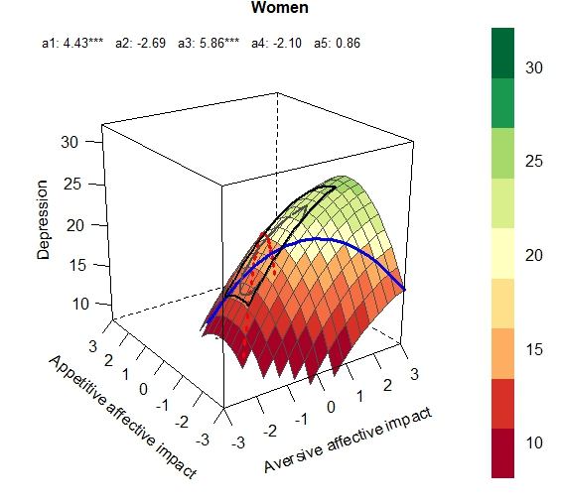 | 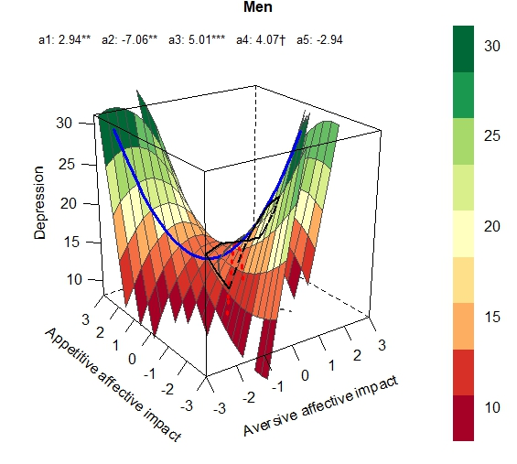
Figure s2
Response Surface Plots for aversive and appetitive comparisons as predictor variables and psychological well-being as outcome variable.

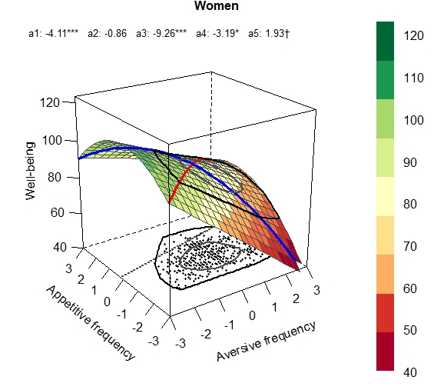 | 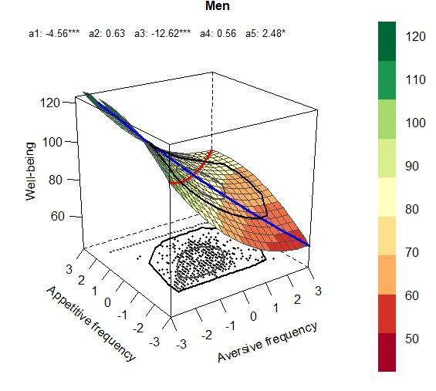
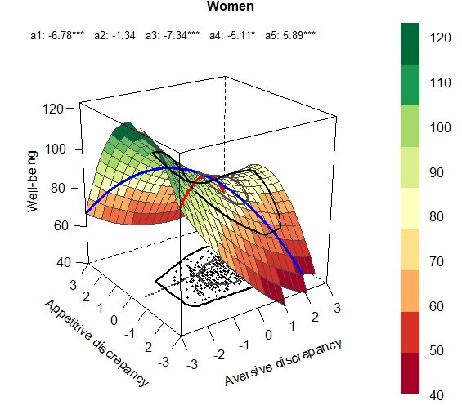 | 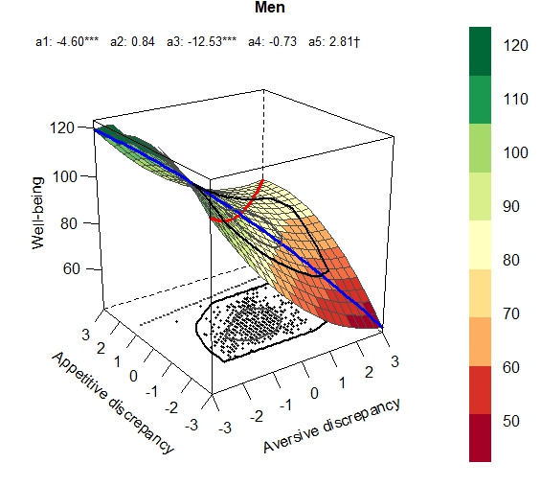
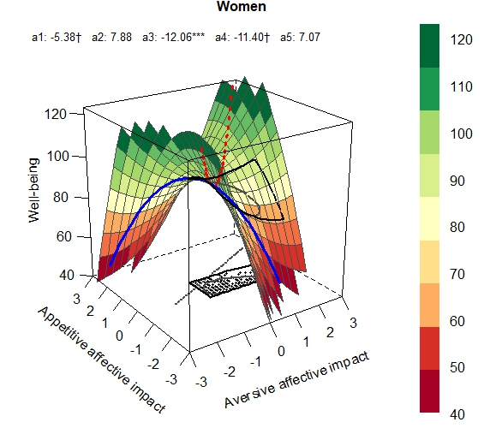 | 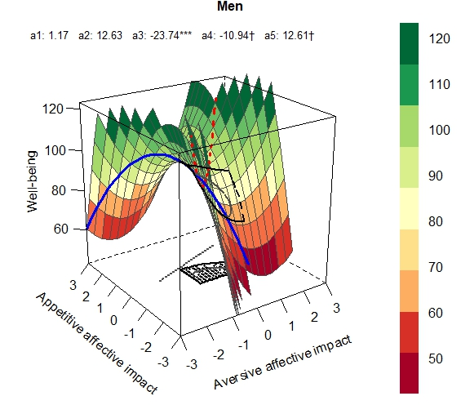
Figure s3
Response Surface Plots for aversive and appetitive comparisons as predictor variables and self-esteem as outcome variable.

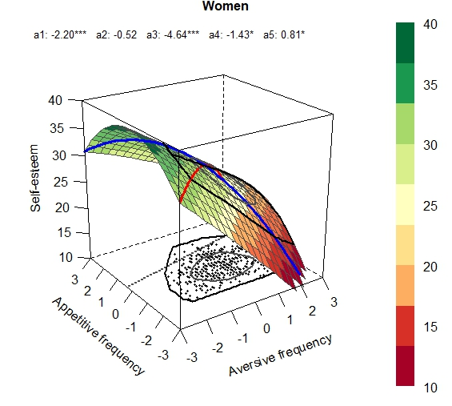 | 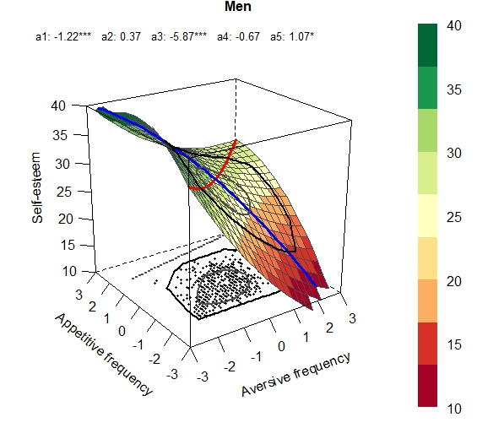
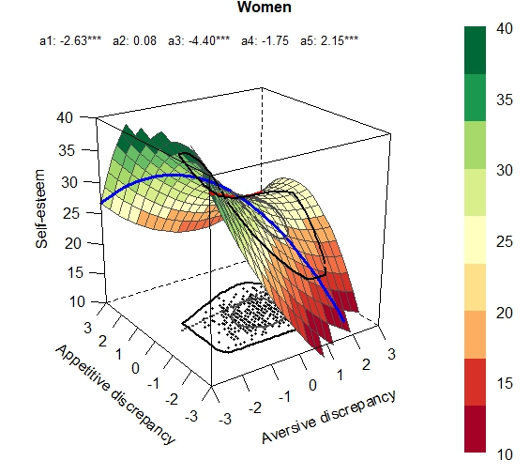 | 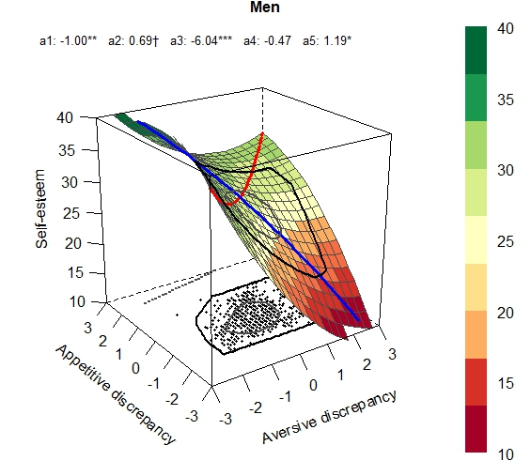
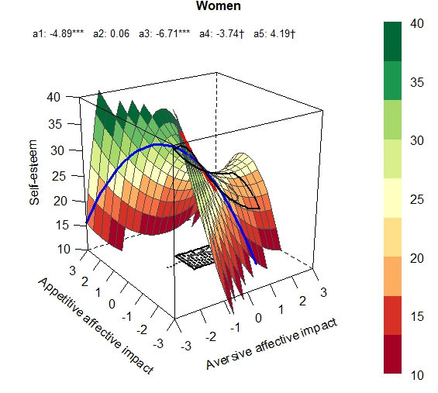 | 