Supplemental Materials

Return to Baseline after an Interpretation Training as a Dynamic Predictor for Treatment Response in Social Anxiety Disorder

Lynn Mobachª
Rachel van Loenen^{b}
Esther Allart-van Dam^{c}
Denny Borsboom^{d}
Reinout Wiers^{b}
Elske Saleminkª

ª Department of Clinical Psychology, Utrecht University, the Netherlands
^{b} Department of Psychiatry, Academic Medical Centre Amsterdam, the Netherlands
^{c} Psychology practice Nijmegen Oost, Nijmegen, the Netherlands
^{d} Department of Psychology, University of Amsterdam, the Netherlands
^{e} Department of Developmental Psychology, University of Amsterdam, the Netherlands

A: Flow chart of study procedure and inclusions/exclusions

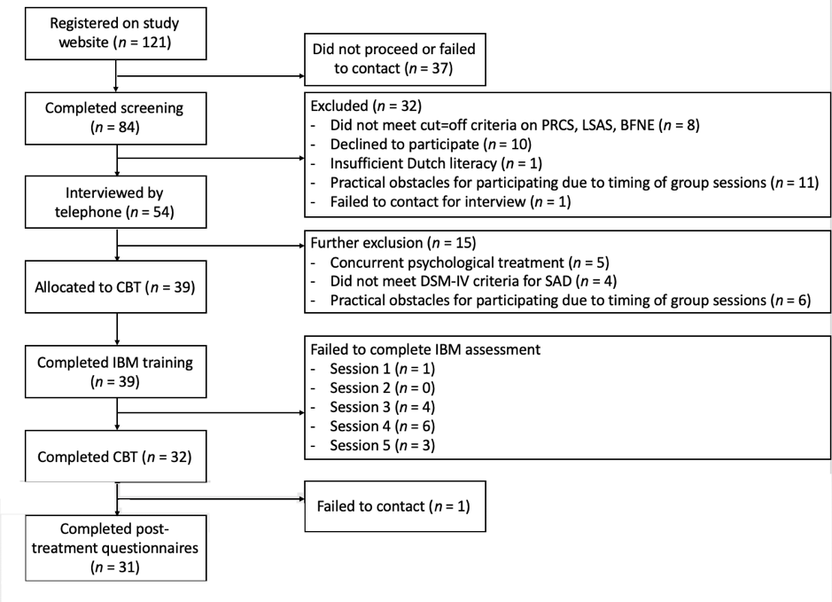

B: Additional details descriptive statistics and Bayesian Models

Missing data percentages for each recognition task were 2.56%, 0%, 10.26%, 15.38%, 7.69%, respectively. There were no differences between participants who completed all recognition tasks and those who had missed at least one recognition task on any of the outcome measures (p’s > .174) nor did participants who missed more than one recognition task did not miss more treatment sessions (p = .572).
Models were checked for convergence by examining Rhat values (<= 1.01) and caterpillar plots. Weakly informative (neutral), default priors of the brms package (Bürkner, 2016; Kerman, 2011) were set for all coefficients in both models because they do not substantially influence the results and because there was no prior information available from which more informative priors could have been derived. All possible random covariance terms between random effects were added. Follow-up analyses for the models consisted of estimated marginal slopes wherever appropriate (emmeans package; v.1.5.0; Lenth, 2020). Emmeans uses the original distribution of the model.

C: Main model results

Table 1
Estimates, estimated errors and credible intervals for the model subtracting positive and negative interpretation BLUPs
Model | Effect | Estimate | Est. Error | 95% CI
Positive interpretations | Intercept | 2.44 | 0.84 | 0.80, 4.10
 | CBM-I Session | -0.14 | 0.23 | -0.59, 0.31
Negative interpretations | Intercept | 0.76 | 0.54 | -0.31, 1.82
 | CBM-I Session | 0.11 | 0.16 | -0.21, 0.42
Note. BLUPS: Best Linear Unbiased Predictors; CBM-I: Cognitive Bias Modification for Interpretations.

Table 2
Estimates, estimated errors and credible intervals for the positive and negative BLUPS predicting change from pre- to post-treatment – Intention-to-treat (SAD-composite score)
Model | Effect | Estimate | Est. Error | 95% CI
Positive interpretations | Intercept | 0.01 | 0.16 | -0.32, 0.33
 | Time contrast | -0.03 | 0.19 | -0.42, 0.35
 | Recovery slope | -0.31 | 0.74 | -1.79, 1.15
 | Time contrast ^{x} Recovery slope | 0.15 | 0.89 | -1.58, 1.92
Negative interpretations | Intercept | -0.14 | 0.16 | -0.45, 0.18
 | Time contrast | 0.15 | 0.19 | -0.22, 0.52
 | Recovery slope | 1.74 | 0.80 | 0.17, 3.32
 | Time contrast ^{x} Recovery slope | -1.95 | 1.00 | -3.90, 0.04
Note. BLUPS: Best Linear Unbiased Predictors; SAD: Social Anxiety Disorder.

Table 3
Estimates, estimated errors and credible intervals for the positive and negative BLUPS predicting change from pre- to post-treatment – Completers-only (SAD-composite score)
Model | Effect | Estimate | Est. Error | 95% CI
Positive interpretations | Intercept | 0.02 | 0.17 | -0.32, 0.36
 | Time contrast | -0.10 | 0.20 | -0.49, 0.30
 | Recovery slope | -0.53 | 0.75 | -2.02, 0.95
 | Time contrast ^{x} Recovery slope | 0.69 | 1.00 | -1.27, 2.67
Negative interpretations | Intercept | -0.11 | 0.16 | -0.42, 0.20
 | Time contrast | 0.13 | 0.18 | -0.23, 0.49
 | Recovery slope | 1.85 | 0.78 | 0.33, 3.42
 | Time contrast ^{x} Recovery slope | -2.82 | 0.96 | -4.68, -0.91
Note. BLUPS: Best Linear Unbiased Predictors; SAD: Social Anxiety Disorder.

Table 4
Estimates, estimated errors and credible intervals for the positive and negative BLUPS predicting change from pre- to post-treatment – Treatment completers-only controlled for baseline (SAD-composite score)
Model | Effect | Estimate | Est. Error | 95% CI
Positive interpretations | Intercept | -0.05 | 0.13 | -0.30, 0.21
 | Time contrast | -0.06 | 0.16 | -0.37, 0.25
 | Recovery slope | -0.57 | 0.62 | -1.78, 0.62
 | Baseline | 1.07 | 0.24 | 0.61, 1.56
 | Time contrast ^{x} Recovery slope | 0.85 | 0.80 | -0.74, 2.42
 | Time contrast ^{x} Baseline | -0.67 | 0.27 | -1.20, -0.13
 | Recovery slope ^{x} Baseline | 1.55 | 1.37 | -1.07, 4.31
 | Time contrast ^{x} Recovery slope ^{x} Baseline | 0.03 | 1.66 | -3.20, 3.35
Negative interpretations | Intercept | -0.01 | 0.12 | -0.24, 0.23
 | Time contrast | 0.04 | 0.16 | -0.26, 0.35
 | Recovery slope | 0.84 | 0.74 | -0.63, 2.27
 | Baseline | 0.84 | 0.17 | 0.50, 1.18
 | Time contrast ^{x} Recovery slope | -3.86 | 1.06 | -5.94, -1.76
 | Time contrast ^{x} Baseline | -0.59 | 0.23 | -1.04, -0.15
 | Recovery slope ^{x} Baseline | -0.74 | 0.98 | -2.79, 1.12
 | Time contrast ^{x} Recovery slope ^{x} Baseline | 3.09 | 1.19 | 0.73, 5.45
Note. BLUPS: Best Linear Unbiased Predictors; SAD: Social Anxiety Disorder.

Table 5
Estimates, estimated errors and credible intervals for the positive and negative BLUPS predicting change from pre- to post-treatment – Intention-to-treat controlled for baseline (SAD-composite score)
Model | Effect | Estimate | Est. Error | 95% CI
Positive interpretations | Intercept | -0.06 | 0.13 | -0.32, 0.19
 | Time contrast | 0.02 | 0.17 | -0.31, 0.35
 | Recovery slope | -0.55 | 0.54 | -1.61, 0.50
 | Baseline | 0.93 | 0.20 | 0.53, 1.33
 | Time contrast ^{x} Recovery slope | 0.27 | 0.76 | -1.23, 1.79
 | Time contrast ^{x} Baseline | -0.70 | 0.26 | -1.22, -0.18
 | Recovery slope ^{x} Baseline | 0.06 | 0.96 | -1.82, 1.97
 | Time contrast ^{x} Recovery slope ^{x} Baseline | -1.21 | 1.35 | -3.88, 1.46
Negative interpretations | Intercept | -0.03 | 0.13 | -0.29, 0.22
 | Time contrast | 0.04 | 0.18 | -0.32, 0.40
 | Recovery slope | 0.47 | 0.65 | -0.82, 1.75
 | Baseline | 0.87 | 0.18 | 0.51, 1.22
 | Time contrast ^{x} Recovery slope | -2.42 | 1.08 | -4.56, -0.29
 | Time contrast ^{x} Baseline | -0.60 | 0.26 | -1.11, -0.08
 | Recovery slope ^{x} Baseline | 0.00 | 0.86 | -1.68, 1.68
 | Time contrast ^{x} Recovery slope ^{x} Baseline | 2.35 | 1.31 | -0.22, 4.95
Note. BLUPS: Best Linear Unbiased Predictors; SAD: Social Anxiety Disorder.

Table 6
Estimates, estimated errors and credible intervals for the positive and negative BLUPS predicting change during treatment – Intention-to-treat (SASCI)
Model | Effect | Estimate | Est. Error | 95% CI
Positive interpretations | Intercept | 4.15 | 0.17 | 3.81, 4.49
 | Time contrast 1 | -0.53 | 0.20 | -0.93, -0.12
 | Time contrast 2 | -0.59 | 0.22 | -1.03, -0.15
 | Time contrast 3 | -0.86 | 0.22 | -1.30, -0.42
 | Time contrast 4 | -1.55 | 0.22 | -1.98, -1.12
 | Time contrast 5 | -1.62 | 0.21 | -2.03, -1.22
 | Recovery slope | -1.10 | 0.79 | -2.65, 0.47
 | Time contrast 1 ^{x} Recovery slope | 0.90 | 0.85 | -0.78, 2.57
 | Time contrast 2 ^{x} Recovery slope | 1.46 | 0.97 | -0.46, 3.33
 | Time contrast 3 ^{x} Recovery slope | 1.11 | 0.96 | -0.80, 2.98
 | Time contrast 4 ^{x} Recovery slope | 0.46 | 0.99 | -1.45, 2.45
 | Time contrast 5 ^{x} Recovery slope | 2.00 | 1.04 | -0.04, 4.08
Negative interpretations | Intercept | 4.19 | 0.18 | 3.83, 4.54
 | Time contrast 1 | -0.56 | 0.20 | -0.95, -0.17
 | Time contrast 2 | -0.62 | 0.23 | -1.06, -0.17
 | Time contrast 3 | -0.82 | 0.22 | -1.24, -0.39
 | Time contrast 4 | -1.54 | 0.22 | -1.96, -1.11
 | Time contrast 5 | -1.63 | 0.21 | -2.06, -1.21
 | Recovery slope | 0.96 | 0.96 | -0.91, 2.85
 | Time contrast 1 ^{x} Recovery slope | -0.69 | 1.10 | -2.86, 1.45
 | Time contrast 2 ^{x} Recovery slope | -1.35 | 1.14 | -3.56, 0.90
 | Time contrast 3 ^{x} Recovery slope | -1.72 | 1.15 | -3.96, 0.57
 | Time contrast 4 ^{x} Recovery slope | -0.59 | 1.20 | -3.01, 1.70
 | Time contrast 5 ^{x} Recovery slope | -1.76 | 1.23 | -4.18, 0.60
Note. SASCI: Social Anxiety Session Change Index.

Table 7
Estimates, estimated errors and credible intervals for the positive and negative BLUPS predicting change during treatment – Treatment completers-only (SASCI)
Model | Effect | Estimate | Est. Error | 95% CI
Positive interpretations | Intercept | 4.16 | 0.19 | 3.80, 4.53
 | Time contrast 1 | -0.52 | 0.21 | -0.94, -0.10
 | Time contrast 2 | -0.61 | 0.22 | -1.04, -0.16
 | Time contrast 3 | -0.87 | 0.23 | -1.31, -0.42
 | Time contrast 4 | -1.56 | 0.22 | -2.00, -1.12
 | Time contrast 5 | -1.67 | 0.22 | -2.10, -1.23
 | Recovery slope | -0.75 | 0.87 | -2.44, 1.00
 | Time contrast 1 ^{x} Recovery slope | 0.94 | 0.89 | -0.79, 2.70
 | Time contrast 2 ^{x} Recovery slope | 1.32 | 0.97 | -0.61, 3.26
 | Time contrast 3 ^{x} Recovery slope | 0.97 | 0.97 | -0.94, 2.89
 | Time contrast 4 ^{x} Recovery slope | 0.30 | 1.00 | -1.63, 2.31
 | Time contrast 5 ^{x} Recovery slope | 1.49 | 1.17 | -0.78, 3.83
Negative interpretations | Intercept | 4.16 | 0.19 | 3.77, 4.54
 | Time contrast 1 | -0.53 | 0.21 | -0.95, -0.13
 | Time contrast 2 | -0.59 | 0.23 | -1.04, -0.14
 | Time contrast 3 | -0.79 | 0.22 | -1.22, -0.36
 | Time contrast 4 | -1.51 | 0.22 | -1.95, -1.09
 | Time contrast 5 | -1.57 | 0.23 | -2.01, -1.11
 | Recovery slope | 0.94 | 0.99 | -1.02, 2.88
 | Time contrast 1 ^{x} Recovery slope | -1.02 | 1.11 | -3.22, 1.12
 | Time contrast 2 ^{x} Recovery slope | -1.50 | 1.13 | -3.72, 0.71
 | Time contrast 3 ^{x} Recovery slope | -1.87 | 1.14 | -4.13, 0.38
 | Time contrast 4 ^{x} Recovery slope | -0.78 | 1.21 | -3.19, 1.55
 | Time contrast 5 ^{x} Recovery slope | -2.42 | 1.32 | -5.06, 0.13
Note. SASCI: Social Anxiety Session Change Index.

D: Exploratory post-hoc model results

Model | Outcome variable | Effect | Estimate | Est. Error | 95% CI
Positive interpretations | BFNE | Intercept | 32.92 | 1.91 | 29.16, 36.70
 |  | Time contrast | -7.28 | 1.62 | -10.49, -4.09
 |  | Recovery slope | 2.39 | 7.59 | -17.43, 12.51
 |  | Time contrast ^{x} Recovery slope | -0.20 | 7.56 | -14.99, 14.71
 | PRPSA | Intercept | 141.33 | 2.73 | 135.98, 146.69
 |  | Time contrast | -33.40 | 3.45 | -40.20, -26.64
 |  | Recovery slope | -4.63 | 12.21 | -28.73, 19.52
 |  | Time contrast ^{x} Recovery slope | 14.66 | 15.82 | -16.55, 45.89
 | SATI | Intercept | 83.64 | 2.44 | 78.84, 88.44
 |  | Time contrast | -34.91 | 3.22 | -41.18, -28.56
 |  | Recovery slope | -3.73 | 10.52 | -24.85, 16.77
 |  | Time contrast ^{x} Recovery slope | -6.68 | 14.58 | -35.29, 22.39
Negative interpretations | BFNE | Intercept | 30.59 | 1.87 | 26.88, 34.24
 |  | Time contrast | -6.23 | 1.71 | -9.65, -2.87
 |  | Recovery slope | 21.55 | 9.26 | 3.33, 39.66
 |  | Time contrast ^{x} Recovery slope | -9.59 | 9.08 | -27.51, 8.45
 | PRPSA | Intercept | 139.70 | 2.69 | 134.41, 144.99
 |  | Time contrast | -31.45 | 3.55 | -38.46, -24.52
 |  | Recovery slope | 17.99 | 14.94 | -11.61, 46.99
 |  | Time contrast ^{x} Recovery slope | -32.59 | 18.86 | -69.90, 5.08
 | SATI | Intercept | 81.86 | 2.42 | 77.08, 86.64
 |  | Time contrast | -31.35 | 3.28 | -37.77, -24.90
 |  | Recovery slope | 17.75 | 12.65 | -7.45, 42.36
 |  | Time contrast ^{x} Recovery slope | -30.33 | 17.19 | -64.22, 3.16
Estimates, estimated error and credible intervals for the positive and negative BLUPS predicting outcome in terms of BFNE, PRPSA and SATI separately

E: Figures showing per-participant slopes in mean negative and positive interpretations across the interpretation assessments

