Supplemental Material:
Measuring appearance-related comparisons: Validation of the Comparison Standards Scale for Appearance

Supplemental Material 1: Exploratory Factor Analysis
Despite our theoretical foundation to conduct confirmatory factor analyses (CFA), we ran exploratory factor analysis (EFA) to gauge whether we missed other factor solutions of the CSS-A that may not align with the a priori defined factor structure. EFAs were conducted separately for comparison frequency, comparison discrepancy, and comparison affect. To discern the number of latent factors, we conducted parallel analysis according to Horn (1965) and visually inspected the scree-plot. Following Fabrigar and Wegener (2011), we additionally inspected the Velicer's Minimum Average Partial (MAP) test, the Very Simple Structure (VSS), and the Kaiser criterion (eigenvalues above 1).
EFA for the comparison frequency component There was no unequivocal factor solution according to the different criteria. The Kaiser criterion, the MAP and the scree-plot (supplemental Figure 1) suggested two latent factors, while parallel analysis indicated five factors and the VSS one underlying factor.
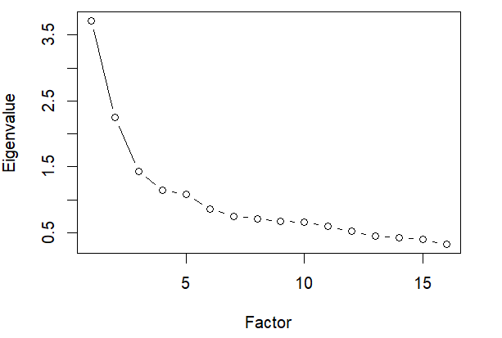
Supplemental Figure 1. Scree-plot for comparison frequency.

EFA for the discrepancy component Again, no unequivocal factor solution emerged according to the different criteria. The Kaiser criterion, the MAP and the scree-plot (supplemental Figure 2) suggested two latent factors underlying latent factors, while parallel analysis indicated five distinct factors and the VSS three underlying factors.
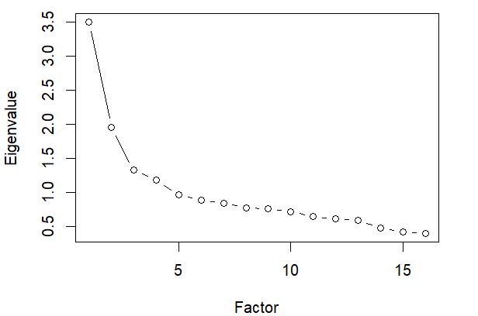
Supplemental Figure 2. Scree-plot for comparison discrepancy.
EFA for the affect component Again, no unequivocal factor solution emerged according to the different criteria. The Kaiser criterion, the MAP and the scree-plot (supplemental Figure 3) suggested one underlying latent factor, while parallel analysis indicated six distinct factors and the VSS four underlying factors.
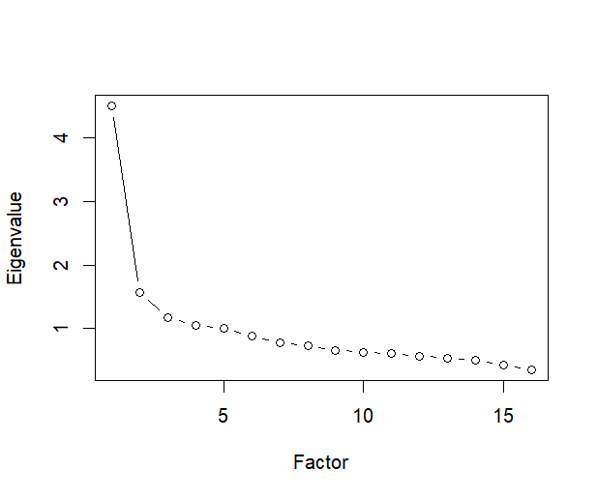
Supplemental Figure 3. Scree-plot for comparison frequency.
Conclusion
Given that the factor solutions could not be unequivocally determined and were not consistent across comparison frequency, comparison discrepancy, and comparison affect, we refrained from continuing with them for our main analyses. The main reason is that these factor solutions do not capture the important theoretical aspects that are central to our hypothesized factor structure. That is, first, to account for the fact that items of the same type of comparison (e.g., all social comparison or all temporal comparison items) may share common variance beyond the aversive and appetitive comparison factors, we allowed the covariances of errors for the same types of comparisons. Second, we examined whether our scale captures an overarching latent factor that represent a general comparison orientation with two specific orthogonal latent subfactors. This complexity is important and inherent to the CSS-A and therefore, we continued with our confirmatory factor analysis framework.
Supplemental Table 1: Descriptive statistics for participants including zeros for discrepancy and affect ratings for individuals who did not engage in the respective comparison type
Item | Frequency |  |  |  |  | Discrepancy |  |  |  | Affect
 | N* | M | SD | Sk | Kt | M | SD | Sk | Kt | M | SD | Sk | Kt
1 (SF) | 965 | 2.47 | 1.56 | -0.08 | -1.10 | 2.71 | 1.58 | -0.37 | -0.89 | -0.66 | 1.13 | -0.09 | 0.40
2 (SF) | 806 | 1.56 | 1.37 | 0.55 | -0.67 | 1.48 | 1.24 | 0.25 | -0.94 | 0.11 | 0.88 | 0.03 | 2.41
3 (SU) | 1007 | 2.87 | 1.51 | -0.44 | -0.76 | 3.13 | 1.54 | -0.68 | -0.45 | -0.83 | 1.22 | 0.03 | -0.12
4 (SU) | 794 | 1.55 | 1.37 | 0.55 | -0.64 | 1.34 | 1.21 | 0.51 | -0.54 | 0.16 | 0.96 | 0.11 | 2.22
5 (TP) | 923 | 2.58 | 1.69 | -0.19 | -1.20 | 2.59 | 1.71 | -0.26 | -1.17 | -0.70 | 1.32 | 0.03 | -0.09
6 (TP) | 717 | 1.55 | 1.53 | 0.63 | -0.77 | 1.29 | 1.33 | 0.65 | -0.63 | 0.15 | 1.08 | 0.25 | 1.57
7 (TF) | 775 | 1.96 | 1.70 | 0.30 | -1.23 | 1.34 | 1.34 | 0.68 | -0.42 | -0.60 | 1.19 | -0.24 | 0.46
8 (TF) | 879 | 2.26 | 1.70 | 0.14 | -1.22 | 2.37 | 1.72 | -0.03 | -1.25 | 0.35 | 1.33 | 0.07 | 0.23
9 (CFIN) | 868 | 2.62 | 1.83 | -0.20 | -1.37 | 2.62 | 1.79 | -0.29 | -1.28 | -0.68 | 1.25 | 0.07 | 0.37
10 (CFIN) | 494 | 0.90 | 1.26 | 1.38 | 1.04 | 0.82 | 1.18 | 1.39 | 1.26 | 0.02 | 0.81 | 0.49 | 5.00
11 (CFEX) | 390 | 0.90 | 1.43 | 1.39 | 0.64 | 0.96 | 1.51 | 1.29 | 0.33 | -0.15 | 0.76 | -0.81 | 6.28
12 (CFEX) | 260 | 0.47 | 1.01 | 2.30 | 4.92 | 0.45 | 0.95 | 2.12 | 3.97 | -0.04 | 0.52 | 0.03 | 14.00
13 (CB) | 722 | 1.68 | 1.59 | 0.47 | -1.01 | 1.24 | 1.25 | 0.62 | -0.53 | -0.62 | 1.06 | -0.62 | 0.38
14 (CB) | 691 | 1.49 | 1.49 | 0.59 | -0.80 | 1.70 | 1.60 | 0.34 | -1.16 | 0.28 | 1.11 | 0.34 | 1.11
15 (DM) | 872 | 2.39 | 1.69 | -0.08 | -1.21 | 2.49 | 1.67 | -0.29 | -1.13 | 0.52 | 1.27 | 0.11 | 0.22
16 (DM) | 491 | 2.00 | 1.37 | 1.18 | 0.26 | 1.01 | 1.35 | 1.02 | -0.19 | -0.04 | 0.83 | -0.01 | 4.65

Note. M = Mean; SD = Standard Deviation; Sk = Skewness; Kt = Kurtosis; N* refers to the number of participants who indicated that they had compared at least once with the respective comparison standard. Discrepancy and affect values are based on these numbers; SF = social familiar; SU = social unfamiliar; TP = temporal past; TF = temporal future; CFIN = counterfactual internal; CFEX = counterfactual external; CB = Criteria-based; DM = Dimensional.

References
Fabrigar, L. R., & Wegener, D. T. (2011). Exploratory factor analysis. Oxford University Press. Horn, J. L. (1965). A rationale and test for the number of factors in factor analysis. Psychometrika, 30(2), 179-185. https://doi.org/10.1007/BF02289447

