Supplementary Materials 1
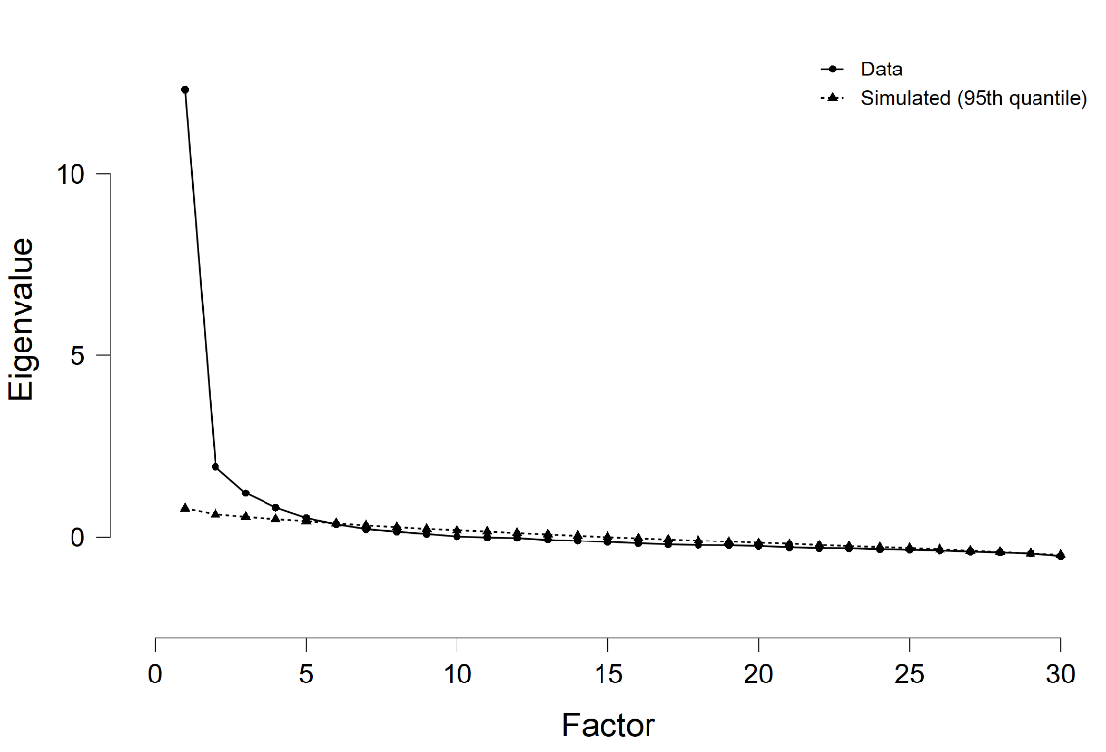

Figure S1. Scree plot presenting eigenvalues with simulated 95th quantile eigenvalues overlaid.

