Personality disorders and their relation to treatment outcomes in cognitive behavioural therapy for depression:
A systematic review and meta-analysis

Online Supplementary Appendices
Appendix A. Search strategy
- (Depress* OR “major depress* disorder*” OR “unipolar depress* disorder*”)
- AND ((personality ADJ disorder*) OR personalit* OR “borderline personality disorder”)
- AND (“cognitive behavio* therap*” OR CBT OR CT OR “cognitive therapy”)
- AND (depress* OR “major depress* disorder*” OR “unipolar depression” OR “affective disorder*” OR “mood disorder*”)

Appendix B. Studies that were screened but excluded from the review
First Author | DOI | Exclusion Reason
Akbari, J | ª | Not written in the English language
Allen, J G | ^{b} | Not a peer-reviewed journal article
Antérion, T | ^{c} | Failed to meet experimental design
Arendarska, A | ^{d} | Not written in the English language
Beck, A T | ^{e} | Not a peer-reviewed journal article
Bagby, M R | 10.1177/070674370805300605 | No diagnosis of a personality disorder
Brown, G K | 10.1521/pedi.18.3.257.35450 | None of the sample had no personality disorder
Brown, J | 10.1007/s00127-005-0896-z | Failed to meet experimental design
Camart, N | ENC-12-2006-32-6-0013-7006-101019-200630172 | Not written in the English language
Campbell, P L | ^{f} | Not a peer-reviewed journal article
Clark, D A | ^{g} | Not a peer-reviewed journal article
Conrad, R | 10.1016/j.pain.2007.07.024 | No use of CBT in the study
Coplan, J D | ^{h} | No use of CBT in the study
Cottraux, J | 10.1159/000229769 | None of the sample had no personality disorder
Dautovich, N D | ^{i} | Not a peer-reviewed journal article
Davis, L | 10.1016/j.beth.2009.09.002 | None of the sample had no personality disorder
De Bolle, M | 10.1521/pedi.2011.25.1.1 | Not possible to examine the effects of PD specifically within CBT treatment condition
Dixon-Gordon, K L | 10.1016/j.beth.2017.03.001 | No MDD present
Dreessen | 10.1016/0010-440X(94)90018-3 | Patients treated with CBT for anxiety disorders
Dunner, D L | 10.1002/(SICI)1522-7162(1996)4:1<34::AID-DEPR4>3.0.CO;2-F | Does not include comorbid PD
Farabaugh, A | 10.1097/00005053-200204000-00006 | Results pooled; no comparison can be made
Farabaugh, A | 10.1016/j.comppsych.2004.10.005 | Not possible to examine the effects of PD specifically within CBT treatment condition
Fournier, J | ^{j} | Not a peer-reviewed journal article
Fournier, J | 10.1016/j.brat.2013.03.010 | Does not include comorbid PD
Free | 10.1080/00207284.1991.11490679 | Does not include comorbid PD
Grilo, C M | 10.1053/comp.2002.35907 | Failed to meet experimental design
Grilo, C M | 10.1037/0022-006X.72.5.767. | No use of CBT in the study
Guimon, J | ^{k} | Not a peer-reviewed journal article
Hautzinger, G | N/A | Not written in the English language
Jackson, B | 10.1016/j.yapd.2006.04.008 | Not a peer-reviewed journal article
Jarrett, R B | ^{l} | Not a peer-reviewed journal article
Karlin, B E | ^{m} | Not a peer-reviewed journal article
Konen, A | ^{n} | Not written in the English language
Kramer, U | 10.1016/j.encep.2012.03.006 | Not written in the English language
Spinhoven, P | 10.1080/02699930500342662 | Does not include comorbid PD
Kuyken, W | 10.1159/000172619 | Does not include comorbid PD
Lee | 10.1023/B:JOCP.0000036632.27389.c4 | Failed to meet experimental design
Levenson, J | 10.1037/a0029396 | No use of CBT in the study
Lin, T | 10.1080/13811118.2018.1436104 | No MDD present
Maddux, R E | 10.1016/j.jad.2009.01.010 | No use of CBT in the study
Mazure, C | 10.1016/0165-1781(90)90148-X | No use of CBT in the study
McCarter, K L | 10.1186/s12888-016-0937-z | Does not include comorbid PD
McMain, S | 10.1176/appi.ajp.2012.11091416 | No use of CBT in the study
Mitjanas, T | º | Not written in the English language
Moller, H | 10.1080/15622970903101665 | Not a peer-reviewed journal article
Moradveisi, L | 10.1016/j.brat.2013.05.006 | No use of CBT in the study
Newton-Howes, G | 10.1521/pedi_2017_31_311 | Not a peer-reviewed journal article
Patience, D A | 10.1192/bjp.167.3.324 | No use of CBT in the study
Quilty, L C | 10.1521/pedi.2010.24.3.392 | Does not include comorbid PD
Rees, C S | 10.1037/a0035158 | None of the sample had no personality disorder
Robins | ^{p} | Not a peer-reviewed journal article
Ruesch, M | 10.1186/s13063-015-0801-3 | Does not include comorbid PD
Saulsman, L | 10.1002/jclp.20278 | None of the sample had no personality disorder
Sharp, C | 10.1007/s00787-014-0574-3 | No MDD present
Shea, M T | ^{q} | Not a peer-reviewed journal article
Simun, A | ^{r} | Not a peer-reviewed journal article
Steinlechner, S | ^{s} | Not written in the English language
Stone, M H | 10.1016/S0193-953X(05)70151-9 | Failed to meet experimental design
Kudak | ^{t} | Not a peer-reviewed journal article
Szanto, K | 10.2165/00002512-200219010-00002 | Failed to meet experimental design
Titov, N | 10.1016/j.janxdis.2015.08.002 | Does not include comorbid PD
Tyrer, P | 10.1192/bjp.162.2.219 | Results pooled; no comparison can be made
Tyrer, P | 10.1177/0020764003049001148 | Results pooled; no comparison can be made
Tyrer, P | 10.1017/S0033291704002569 | Results pooled; no comparison can be made
Vyskocilova, J | 10.5507/bp.2011.005 | No MDD present
Wenning, B | ^{u} | Not written in the English language
Whisman, M | ^{v} | Not a peer-reviewed journal article
Yanes, P K | 10.1177/1534650110383307 | Failed to meet experimental design
ª Akbari, et al, (2009), Journal of Psychology, 13, 3, 342-359.
^{b} Allen, J G (2006), Coping with depression: From catch-22 to hope.
^{c} Antérion, et al (2002), Encephale, 28(2):154-9.
^{d} Arendarska, A, et al, (2006), Psychoterapia, (4): 11-34.
^{e} Beck, A T, (2015), Cognitive therapy of personality disorders.
^{f} Campbell, P L (2002), Dissertation Abstracts International: Section B: The Sciences and Engineering, 63, 5B, 2574.
^{g} Clark, D L (2015), Cognitive therapy of personality disorders., 3rd ed.
^{h} Coplan, et al (1993), J Clin Psychiatry, 54 Suppl:69-74.
^{i} Dautovich, N D (2011), Cognitive behavior therapy with older adults: Innovations across care settings.
^{j} Fournier, J (2011), Dissertation Abstracts International: Section B: The Sciences and Engineering, 71, 11B, 7085.
^{k}Guimon, J (2004), European Journal of Psychiatry, Volume 18, Issue SUPPL., 2004, Pages 49-60
^{l} Jarrett, R B (1997) Treatment strategies for patients with psychiatric comorbidity, 135-162.
^{m} Karlin, B E (2011), Cognitive behavior therapy with older adults: Innovations across care settings, 1-28.
^{n} Konen, A (1992), Treatment of depressed patients: current trends. Combination cognitive group therapy with cognitive adjustment for depressed inpatients, 29;81(40):1192-5.
º Mitjanas, T, (2004), Revista de Psiquiatria de la Facultad de Medicina de Barcelona, 31(4):174-182.
^{p} Robins, et al (2008), Adapting cognitive therapy for depression: Managing complexity and comorbidity.
^{q} Shea, et al (1992), Journal of Consulting and Clinical Psychology, 60(6), 857-868.
^{r} Simun, A (1999), Dissertation Abstracts International: Section B: The Sciences and Engineering, 60, 3B, 1316.
^{s} Steinlechner, et al (2012), Behavioral Therapy and Behavioral Medicine 33 (2): 176-187.
^{t} Kudak, (2011), Combining CBT and medication: An evidence-based approach.
^{u} Wenning, et al (2002) Zum Zusammenhang von depressiven Erkrankungen und Personlichkeitsstorungen, 6(4), 230-242.
^{v} Whisman M (2014), The Oxford handbook of depression and comorbidity.

Appendix C. Risk of bias assessment
C1. Randomised controlled trials
Author & Date | Risk of bias arising from the randomization process | Risk of bias due to deviations from the intended interventions (effect of assignment to intervention) | Risk of bias due to missing outcome data | Risk of bias in measurement of the outcome | Risk of bias in selection of the reported result | Overall Rating
Fournier, et al (2008) | Low | Moderate | Low | Low | Low | Moderate risk
Hardy, et al (1995) | Low | Moderate | Unclear | Low | Low | Moderate risk
Joyce, et al (2007) | Low | Low | Low | Low | Low | Low risk
Shea, et al (1990) | Low | Low | Low | Low | Low | Low risk
Tyrer, et al (1990) | Low | Low | Moderate | Low | Low | Moderate risk
Van Bronswijk, et al (2018) | Low | Low | Low | Low | Low | Low risk

C2. Observational cohort studies
Author & Date | Was the issue clearly focused? | Was the cohort recruited in an acceptable way? | Was the outcome (Depression levels) accurately measured to minimise bias? | Confounding variables | Completeness of results | Precision of results | Believability of results | Applicability to intended population | Fit with other research | Implications of the study | Overall rating
Ball, et al (2000) | Low risk | Low risk | Low risk | Moderate risk | Low risk | Moderate risk | Low risk | Moderate risk | Low risk | Low risk | Moderate risk
Craigie, et al (2007) | Low risk | Low risk | Low risk | Low risk | Low risk | Low risk | Low risk | Low risk | Low risk | Low risk | Low risk
Harte & Hawkins II | Low risk | Moderate risk | Low risk | Low risk | Low risk | Low risk | Low risk | Low risk | Low risk | Moderate risk | Moderate risk
van den Hout, et al (2006) | Low risk | Low risk | Moderate risk | Moderate risk | Low risk | Moderate risk | Low risk | Low risk | Moderate risk | Poor | Moderate risk
Kuyken, et al (2001) | Low risk | Low risk | Low risk | Low risk | Low risk | Low risk | Low risk | Low risk | Low risk | Low risk | Low risk

Appendix D. Funnel plot for primary random-effects meta-analysis

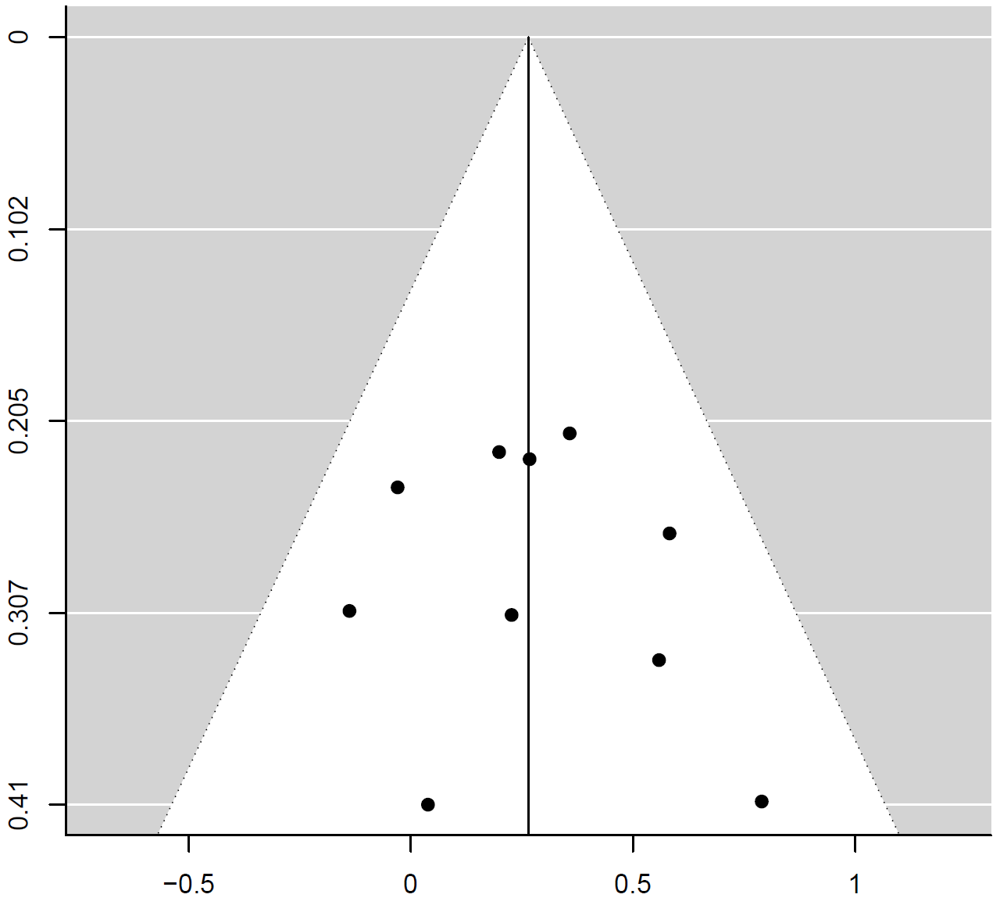
Standard error
Effect size

