Supplemental material 4
Figures S22-S33
Figure S22
Funnel plot for child-reported PTSD symptoms without outlier studies
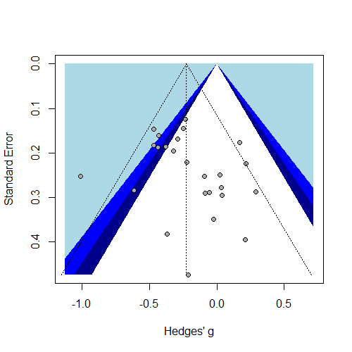
Figure S23
Funnel plot for parent-reported PTSD symptoms without outlier studies
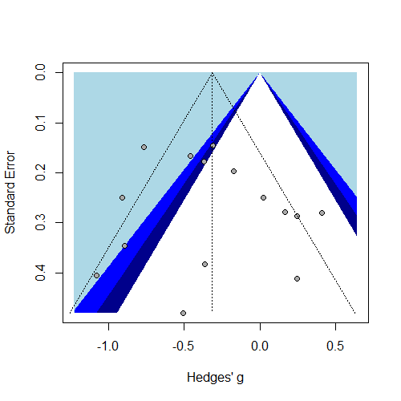
Figure S24
Funnel plot for child-reported depressive symptoms without outlier studies
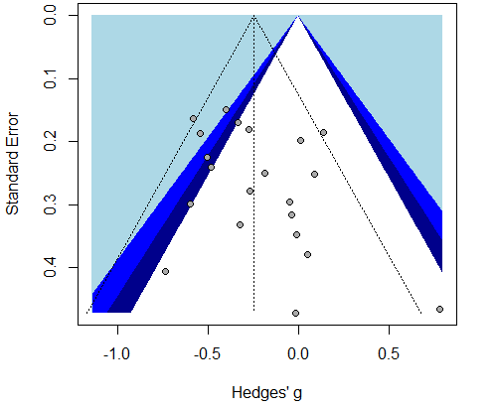
Figure S25
Funnel plot for parent-reported depressive symptoms 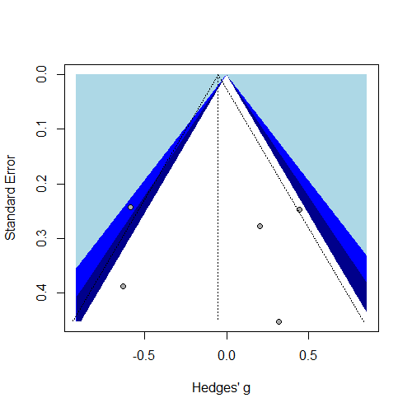

Figure S26
Funnel plot for child-reported anxiety symptoms
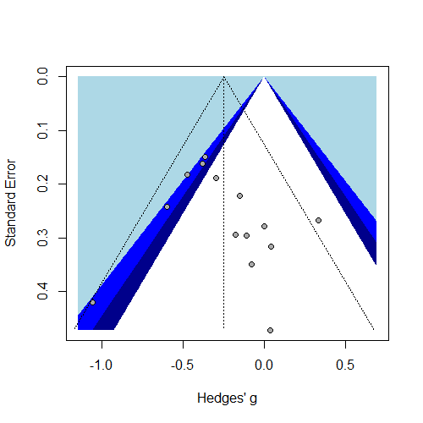
Figure S27
Funnel plot for parent-reported anxiety symptoms
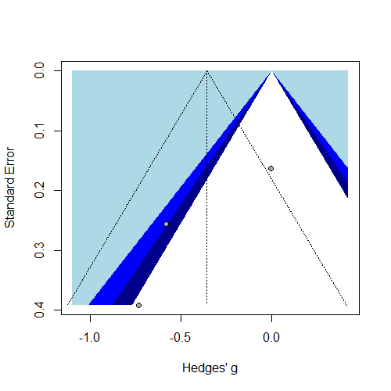

Figure S28
Funnel plot for parent-reported ADHD symptoms
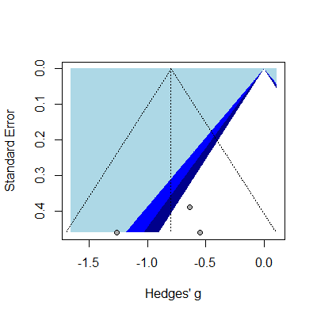
Figure S29
Funnel plot for child-reported internalizing symptoms without outlier studies
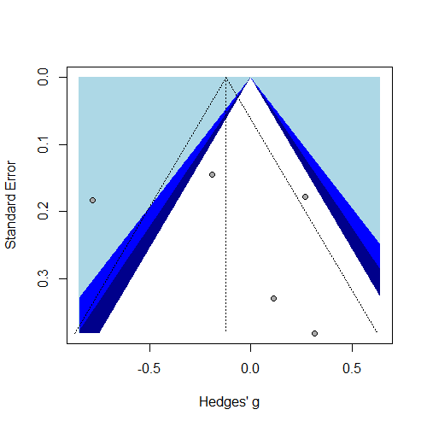

Figure S30
Funnel plot for parent-reported internalizing symptoms without outlier studies 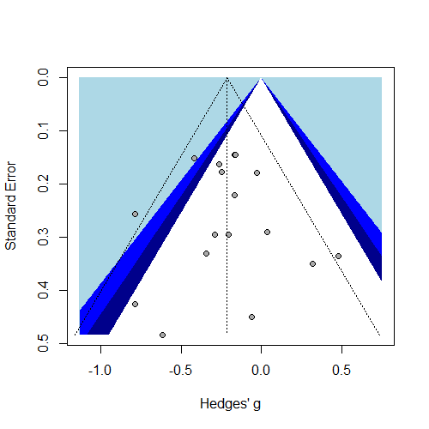
Figure S31
Funnel plot for child-reported externalizing symptoms
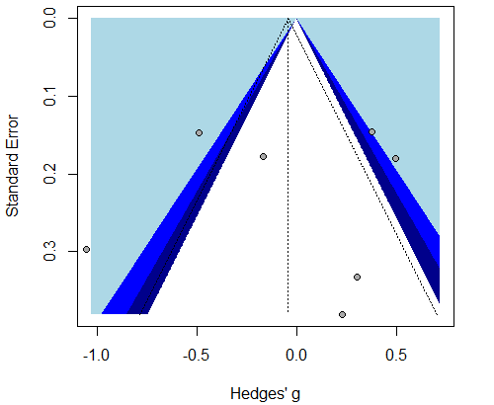

Figure S32
Funnel plot for parent-reported externalizing symptoms
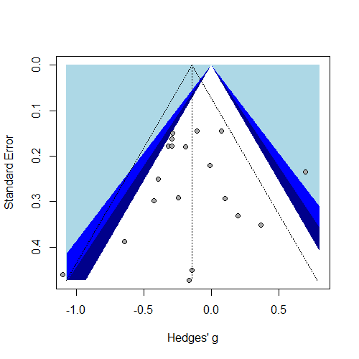
Figure S33
Funnel plot for behavior problems
