Supplemental material 3
Figures S1-S21
Figure S1
Forest plot for child-reported PTSD symptoms at three to four months
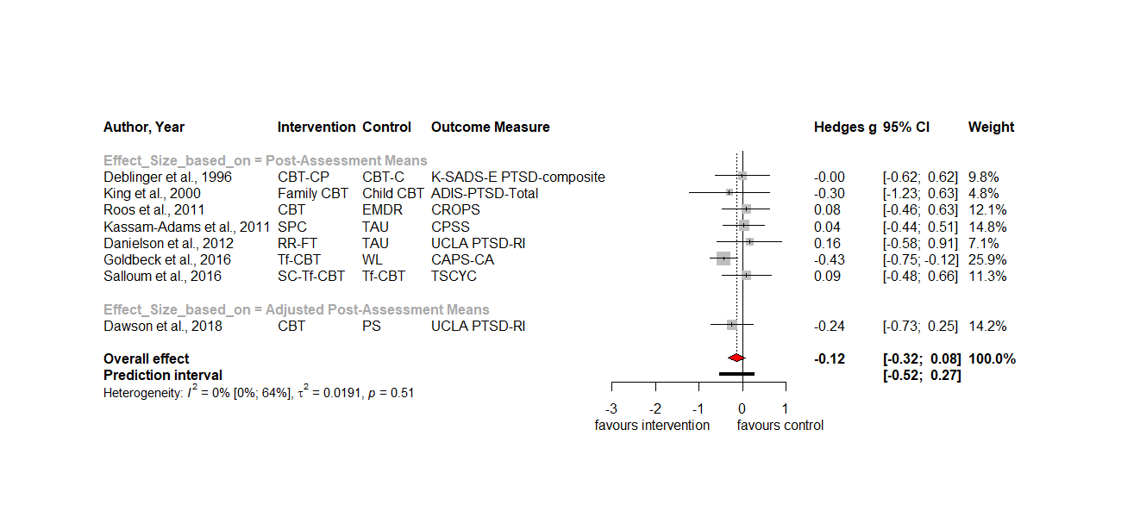Figure S2
Forest plot for child-reported PTSD symptoms at six months
Figure S3
Forest plot for child-reported PTSD symptoms at twelve months
Figure S4
Forest plot for parent-reported PTSD symptoms at three months
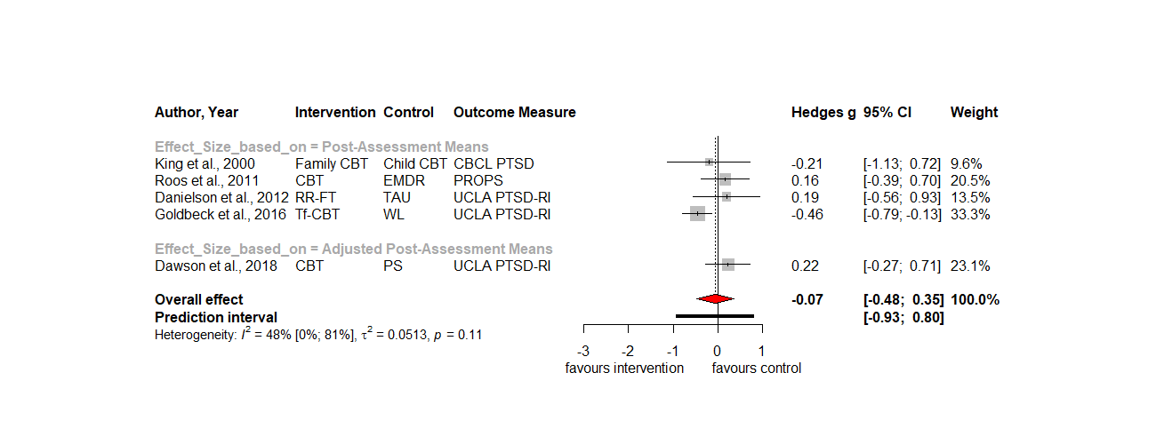
Figure S5
Forest plot for parent-reported PTSD symptoms at twelve months
Figure S6
Forest plot for child-reported depressive symptoms at three to four months

Figure S7
Forest plot for child-reported depressive symptoms at six months
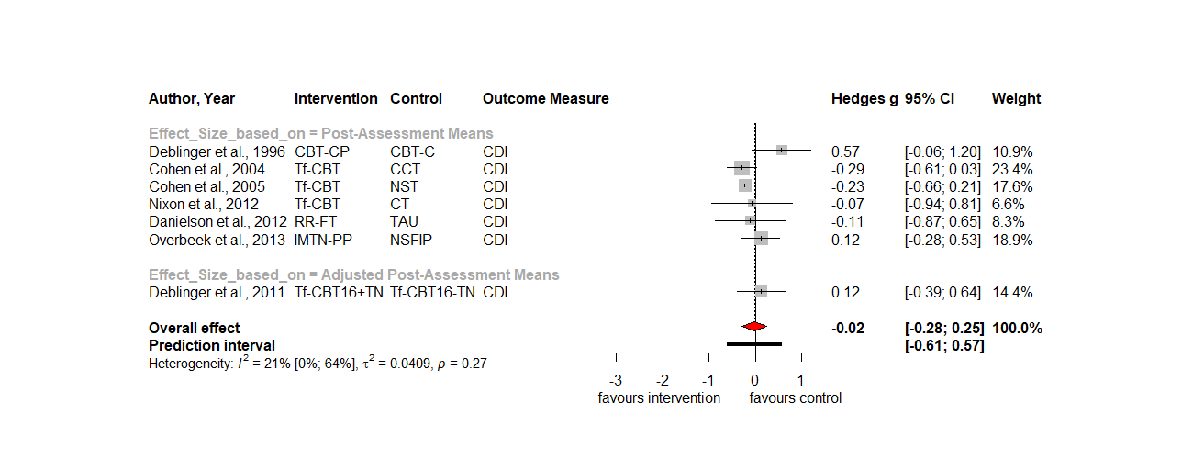
Figure S8
Forest plot for child-reported depressive symptoms at twelve months
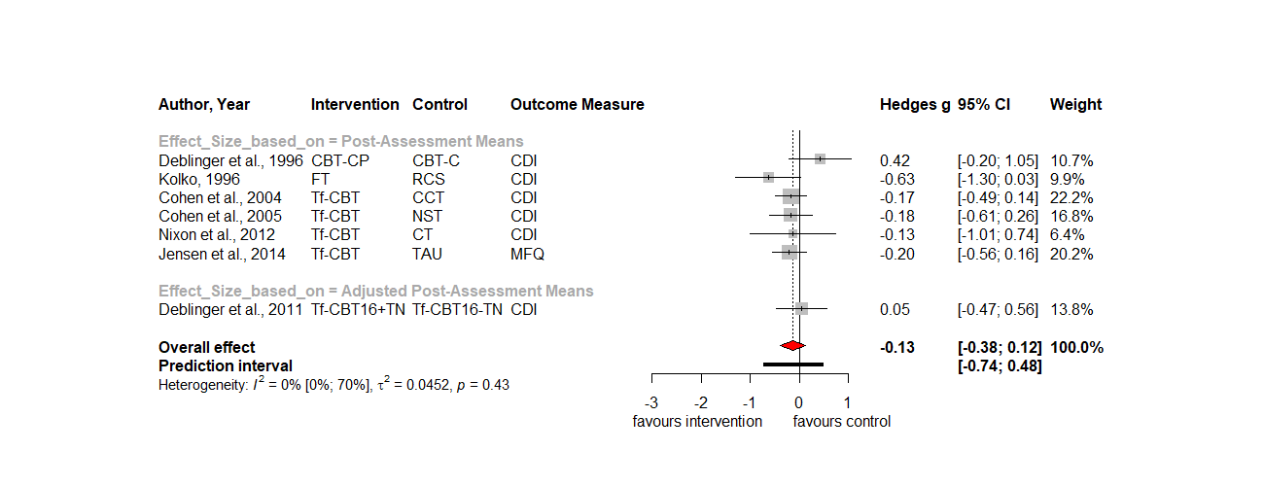
Figure S9
Forest plot for child-reported anxiety symptoms at three to four months

Figure S10
Forest plot for child-reported anxiety symptoms at six months
Figure S11
Forest plot for child-reported anxiety symptoms at twelve months
Figure S12
Forest plot for child-reported internalizing symptoms at twelve months

Figure S13
Forest plot for internalizing symptoms at three to four months
Figure S14
Forest plot for internalizing symptoms at six months
Figure S15
Forest plot for parent-reported internalizing symptoms at twelve months
Figure S16
Forest plot for child-reported externalizing symptoms at twelve months
Figure S17
Forest plot for externalizing symptoms at three to four months
Figure S18
Forest plot for externalizing symptoms at six months
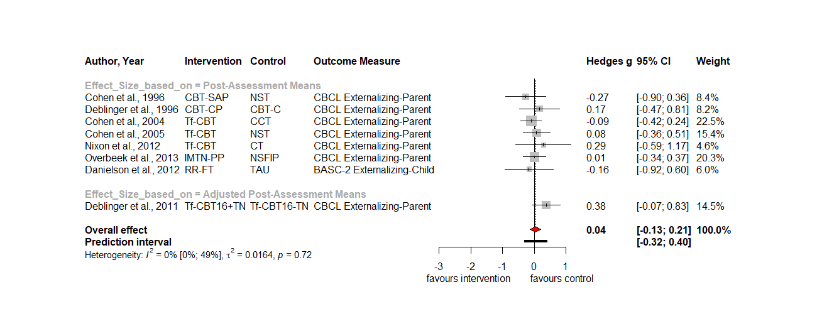

Figure S19
Forest plot for parent-reported externalizing symptoms at twelve months
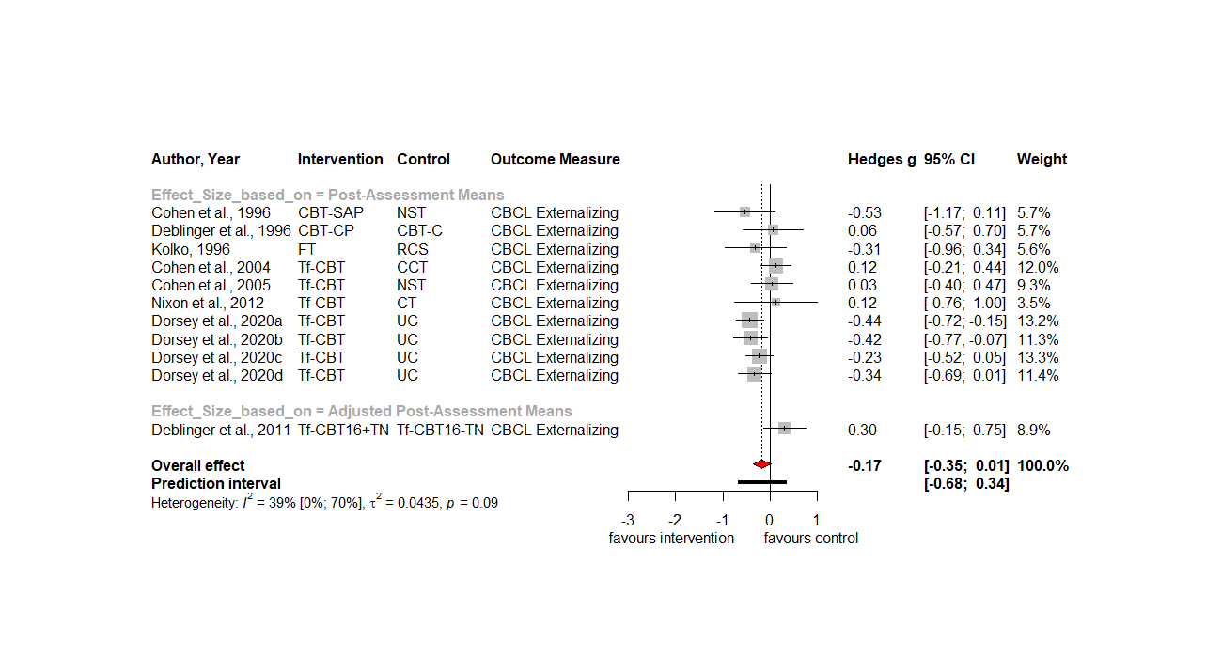
Figure S20
Forest plot for behavior problems at six months
Figure S21
Forest plot for behavior problems at twelve months

