Social and emotional characteristics of girls and young women with DDX3X-associated intellectual disability: A descriptive and comparative study
Elise Ng-Cordell^{1,2}, Anna Kolesnik-Taylor², Sinéad O’Brien², Duncan Astle², Gaia Scerif³, Kate Baker^{2,4}
1. Department of Psychology, University of British Columbia, Vancouver
2. MRC Cognition and Brain Sciences Unit, University of Cambridge
3. Department of Experimental Psychology, University of Oxford
4. Department of Medical Genetics, University of Cambridge

Corresponding author: Kate Baker, kate.baker@mrc-cbu.cam.ac.uk

Supplementary Material
Supplementary Information 1. Genetic diagnoses in the ID-comparison group
Supplementary Information 2. Participants’ gene variant information
Supplementary Information 3. ADI score profiles – Current
Supplementary Information 4. ADI score profiles – Most Abnormal / age 5
Supplementary Information 5. Scatterplots for within-group correlations
Supplementary Information 6. Regression models with group and interaction terms

Supplementary Information 1. Genetic diagnoses in the ID-comparison group
Gene | N
ARID1B | 3
CASK | 1
CTNNB1 | 1
DYRK1A | 1
EHMT1 | 3
GRIN2A | 1
KAT6B | 1
SETD5 | 4
SHANK1 | 2
STXBP1 | 5
TRIO | 1
Total | 23

Supplementary Information 2. Participants’ gene variant information

Participant no. | Decipher/100K Genome ID | Inheritance | Variant type | Amino acid change | Nucleotide change | Pathogenicity | ID severity
1 | 272869 | De novo | Missense | p.Cys467Tyr | c.1400G>A | Likely pathogenic | Severe
2 | 273466 | De novo | Splice (acceptor) | - | c.46-2A​>G | Likely pathogenic | Mild
3 | 272597 | De novo | Stop-gained | p.Ser24Ter | c.71C​>A | Pathogenic | Mild
4 | 264193 | De novo | Stop-gained | p.Arg291Ter | c.871C​>T | Likely pathogenic | Mild
5 | 261890 | Inherited | Missense | p.Arg533His | c.1598G​>A | Likely pathogenic | Moderate
6 | 267102 | De novo | Missense | p.Ala392Pro | c.1174G​>C | Likely pathogenic | Severe
7 | 267105 | De novo | Missense | p.Ala392Pro | c.1174G​>C | Likely pathogenic | Moderate
8 | 261162 | De novo | Stop-gained | p.Arg45Ter | c.133C​>T | Pathogenic | Moderate
9 | 290561 | De novo | Splice (donor) | - | c.281+1G​>C | Likely pathogenic | Moderate
10 | 300283 | De novo | Missense | p.Arg474Cys | c.1420C​>T | Likely pathogenic | Mild
11 | - | - | - | - | - | - | Moderate
12 | 277307 | De novo | Splice (donor) | - | c.45+1G>T | Pathogenic | Mild
13 | 303778 | De novo | Frameshift | p.Lys208SerfsTer13 | c.623delA | Pathogenic | Borderline
14 | - | De novo | Missense | Cys341Arg | c.1021T>C | - | Severe
15 | 282969 | De novo | Splice donor | - | c.45+1G>A | Pathogenic | Profound
16 | - | - | - | - | - | - | Moderate
17 | - | De novo | Splice (acceptor) |  | c.766-8_766-2del | Likely pathogenic | Mild
18 | - | - | - | - | - | - | Moderate
19 | - | Unknown | Frameshift | p.Asn124LysfsTer5 | c.372_373delCA | - | Mild
20 | 307552 | De novo | Frameshift | p.Phe83Ter | c.241_242insCTAG | Pathogenic | Borderline
21 | 210015169 | De novo | Frameshift | p.Gly153Leufs*69 | c.455_456dupCT | Pathogenic | Mild
22 | 281511 | De novo | Missense | p.Ser542Leu | c.1625C>T | Likely pathogenic | Moderate
23 | - | Unknown | Splice site | - | c.765+1G>A | Pathogenic | Mild

Supplementary Information 3. ADI score profiles - Current
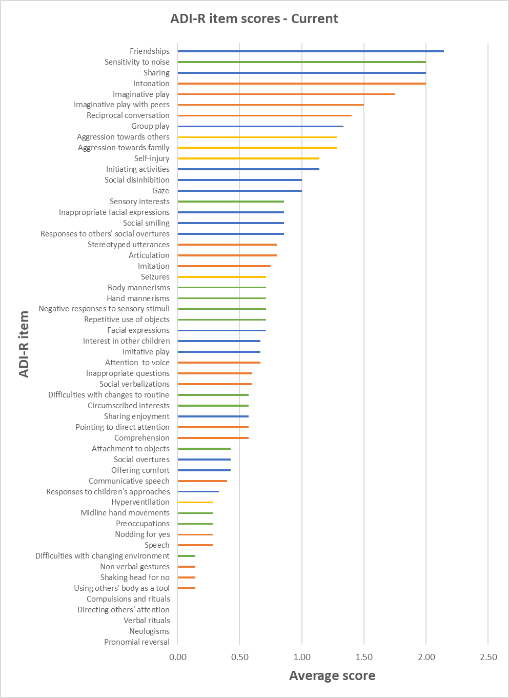
Note. Orange items = Language and Communication, Blue = Social Development and Play, Green = Interests and Behaviours, Yellow = General Behaviours.

Supplementary Information 4. ADI score profiles – Most Abnormal / age 5
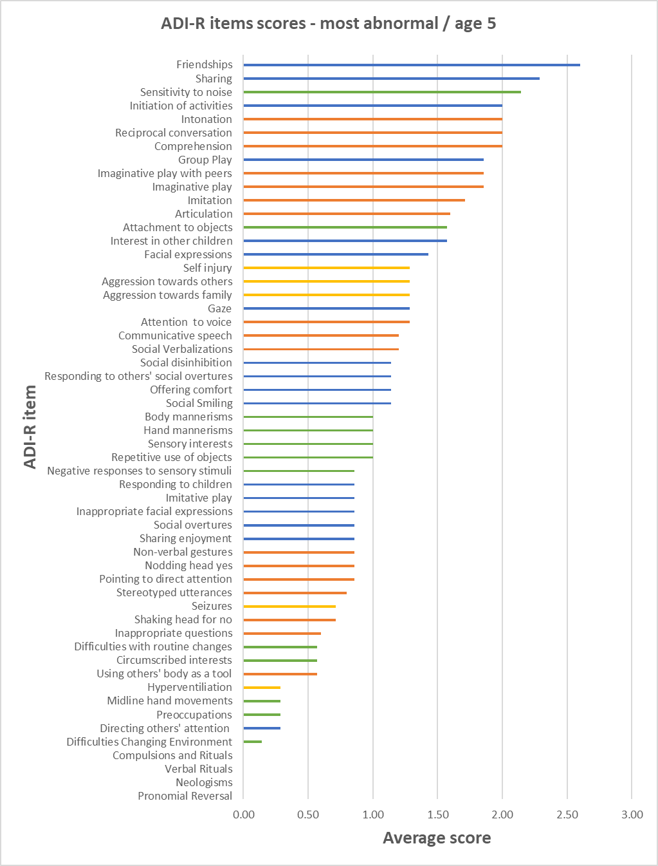
Note. Orange items = Language and Communication, Blue = Social Development and Play, Green = Interests and Behaviours, Yellow = General Behaviours.

Supplementary Information 5. Scatterplots for within-group correlations
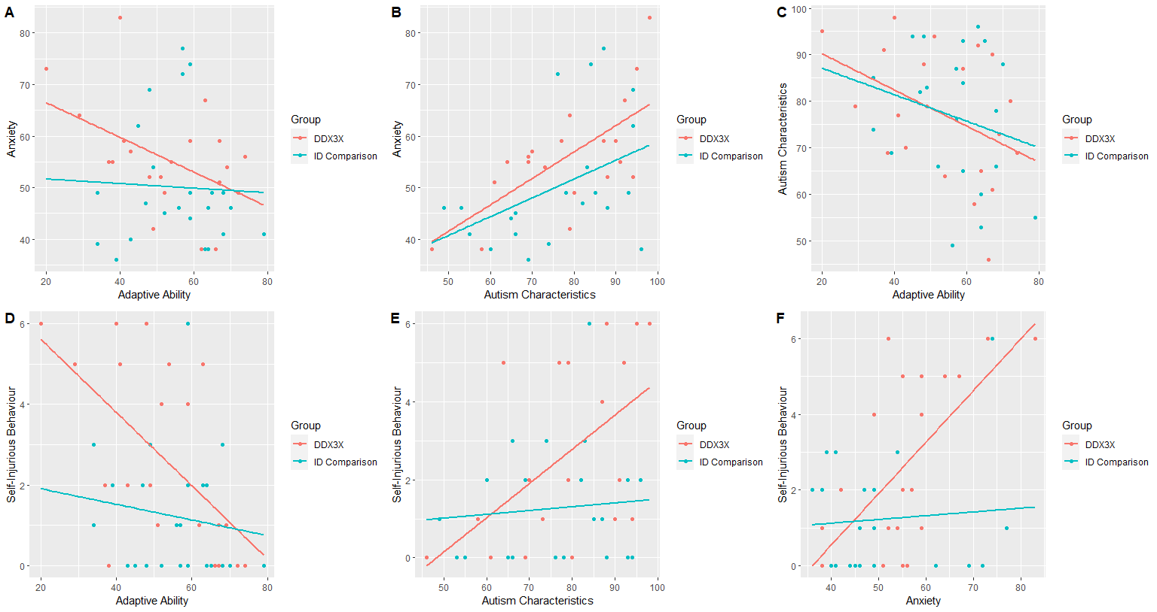
Supplementary Information 6. Regression Models with Group and Interaction Terms
Dependent variable  Predictors | ANOVA | Adjusted R² | B | Std. Err | Beta (β) | t | p | 95% CI for B
Anxiety (n = 44) | F (3,40) = 2.25, p =.10 | .14
Group |  |  | -20.96 | 14.71 | -.90 | -1.41 | .17 | [-5.45, 9.02]
Adaptive ability |  |  | -.63 | .39 | -.72 | -1.60 | .12 | [-1.42, .17]
Group* Adaptive ability |  |  | .29 | .26 | .89 | 1.11 | .27 | [-.24, .83]
Self-Injury (n = 44) | F (3,40) = 6.68, p =.001 | .28
Group |  |  | -5.13 | 2.28 | -1.26 | -2.25 | .03 | [-9.74, -.51]
Adaptive ability |  |  | -.16 | .06 | -1.05 | -2.66 | .01 | [-.29, -.04]
Group*Adaptive ability |  |  | .07 | .04 | 1.24 | 1.74 | .09 | [-.01, .15]
Self-Injury (n = 44) | F (3,40) = 7.39, p <.001
Group |  |  | 5.62 | 2.55 | 1.38 | 2.20 | .03 | [.46, 10.78]
Anxiety |  |  | .26 | .08 | 1.49 | 3.35 | .002 | [.10, .42]
Group*Anxiety |  |  | -.13 | .05 | -1.81 | -2.69 | .01 | [-.22, -.03]
Self-Injury (n = 42) | F (3,38) = 4.85, p =.006
Group |  |  | 4.76 | 3.16 | 1.17 | 1.51 | .14 | [-1.64, 11.16]
Autism char. |  |  | .17 | .07 | 1.14 | 2.55 | .02 | [.03, .30]
Autism char.*Self Injury |  |  | -.08 | .04 | -1.69 | -1.94 | .06 | [-.16, .00]
Note. Method = Enter.

